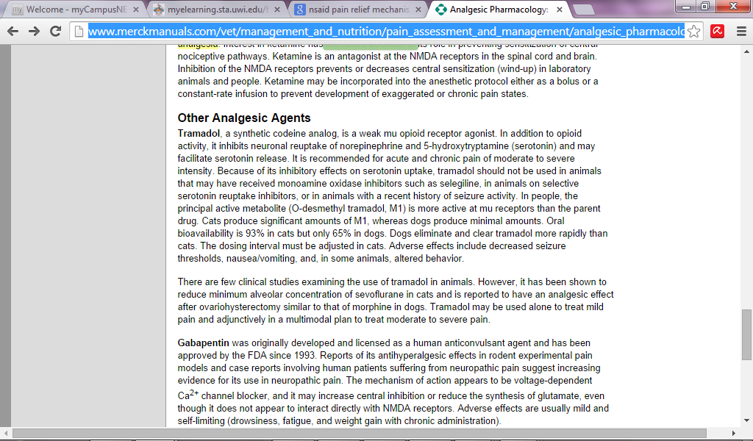

Source : <http://www.merckmanuals.com/vet/management_and_nutrition/pain_assessment_and_management/analgesic_pharmacology.html?qt=NSAID%20Analgesia&alt=sh>