Gowin’s Knowledge Vee:

A Tool for Matching Concepts and Methods

to the Challenges of Inquiry

Kip Ault, Ph.D.
Lewis & Clark Graduate School of Education and Counseling
Beijing Normal University Concept Mapping Workshop
November-December, 2014

D. Bob Gowin designed the “Vee Diagram” (1987, 2005) as a representation of the basic elements of disciplinary inquiry and how they interact with each other. The Vee is a dissection tool for uncovering the anatomy of a particular inquiry. The Vee depicts how methods combine with concepts to generate new insights through inquiry. The Vee opens with a “focus question” and points to the events of interest. The focus question frames the inquiry in terms of key concepts and directs attention to the events of interest. The Focus question “tells” about events at the same time as it “asks” about them.
A Vee holds the “events of interest” in the twin grip of conceptualization and record-making. Think of a concept-event-record triangle at the base of a Vee as inquiry’s anchor. The Vee points (literally) at what happens that needs understanding. Concepts grasp the event from one side while records of its occurrence seize it from the other. Inquiry begins and ends with an “event-sense” of the phenomenon of interest gained by focusing attention with concepts and records.
For the purposes of the Vee, concepts are defined as signs or symbols—including words or phrases—that signify patterns in the occurrence of events. Concepts refer to some events and not to others: boundaries to their meanings are established by virtue of their relationships to each other. Both concepts that refer to events and concepts about methods of inquiry appear in the form of concept maps on Vees. In essence, the Vee puts the concept map to work grasping events, framing questions, understanding methods, phrasing principles, and stating claims.
The Vee—metaphorically, a map of inquiry—places new claims in the context of both thinking and doing. The Vee’s left arm outlines thinking and its right arm scaffolds doing. For Gowin, thinking moves up and down a hierarchy from worldview through theory and principles to particular concepts anchored in events. Thinking also moves back and forth between concepts and principles on the left arm and “doing” on the right arm. Vees prompt thinking about methods: what to do and why to do it in order to answer the focus question. There is active interplay between thinking and doing at every level and across levels. A productive match (i.e., one that solves problems in a particular context) between thinking and doing is crucial. If a properly and carefully constructed Vee fails to represent this match, then the inquiry itself likely has flaws.
The doing side (right arm) features a hierarchy the same as the thinking side (left arm). Close to events and the point of the Vee are “records”—the initial inscriptions of events. Transformations of records produce data. Further applications of methods amplify patterns or relationships in the data to produce “generalizations.” Claims of new knowledge rest upon these patterns in (and generalizations from) the data and can therefore be traced back through the evidence to the event of interest.
Well-warranted knowledge claims add to the resources on the thinking side. In effect, new knowledge becomes principles for guiding subsequent inquiry. Inquiry Vees march along in zig-zag fashion: descending through conceptualization to an event-sense of the phenomenon of interest, then rising from records in keeping with trusted methods to warrant new knowledge. New claims of knowledge answer the focus questions. The trusted new knowledge then assumes a role in the conceptualization of events and guides the next episode of descent into events and rise to claims. Inquiry, in this sense, “recycles” understanding as the Vees go marching along—repeatedly descending into events and rising with improved understanding.
Inquiry generates claims in two categories: knowledge and value. Valuing begins with feeling the significance of a claim. Value claims argue for the importance of the new knowledge, either within the field of inquiry or beyond. They answer the question, “So What?” Value claims are composed in a variety of styles, for example, the familiar comparative style: “X is better than Y.” Gowin describes five rhetorical styles for claiming value:
1. Intrinsic: “X is good”
“Being happy is good.” (Being happy in a good in itself.)
“The wolf is a magnificent creature.”
2. Comparative: “Y is better than Y.”
“Being happy is better than making money.”
“Wolves are more magnificent than coyotes.”
3. Instrumental: “Y is good for Y.”
“Being happy is good for my health, my work.”
“Being happy is good for those around me.”
“Wolves are good for wildlife population stability.”
“Coyotes are good for controlling populations of pesky roadrunners.”
4. Decision: “You ought to choose X.”
“Choosing to be happy is something a person ought to do.”
“People ought to conserve populations of wolves.”
“The government should exterminate coyotes.”
5. Ideal: “X is right.”
“It is right for a person to be happy.”
“A person has a right to happiness.”
“Wild species have a right to survive.”
“In the best of all possible worlds, people honor diversity of species.”
A Vee diagram does echo “the” scientific method or hypothesis testing—but with a greatly amplified emphasis on the relationship of conceptual understanding to method of inquiry. It also stresses the value of the concept-event-record triad: phenomena are grasped in mind and by action simultaneously. “Motion,” for example, is a concept meaning change in position with respect to time. The meaning is wrapped up in how to record an instance of the event.
Gowin advises constructing Vees in order to represent fields as diverse as literary criticism, historiography, and theological studies. The Vee is a heuristic—a starting point for analysis and not the object of interest itself. The function of the Vee is to unpack specific claims in relation to the diverse contexts of inquiry that generated them. The relationships among the parts matters most. The Vee brings them to focus.
Vees scaffold lab reports and field studies equally well. They are useful to both the experimental and historical styles of science. An outline of Gowin’s Vee and example of its completion appear below.
In summary, Vee diagrams display answers to the following five questions about an investigation:
- What are the events of interest and what question focuses attention on them? The focus question sits on top of the Vee and the description of events appears below the Vee.
- How are the events of interest represented? Representations appear as concepts on the left and records on the right side of the Vee near the bottom. Concepts and records both refer to events; concepts also derive meaning from relationship to each other. Concept relationships are best depicted in a concept map.
- What principles guide thinking? Principles occupy the theory or model level on the upper left side of the Vee. Principles are composed of concepts. So, too, is the focus question. Principles are high level propositions that guide thinking and doing.
- How are records transformed into data and generalizations? Data appear in organized form on the right side of the Vee in the middle. Transformations depend upon the application of principles that guide methods. Generalizations amplify, clarify, and state patterns in the data.
- What are the claims produced in this context of inquiry, both of new understanding and its value? Claims reside on the upper right side of the Vee. Claims stem from the interpretation of data and generalizations in terms of concepts, principles, and theory that appear on the left side. Knowledge claims may be lawful, probabilistic, correlative, descriptive, predictive, explanatory, or causal. Value claims answer, “So what?” and are phrased as intrinsic, comparative, instrumental, decision, or ideal.
Gowin (1970, 1981) originally proposed five similar questions for understanding the structure of knowledge expressed in any work:
1. The telling question. What is the telling question of the work?
2. The key concepts. Conceptual structure. What are the key concepts?
3. Methods. What methods were used to answer the telling question?
4. Knowledge claims. What are the major claims in the work?
5. Value claims. What value claims are made in the work? (1981, p. 88)

Title
Thinking (Conceptual) | Focus Question(s) (focus questions alert our attention to the events of interest and, in some cases, how we might study them; key concepts appear in the phrasing of the focus questions, as well as in the knowledge claims; hypotheses are tested as one means of answering the Focus Questions.)  Inquiry requires the active interplay of conceptual and factual thinking, with the conceptual structure governing the posing of questions, the selection of events, the design of procedures, and the interpretation of the data. The data, once fashioned into trusted new claims, impact prior knowledge, leading to elaboration, change, or refutation, of existing claims, concepts, principles, or theory, or to the imaginative emergence of new alternatives to any of these elements. | Doing (Factual)
Theory (theories explain; theories often present models; theories propose general principles based upon the study of particular cases; theories often rely on constructs for coherence; theories generate reliable predictions and testable hypotheses; theories have names: for example: Self-theories (Dweck) Conceptual Change, Behaviorism, Judicial Discipline, Newton’s Gravity) |  | Claims (knowledge claims answer the focus questions; they follow from interpreting the data, inspecting the tables or the transcripts, from analysis of the organized records of events; claiming uses the concepts and principles brought to the inquiry as expressed on the Left Side; new claims may bring about a change in the pattern of thought that started the study; claims may be descriptive, correlational [assert a relationship], or causal [propose a mechanism] in nature; value claims [intrinsic, comparative, utilitarian, judicial, ideal] state the worth of the new knowledge and to whom; claims fit within theoretical or conceptual structures)
Principles (general statements using key concepts and asserting values that are important guides to thinking and doing; principles come from prior knowledge claims proved to be of high worth) |  | Data (data are transformations of the records; data organize records into useful forms--useful in the context of answering the focus questions; data are adequate for their purpose and require an appropriate form of representation; data amplify and clarify patterns that exist within the records of the events)
Concepts (words or phrases or symbols; concepts label or signify patterns; concepts are the categories that organize our thinking; concepts derive meaning from referring to a set of objects or range of events and from their relationship to other concepts; concept maps are a good way to represent meaning derived from reference and relationship) |  | Records of Events (the paper records, memories, journal entries, test scores, observed behaviors that record the events of interest; records are subsequently studied with care; records may record the values taken on by the dependent and other variables; different techniques and instruments turn observations into records; facts are records trusted to record the event of interest)
Events and Objects (events are what happens; objects are used to make events happen;
to inquire or to investigate is to pose questions about events; researchers may make events happen;
events are the important phenomena you wish to improve your thinking about;
events are what the data stands for,
what you must carefully record in order to do the work of answering questions; events anchor the V)
Focus Question: HOW DO ISOPOD ORGANISMS
RESPOND TO A TEMPERATURE GRADIENT?

Theory or Model: | Value Claims:
Ecological "niche" theory:  Functions of a species within its habitat as determined by adaptations to biological and physical factors than limit its abundance. | The isopod tray is useful for exploring the effect of temperature gradients in the environment on small organisms.  Knowing the range of temperature preferred by isopods may help to predict their seasonal abundance and plan for effective pest control.
Principles:

- Organism behavior is a response to environmental stimuli.  - Physical factors limit the range preferred by an organism.  - The "tray device" controls for important variables. | Knowledge Claims:  1. Isopods congregate near each other, along edges of structures, and under debris. This tendency to congregate interacts with preference for a temperature range, moisture and light being kept constant.
Theory: | 2. The isopod species called "sowbugs" prefers to locate itself along a temperature gradient within the range of ___ to ___ ºC.
Niche Limiting Factor
 | Generalizations/Interpretations:
Competitive Exclusion
 | Section ___ has the most pillbugs.
 | Section ___ has the most sowbugs.
 | Data:
Concepts: | Section Number
 | 1 2 3 4 5 6 7
Temperature Gradient | Temp.
Behavior Organism | No. of Bugs
 | (Average)
Species Crustacean
 | Records:
- Number of bugs in each section counted every 15 seconds for two minutes.
- Temperature of each section of gradient.
- Type of isopod (pillbug or sowbug).

Events: Isopods crawling about on a sandy tray, one end on ice, the other on a hot water bottle
(near boiling), illuminated with red light, covered with Plexiglas, and kept very moist.

The Influence of Interactive Zoo Exhibits on
Visitor Attitude and Conservation Action

V Diagram: Conceptual Arm  (Thinking)  World View:  Zoos exist to raise social awareness of conservation and animal rights.  Philosophy:  Zoogoers are much less knowledgeable about animals than other groups claiming an interest in animals.  Hypothesis or Theory:  Zoo visitors who experience an interactive elephant demonstration will be more likely to actively support elephant conservation than those who just visited and saw the animals in the exhibit and read graphics.  Principles:  Learning in an informal setting is more attitudinal than cognitive.  Concepts:  Interactive experience  Informal learning  Knowledge-based information vs. Conservation issues | Focus Question(s):  1) Will visitors who have an interactive experience with a zoo demonstration and bio-fact program be more likely to support elephant conservation issues than visitors who just visit the animals and read the graphics?  2) How can zoos effectively educate the public on conservation, wildlife and natural habitats in order to change attitudes, and ultimately behaviors? | V Diagram: Factual Arm  (Doing)  Value Claims:  Zoos must present conservation issues even though they are controversial.  Zoos should take on a more active and perhaps political role in advocating by means of visitor education  Knowledge Claims:  Modest support to hypothesis  “Dramatic and entertaining presentations could provide a means to mix an affective personal message with factual information.”  Technology may be a way to do this.  Data:  Return rate of 18.3% for solicitation cards.  Rate higher for visitors that had higher levels of interaction, highest 29.7% to lowest 11.6%  Records of Events:  Answers to question, number of people who signed the petition and/or sent in cards
Events and Objects:
471 zoo visitors selected with 350 visitors completing a survey of 25 close-ended questions, signing petitions, and taking conservation-action solicitation cards (to return).

VOLUNTARY LEARNING

1. Meaning is inference. The simple formula of “X stands for Y, X thus means Y” is taken as the root notion of meaning. To grasp a meaning is becoming aware of how any given X comes to stand for (is taken as a sign of) any new Y. We make the inference that the footprint in the sand means that a creature walked there. Much meaning is inference-making.

2. Meaning is social. The shared human activity of taking the same sign to stand for or to signify the same object, quality or element in an event is a social act. The relation between teacher, learner and curriculum is a social relation. Teacher and student must come to share the same signs for the same events found in educative materials. Learning deriving from shared meaning may be undertaken individually, but the context for making such learning meaningful is social.

3. Reorganization of meaning. The basic reorganization (that is learning) is between person centered claims and knowledge centered claims. This relation requires both claims to become self-evident to learners. Since adult learning is idiosyncratic, each person has a task of self-analysis to determine what is already known (the power for learning something new), and what is needed to become known (the person’s entry point of “dumbness”, ignorance, immaturity, lack of skill, etc.).

4. Making an object of the self. Voluntary, deliberate individual learning is facilitated when the person regards his or her self as an object. lf you are to learn about learning for yourself, you must take yourself as an object, an instrument, as something to be managed, as having chronic patterns that interfere, as a house of conceptions and misconceptions. Yoluntary learning requires individual control of learning.

5. Learning patterns are artifactual. Whatever learning may be as a “natural” biological, chemical, physiological, neural event in nature, voluntary learning depends upon agents who can take the self as an object. Language is the primary instrument for this occurrence. Since language is a cultural artifact, it is probably also true that learning processes and patterns themselves are artifactual.

6. Learning patterns are socialized: We learn values as patterns of social activity. For example, human sexuality is a social construction of reality. The patterns are artifactual. We learn “sexiness”, eating patterns, working patterns, etc. in a social context; they are determined socially. So, too, with patterns of learning. We “Learn to be smart” or we “Learn to be dumb.” Ironically, the social context is what makes us an individual.

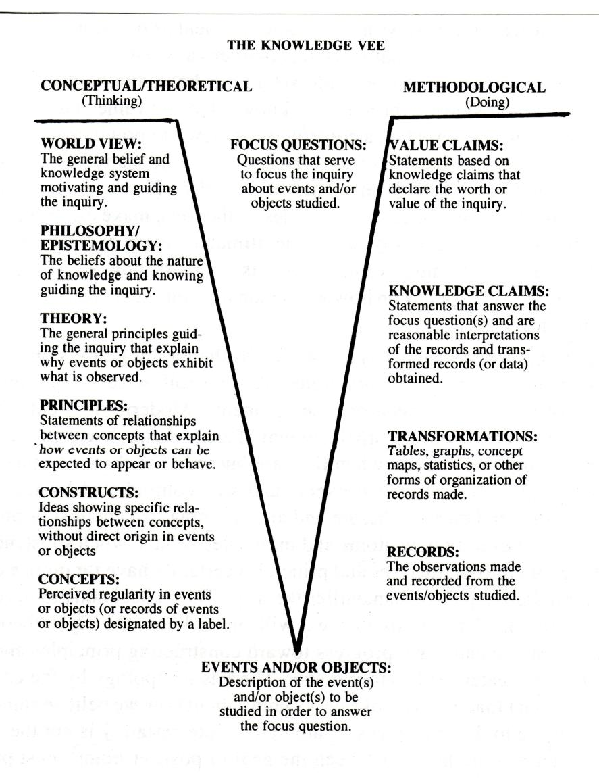

Gowin’s Knowledge Vee.

Gowin, D. B. (1981, 1987). Educating. Ithaca, NY: Cornell University Press.
Gowin, D. B. (1970). The structure of knowledge. Educational Theory, 20(4), 3 19-328.
Gowin, D. B., & Alvarez, M. C. (2005). The Art of Educating with Vee Diagrams. NY: Cambridge University Press.

