PROXIMAL PARAVERTEBRAL NERVE BLOCK
- Most commonly used to access the abdominal cavity
- You can actually accomplish entry into the abdominal cavity via the distal paravertebral nerve block, infiltration anaesthesia and segmental epidural anaesthesia. All provide anaesthesia of the flank region for abomasal displacement, rumenotomy, caesarean section or intestinal surgery.
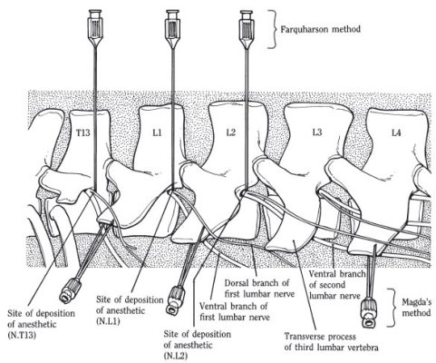

- This method will provide excellent anaesthesia for the entire flank area via a blockade of the last thoracic (T13) and first two lumbar (L1 and L2) spinal nerves as they emerge from the intervertebral foramina.
- The nerves were approached via the dorsal aspect of the transverse processes of the lumbar vertebrae.
- The ends of the transverse processes are palpated. Start caudally just in front of the tuber coxa with L5 and working cranially to the L1.
- The catheter was placed as a trocar 1 to 2 cm off the dorsal midline, in line with the cranial aspect of the transverse process of L1.
- Pass the needle ventrally until the transverse process is encountered. You will feel something hard and the needle will be unable to penetrate.
- Walk the needle off of the cranial edge of the process and pass it ventrally to penetrate the transverse ligament and the fascia.
- After penetration of the fascia, the lidocaine was administered into the hub to ensure it was not sucked into a dead space, then administered.
ADVANTAGES | DISADVANTAGES
Minimal amount of anaesthetic required | Difficulty in finding landmarks in fat ruminants and heavily muscled animals
Large area of desensitization. Wide an uniform area of analgesia and muscle relaxation | Scoliosis of the spine- makes closure of incision more difficult
No lidocaine in the incision site | Moderate ataxia
Rapid onset of local anaesthesia | Possibility of penetrating a major blood vessel or the spinal canal
Decreased intra-abdominal pressure | More skill or practice required for consistent results
Table 1: The advantages and the disadvantages for the proximal paravertebral nerve block.
How to determine success?
- Increased temperature of the skin.
- Analgesia of the skin, muscles and peritoneum of the abdominal wall of the paralumbar fossa
- Scoliosis of the spine toward the desensitized side

DISTAL PARAVERTEBRAL NERVE BLOCK
- This method desensitizes the dorsal and ventral rami of the spinal nerves T13, L1 and L2 at the distal ends of the transverse processes of L1 and L2 and L4, respectively.
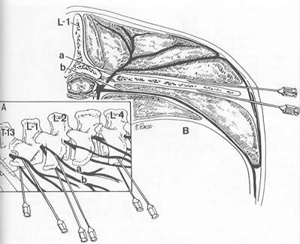
- The needle is inserted ventral to the transverse process and the anaesthetic is infused in a fan-shaped pattern.
- The needle can be removed completely to be reinserted or redirected dorsally, in a caudal direction where the local anaesthetic is again infused in a fan-shaped pattern.
- Procedure is repeated for the transverse processes of the second and fourth lumbar vertebrae.

ADVANTAGES | DISADVANTAGES
Lack of scoliosis and ataxia | Larger doses of anaesthetic required
Easier to perform | Variations in efficiency caused by variation in anatomic pathways of the nerves
Offers more consistent results | Difficulty in locating the transverse processes in fat animals
Reduced risk of penetrating large blood vessels or nerves
Use of common- sized needles
Table 2: The advantages and disadvantages of the distal to the proximal paravertebral nerve blocks.

