VETM 4341 LARGE ANIMAL SURGERY - 2014 SEMESTER I
SURGERY LABORATORY GROUPS – LAB 2 – 16/9/14

GR | GROUP MEMBERS | PROCEDURE - 1 | PROCEDURE - 2 | PROCEDURE - 3 | PROCEDURE - 4
 |  | xylazine (0.025 mg/kg), IV | Epidural – 2% lidocaine (0.2mg/kg). S-C1 of Ci-C2 space 45º . The “hanging drop” technique OR The “lack of resistance” tech | Block-T₁₃, L₁, and L₂  Proximal paravertbral  Draw nerves and landmarks. Explain procedure. | - IV regional – Hind leg -cranial br lat saphenous vein. 5-10 cc 2% lidocaine IV
 |  | xylazine (0.025 mg/kg) IM. | Epidural – 2% lidocaine (0.2mg/kg). S-C1 of Ci-C2 space 45º . The “hanging drop” technique OR The “lack of resistance” tech | Block-T₁₃, L₁, and L₂  Distal paravertbral  Draw nerves and landmarks. Explain procedure. | - IV regional – Front leg – Cephalic or Dorsal common digital vein III. 5-10 cc 2% lidocaine IV
 |  | xylazine (0.025 mg/kg), IV | Epidural – 2% lidocaine (0.2mg/kg). S-C1 of Ci-C2 space 45º . The “hanging drop” technique OR The “lack of resistance” tech | 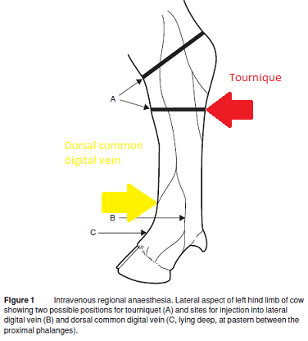 | - Nerve block – Hind leg - peroneal and tibial nerve block. 5-10 cc 2% lidocaine IV
 |  | xylazine (0.025 mg/kg), IM | Epidural – 2% lidocaine (0.2mg/kg). S-C1 of Ci-C2 space 45º . The “hanging drop” technique OR The “lack of resistance” tech |  | - IV regional – Hind leg -lat saphenous vein above hook joint. 15-20 cc 2% lidocaine IV

PROCEDURE – 1 – ALL GROUPS – If you require better ANALGESIA of animal give ketamine (1 mg/kg IV). Reversal of xylazine should not be attempted until sufficient time has elapsed to allow the ketamine anesthesia if used to be resolved (15–20 minutes post-IV administration). Reversal if required tolazoline (2x xylazine dose IV). Cmaps should include signalment, PE findings, anaesthesia and monitoring protocol. All drugs dosage (inclusive of emergency drugs), calculations, time given, route and withdrawal times (meat and/milk) recorded. Each procedure performed should be documented in detail with complications/problems, and client education. Be sure to mention all pre-, intra-, and post- operative considerations. Each group is required to observe your animals for the next 7 days and treat any complications that arise.
Alternative hindlimb block above the hock, providing analgesia below the hock:
CATTLE -
1) Fibular (peroneal) nerve:
Palpate the bony prominence of the caudal edge of the lateral condyle of the tibia. The nerve runs immediately behind the caudal edge of this bone and over the fibula and may be palpable against the bone. Insert an 18 or 20 gauge 2.5 cm needle through the skin and through the aponeurotic sheet of biceps femoris until the point of the needle just touches the caudal edge of the lateral condyle of the tibia. Inject 20 ml of 2% lidocaine hydrochloride.
2) Tibial nerve (on the medial aspect of the limb, just in front of the gastrocnemius tendon).
Grasp the gastrocnemius (Achilles) tendon between the thumb and index finger of one hand about 10-12 cm above the summit of calcaneous. Insert a 2.5 cm needle just below the thumb until the point of the needle can be felt by the index finger, just below the skin on the other side of the tendon. Inject 15-20 ml local anaesthetic solution. Inject an additional 5 ml on the medial side of the leg to block a small cutaneous nerve at this site. Analgesia develops after 15 minutes.
SHEEP AND GOATS –
Peroneal nerve block:
The peroneal nerve is found where it runs obliquely below the lateral condyle of the tibia, from caudodorsally to cranioventrally, about 2.5 cm below the lateral condyle of the tibia; it may be palpated by using thumbnail pressure to move the skin and underlying tissues. 5 mL of 2% lidocaine is injected at this site.
Tibial nerve block:
On the medial side of the leg at the hock, between the flexor tendons and the tendon of gastrocnemius, inject 4 mL of 2% lidocaine. Inject an additional 1 mL of lidocaine on the lateral side of the limb at the same site; this blocks a small cutaneous nerve which is a branch of the common peroneal nerve originating at the middle of the thigh. Onset of analgesia should occur within 15 minutes. As the block takes effect the hock straightens (tibial nerve block) and the animal will stand on the dorsal surface of the fetlock (peroneal nerve block).
