Indus Valley River Civilization
Grade level: 6
Strand: History
Topic: Early Civilizations
Content Statement #2: Early civilizations (India, Egypt, China and Mesopotamia) with unique governments, economic systems, social structures, religions, technologies, and agricultural practices and products flourished as a result of favorable geographic characteristics. The cultural practices and products of these early civilizations can be used to help understand the Eastern Hemisphere today.
The Indus Valley Civilization was an ancient civilization located in what is Pakistan and northwest India today, on the fertile flood plain of the Indus River and its vicinity. Evidence of religious practices in this area date back approximately to 5500 BCE. Farming settlements began around 4000 BCE and around 3000 BCE there appeared the first signs of urbanization. By 2600 BCE, dozens of towns and cities had been established, and between 2500 and 2000 BCE the Indus Valley Civilization was at its peak.
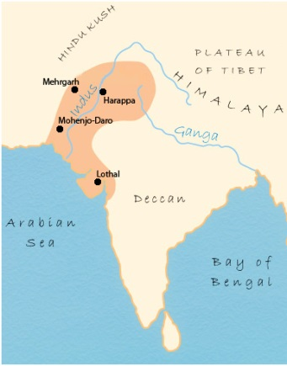
Map of Region
Artifact: a map that shows the location of the Indus Valley River Civilization, including the features that acted as a citadel for the civilization.
The Indus Valley River Civilization stretches across present day India, Pakistan, Bangladesh, Nepal, Sri Lanka, and Bhutan. The ruins of twin cities Harappa and Mohenjo-Daro, located 350 miles from one another, along with remnants of other settlements in the area, revealed great clues about this civilization. The civilizations natural borders, shown in the map, sheltered it from attack and disease. The river allowed for irrigation of crops and transportation.

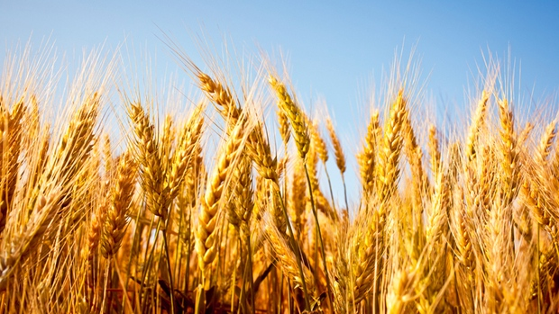
Agriculture
Artifact: wheat, rice and cotton
The Indus River allowed for the development of irrigation systems that helped provide the civilization with food for themselves. Their primary crops were wheat and barley, but they also harvested rye, peas, cotton and rice.

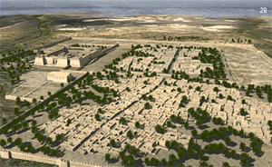
Organization
Artifact: a model of the city’s streets and protective walls
Harappa is believed to have gotten its start as a farming village around 3300 BC. Mohenjo-Daro is the twin city and both formed the hub of the civilization. Since their planning principles were followed without change at all other sites, these two cities laid the groundwork for the other cities that followed. Both cities were a mile square with defensive outer walls. The street layout shows an understanding of traffic with rounded corners to allow turning of carts easily, and dividing the city into 12 blocks. Except for the west-central blocks, the basic unit of city planning was the individual houses. For protection from seasonal floods and polluted waters, the settlements were built on giant platforms and elevated grounds. Upon these foundations, networks of streets were laid out in neat patterns of straight lines and right angles. The buildings along the roads were all constructed of bricks that were uniform in size.
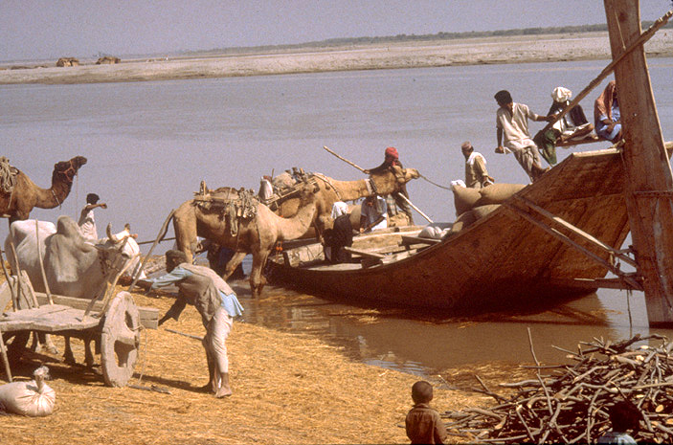
Trade
Artifact: a boat
The economy depended greatly on trade. Trade was conducted within the civilization as well as with Mesopotamia. Advancement in technology led to carts and early boats that were used as the main method of trade and travel. It was this intensive devotion to craftsmanship and trade that allowed the Harappan culture to spread widely and prosper greatly. Each time goods were traded or neighbors entered the gates of the cities to barter, Indus culture was spread.

Sanitary
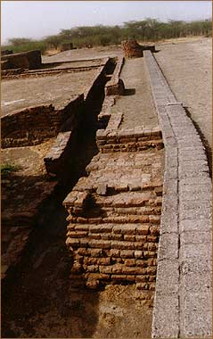
Artifact: a wash tub
The evidence suggests they had a highly developed city life; the brick houses of all city dwellers were equipped with bathing areas supplied with water from neighborhood wells. Sophisticated drainage systems throughout the city carried dirty water and sewage outside of living spaces. Even the smallest houses on the edges of the towns were connected to the systems — cleanliness was obviously of utmost importance.
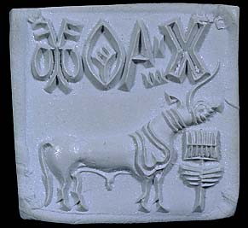
Rulers
Artifact: clay “seal” with animal imprint
Rulers within the cities of the Indus Valley governed through the control of trade and religion rather than military strength. There is no indication of warfare or weapons that may have been used. The rulers carried seals with animal symbols and writing and wore ornaments of rare material. Each animal symbol represented some form of power: the bull symbolized the leader of the herd, virile and strong; the elephant symbol was attached to goods being traded; the buffalo represented a posture of defense to protect; the tiger was used by minor administrative officers; the unicorn appears to be an important symbol of the elite and was used in governing the different settlements, assuming the economic and political power in the major cities.
Uses for this artifact box:
I could see myself using this box in one of two ways while teaching the ONLS as a 6th grade social studies teacher:
- I would use artifact boxes, all with items that covered similar areas (i.e. religion, status, transportation, etc.), for each river civilization to introduce and engage the students at the beginning of the unit. I would have them guess what each artifact represents and tell why within small groups. I would have the groups rotate the boxes and determine the similarities and differences between the civilizations.
- I would have small groups jigsaw the river civilizations, just like we did for this class, with a given set of areas they needed to find information on. The group would then create their own artifact box and share with the class. As a whole, the class would come up with similarities and differences between them.
Resources
Ancient Indus Sanitary drainage at the acropolis, Lothal. (n.d.). Ancient Indus Sanitary drainage at the acropolis, Lothal. Retrieved July 15, 2014, from http://www.harappa.com/lothal/14.html
Early Civilization in the Indus Valley. (n.d.). ushistory.org. Retrieved July 15, 2014, from http://www.ushistory.org/civ/8a.asp
Indus River Valley Civilization. (2011, September 11). . Retrieved July 7, 2014, from http://www.rivervalleycivilizations.com/indus.php
Indus Valley Civilization. (2013, October 13). Ancient History Encyclopedia. Retrieved July 7, 2014, from http://www.ancient.eu.com/Indus_Valley_Civilization/
Indus Valley. (n.d.). AllAboutHistory.org. Retrieved July 7, 2014, from http://www.allabouthistory.org/indus-valley.htm
Indus Valley Sealing. (n.d.). Indus Valley Sealing. Retrieved July 7, 2014, from http://www.harappa.com/seal/7.html
Indus Valley: Teacher's Resources. (n.d.). BBC News. Retrieved July 15, 2014, from http://www.bbc.co.uk/schools/primaryhistory/indus_valley/land_of_the_indus/teachers_resources.shtml
Mayer, A. (2012, October 8). Why are we waging a war on wheat?. . Retrieved July 15, 2014, from http://www.cbc.ca/news/health/why-are-we-waging-a-war-on-wheat-1.1229404

