*I have not evaluated SMART Senteo, Promethean/Logical Choice Activote, Quick Tally, Pearson/Scantron Engage, TI-Navigator, iRespond, Ortek, Interactive Horizons IRIS, iRespond, GeneeUs, EduGame, Dolphin Inteactive Presenter, CLiKAPAD, iTech Keypads, Sun-Tech, or XTOL*.

**Socrative Teacher (Free)**

Socrative can engage the entire classroom with educational exercises and games while capturing student results in real-time. Interact with the data to further student understanding in the moment, and review the reports to prepare for future classes. Socrative will even aggregate and grade our pre-made activities! Create a library of activities and share them with your colleagues and learning community.

MOST POPULAR ACTIVITIES:

✔ Short Answer Questions: Ask an open-ended question. Students respond and all their answers populate your screen for projection. Then ask students to vote on their favorite and watch the results come in.

✔ Quick Quiz: A teacher paced or student paced activity with multiple choice and/or short answer questions. Results can be viewed question by question and exported to a report that is automatically aggregated and graded.

✔ Create a Quiz: Design your own Quick Quizzes with our built in feature or import them with our Excel template. Share with your community!

✔ Space Race: Teams of students answer multiple choice questions in this fast-paced rocket race game. First team to get their rocket across the screen wins! You’ll get a graded report!

✔ Exit Tickets: Get a quick, paper-free pulse-check at the end of class. All answers are aggregated into a report!

✔ Multiple Choice: Ask a MC question, and see student responses on the projection screen as a bar chart.

**Socrative Student (Free)**

Socrative brings smart clickers, student response and ease of use to a whole new level. Be engaged for the entire class with educational exercises and games. See all your classmates’ ideas in real time and interact with the responses. Provide instructor feedback on the lessons and how well students understand the material. Ask your own poll questions for the entire class or build a premade activity for the whole class. --WORKS ON ANY DEVICE WITH A WEB BROWSER: Tablets, Smartphones & laptops (some types of Blackberries)

MOST POPULAR ACTIVITIES:

✔ Short Answer Questions ✔ Space Race ✔ Exit Tickets ✔ Quick Quiz ✔ Multiple Choice

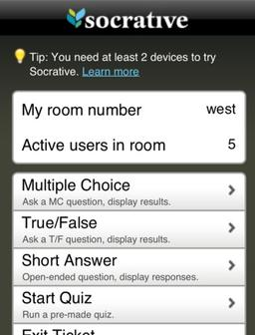 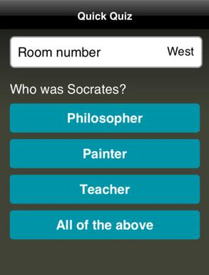

Teacher Student

**iResponse Teacher Utility (Free)**

iResponse is a classroom responder system. It allows instructors to formulate and send questions at any time. Free software is needed to be downloaded to installed on a wireless PC or Mac. Signals are sent through the wireless connection. It is currently an iPhone app.

**iResponse Pro (Student Version** $4.99)

iResponse PRO Classroom Responder System contains all the features of the iResponse (standard version) but now includes the ability to distribute a complete test(s) to devices connected to the class session via Wi-Fi. The distributed test(s) may be completed during the session or as a take home assignment, with an instructor specified time limit if required.

The iResponse system provides education and training institutions with the ability to use the iPhone, iPad, Android and iPod touch to transform their lectures into an interactive learning experience. This will help students increase their learning and retain knowledge.

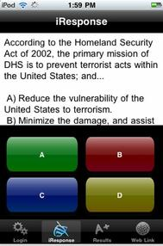 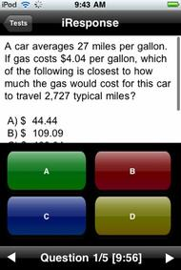 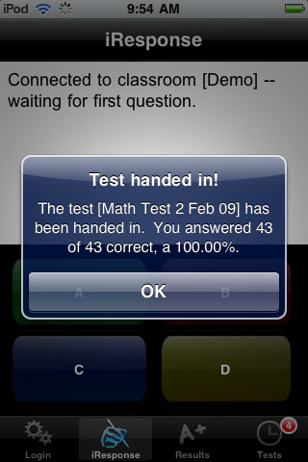

iResponse iResponse Pro iResponse Pro

**eClicker (Free)**

eClicker is a personal response system that allows teachers to poll their class. eClickers is designed for up to 64 clients with a easy-to-use question viewer.

**eClicker Host (**$9.99)

eClicker Host is a personal response system that allows teachers to poll their class. This is the teacher software that works with the free eclicker software. eClicker Host allows up to 32 connections connected through WiFI.

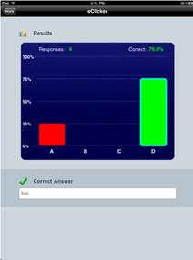 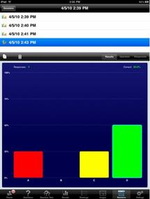

eClicker eClicker Host

**Responseware** (Free app, but requires subscription for service)

ResponseWare is a TurningPoint response technology requiring a subscription service that allows students or meeting participants to use an iPhone, iPad, iPod Touch or Android device to respond to interactive polling questions that are presented during a class or meeting presentation. Through an Internet connection, ResponseWare sends user responses to the presenter’s presentation and group response can be displayed in real-time.

ResponseWare is a web-based tool for presenters to engage their audience and assess their comprehension. Based on results, presenters can then adjust content to better meet the needs of their audience. Responses can be tracked by individuals for later reporting and point values can also be assigned.

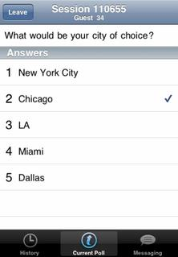

**SRN Client (Free)**

Student Response Network (SRN) is a “virtual Clicker” student/audience response system designed for use in wired school computer labs or with wireless laptop groups, a software-only solution for use with networked client devices.

SRN Client for iPhone/iPod extends the response options from Windows, OSX and Linux desktops and laptops to Apple’s handheld mobile devices. Now in 802.11 wireless settings, we could use our iPhone or iPod to connect to response sessions in class and participate as if we had access to one of those bulkier computers – except you have the same power in the palm of your hand.

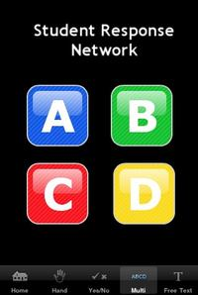

**VisionTree**

VisionTree Mobile users can use their own devices (Blackberry, iPhone, iPod Touch, iPad, Netbook, Laptop, etc.) VisionTree allows you to capture real-time feedback, measure learning & document results

VisionTree Mobile works on any web-enabled device (Smartphone, PDA, Laptop), requires no software, and can easily be deployed for large events or small classess. Unlike a basic keypad solution which limits the types of questions that you can ask (Yes / No, A, B, or C, etc) you can ask any type of question using sliding scales, checkboxes, ranking, free-text, or create your own question. The measurement module allows attendees to fill out surveys, feedback forms, CME/CEU and other custom forms. Attendees can send questions to the speaker or panel anonymously using their VisionTree app. These questions can then be filtered, edited and approved for a speaker or panel to answer. VisionTree Mobile now allows for posted Twitter feeds into the Q&A module for editing and live review. All data can be exported to Excel or PDF and the reports can be placed directly into PowerPoint

Entirely web-based, which means there is no integration necessary with PowerPoint. VisionTree will run in parallel with a meeting or class and allow you capture data even if a speaker doesn't have a specific time set away for audience response. For example, after each speaker, an attendee would select "Give Feedback" and would rate the speaker on a scale of 1-5, and provide any comments or suggestions. This allows you to capture the ratings in real-time, at the moment of interaction and gives you a greater quality and quantity of feedback.

