**Question**: For the manometer shown below, where h = 12 cm Hg and Patm = 0.973 atm.  What is the pressure of the gas?

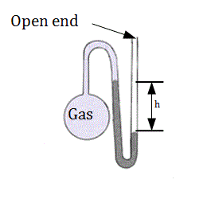

1. 0.158 atm
2. 0.815 atm
3. 0.842 atm
4. 0.957 atm
5. 1.13 atm

**Concepts:** ​To answer this question we need to understand how to read and interpret an open-ended manometer.

**Connections**:

*What is given?* We are given an image of a manometer, the atmospheric pressure and the height different between the two columns of mercury.

*What do I want to know?* We want to know the pressure of the gas in the manometer.

An open-ended manometer is most easily visualized as a “tug-of-war”. The atmosphere is pushing down on the open end of the manometer and the gas is pushing down on the other. The pressure that is higher wins the battle and that side of the manometer has a lower level of mercury. The difference in pressure is measured by the height difference of the two columns of mercury.

We can therefore say that the pressure of the gas is equal to the pressure of the atmosphere plus/minus the height difference. It is best to use your common sense to determine whether to add or subtract the height. Use the image to determine which pressure must be greater!

Be sure you understand everything above before moving on to the solution below.

**Solution:**

We know that the gas pressure must be less than the atmospheric pressure so we can say:

Pgas = Patm − h

We are given the height in centimeters, but we convert to atmospheres using mm Hg so we convert the height:

h = 12 cm Hg = 120 mm Hg

We are given the atmospheric pressure:

Patm = 0.973 atm.

Therefore:

Pgas = 0.973 atm &minus120 mm Hg

Our units must match though, so we convert 120 mmHg into atm

120 mmHg/760 mmHg/atm = 0.1579 atm

Pgas = 0.973 atm − 0.158 atm = 0.815 atm