**Question**: The plot shows the distribution of speeds of 3 different gases at the same temperature. Which of the following statements is(are) true?

1. The curve labeled C corresponds to the gas sample with the greatest average speed.
2. The molecular weight of A is greater than B.
3. C corresponds to the gas with the greatest average kinetic energy.

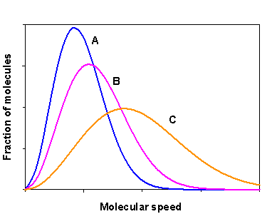

1. I only
2. II only
3. III only
4. I and II
5. I and III
6. All three are true

**Concepts:** To answer this question, we need to be able to interpret a Maxwell-Boltzmann distribution of gas speeds while relating the distinct (yet intimately related) concepts of temperature, average kinetic energy, average speed and molecular weight.

**Connections**:

*What is given?* We are given a plot with three distributions plotted on it. We are told that the distributions are for different gases, but that they are at the same temperature.

*What do I want to know?* We want to know which of the three statements is true. To do this we need to evaluate each statement, identify what key concepts are present in the statement and relate those concepts to the plot.

*What else do we need to know:* The curves give the distribution of speeds of the molecules in a collection, i.e., they tell how many molecules are moving at a given speed. If the fraction of molecules for a given speed is small that means that there are very few molecules in the sample that move at that speed. If the fraction is large (as at the peak of each curve) that means that the number of molecules that move at that speed will be larger. The area under the curve is related to the number of molecules in the sample.

From the shapes of the curves we can see that curve A has more molecules that move slowly than the others. As we move from curve A to B to C, the speeds of the molecules spread out over a greater range, so that there are more molecules moving faster (on average). Curve C has the most molecules that move fast.

Since all of these gases are at the same temperature, they will have the same average kinetic energy. But the spread in the distribution of speeds indicates that the root mean square (rms) speed will NOT be the same. The rms speed (urms) is related to the mass of the gas as well as the temperature:

$$u=\sqrt{\frac{3RT}{M}}$$

Be sure you understand everything above before moving on to the solution below.

**Solution:**

I. The curve labeled C corresponds to the gas sample with the greatest average speed.

I is **true**: these plots show the distribution of speeds, so the lower the speeds the more compact the distribution will be. The average speed is just a bit to the right (at higher speed) than the most probable speed (that corresponds to the peak) in these distributions. Clearly curve C has the highest speeds and thus has the greatest average speed.

II. The molecular weight of A is greater than B.

II is **true**: We know that the gases are at the same temperature, therefore, they have the same average kinetic energy, however, the fact that the distributions of speeds are different indicates that the rms speed for these is not the same. The root mean square speed is related to the temperature and mass of the gas as shown in $$u=\sqrt{\frac{3RT}{M}}$$

Given that T is the same for all of the gases, the molecule with the largest M will have the smallest u. A must have a higher molar mass (M) because it has the narrowest distribution of speeds; it has more molecules moving at lower speeds and thus has the lowest rms speed of the three gases.

III. C corresponds to the gas with the greatest average kinetic energy.

III is **false:** the gases are all at the same temperature. By definition this means they all have the same average kinetic energy.

Answer D: Both I and II are true.