**Content Analysis**

Once you have a collection of articles for a given purpose, in this case a literature review, you will need to understand the content across your collection in order to summarize, at least. There are many approaches to content analysis. One quick and easy method is to use Voyant Tools. I will illustrate using its [Scatterplot Tool](http://voyeurtools.org/tool/ScatterPlot/), although [there are a number](http://voyeurtools.org/tool/ScatterPlot/) you can try, depending upon your content analytic needs, with tutorial videos [here](http://docs.voyant-tools.org/videos/).

Open Voyant Tools Scatterplot in your browser:

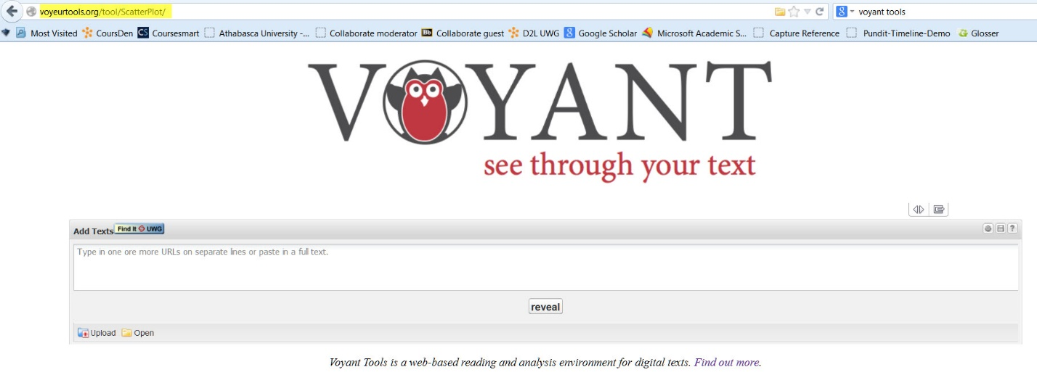

Then click on the lower left Upload button. This will give you:

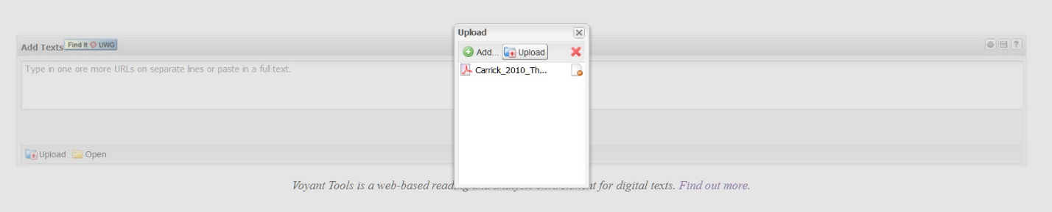

Voyant tools will handle PDFs, so I clicked Add, and then found (Carrick, 2010) in my folder. Once it appears in the Upload box, click the Upload button. The file is uploaded to the Voyant Tools server and analyzed and will yield:

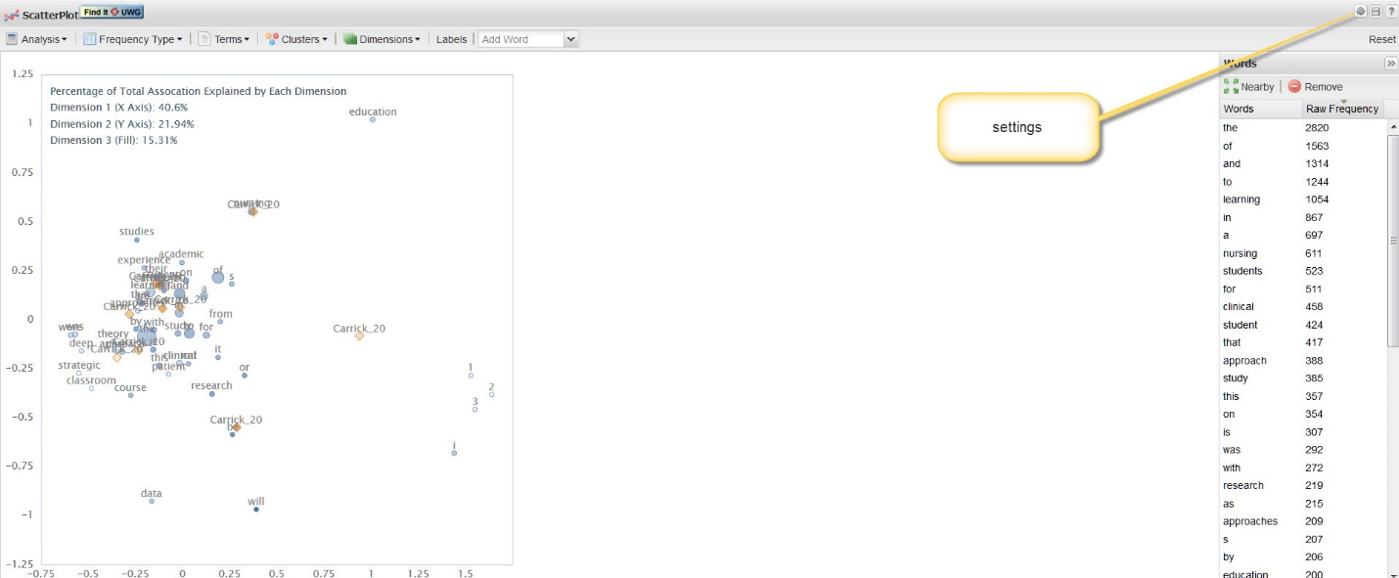

On the left you will see a correspondence plot of the key concepts in the paper, along with a list of frequency terms on the right hand side. Many of these terms are of no interest, as they are articles, prepositions and other joining words, so we click on the top right settings icon (cog wheel) and choose a Stop Words list. Words in this list will be excluded from the subsequent frequency analysis. In this case I chose Taporware (English) and clicked OK.

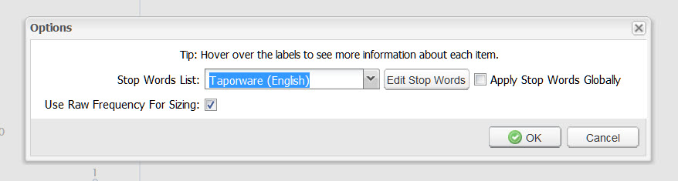

The results are shown below:

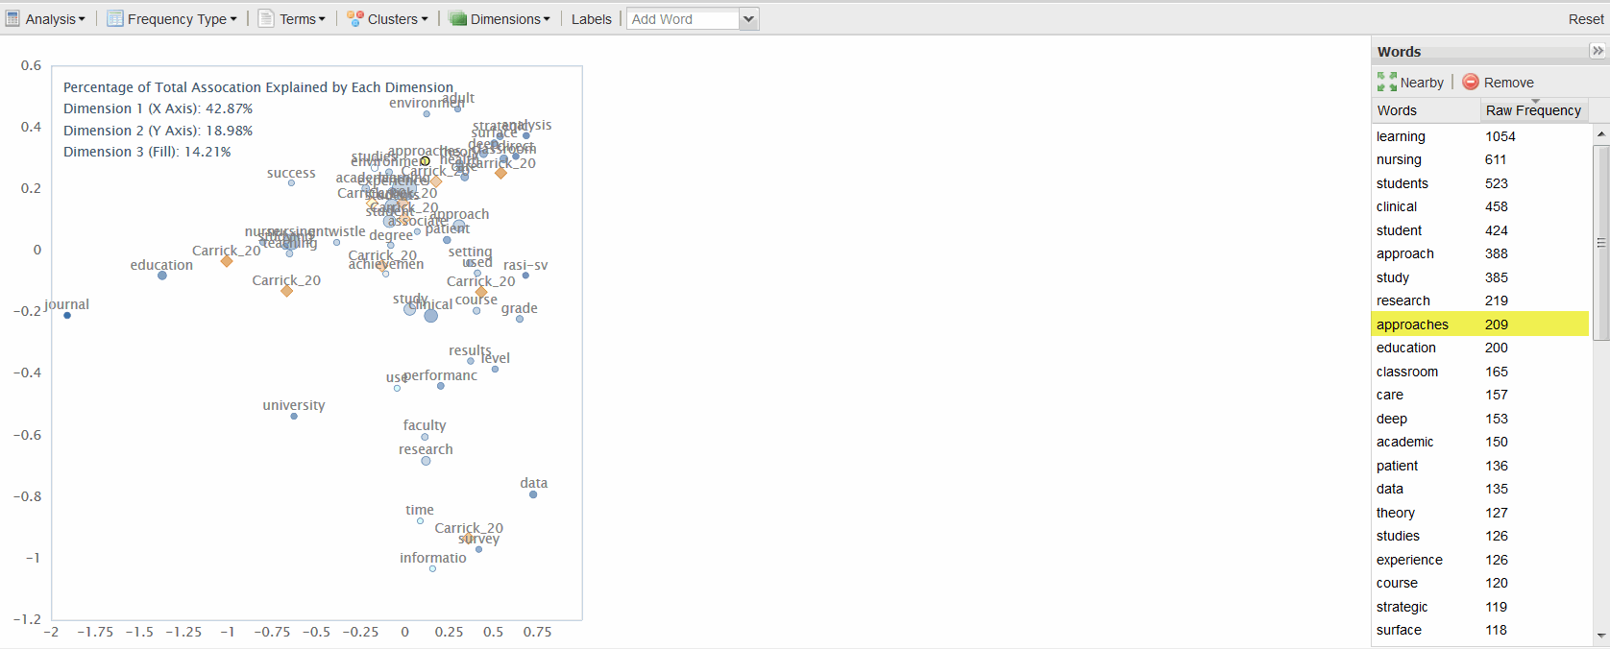

I can drill down further into any of the frequency terms by selecting and clicking on a term. In this case I wanted to see the context and usage of ‘approaches’ and the immediate output is shown below:

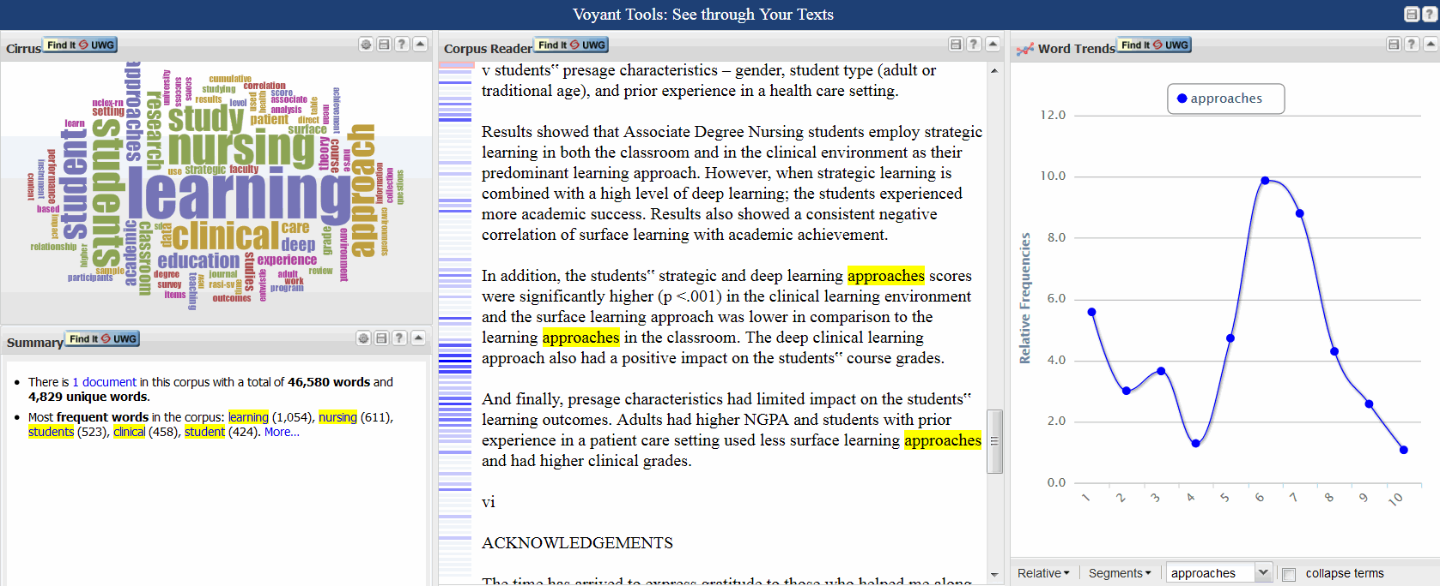

So I am able to locate all occurrences of any concept in context and see the relative frequencies of its usage throughout the text, on the right.

**Multiple Texts**

Voyant Tools will handle up to ten articles at a time, but is very quick and easy to use for 1- 10 articles to get a feel for content across several articles.

**Example of Usage**

Using one of Sally’s articles (Berg, Wong, & Vincent, 2010), we could upload it to Voyant Tools Scatter Plot, apply Stop Words and get:

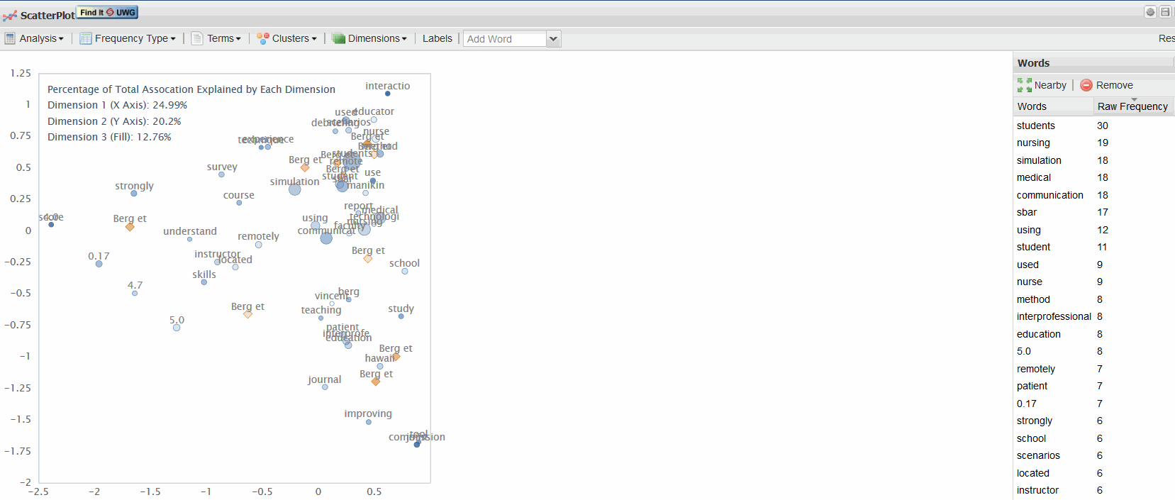

If Sally wanted to, she could do a content analysis, one article at a time, and copy/paste the top 20 or so concepts from the Voyant Tools analysis into a content analysis table or matrix, either in Word or Excel:

|  |  |  |  |  |  |  |  |  |
| --- | --- | --- | --- | --- | --- | --- | --- | --- |
| **Article** | **students** | **simulation** | **caring** | **care** | | **social** | **medical** | **communication** |
| (Berg, Wong, & Vincent, 2010) | √ | √ |  |  |  | | √ | √ |
| (Abendroth & Graven, 2013) | √ | √ |  | √ | √ | |  |  |

This would allow her to quickly grasp which concepts characterized which articles, but would be tedious for a large number of articles and take a lot of time (about 2 hrs for 19 articles).

In contrast, look at part of the content analysis sequencing from Crawdad below, which took 90 seconds:

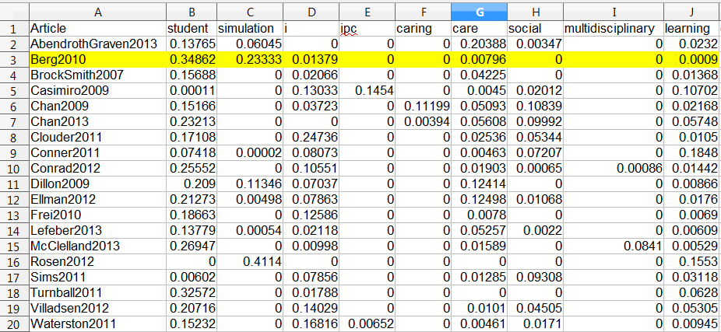

**References**

Abendroth, M., & Graven, L. J. (2013). Integrating care of older adults into the nursing curriculum: A case exemplar project. *The Journal of Nursing Education*, 1–4. Retrieved from http://europepmc.org/abstract/MED/23952775

Berg, B. W., Wong, L., & Vincent, D. S. (2010). Technology-enabled interprofessional education for nursing and medical students: A pilot study. *Journal of Interprofessional Care*, *24*(5), 601–604. Retrieved from <http://informahealthcare.com/doi/pdf/10.3109/13561820903373194>

Carrick, J. A. (2010). *The effect of classroom and clinical learning approaches on academic achievement in associate degree nursing students* (D. Ed.). Indiana University of Pennsylvania, United States.