Mimi Wreath
Artifact Box

Indus Valley River Civilization (India)

Ohio Academic Content Standards (Social Studies)
- Theme: Regions and People of the Eastern Hemisphere
  - Strand: History
    - Topic: Early Civilizations
      - C.S. 2: Early civilizations (India, Egypt, China, and Mesopotamia) with unique governments, economic systems, social structures, religions, technologies and agricultural practice and products flourished as a result of favorable geographic characteristics. The cultural practices and products of these early civilizations can be used to help understand the Eastern Hemisphere today.
- Theme: Regions and People of the Eastern Hemisphere
  - Strand: Geography
    - Topic: Places and Regions
      - C.S. 5: Regions can be determined, classified and compared using various criteria (e.g., landform, climate, population, cultural or economic).
- Theme: Regions and People of the Eastern Hemisphere
  - Strand: Geography
    - Topic: Human Systems
      - C.S. 6: Variations among physical environments within the Eastern Hemisphere influence human activities. Human activities also alter the physical environment.
- Theme: Regions and People of the Eastern Hemisphere
  - Strand: Government
    - Topic: Roles and Systems of Government
      - C.S. 10: Governments can be categorized as monarchies, theocracies, dictatorships or democracies, but categories may overlap and labels may not accurately represent how governments function. The extent of citizens’ liberties and responsibilities varies according to limits on governmental authority.

Connection to Common Core Standards:
- CCSS.ELA-Literacy.RH.6-8.2: Determine the central ideas or information of a primary or secondary source; provide an accurate summary of the source distinct from prior knowledge or opinions.
- CCSS.ELA-Literarcy.RH.6-8.7: Integrate visual information (e.g., in charts, graphs, photographs, videos, or maps) with other information in print and digital texts.

Connection to Other Core Subjects:
- Mathematics: The Indus Valley River Civilization created the first known units of measurement. Students can compare/contrast their system and the system we use today. Students will have the opportunity to practice measuring skills.
- Science: The Indus Valley River Civilization depended upon boats with sails to travel the distance to conduct trade. They also had horse and cart operations for trade. Students can study river flow with distance and speed to determine which mode of transportation was most effective.

Introduction:
The Indus River Valley Civilization began around 2300 B.C. along the Indus, Ravi, and Sutlej Rivers. The remains of the civilization were not discovered until the 1920s. Much of the civilization remains a mystery. The Indus River Valley Civilization was centered around two large urban areas. It existed at the same time as Egyptian and Mesopotamian Civilizations but was actual twice the size of each. Unlike many of their counterparts, the Indus River Valley peoples seemed to be a peaceful group who had no distinct rulers, no riches and temples, few weapons, and no evidence of battles or wars.
Perhaps the most interesting fact about the Indus River Valley Civilization is that we have yet to decipher their writing. Stone seals have been found with writings on them, but it is unknown what the seals stand for, whether it is religious or familial. The people of the civilization lived in well-planned cities where the streets met in a 90 degree grid pattern. People lived in brick houses that were mostly uniform in size. The elite in the caste system had access to private toilets, but in actuality the whole civilization was sanitary. Everybody had access to baths, if not in their own homes, and the civilization may have had the first ever sewer system that has been discovered.
The Indus River Valley Civilization developed the first known system of measurement, and it was quite accurate. This is why they were able to have such “modern” cities and amenities. They also developed a horse and cart system as well as small boats that made it possible for them to trade with neighboring countries. It is unknown exactly how the civilization met its demise. It is possible that they were invaded by Aryan nations, or environmental changes may have made their peaceful life unsustainable.

Artifacts:
Horse-drawn cart / Boat (Trade and Transportation/Movement):  The Indus Valley River Civilization was a front-runner in transportation. They were dependent upon trade so they used carts for trade on land and small wooden boats (possibly with sails) to navigate to other civilizations that could be reached by river. They also used technology to produce an intricate irrigation system to facilitate the growth of crops.  Ideas for Project Based Learning: Research use of both modes of transportation. Compare/Contrast benefits of each mode. Create a diorama/model exposing benefits of each mode of transportation. Design an upgrade to each that would be relevant to the time (i.e. no motors, etc). | 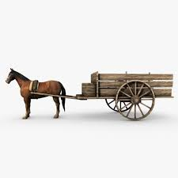  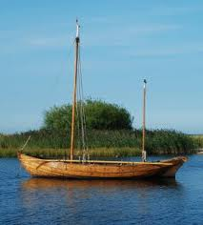
Measuring Devices (Science/Technology):  The Indus Valley River Civilization is the first society to develop a measuring system. The Indus Valley system was incredibly accurate. This led to the ability to develop 90 degree angle crossroads as well as structurally sound buildings. Their units of measure allowed them to accurately measure weight, distance, and time.  Ideas for Project Based Learning:  Using exact measurements and drawn to scale, create a community including caste system, farming and trade practice, sewer/sanitation system, market system, etc.  Use their system of measure to measure everyday objects (tie in with Math) and compare these measures to our own system of measurement. | 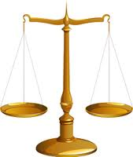  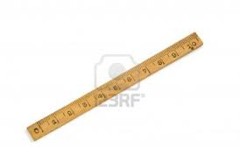
Blueprints (Relationship between places):  Rather than making their homes out of clay or wood, the Indus Valley peoples built homes of brick in which all the bricks were uniform in size. Because of our inability to decipher their writing, most of what we have concluded about the Indus Valley River Civilization is from studying their architecture. The city dwellers lived in brick homes that were uniform in size (one or two stories tall) and had openings onto streets and to inner courtyards.  Ideas for Project Based Learning:  Tie-in to the story “The 3 Little Pigs”  Home building project using Legos or other building products. Shows the importance of planning and structural soundness (ties in with Measurement).  Future findings: Pretend you are a scientist in the year 3000 A.D. You can’t decipher the writings from the 21st century but you have found structural remains. What do these remains tell you about the culture of the past? | 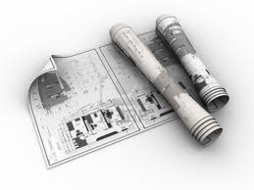  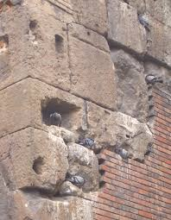
Toilet/Tub (Technology):  The Indus Valley River Civilization invented indoor plumbing. The peoples of this civilization lived a very civilized and sanitary life where baths and showers were daily occurrences. Most often in each house there was a room with a brick floor with a drain in it where they could dump pitchers of water over themselves to shower, or block the drain in order to take a bath. There were also community bath houses, though these may have been used primarily for religious ceremonies and such. The Indus people also had a sewer system that allowed for human waste to be removed from dwellings sanitarily. Rich people had actual toilets with terracotta piping to expel waste while poorer people used urns and sump pots but still had access to the sewer system.  Ideas for Project Based Learning:  Research Third World Civilizations that are still without a proper sanitation system. Design and present a plan for a sanitation system that will help these communities thrive.  Compare the technological inventions of the Indus Civilization with the technologies of our time that are most important to you. Will our technologies “Wow” future generations as the Indus technologies have “wowed” us? | 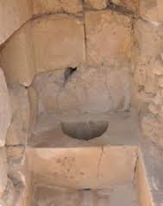    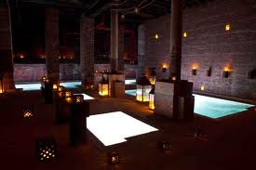
Indus Script/ Seals (Communication)  Since its discovery in the 1920s, nobody has been able to decipher the Indus writings. There are over 400 symbols used in the writings though most inscriptions are only 4 or 5 symbols in length. Some believe that the Indus Civilization was literate while others believe that they only used a sign-system, primarily for trade purposes rather than communication.  Ideas for Project Based Learning:  Have students create their own written language including a code.  Have students “decipher” some of the Indus script (maybe 20 symbols). Why do they think this is what the symbol stands for?  Students create their own family seal.  Students create a story or diary entry using symbols from Indus script and our own written language. | 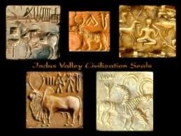

Sites used for preliminary research:

www.apworldhistory101.com/history-of-india/indus-river-valley/
www.ushistory.org/civ/8a.asp
www.rivervalleycivilizations.com/indus.php
www.timemaps.com/cilization/Indus-Valley-civilization
www.harappa.com/har/indus-saraswati.html
www.csuchico.edu/~cheinz/syllabi/asst001/fall97/2chd.htm

