The Network Architecture of CmapTools

Technical Report IHMC CmapTools 93-02

Alberto J. Cañas, Greg Hill, Carlos Pérez, Juan David Pérez, Adrián Granados
Institute for Human and Machine Cognition
40 South Alcaniz St.
Pensacola Fl 32501
www.coginst.uwf.edu

Introduction

The CmapTools software suite was designed with the purpose of providing an environment that would enable and encourage collaboration and sharing in the construction and use of knowledge models based on concept maps (Cmaps). The client program works fine as a standalone tool, allowing the user to construct concept maps and store them on the user computer’s hard drive, establish links among maps and to resources in the hard drive, and print the maps. However, the ease with which knowledge models can be shared and collaboration can be established through Places (servers) is what makes CmapTools unique.

Client-Sever Architecture

The client program CmapTools is used construct and manipulate Cmaps. The program runs on the user’s computer, allowing the user to create knowledge models and store them.

The storage of the knowledge model can take place in the computer’s hard drive or on a Place (server). To store the knowledge models in the user computer’s hard drive no software in addition to CmapTools is needed. However, to share a knowledge model with users in other computers, the client program needs to communicate through a computer network with a Place: a server computer running the CmapServer software. Figure 1 shows a user running the CmapTools software on his computer, storing and retrieving Cmaps from the “Place” server.

Several users can be accessing the same Place concurrently, storing and retrieving concept maps. This way, users can easily share and collaborate in the construction of their knowledge models.

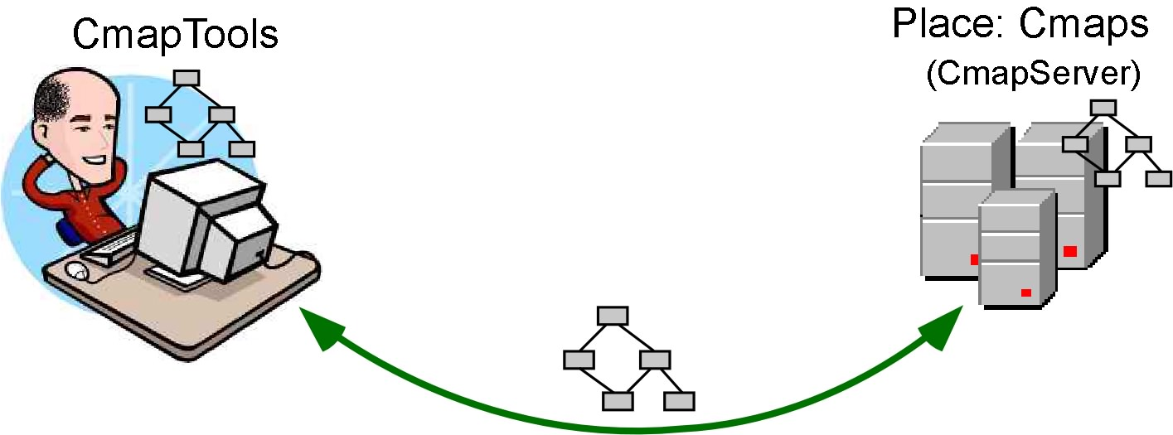

Figure 1: Client CmapTools saves and retrieves Cmaps from a Place (CmapServer)

Locating A Place

When the CmapTools program starts executing, it needs to locate available Places. First, the program tries to locate Places on the Local Area Network (LAN) where the client program’s computer is running. Second, and most important, the program tries to locate Places available throughout the Internet. To facilitate collaboration and sharing, the Network Architecture of CmapTools has been designed in such a way that a user will automatically and transparently be able locate all Places that are available (that is, not “hidden” by their administrators), wherever they are located on the Internet. Third, the user can explicitly provide CmapTools with the Internet address of a particular Place he/she wants to locate. We discuss each of these in the following paragraphs.

a) Servers in the Same Local Area Network

The CmapServer automatically broadcasts its presence on the LAN where it is installed, using the “Service Location Protocol” (SLP) [1, 2] mechanism, a protocol for locating resources in a network. When the CmapTools client starts executing -- and periodically while it is running -- it checks for the presence of CmapServers in the LAN. As shown in Figure 2, clients installed in the same LAN as a server will automatically find the Place located in that server through its broadcast. No configuration is needed on the client or server side, the discovery and location is automatic.

The broadcast information from the server provides the client information on what “Services” are running in that particular server. For example, it will let the client know whether the server is capable of handling Discussion Threads, Knowledge Soups, or Synchronous Collaboration Sessions among other services. The administrator for the CmapServer can configure the server to run only a particular set of services.
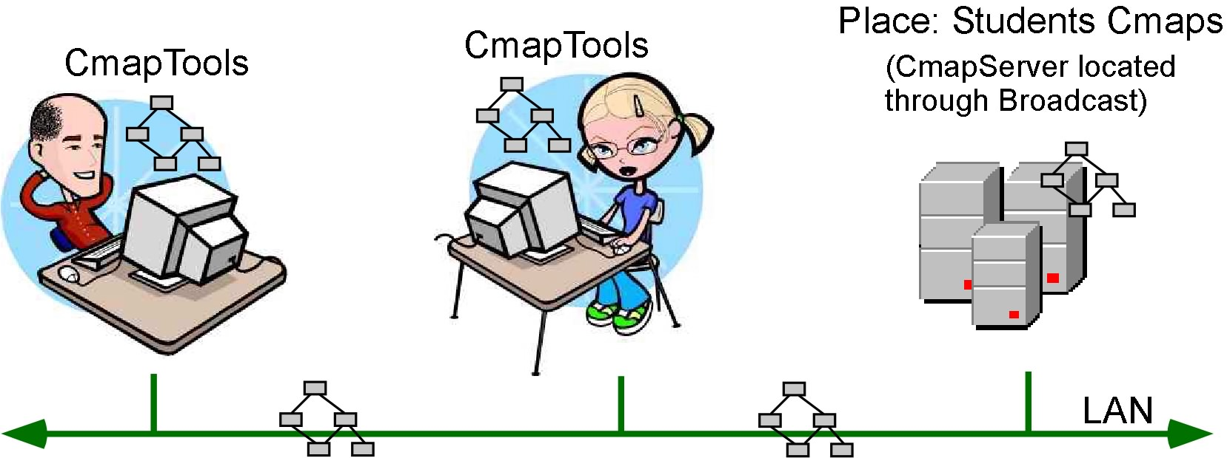

Figure 2: CmapTools clients and CmapServer running on the same LAN: the clients find the Place via broadcast.

c) Locating Places through the Directory of Places

Servers can be located anywhere in the world as long as they are accessible via Internet and not protected behind a firewall. However, there needs to be a mechanism by which the CmapTools client can find these servers. This need is handled by the Directory of Places using the SLP protocol.

The Directory of Places is a special type of server that handles “registrations” from CmapServers. When a CmapServer starts running it contacts the Directory of Places it has defined in its configuration. In addition to its Internet address, the CmapServer provides other pertinent data, such as its name (Place) and other identifying information, and the services it is running (services include Discussion Threads, Knowledge Soups, Synchronous Collaboration, etc.). Periodically, the CmapServer contacts the Directory of Places providing a “heartbeat” – an indication that it is still up and running. If a Directory of Places does not receive a heartbeat from a CmapServer for a period of time, it removes it from its list of active servers.
Figure 3 shows four CmapServers reporting to a Directory of Places. Notice that the Directory of Places does not store any Cmaps. All it keeps is information about the CmapServers that are up and running and that have reported to it.
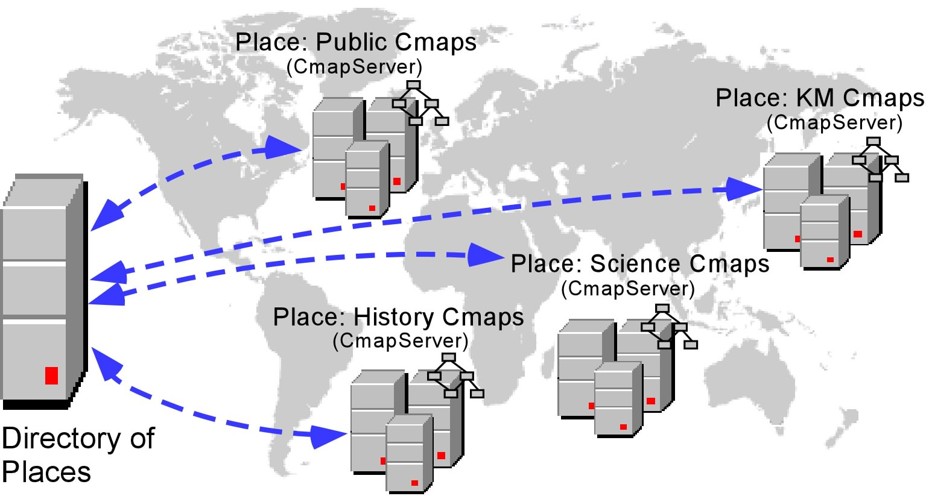

Figure 3: CmapServers register with a Directory of Places and periodically let it know they are up and running

When the client CmapTools program starts executing, it contacts the Directory of Places defined in its configuration and retrieves the list of CmapServers that are available. It then proceeds to contact each of those servers to make sure it is accessible and retrieve information about the Place. Recently installed CmapServers will be located and show up in the CmapTools client. Figure 4 shows a CmapTools client obtaining the servers information from the Directory of Places and accessing the various servers.
b) Locating “Private Places”
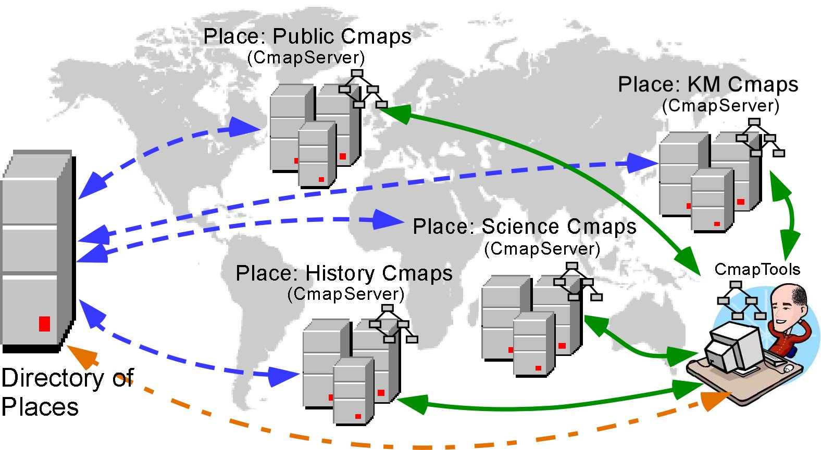

Figure 4: CmapTools client contacts the Directory of Places to obtain a list of CmapServers, and then contacts each Place separately

CmapServers may be configured not to register with a Directory of Places, or may be behind a firewall that prevents the registration from taking place. If the client CmapTools program is not on the same LAN as the server, then the user must explicitly provide the Internet address (IP or domain address) of the server in the program’s Preferences dialogue box (Edit/Preferences menu item in CmapTools). In addition to the IP address, the user must provide the “Port” on which the server is listening. By default, port 1099 is used. We refer to Places that are located via the explicit Internet address provided by the user as Private Places. Once the address of a Private Place is provided, the client will attempt to locate that Place every time it is executed. The same dialogue box can be used to remove a Private Place from the list of servers to be contacted.

Figure 5 shows two CmapTools users. The one on the left is accessing the “Students Cmaps” Place via broadcast, while the user on the right is also accessing the “Corporate Cmaps” Place that was located by explicitly giving its Internet address. Additionally, both of these users could be working on Places located via the Directory of Places described above.

A Private Place does not have to be behind a firewall or inaccessible via broadcast or through the Directory of Places. A server on the same LAN as the client, or one that is registered with the Directory of Places can be added as a Private Place in a client. The client program will locate the server by various means and will know that it corresponds to the same Place.
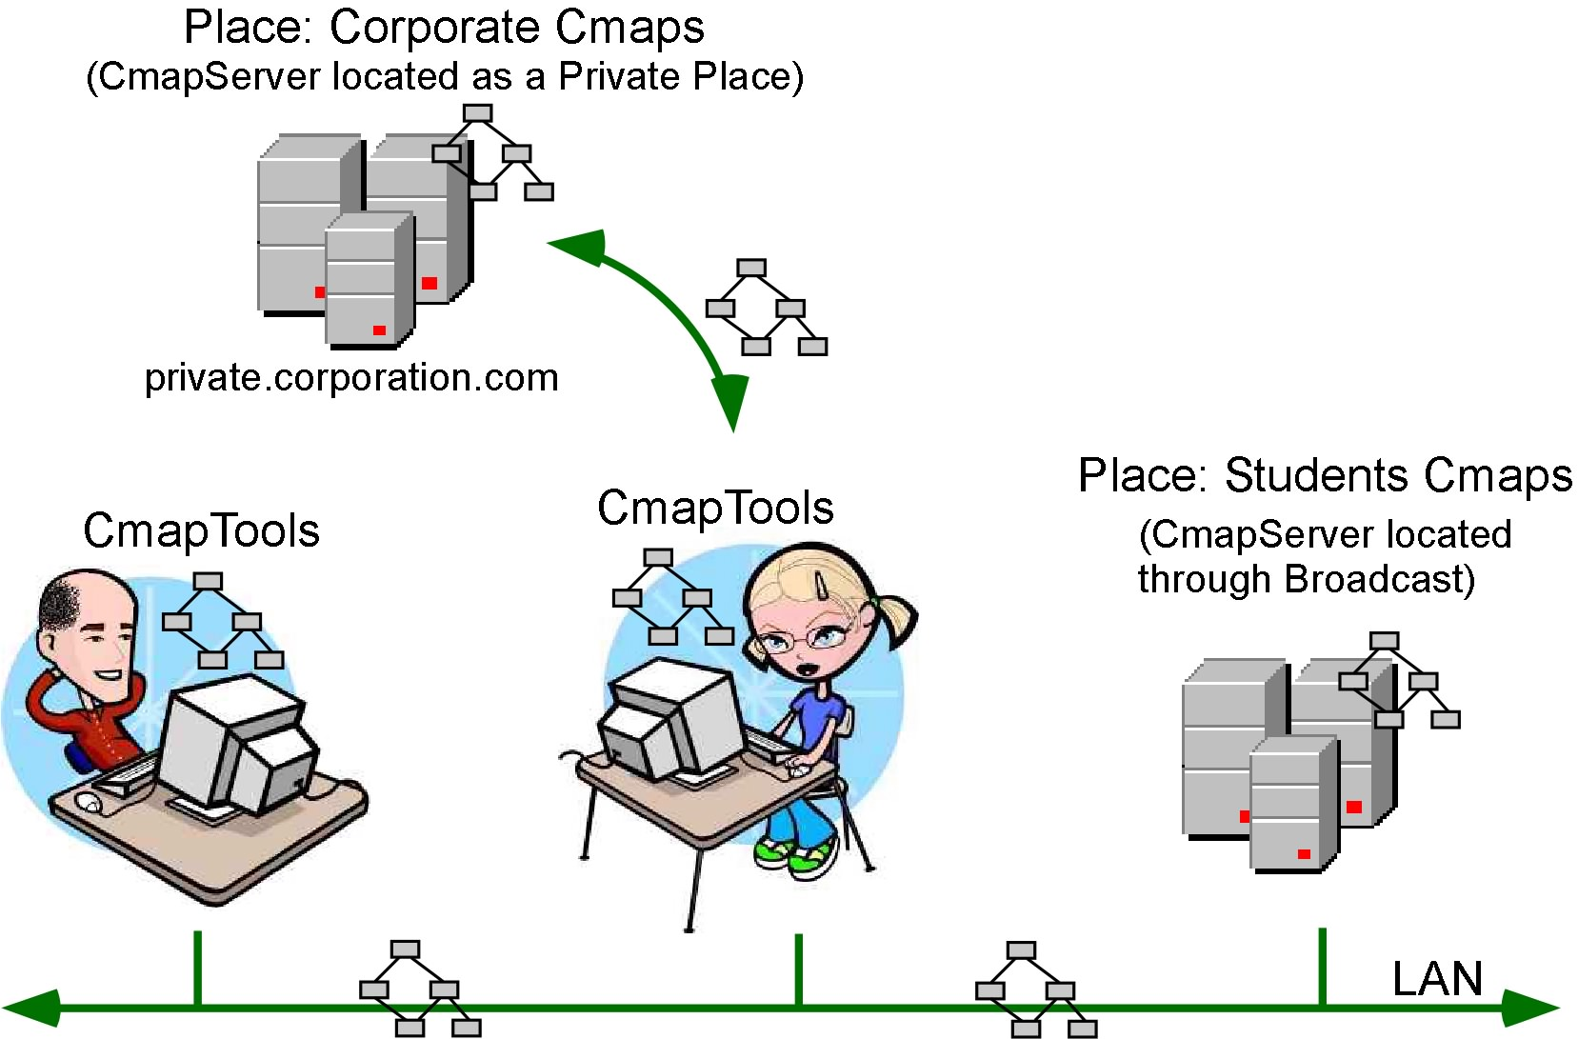

Figure 5: The CmapTools user on the left accesses the LAN server (Place: Students Cmaps) while the other user accesses Students Cmaps and the Private Place Science Cmaps.

Figure 6 shows a CmapTools client connected to a variety of Places through the three mechanisms described above. The “Students Cmaps” Place is located via broadcast since the user’s computer is on the same LAN as that CmapServer. “Corporate Cmaps” is located as a Private Place by explicitly providing the Internet address of the CmapServer. “Public Cmaps”, “Science Cmaps”, and “History Cmaps” were located via the Directory of Places.

As the client program executes, it periodically checks with the Directory of Places for CmapServers that have become available or are no longer online.

Indexing and Searching

The mechanism for locating Places described in the previous section allows the CmapTools client to access Places located throughout the Internet, within an Intranet or in the same LAN. Looking for a particular resource within this collection of servers can take time. Each Place can contain a large number of knowledge models, and knowledge models can vary in size from a single Cmap to hundreds or thousands of resources (Cmaps, images, videos, text, links to Web pages, etc.).
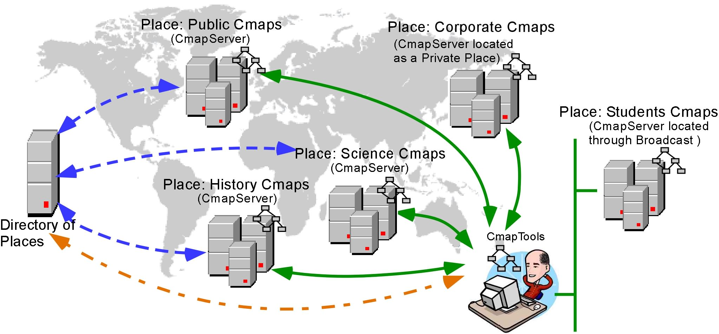

Figure 6: A CmapTools user takes advantage of the three mechanisms to locate Places (broadcast, Private Places and Directory of Places) to access Cmaps from a variety of CmapServers.
To speedup and simplify searches for Cmaps and resources, all Cmaps and resources at the CmapTools client and at each CmapServer are indexed. The index includes: for each Cmap, all concepts, linking phrases, properties (owner, focus question, etc) notes (whether hidden or not); for all resources, the names and captions (images, videos, sounds, etc.), and in the case of links to texts or web pages, their contents. All this information is readily available for searching. Indexes and searches are implemented using the Jakarta Lucene engine [3], which provides fast response and a powerful query language.

With the number of CmapServers increasing and their location distributed throughout the world, searching for Cmaps about a particular topic would imply searching each CmapServer individually. To speed up global searches, CmapServers periodically send copies of their indices to an IndexServer, as shown in Figure 7.

When it starts up, the IndexServer registers with the Directory of Places it is configured to register with, and periodically reports that it is still running. The availability of the IndexServer is passed-on to the CmapTools clients and CmapServers that contact the Directory of Places.

The CmapServers contact the Directory of Places to find the address of the IndexServer. From there on, they periodically send a copy of their index to the IndexServer. By accumulating all these indices, the IndexServer acts as a central indexer for all CmapServers.
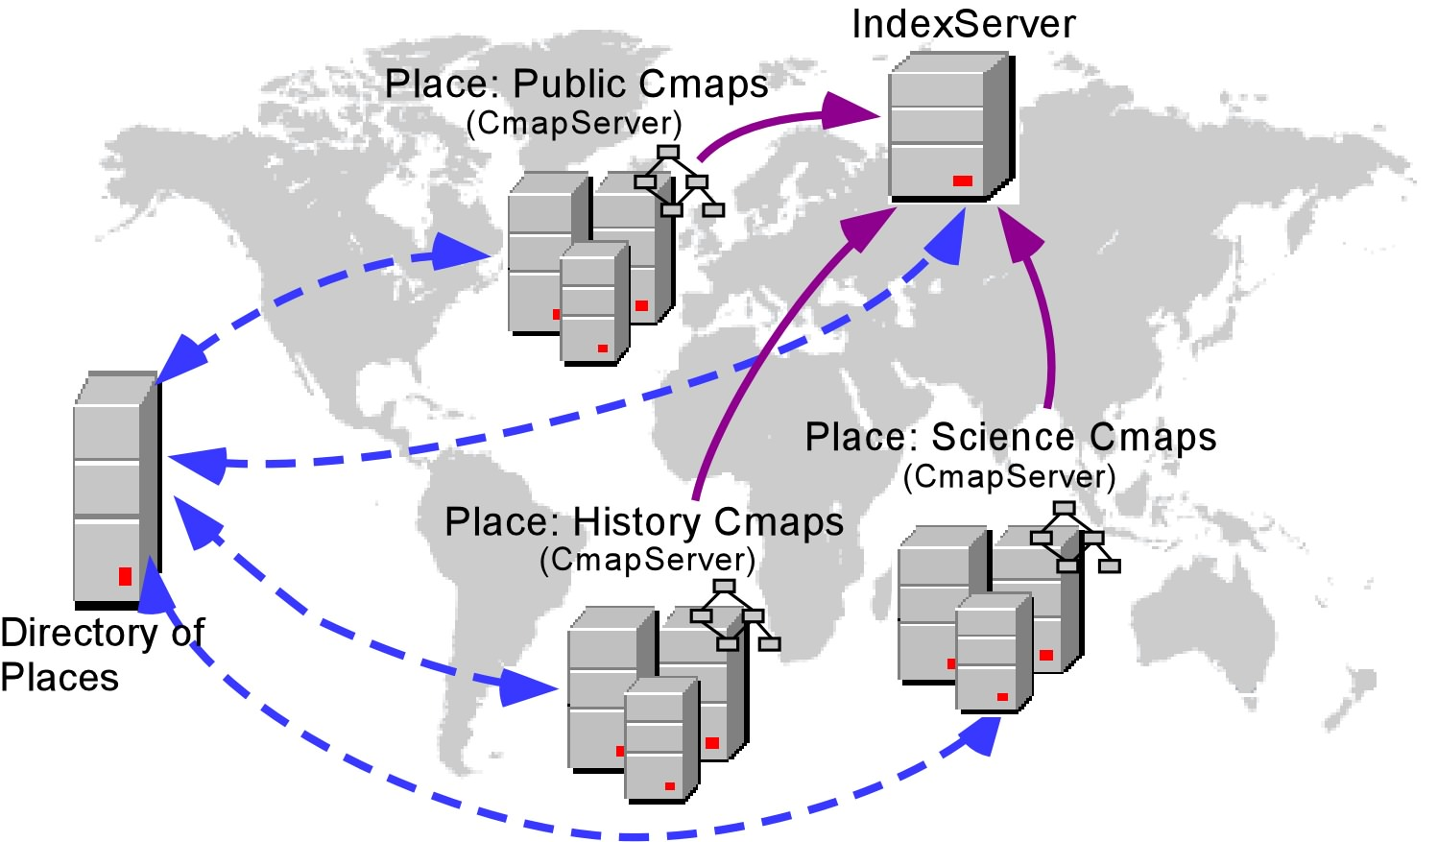

Figure 7: CmapServers periodically send copies of their Indices to the IndexServer
The CmapTools clients also receive from the Directory of Places the Internet address of the IndexServer. By sending a Query to the IndexServer instead of to a particular CmapServer, the user is covering all CmapServers registered with the Directory of Places in a single search.

The user has the option of specifying the location where a particular search will take place. A search on the user’s computer will locate Cmaps and resources in MyCmaps. The user can also specifically select one or more CmapServers as targets of the search.
The default search in the CmapTools client includes searching through the IndexServer (which covers all CmapServers registered with the Directory of Places), searching directly through other CmapServers known to the CmapTools client but not covered by the IndexServer (e.g. Private Places or CmapServers located only through broadcast), plus searching MyCmaps.

Replication of Directory of Places

The Directory of Places plays a key role in the communication between nodes of the CmapTools network. Through the Directory of Places, the CmapTools client finds CmapServers and IndexServers, and the CmapServers find. It is therefore essential that the Directory of Places be always available and respond fast to requests.

To guarantee the service provided by the Directory of Places, the network allows for replication of Directory of Places. This means that in a network, there can be more than one Directory of Places, and they will all exchange information and keep each other up-to-date. Figure 8 shows seven CmapServers and an IndexServer registering via three Directories of Places. In this case, all CmapServers will receive the address of the IndexServer in order to send their indices for searches.
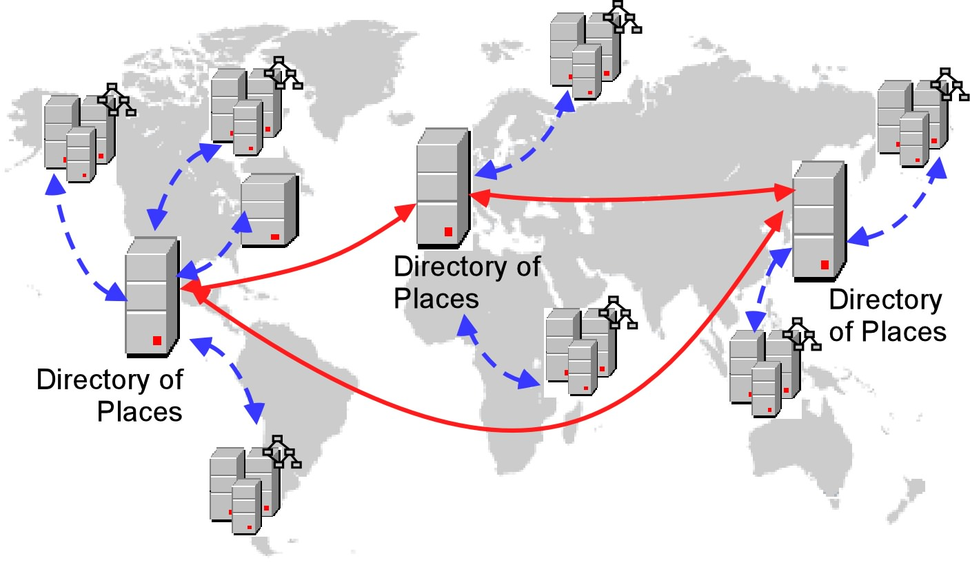

Figure 8: Directory of Places may be configured to replicate, making it indifferent which Directory of Places a CmapServer or IndexServer registers with.

A CmapTools client contacting one of a group of replicated Directories of Places will receive information regarding all servers (CmapServers and IndexServers) registered with any of the Directories of Places. Figure 9 shows a user’s CmapTools client registering with a single Directory of Places but interacting with all CmapServers in the network.

Scopes

The network described above assumes a set of CmapTools clients and servers (CmapServers, IndexServer, Directories of Places) linked together to allow sharing and collaboration between all of them.

An organization may need to have two parallel sets of clients and servers that it wants to handle as separate “logical” networks, even if they are running, for instance, on the same LAN. For example, at the Institute for Human and Machine Cognition the “development” network runs on computers standing side by side with the “Public” network (which includes, among others, the publicly available CmapServer “Public Cmaps”). Users developing knowledge models need not see the “development servers” and developers do not need to see “public” servers.

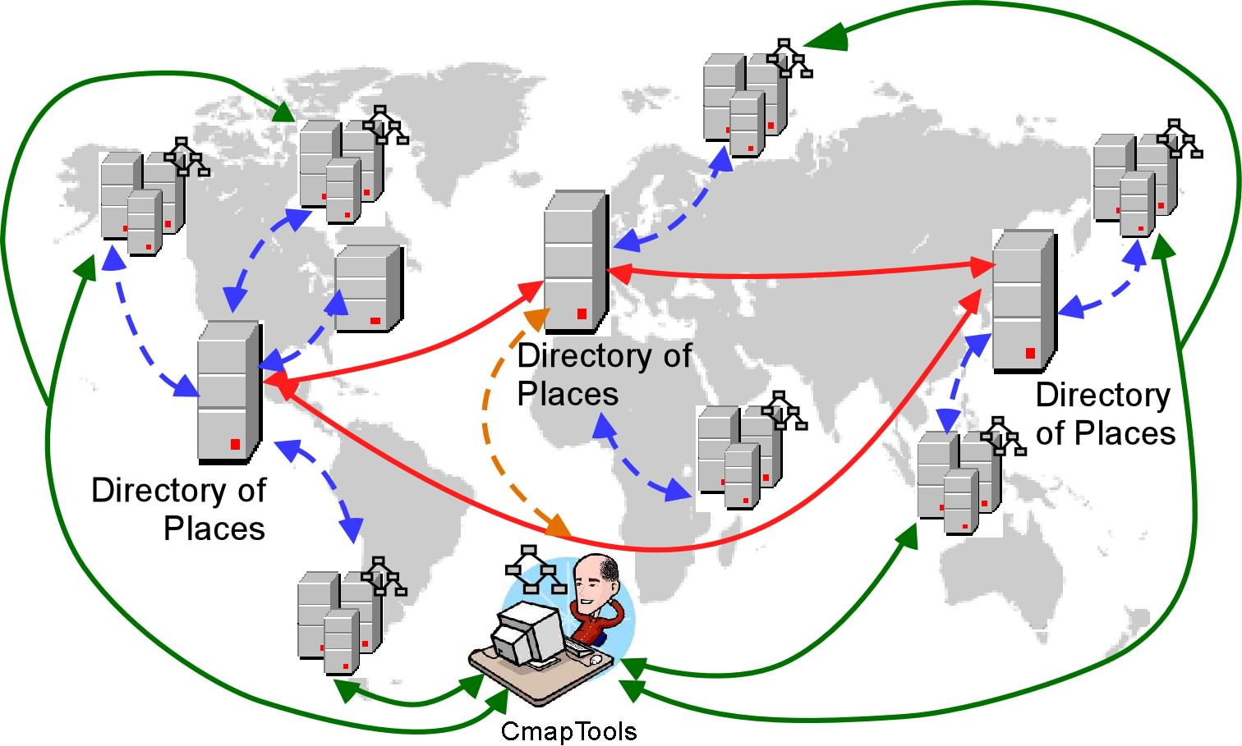

Figure 9: CmapTools client accessing various CmapServers located via the replication of the Directories of Places
The separation between these two “logical” networks is achieved by defining each network to have its own “scope”. A scope is the “identifier” of the network. Each CmapTools client, CmapServer, IndexServer, and Directory of Places can belong to one or more scopes. They ignore any information that does not correspond to a scope to which they belong. The “Public” CmapTools network, for example, has scope “cmapdp”.

The CmapTools software (client, servers, etc.) by default is configured to use scope “cmapdp”, so any client installed will by default be part of this scope. Any of the programs can be configured to use another scope instead of, or in addition to, “cmapdp”. So a user who decides to install a CmapTools client and a CmapServer in a LAN where there are other CmapTools clients running can change his/her CmapServer’s scope, and add that new scope to his/her CmapTools client, and that way the client would see all the other servers, but his/her server would be “hidden” from the other clients. Similarly, and organization may decide to have all its clients and servers under a different scope, with no access to “cmapdp”.

Just as a CmapTools client can be in more than one scope, a Directory of Places can be configured to serve more than one scope, and CmapServers can be configured to belong to more than one scope.
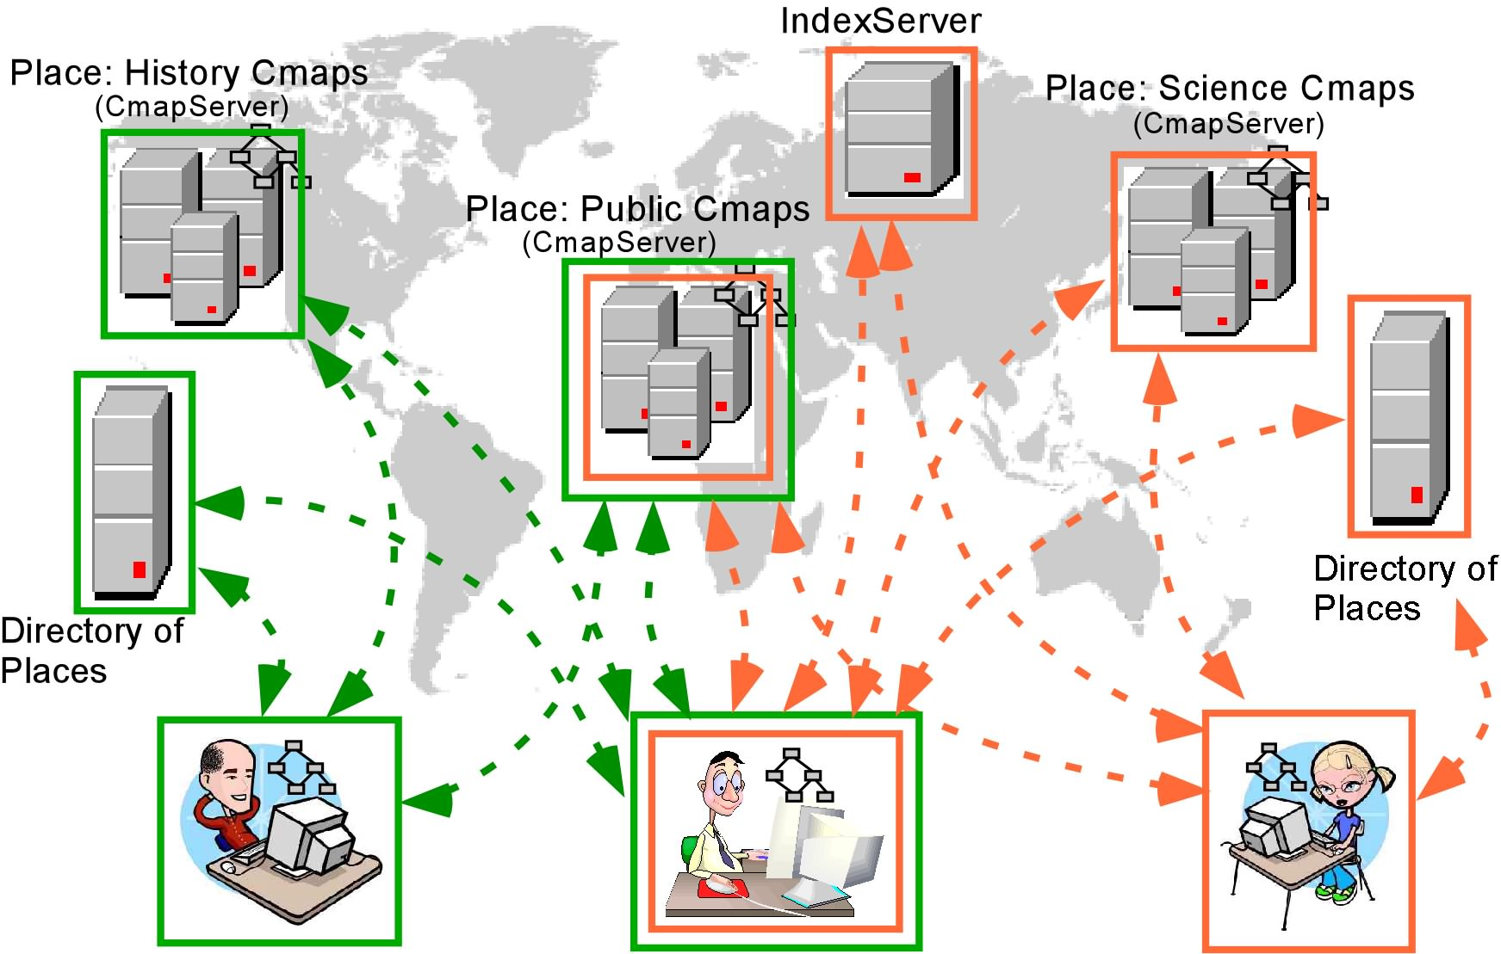

Figure 12. Two scopes (shown as green and orange) allow the users at the left and right to access different networks, while the user in the middle to access both networks. The “Public Cmaps” Place is part of both scopes.

Figure 12 shows two “scopes”, represented by the orange and green colors (scopes are identified by their “name” in CmapTools, color is used in Figure 12 for illustration purposes). The green scope consists of the Directory of Places and a CmapServer at the left of the Figure, plus the “Public Cmaps” CmapServer in the middle. The orange scope includes the Directory of Places and CmapServer at the right, and shares the “Public Cmaps” CmapServer with the green scope. The user on the left has his CmapTools client configured for the green scope, and can access the two CmapServers and the Directory of Places registered in that scope. The user at the right can access the Directory of Places and CmapServers registered with the orange scope. The user in the middle has CmapTools configured for both green and orange scopes and can thus access all CmapServers and Directories of Places on both scopes.

The scope is not meant to be a security mechanism. Users can easily add and delete scopes to their CmapTools client or administrators to their CmapServers or Directory of Places, and there is one means to protect a scope (e.g. via passwords or other mechanism). It is intended to be a means of partitioning or organizing the different sets of clients and servers according to the users’ needs.

References

[1] Service Location Protocol Project (http://www.srvloc.org/)

[2] Service Location Protocol (http://www.ietf.org/html.charters/svrloc-charter.html)

[3] Jakarta Lucene (http://jakarta.apache.org/lucene/docs/index.html)

A Knowledge Model is a collection of concept maps and associated resources about a particular domain of knowledge.
Resources are files linked to concept maps that help explain and complement the information in the map. They can be of any type, including videos, images, text, web pages, documents, presentations, and other Cmaps, among others.

