How Does Tectonic Plate Activity on Earth Help Regulate It’s Atmosphere?
ASTR178 Other Worlds: Planets and Planetary Systems
Concept Map Discussion

External Group D

The Origin of Tectonic Plates and Their Role in Volcanism
About 4.6 billion years ago the Earth was a growing conglomerate of impacted bodies orbiting a forming star. It is believed that around 4.5 billion years ago, a large Mars-sized body collided with the Earth, generating enough debris and heat to form the moon and melt what remained of the Earth. Gravity pulled this molten mass together, pulling denser matter to its centre, and divided the Earth into ascending layers of density. Gasses forced to the surface formed the Earth’s oceans and atmosphere. As the Earth’s surface cooled, it surface solidified, forming a crust.
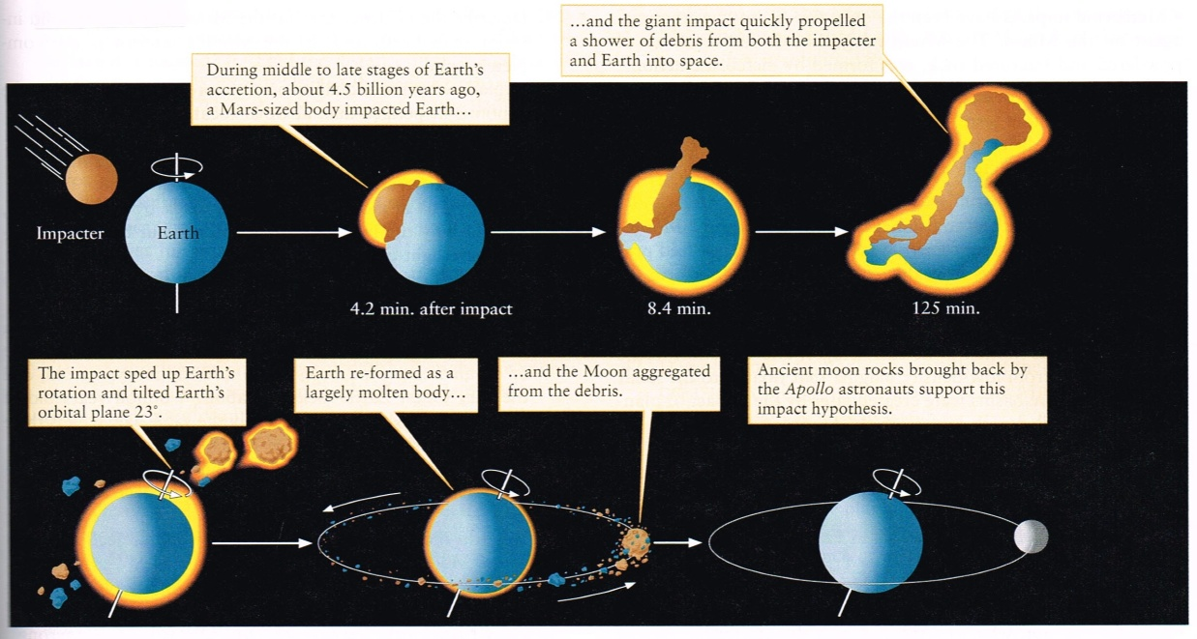
The Earth’s inner-core is roughly 5500⁰C, and is kept solid by the immense pressure at this depth. This heat is transferred outward creating convection currents in the liquid outer core and very slow moving convection currents in the solid, but hot mantle. Because pressure and melting points decreases with depth, the very outside of the mantle is a region of partial melting known as the asthenosphere. Sometimes hot rising plumes from within the mantle rise to the surface, where they penetrate the crust and create inter-plate volcanism.
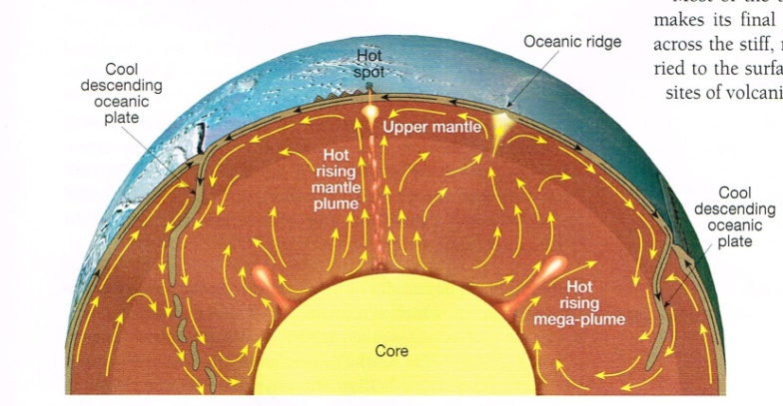
The crust, which is divided into several plates, floats on top of the denser partially molten asthenosphere, drifting with the slow moving convection currents.
These plates are divided into two types, Oceanic plates and lighter Continental plates. Plates can slide past each other as transform faults, drift apart, or can be subducted underneath lighter overlying plates. When plates drift apart, the release of pressure melts and pulls the underlying mantle to the surface where it cools and forms new crust. This creates an active region of volcanism and earthquakes. When oceanic plates are subducted, they create uplift, buckling, and deposit new material on the overlying plate and form an oceanic trench as they carry water down into the mantle. This causes melting in the mantle which rises through the asthenosphere and into the overlying plate. This creates volcanic mountain ranges and island arcs. The subducting plate is then recycled into the downward flow of the mantle’s convection current.
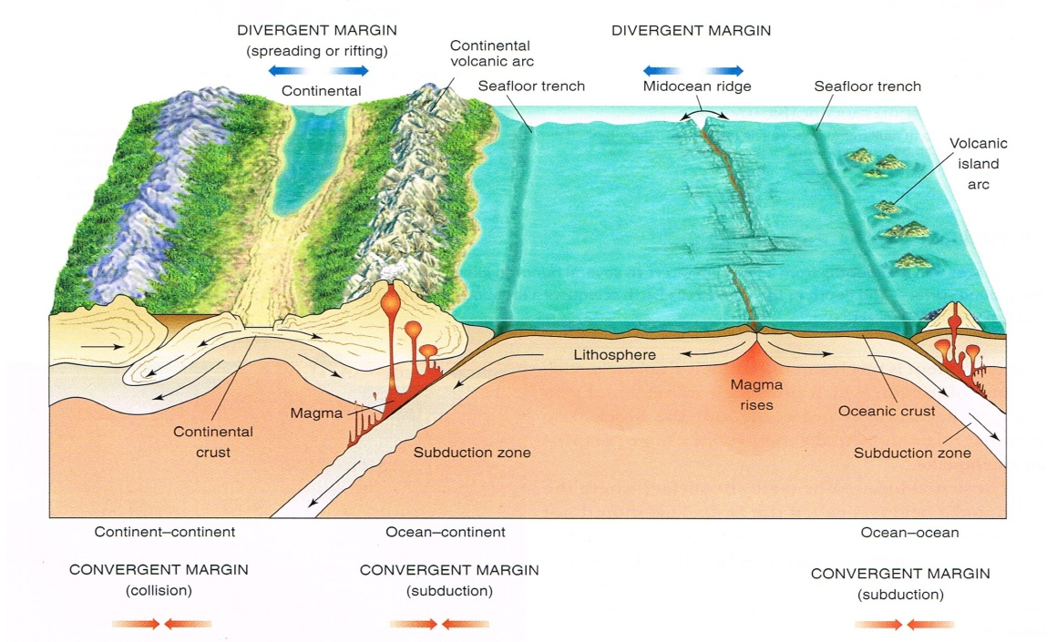

Part 2 – Elsa Dechert
The Role of the Atmosphere and Carbon on Earth’s Temperature
Water vapour is a greenhouse gas that traps infrared radiation from the Earth’s surface and so in the early stages of the atmosphere, it is this water vapour that maintained the high temperature of the surface of the planet (insert textbook reference here).
As the water vapour eventually turned to droplets and formed the oceans, it was lost from the atmosphere, which left a reduced greenhouse effect. This in turn lowered the surface temperature. In theory, the Earth should have frozen over.
The presence of carbon on Earth prevented this potential freeze over. When oxygen carbon combine, carbon dioxide is formed; another greenhouse gas (textbook reference).
Volcanic activity, through outgassing, has caused carbon dioxide to enter the atmosphere. This release of carbon into the atmosphere is a result of partial melting in the Earth’s interior (Dasgupta & Hirschmannb, 2010).
Meteorites containing carbon would have also added to the carbon recipe of the Earth to some degree (Swart et al., 1983).
The ice on Earth melted when the temperature rose by the increasing contribution of carbon dioxide in the atmosphere. Water then evaporated back into the atmosphere, enhancing the greenhouse’s cyclic effects (textbook reference).
For the carbon dioxide to prevent the Earth from a constant freeze over, the amounts would have been much greater than they are today. Excess becomes trapped in rocks but dissolves in rainwater but forms into a class of carbonates when mixed with other substances when combined in the oceans. These carbonates eventually become recycled via subduction into the Earth’s crust (textbook reference). Most of the carbon dioxide was removed from the atmosphere in this manner within the first billion years of the formation of the Earth but the Sun’s increasing intensity has kept this temperature balanced.
If the balance is maintained then carbon in the atmosphere assists in the maintenance of a healthy atmosphere.

Sarah Mills 42411378

An imbalance of this regulatory system is achieved by the recycling of carbon dioxide between the atmosphere and the Earth’s mantle. The mechanism by which Earth self-regulates its temperature is called the carbon dioxide cycle. This ‘Carbon Cycle’ is the central concept of our map, demonstrating how this cycle is inherently dependent on functions caused by tectonic plate activity.
The Carbon Cycle acts as a long-term thermostat for Earth, because the overall rate at which carbon dioxide (CO₂) is pulled from the atmosphere is very sensitive to temperature. As seen in the concept map, tectonic plate activity carries the carbonate rocks to the subduction zone and further carried downward deeper into the mantle. As the subducted carbonate rock melts it releases its CO₂, which outgases back into the atmosphere through volcanoes. The increased and decreased CO₂ concentration strengthens and weakens the greenhouse effect by warming and cooling the planet, respectively. Without plate tectonics, CO₂ would remain locked up in seafloor rocks rather than being recycled through outgassing, similar as those climate changes that has occurred on Venus and Mars. The atmospheric CO₂ then dissolves in rainwater, creating a mild acid. This mildly acid rainfall erodes rocks on the Earth’s surface, and the rivers carry the broken-down minerals to the oceans. Once in the oceans, the eroded minerals combine with dissolved CO₂ and fall to the ocean floor, making carbonate rocks. The Carbon Cycle begins again.

Both convergence and divergence of continents have been considered to trigger the snowball events in the context of reducing the greenhouse effect by decreased volcanic activity. The decrease in CO₂ made the climate cooler creating large areas of ice and snow. This glaciation period caused an increased albedo resulting in positive feedback for cooling and further glaciation. Further tectonic plate activity that moved the continents provided a continuous formation of volcanic eruptions that in turn built up the CO₂ in the atmosphere. The increased concentration of CO₂ in the atmosphere from the mantle provided the greenhouse effect, causing the deglaciation of snowball Earth due to the increased temperatures. Once the melting of ice and snow began, the runaway albedo effect enhanced the melting, and the Earth switched back from winter temperatures to summer temperatures.

References:

Bennett, J., Donahue, M. Schneider, N. & Voit, M., (2012). The Essential Cosmic Perspective (6th ed.), San Francisco: Addison-Wesley.

Dasguptaa, R. & Hirschmannb, M.M. (2010). The deep carbon cycle and melting in Earth’s interior, Earth and Planetary Science Letters. 298(1-2): 1-13.

Johnstona, F.K.B., Turchyna, A.V. & Edmondsa, M. (2011). Decarbonation efficiency in subduction zones: Implications for warm Cretaceous climates, Earth and Planetary Science Letters. 303(1-2): 143-152.

Le Hir, G., Ramstein, G., Donnadieu, Y. & Pierrehumbert, R.T., (2007). Investigating plausible mechanisms to trigger a deglaciation from a hard snowball Earth. Geoscience. 339: 274-287.

Merali, Z. & Skinner, B.J. (2009). Visualizing Earth Science, New Jersey: John Wiley & Sons.

Ramstein, G., Fluteau, F., Besse, J. & Joussaume, S., (1997). Effect of orogeny, plate motion and land–sea distribution on Eurasian climate change over the past 30 million years. Nature, 386(6627): 788-795.

Santosh, M. & Omori, S., (2008). CO2 windows from mantle to atmosphere: Models on ultrahigh-temperature metamorphism and speculations on the link with melting of snowball Earth. Gondwana Research. 14: (82-96).

Swart, P.K., Grady, M.M., Pillinger, C.T., Lewis R.S. & Anders, E. (1983) Interstellar carbon in meteorites, Science. 220(4595): 406-410.

Clark, I F, and B J Cook. Geological Science: Perspectives of the Earth. Canberra: Australian Academy of Science, 1995.

Freedman, Roger A, Robert M Geller, and William J Kaufmann III. Universe. Ninth Edition. New York: W.H.Freeman and Company, 2011.

Grotzinger, John, Thomas H Jordan, Frank Press, and Raymond Siever. Understanding Earth. 5th. New York: W. H. Freeman and Company, 2007.

Tarbuck, Edward J, and Frederick K Lutgens. Earth: an introduction to physical geology. 10th. New Jersey: Pearson Prentice Hall, 2011.

