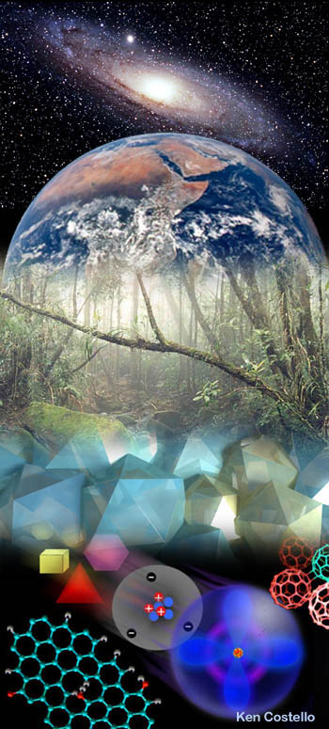
College Prep. Chemistry
Course Expectation Sheet 2012-2013

Teacher: Mr. Gorman Room: C325
Phone: (508) 234-6221 x 2325 Email: jgorman@nps.org

Course objectives and goals: Chemistry seeks to understand the composition, structure, properties of substances and the interactions between them. Additionally, students will develop the ability to apply learned concepts to real world problems. The following major concepts will be covered in this course: Measurements & problem solving, properties of matter, atomic structure, periodicity, chemical bonding, chemical reactions & stoichiometry, gases and kinetic theory, solutions, acid & bases, equilibrium & kinetics and oxidation & reduction reactions.

Course text: Chemistry – Connections to Our Changing World, Prentice Hall, 1996

Grading Scheme: Grading will be based on your percentage of the total points possible. The point value for assignments will vary for example: tests =100 ; lab reports = 50-100 ; quizzes= 25-50; homework/ whiteboard presentation= 5. (these are examples, actual points values may vary)

Coarse Requirements:
Honor Code
- Any work that is turned in (homework, test, quiz, etc) should represent only your thoughts and understandings. On homework assigned, you may talk with whomever you wish (including other students, tutors, teachers, etc.)
- No collaboration or discussion of any kind is allowed on quizzes and tests. You are expected to follow the school expectations to the letter at all times during the year.
Missed Classes
- Missing class for any reason (including sports or illness) can stall your progress in understanding physics. Still, almost everyone will occasionally miss a physics class. Please check in with me, either in person or by email, when you miss a class so that you can get back on track as quickly as possible.
Assignments & Assessment
- Keep labs, notes and homework in your three-ring binder in chronological order.
- Lab reports are generally worth just as much as tests so if you happen do bad it should be balanced out by the other. Late lab reports receive a 10 point deduction per day.
- Homework is due at the beginning of the class period.
- Group work is an integral part of this course and will be reflected in your grade as evidenced in the lap report rubric.
Required Supplies
- 3 three-ring binder with 3-hole punched paper or notebook with pockets
- scientific calculator preferred
- Pencil - Reason: the pathway to learning is filled with mistakes. You must give yourself permission to make mistakes and to correct your mistakes.

Teacher Expectations:
- R (Responsibility): Each student should come to class prepared with their notebook, a writing utensil, textbook, and any required assignments. All work should be completed and passed in on time. Lab equipment and materials should be handled in a proper manner as instructed and demonstrated by the teacher.
- A (Achievement): Preparation for class and completion of all assignments is necessary to achieve your best. The Northbridge High School Rubrics and modifications thereof will be used as a fundamental aspect of assessment.
- M (Mutual Respect): for the other members of the class and the teacher is a must. In this classroom, each person should strive to help others in understanding the concepts being studied.
- S (Service): Please, keep our classroom clean and well kept. All materials from labs and activities should be put away in their proper places.
Extra Help: Thursday afternoon 2:00-2:30 or by appointment
College Prep. Chemistry - 2012-2013
Mr. Gorman

Best of luck to you as you begin a new school year here at Northbridge. I look forward to sharing this year together and hope that you will enjoy the class and studying chemistry! Please sign below...

Verification of Receipt: This will be signed by all students after the course expectations sheet has been read and discussed in class; this will also record the number of the textbook given to you. The book is expected to be returned in the same condition.

A. Teacher: I will do my best to assist each of my student’s in a successful year of learning chemistry!
B. Student: I have received my course expectation sheet for chemistry, read it and understand all course requirements. I will try my best to fulfill all requirements of me.
Print Name Student’s Signature Book #
____________________________________ _____________________________________ ________
____________________________________ _____________________________________ ________
____________________________________ _____________________________________ ________
____________________________________ _____________________________________ ________
____________________________________ _____________________________________ ________
____________________________________ _____________________________________ ________
____________________________________ _____________________________________ ________
____________________________________ _____________________________________ ________
____________________________________ _____________________________________ ________
____________________________________ _____________________________________ ________
____________________________________ _____________________________________ ________
____________________________________ _____________________________________ ________
____________________________________ _____________________________________ ________
____________________________________ _____________________________________ ________
____________________________________ _____________________________________ ________
____________________________________ _____________________________________ ________
____________________________________ _____________________________________ ________
____________________________________ _____________________________________ ________
____________________________________ _____________________________________ ________
____________________________________ _____________________________________ ________
____________________________________ _____________________________________ ________
____________________________________ _____________________________________ ________
____________________________________ _____________________________________ ________
____________________________________ _____________________________________ ________
____________________________________ _____________________________________ ________
____________________________________ _____________________________________ ________
____________________________________ _____________________________________ ________
____________________________________ _____________________________________ ________
____________________________________ _____________________________________ ________
____________________________________ _____________________________________ ________

