The road map for self-organizing logistics: status, ambitions and tasks for TNO
Part 1 - Background
- Since logistics is a complex domain, we adopted the following decomposition in layers:
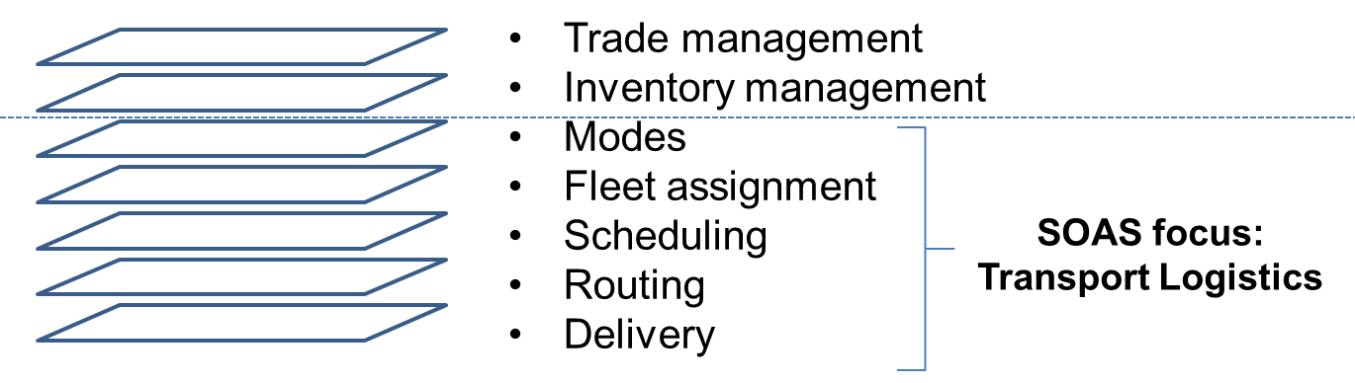
Figure 1- Overview of logistics areas and current focus of TNO
Starting from the bottom part of Figure 1:
  - Delivery refers to the final part of the supply chain in which agreements are made to deliver an item to its final destination, e.g., a parcel that arrives to a certain city and needs to be delivered at the customer’s address.
  - Routing refers to the path/route actually used to transport the item,
  - Scheduling refers to the activity of planning this route,
  - Fleet assignment refers to the allocation of transport means, and
  - Modes refer to the choice of a (combination of) suitable mode of transport, i.e., by road, rail, sea, or air.
These 5 bottom layers concern the physical processes that characterize logistics and we refer to them using the term transport logistics. On top of transport logistics, we positioned the inventory and trade management levels, which are also of strategic importance. Inventory management concerns issues of balancing stock levels of raw materials, components and finished products in order to fulfill the demands of customers and to ensure adequate stock levels in all physical locations. Trade management concerns market strategies to regulate trade in a global economy in which volumes and values can be transferred dynamically and in short time around the globe.
- Currently, all the logistics layers mentioned above are to some extent self-organizing and are characterized by well-designed processes that are quite efficient. However, these processes heavily rely on human intervention (people making phone-calls and exchanging e-mails, making less-than-optimal decisions regarding planning and scheduling), are only automated in a limited manner, and cannot deal with uncertainty and unexpected circumstances in real time.

- The current activities of TNO are focused on the TRANSPORT layers, but are not sufficiently well aligned to promote and drive self-organizing systems. The TNO objectives are therefore twofold: (1) to articulate and develop the proposition on self-organizing transport logistics and (2) to develop a new product/market proposition concerning the top layers, where besides support to transport activities, support to value added logistics and trading is added.
- Within the current focus the SOAS project aims at developing the understanding on Self-Organizing Transport Logistics (SOTL), as highlighted in Figure 1. We acknowledge that SOTL is just a starting point and further work needs to be done to investigate the role and application also of self-organizing principles for the trade management and inventory management layers in Figure 1. However, this new business development remained out of the scope of this document and from now on we will refer to systems for SOTL.
Part 2 - Motivation
- In the past decades, logistics companies have grown individually with the goal of increasing efficiency, cutting costs and improving service offers for their customers
  - Some of these companies became large-scale providers that own resources globally (hubs, airplanes, trucks, etc.) and can integrate several logistics services for their customers. We call these companies “global integrators”.
  - Other companies specialized their offers to specific segments of the logistics market. We call these companies “regional (logistics service) providers”.

- Currently, the goals of both global integrators and regional providers are the same as in the past, i.e., increase efficiency, cut costs and improve service offers to their customers. However, it is now necessary to become also responsive and flexible to cater to more demanding customers and unexpected circumstances in real time.
  - Global integrators have the means to keep growing individually toward the accomplishment of the new goal at a systems level, reaching out door-to-door.
  - Regional providers need to collaborate with each other, also with competitors, since they do not have the means to face the new challenge individually. Some attempts of creating collaborative transport services are emerging, together with virtual freight market places on the Internet for matching customer requests and provider offers. However, a lot of work needs to be done to incorporate these initial efforts in one integrated solution.

- We believe that in the near future regional providers will become more collaborative and will see new intermediaries replacing the old ones, accompanied by the development of virtual market places to facilitate this collaboration, while global integrators will further grow independently. The two streams (regional providers/collective and global integrators/individual) are shown in Figure 2 and are both essential to realize Self-Organizing Transport Logistics (SOTL). The question whether the two streams will proceed in parallel (i.e., competing with each other) or eventually converge it is still open and is an interesting topic for future analysis.
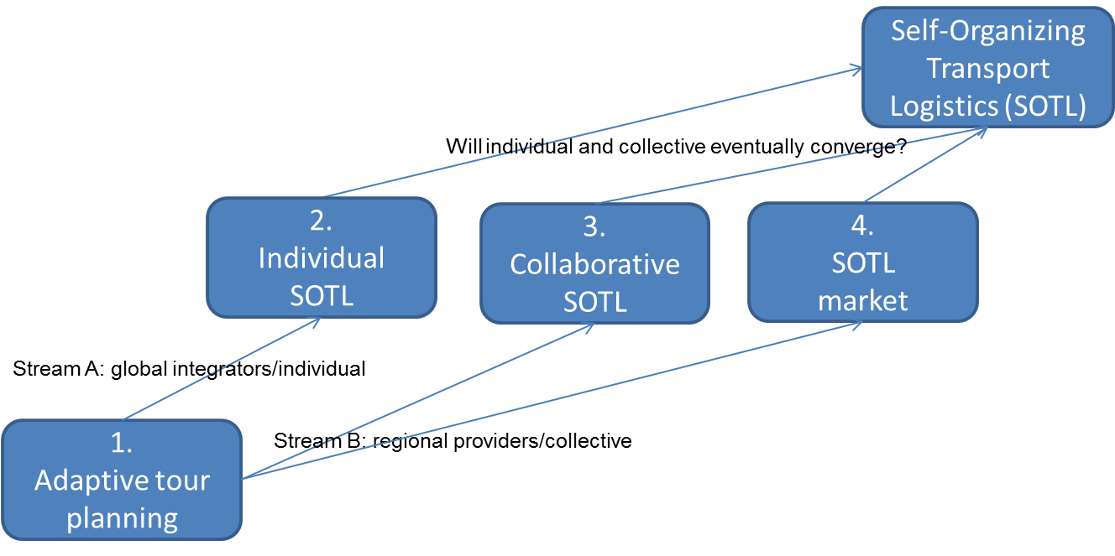
Figure 2 – Individual and collective streams in Self-Organizing Transport Logistics (SOTL)
- Figure 3 positions the innovation areas in Figure 2 (which are divided in the two streams of individual and collective) with respect to the 5 layers of transport logistics in Figure 1.
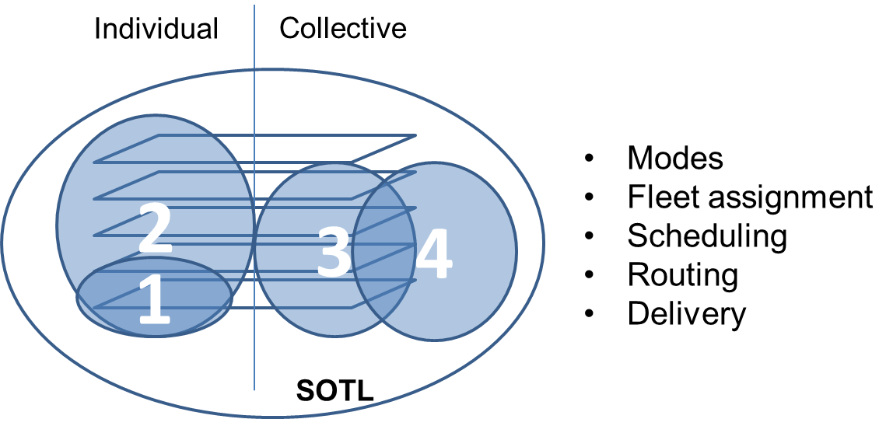
Figure 3 – SOTL innovation areas for individual and collective

Part 4 – Approach
- We focus on SOTL and the 4 innovation areas in Figure 3 analyzing how SOAS principles can be beneficially applied and what are the next steps to be taken in each area.
- We identify example systems for SOTL, one in each innovation area (4 systems)
- For each of these systems, we use the general guidelines provided by the SOAS project to develop roadmaps for the period 2012-2017.
- For each roadmap, we follow the same pattern:
  - we define a self-explaining name for the system of interest, which also implies the system goal;
  - we identify the impact expected with the adoption of this system and the market potentially interested in it;
  - we investigate the technologies that need to be adopted towards the development of the proposed system and the underlying science;
  - we list the relevant actors involved with the system, how they are related to each other and how their relationships evolves through time;
  - we identify some obstacles that could slow down or prevent the realization of the proposed system or its introduction in the market.

Part 5 – Roadmaps
Innovation area 1: an adaptive tour planning system
Currently, tour planning is rather static since it makes use of fixed routes that can guarantee high efficiency in normal conditions, but cannot adapt to real time changes and unpredictable events, e.g., traffic congestions due to road accidents, a failure in the cooling system of a truck that transports perishable goods, a last minute change in the customer’s expected delivery time and/or place, and so forth. Moreover, tour planning is highly centralized and relies on human intervention (often, people that make phone calls and exchange e-mails), which is costly and error-prone. Real time information collected by on-board systems for carriers can be used to make tour planning dynamic and adaptive. Moreover, dynamic planning can be realized at the lowest units (trucks) instead of central planning agency.
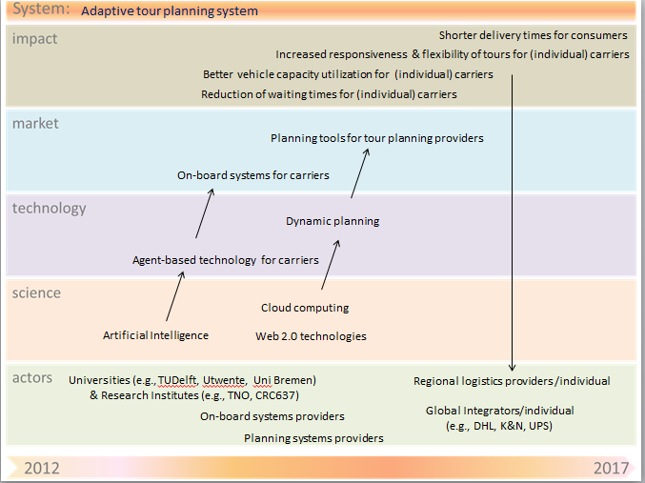
Figure 4 – Road map for adaptive tour planning

Obstacles:
- Availability of information to improve real time decision making and governance models to coordinate the level and amount of data sharing, based on pre-specified agreements
- High transaction costs, difficulty of coordination and risk of information leakage with central planning
- Unwillingness to share information
- Distribution of intelligence to nodes (moving nodes and nodes at fixed locations)
- On board computers (or apps on smart devices) acting as sensors for creating location awareness

Innovation area 2: a self-organizing parcel delivery system
A challenge for global integrators consists of providing parcels/containers with some degree of intelligence (RFID sensors and algorithms for agent-based parcel routing) to reduce waiting times and make delivery more efficient. A necessary condition for realizing this self-organizing parcel delivery system is the adaptive tour planning system described above. As an example, parcels/containers could follow simple goals such as “go to the nearest hub with available capacity to store you and trigger a notification for a trucker to come and pick you up”. In this way, truckers could stop at a certain hub only if there are parcels/containers to be actually picked up and keep driving otherwise (in contrast, now they have to stop anyway and check whether there are signs placed on top of parcels to indicate that are ready to be picked up). On a different physical scale, this innovation could support the storage and retrieval of sea containers at terminal locations.
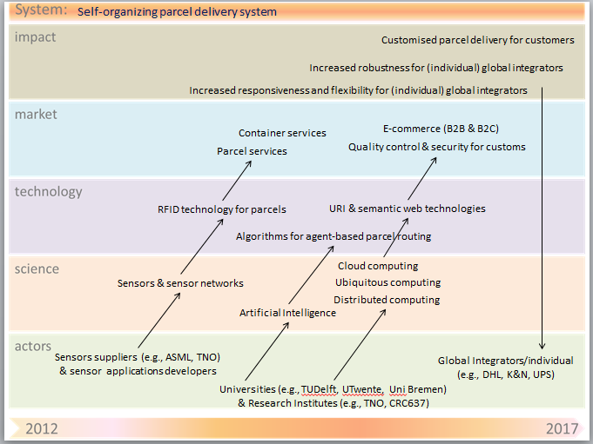
Figure 5 – Road map for self-organizing parcel delivery
Obstacles:
- Scalability of agent technology: agents are necessary in a decentralized architecture to process locally the relevant information coming from RFID tags, and take decisions based on this information. Are agent-based solutions scalable for huge amounts of parcels to be delivered?
- Granularity level of agent-based solutions: where the agents should be for optimal and scalable solutions? E.g., (ordered from low to high granularity) parcels, packages, containers, vehicles, hubs, etc.
- Reusability of technological solutions: to what extent can technological solutions, such as sensors and agents, be reused? E.g., products (no reusability), packages (low reusability), containers (good reusability) , vehicles (high reusability).
- Costs of sensors and RFID technology are still too high to implement intelligence on each parcel.

Innovation area 3: a container capacity management system
Currently, when a barge operator receives a phone call to pick up a container that is waiting for hinterland transport, the centrally planning agency that organizes the transport is not able to re-schedule the delivery planning to pick up the available container in the port in short time. Therefore, an adaptive tour planning system as described above is necessary to allow re-scheduling according to the new (real-time) request. In addition, since the mentioned adaptive tour planning system is designed for individuals, some form of collective planning and communication among carriers using decentralized sensors, dynamic planning agent-networks and applications could be introduced to optimize the allocation of containers to hinterland transport equipment among several operators. By adding intelligence to containers using RFID technologies and agent-based solutions, an intelligent container could also decide to take a suitable barge based on its delivery goals, disclosing its information only to the relevant barge.

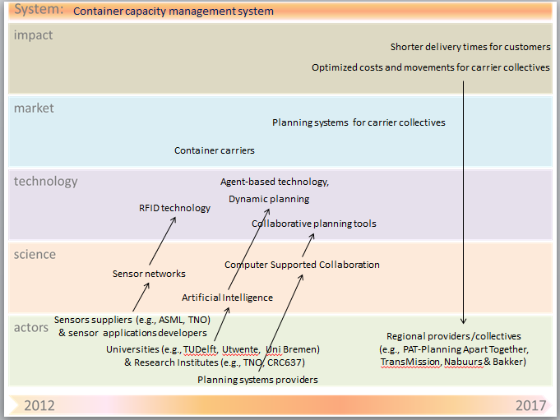
Figure 6 – Road map for container management
Obstacles:
- Availability of information to improve real time decision making and willingness to share the information. We can provide IT solutions to improve communication and information sharing using web technologies and so forth, but are stakeholders willing to provide and share this info?
- Availability of inter-operable decentralized/distributed tour planning systems able to effectively coordinate among multiple partners for which it produces a tour planning in order to allow regional logistics providers to collaborate with each other in the execution of logistical services.
- Sensor and RFID costs for containers, communication costs, costs of facilities to construct a network (e.g. GSM, wireless sensor networks with detection mechanisms in inland waterways, satellite)
- Complexity in decision making: only parts of the network are known, how does optimization of these parts affect the total network? Is it only feasible if these parts are loosely coupled, e.g. via vessels or other transport means with fixed schedules?
- Scalability of agent technology: agents are necessary in a decentralized architecture to process locally the relevant information coming from RFID tags, and take decisions based on this information. Are agent-based solutions scalable for huge amounts of container movements?

Innovation area 4: an hybrid freight market system
E-markets for freight capacity now rely mostly on volume information and are rather static. Although some platforms for freight market on the Internet exist (e.g., Transport Marketplace, Vozeeme), the actual matching of freight capacity requests and freight capacity offers occurs off-line (i.e., behind the scenes), with limited or no IT support (once again, people that make phone calls and send e-mails). Moreover, these e-markets function within the existing regime of pre-planned tours and the pricing mechanisms do not consider real-time changes and re-routing. An underlying adaptive tour planning system as described above, can be used to provide actual routes in order to calculate prices dynamically according to these routes. Moreover, electronic freight auctions (which already exist as isolated initiatives) could be integrated with the mentioned e-markets in a global IT platform solution (hybrid freight market) for allocating spot freight to planned tours.
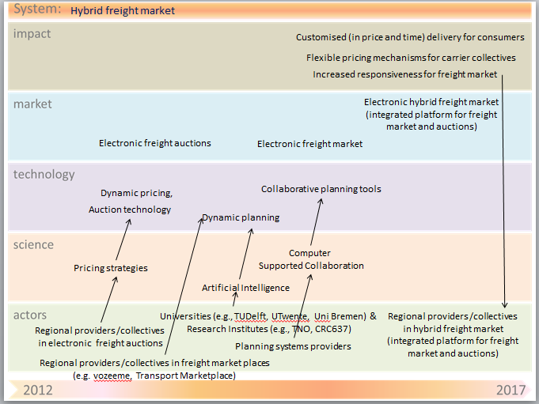
Figure 7- Road map for hybrid freight market
Obstacles:
- Unwillingness to share information about excess capacity
- Overview of available capacity in market is lacking
- Lack of interoperability and general ‘digitalization’ among IT solutions of regional providers/collective

Part 5 – Conclusions and recommendations
Currently the roadmaps presented above are developed separately with different partners. There is no certainty that the roadmaps will develop well. TNO, however, can (and does) contribute heavily to the development of these systems. The notion of self-organization needs to be reinforced however as it is now often implicit and sometimes suffers from counterproductive, centralization tendencies. Agreeing with the market on the fact that these roadmaps develop towards self-organizing systems is therefore a necessity. The roadmaps offer critical paths and barriers that mark the points where TNO could intervene.
The convergence of the individual roadmaps towards a broader, co-operative SOTL roadmap is a vision that is not necessarily shared by all. We see this part as the unique vision, or hypothesis, of TNO which will need to be validated along the way. It is a means of communication which will need to be adjusted continuously, in dialogue with academia and the market. It allows TNO to develop and test new propositions for an integrated architecture for SOTL.
For the future the roadmaps should be extended with more of the “virtual logistics” around trade and inventory management. These activities bare strategic value for the Netherlands as they will allow the Netherlands to increase its added value further in its support of global supply networks. In addition it will help to extend our involvement in global supply networks that are not part of an import or export movement, or do not pass through the Netherlands. This is the next level of the self-organizing logistics roadmap that could and should be part of the TNO proposition for the future.

Some vehicle routing and dispatch solutions (e.g., Ortec OTD) already support real time feedback of information to adapt to changes in the orders or the environment. Other solutions based on statistical properties calculate routes with certain ‘time penalties’ for busy/congested pieces of road. However, these are initial attempts towards adaptive tour planning and a lot of companies do not (effectively) adopt these solutions yet. Moreover, real-time feedback mostly relies on on-board systems, but more data sources could be considered (weather services, etc.)

