Instructional Design

By Victoria Maultsby

June 17, 2012

Rationale
John Dewey, who was a supporter of Progressivism, believed that one of the major responsibilities of a teacher is to know how to create conditions that facilitate individual growth (Smith, 2001). One of the greatest challenges to for Language Arts teachers in this time of standardized testing is fostering growth in individual students. The current curriculum fails to consider students and their individual learning styles when plotting the course to mastery.
To this end, my instructional design seeks to provide that consideration and differentiation according to students’ learning styles and needs. The design covers the first subunit under Unit 1: Understanding the Community. Its purpose is to create globally-aware critical thinkers and problem-solvers that can effectively communicate and act upon their acquired knowledge and skills. The teacher will use a variety of learning experiences to foster student growth, both intellectually and personally, through thought, discussion, and application of knowledge. The design covers the first Unit: Understanding the Community. This unit provides the foundation students will need to be successful throughout the course. It will seek to meet students where they are in relation to the material and concepts to be explored. The lessons themselves follow the 5-E Learning Cycle Model because it most closely lends itself to the goal of attaining maximum student growth and mastery. The lesson plans will incorporate delivery and content that appeal to multiple learning styles in order to maximize student engagement and retention of information.
(references are at the end)
Unit Learning Outcomes

Unit 1: Understanding the Community
Subunit 1: Types of Communities and Their Characteristics
- Students will define community.(memory/recall)
- Students will identify the characteristics of a community. (application/comprehension)
- Students will examine different types of communities. (analysis)
- Students will examine and analyze how communities work. (analysis)
- Students will compare and contrast two types of communities. (application/evaluation)
- Students will evaluate the effect of communities on individuals. (evaluation)
- Students will generate a persuasive text that reflects their understanding of the effects of community on individuals. (Synthesis)
Subunit 2: Literature and Communities
- Students will identify popular topics in non-fiction literature for selected communities. (Analysis)
- Students will make inferences about communities and their members based on selected readings. (Application/Analysis)
- Students will create a presentation that illustrates how literature conveys the values, morals, and norms of that community.(Analsis/Synthesis)

Pre-Assessment
There will be two pre-assessments administered for Unit 1: Understanding the Community. The first will be the Learning Styles Assessment which will allow both the student and the teacher to better understand how the student best assimilates new data or concepts. This will give the student some ownership for learning and it will arm the teacher with vital insight into how best to approach that student with new information or how best to place that student during group activities or individual enrichment.
The second pre-assessment will be a short Smart Response quiz with the Smart Clickers. This method of pre-assessment provides students with privacy and freedom to respond honestly without fear of ridicule by peers while giving the teacher instant feedback about students’ prior knowledge. The pre-assessment includes true/false, multiple answer, and text opinion questions so that students have a variety of ways to express their prior knowledge on the subject of communities.
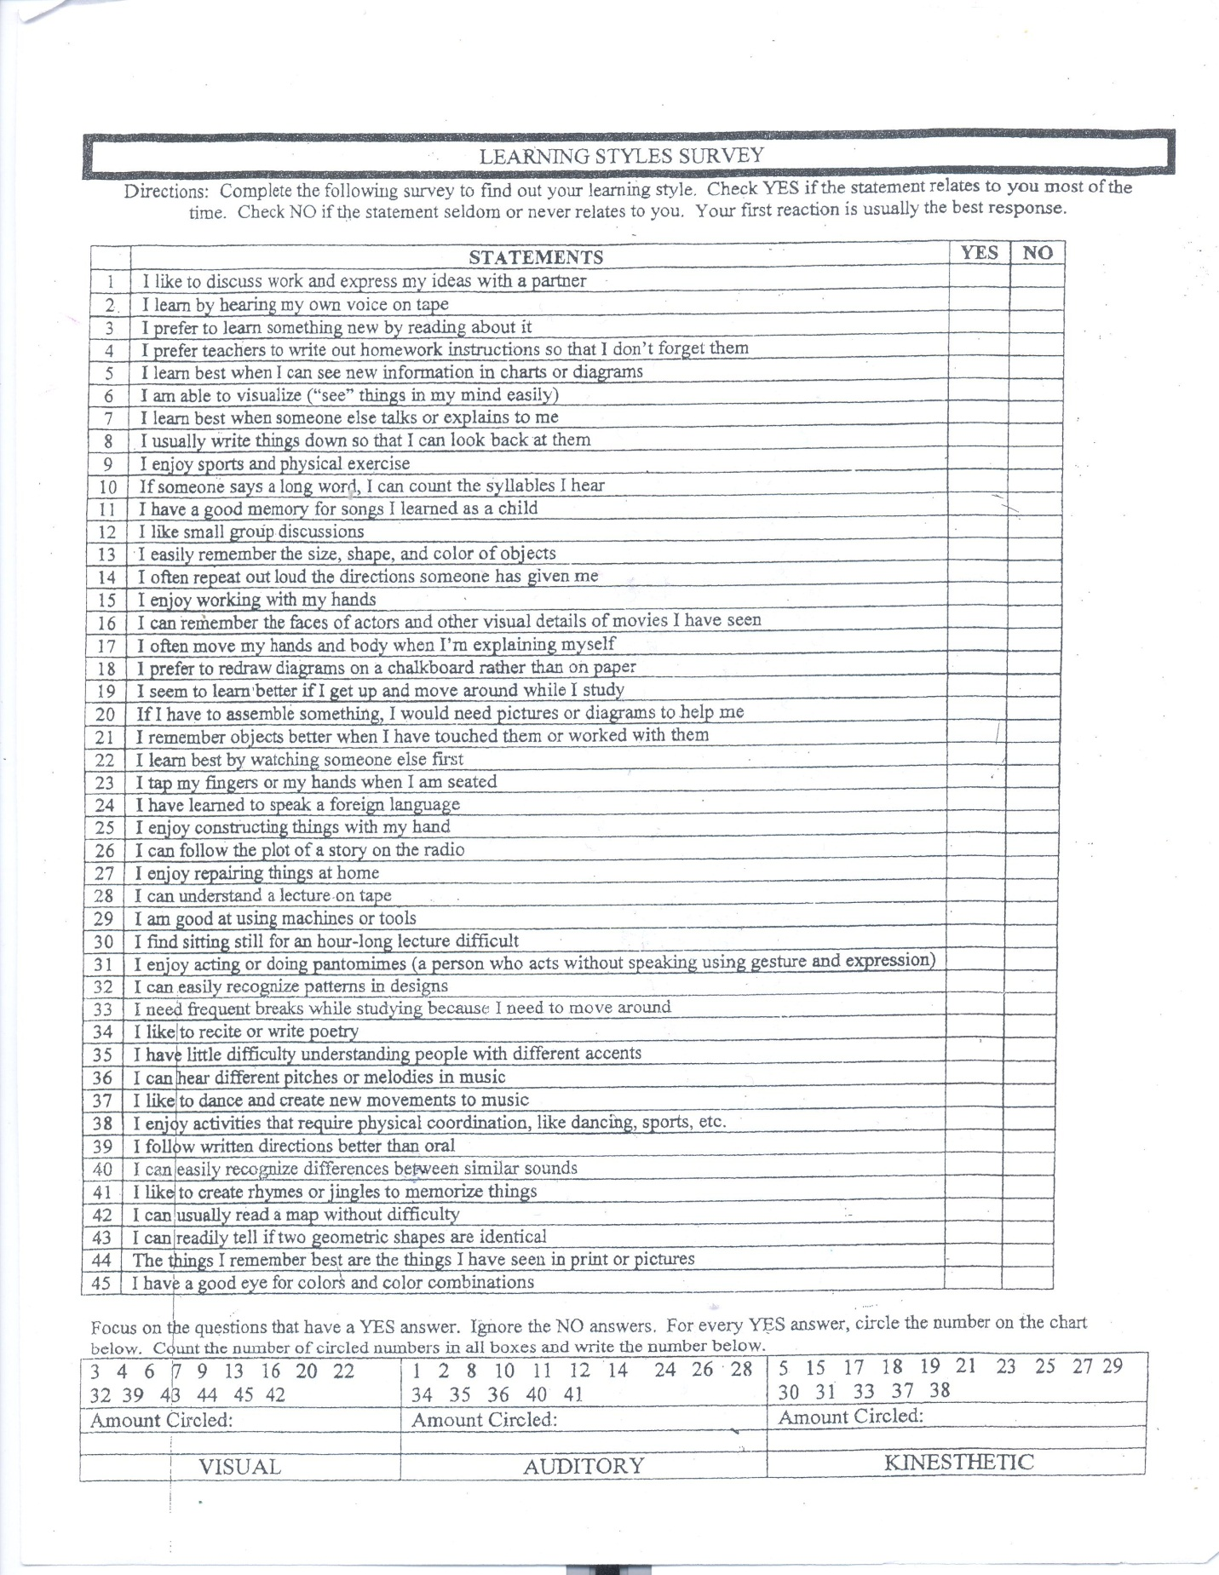

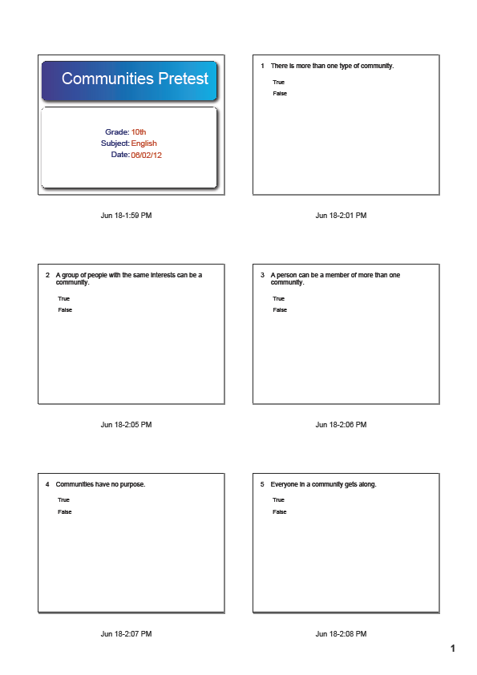
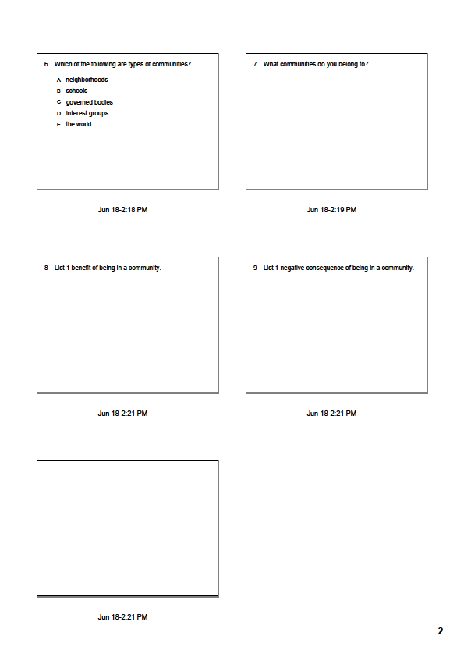
Lesson Plans
Lesson 1
- Concept To Be Learned: The definition, characteristics, and types of communities.

- Lesson Objective: I can identify communities by characteristics and type. (application/evaluation).

- Procedures:

Phases: Description of Activities

- Engagement (15 minutes): Students will be paired up and given the following riddles to ask each other and answer: 1. I am not animal or plant; I am not always tangible but visible everywhere. I have many different types and you are a part of at least two or three of me. What am I? Answer: Community 2. I am a part of something bigger than myself, even if I don’t want to be. Answer: Individual, Person. Students should ask one question and answer one question. Students and teacher will discuss students’ perceptions of the riddles and their answers, as well as the students’ concept of community. Students will record the definitions for community as well as their organizational types at the end of the short discussion.

- Exploration (60 minutes of 10 minute rotations): The teacher will divide the class into three groups. (First 10 minutes) Each group will brainstorm a list of communities (they may use the internet as a resource) and classify them according to their organizational structure. (Second 10 minutes) Each group will assign a visual link to each of the types of organized communities (use Google images). (Third 10 minutes) Each group will complete the Smart board category sort for their selected communities. The category headings should reflect two of the organizational types and have the linked image as well. (Fourth 10 minutes) Groups will trade and complete each other’s Community Organization Sort and discuss questions, accomplishments, next steps. (Fifth 10 minutes) Choose 1 community from the list and research how that community has impacted the lives of its members. Students will be able to discuss the following: Is it positive or negative? How do you know? (Final 10th minutes) Students will search for a second example of that community’s impact on individuals to determine if their first example is isolated or the norm.

- Explanation (25 minutes) Individually students will journal their findings from the Exploration section of the lesson. They will explain what they understand communities, their types, and their impact on individuals. They will reflect on the impact communities have had in their lives. This should be used as the basis for their persuasive essay which will serve as their evaluation piece.

- Extension (30 minutes) individually students will create a representation of their own community membership. They may create a rap or poem, power point, graphic organizer, pie chart, or 3-D web (string, cardboard, etc.), to examine their connections to various communities. They may use any method of expression that adequately conveys their comprehension of the definition of community and an understanding of types by organization. Their presentation should also clearly convey whether the communities have had positive or negative influences on them.

- Evaluation (45 minutes) Students will write a persuasive essay about the positive or negative effects of community on the individual. Their essays will include at least one example from their own life as support for their position on the nature of communities as well as the examples found in their research. They may use their notes during the writing process.

Materials Needed: laptops, smart board, LCD projector
Persuasive Essay Rubric
30-25 pts. | 25-15 pts. | 15-0 pts.
Student clearly states perspective on the topic in the first paragraph. | Student’s perspective is stated in the first paragraph, but it may not be clear. | The student’s perspective is not stated in the first paragraph.
Student provides adequate support (at least 3 examples) for their position. | Student provides examples which may be incomplete or do not fully support their position. | Student does not provide examples to support their position.
Student uses appropriate diction which reflects consideration of the intended audience. Strong persuasive words are used throughout the paper. | Appropriate use of diction is not consistent throughout the paper, or persuasive language does not strengthen position. | Diction is inappropriate for the intended audience, or no persuasive language was used.
Student has made no more than 2 errors in capitalization, punctuation, and spelling. | Errors in grammar exceed 4 and detract from persuasive impact of paper. | Errors in grammar are numerous and undermine persuasive impact of paper.

Lesson 2
- Concept to Be Learned: Make inferences about a community based on selected readings.

- Lesson Objective: I can make inferences about a community based on information from readings.

- Procedures:
Phases: Description of Activities
- Engagement: (15 minutes) Students will view the following clip, http://www.youtube.com/watch?v=TqTkha4fD5k&feature=related. They will complete an inferences chart based on what they observe in the video, and then compare/contrast their inferences with two neighbors. The last five minutes will be used for whole class discussion of findings and the generation of a class inference list on the dry erase board.

- Exploration:(45 minutes) Students will read a non-fiction article from The New York Times called “A Perfect Weapon for the Meanest Wars” by Jeffrey Gettleman and a fictional short story, “Kaffir Boy” from the World Literature book. Students will fill in the final section of the inference chart based on either of the readings.

- Explanation: (25 minutes) Students will trade charts and evaluate the inferences of their peer. Are the findings based on information in the reading, and if not have the students provide a detail from the reading that either supports or refutes the inference.

- Extension: (30 minutes) Students will seek to prove the validity of their inferences about the selected communities by finding more information or examples from the internet or classroom magazines.

- Evaluation: (45 minutes) Students will present their findings in an oral report to the class. They will be graded based on an oral presentation rubric.
Materials Needed: LCD projector, World Literature by American Guidance Service,http://www.nytimes.com/2007/04/29/weekinreview/29gett.html?pagewanted=all, inference chart
*Give specific details that support your inferences. | Inferences based on observed information  Community in Clip:________________ | Inferences based on observed information from a community from our reading. Selected community:__________________
Type of Community
(How does it seem to be organized?)
Expectations of community
(How are people supposed to act or behave? What are they supposed to do in certain situations?
Morals or Values of the Community? (Right and wrong in that community)
How do the individuals seem to feel about the community?

30-20 pts. | 20-10 pts. | 10-0 pts.
Speaker clearly states inferences and provides three reasons for each inference. | Speaker clearly states inferences, but fails to provide adequate information to support inferences. | Speaker does not clearly state inferences or provide information to support them.
Volume, rate, and diction are appropriate for audience. | Volume, rate, and diction were inconsistent for audience. | Volume, rate, and diction made it difficult to understand the speaker.
Inferences and information are logically connected. | Logic behind inferences is inconsistent. | There is no visible connection between inferences and information.

Lesson 3
- Concept to Be Learned: Community Culture is conveyed through literature, media, and art.

- Lesson Objective: I can create a multi-media presentation on community culture

- Procedures:

Phases: Description of Activities

- Engagement: (16 minutes) Students will view the following video clip and discuss. Have them think of art they have seen that communicated something about a community. What was it? What did it represent about the community?http://www.youtube.com/watch?v=aEMDqNqlTD4&feature=related

- Exploration:(30-45 minutes) Students, in pairs, will explore newspapers, art books, internet, literature book, etc. to find examples of art or print representations of community culture. Students may choose 1 community or many, but they should come away with at least 3 examples of community culture conveyed through literature or art.

- Explanation: (20 minutes) Students, individually, will write at least two paragraphs discussing how their examples of art and literature convey aspects of community. They will also brainstorm ways to illustrate these connections for their evaluation piece.

- Extension: (30-45 minutes) Students will choose 1 literary piece from the World Literature book. Create a list of community cultural traits that can be identified based on the writing. Find two works of art that complement the aspects of community found and explain what characteristics in the art made you choose it.

- Evaluation: (45-60 minutes) Students will create a multi-media project that focuses on 1 community and how they convey their culture through literature and art.
Materials Needed:

Post Assessment
The post-assessment will not be carried out through a standardized test, but through the generation of a written persuasive text and the creation of a multi-media presentation that exhibits the level of mastery the individual student has achieved.
In their persuasive texts, students will exhibit the degree to which they understand and can convey their perspective on communities and individuals. They will use language conventions and effective persuasive techniques to persuade the audience to agree with their perspective on the impact of society on the individual.
The multi-media presentation will test students’ ability to analyze communities and their cultures through representative literature. Students will select one piece of literature that they
believe conveys the values, expectations, and norms of their selected community. They will show examples of these connections in both literature and the real-world. This is thought to be a more thorough assessment practice because it allows for a broader interpretation and representation of the learned material.

 | 30-20 pts. | 20-10 pts. | 10-0 pts.
Values/Morals of the Society | At least 3 significant examples from literature with their reality-based evidence are included in the presentation. The origins of the values/morals must be included and explained. | At least 3 significant examples from literature with their reality-based evidence are included in the presentation. The origins may be unclear or unexplained. | Some examples are missing or incomplete. The origins are unexplained.
Expectations of the Society | There are at least 5 examples of societal expectations; they are clear and coherent. The expectations should be archetypal and pervasive-they should apply to the majority. | The expectations do not apply to the majority of society, or fewer than 5 but at least 3 were presented. | More than two examples were missing or they were incorrect.
Norms of the Society | The normal behaviors and functions of the individuals within the community are clearly illustrated through the literature and real-world examples. The audience would understand how to behave there. | There may be some confusion or 1-2 incomplete examples of normal behavior and functioning of individuals in the community. | There is a great deal of confusion or ambiguity about normal behavior in the society, or more than 2 examples are incomplete or missing.

References

Chiarelott, Leigh (2006). Curriculum in Context. Belmont, CA: Wadsworth, Cenage Learning.

Ornstein, A. & Hunkins, F. (2009). Curriculum: Foundations, principles, and issues (5th ed.).
Boston, Mass: Pearson Education, Inc.

Smith, Mark K. (2001) ‘John Dewey’, The Encyclopedia of Informal Education,
http://www.infed.org/thinkers/gardner.htm.

Ed. (1999). AGS World Literature (6th ed.). Circle Pines, Minn. : AGS, American Guidance
Service.

