Instructional Design

Cold War

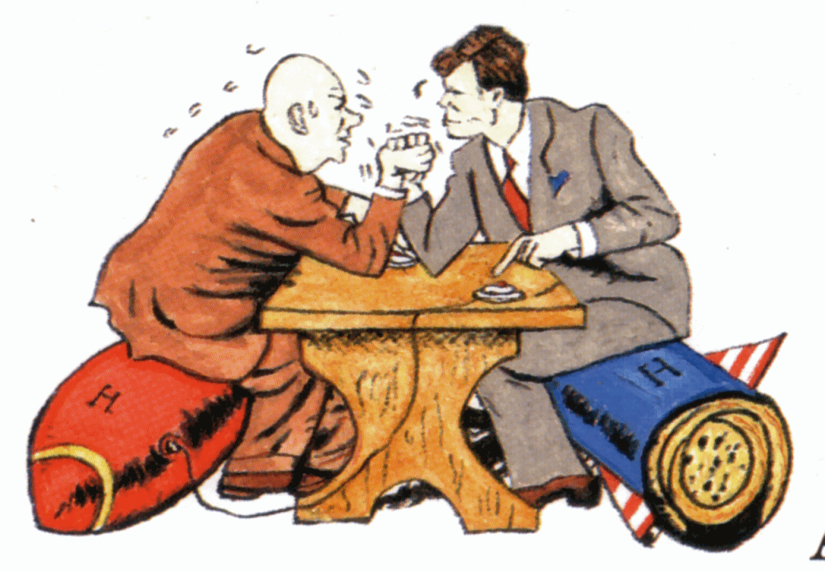

By: Chris Walton

How do we grab and maintain student attention in a world gone mad with technical gizmos? How can we teachers compete with Facebook and Twitter addictions? When we see text language in emails, extended response questions, and research papers are we to throw our hands to the sky and curse Verizon, Apple, or Kindle? Or, do we capitalize on this technology and social media formats to actually teach students the content they need to know that will, in my case, help them not only pass but flourish on the Social Studies OGT taken during their sophomore year? The instructional model I chose to tackle this problem is the Project Based Lesson Plan Model. Because what I have planned in terms of student outcomes could vary greatly, I believe the Project-Based Lesson Plan Model has a great deal of merit.

Another reason I chose the Project-Based Lesson Plan Model is because of how our administration at Perkins Local Schools sees our curriculum progressing. We were a Stem school until the Stem grant expired at the end of the 2011-2012 school year. We are now a 21st Century Learning Skills School where project-based and collaborative learning is expected from the teachers. Collaboration, the correct use of available technology, and enhancement of public speaking skills is also stressed. The real trick to successful project-based learning is making the projects relevant to our students. If my students can’t see a real world application to a particular project, their “interest and motivation to complete the learning tasks will be minimal” (Chiarelott, 2006).

Another reason I chose the Project-Based Lesson Plan Model to teach the Cold War Unit in a completely different manner (at least part of the unit, that is) is because of my teaching style. I am not the type of teacher that has to have total control over every aspect of learning in my classroom. Sometimes, the best learning occurs spontaneously with a teacher that can roll with the punches and take quick advantage of those teachable moments. The lessons that follow will have discernible structure, but they will also allow for “change-ups” along the way (Chiarelott, 2006).

As for contextualized learning, the Project-Based Lesson Plan Model is well-suited. Real world challenges and problems, active and engaged learning, and a deeper knowledge of the subject matter can be a result if the teacher knows what he/she is doing (Edutopia, 2012). As mentioned earlier, I am going to subscribe to the “If you can’t beat them, join them” model when it comes to technology and social media formats. For my teenage students, you can not get more real world and relevant than Facebook and Twitter. During the first sub-unit, Causes of the Cold War, I will assess what the students all ready know and what and where I will need to focus my attention in subsequent lessons. For the crux of the lesson, my students will be researching randomly assigned real characters from the movie *13 Days,* that deals with the Cuban Missile Crisis, a penultimate event of the Cold War. After thoroughly researching their character, the students will fill out out a fake Facebook page with the information gleaned from their research.

The next step in the lesson will be a live, interactive role play between students as they watch the movie *13 Days*. Each student will be assigned one of the five major characters of the movie and then put into groups of five. On a Google Doc, with a template I provide, the students will send Tweets to each other in character as the movie progresses. Included in their Tweets should be proper use of hashtags and school appropriate language, which I will monitor in real time because their Google Docs will be shared with me.

The final sub-unit will consist of student reflections. The students will reflect on what they knew prior to the assignments, what they learned from the assignments, and what they still may have questions about. Finally, the students should also discuss what they liked, what they did not like, and what they would change about the assignment to make it better. I believe some teachers miss this important last step, thus preventing them from improving their instruction.

Unit Intended Learning Outcomes

Subunit One: Causes of the Cold War

* Students will be able to explain the motives of both Superpowers in forming NATO and the Warsaw Pact.
* The students will distinguish between the U.S.’s policy of containment and the Truman Doctrine. (Analysis)
* The students will understand the function of Soviet Satellite States. (Analysis).
* The students will be able to predict the outcome of the relationship between the U.S. and the U.S.S.R. at the conclusion of the Potsdam and Yalta Conferences. (Synthesis)
* The students will be able to compare/contrast the actions and policies of Stalin and Khrushchev. (Evaluation)

Subunit Two: Cold War Events

* The students will be able to explain how the United State’s involvement in the Korean War was related to its policy of containment. (Analysis)
* The students will be able to infer Khrushchev’s motives of putting nuclear warheads in Cuba. (Analysis)
* The students will be able to make a distinction between the LBJ’s and JFK’s administration as they relate to Vietnam. (Analysis)
* The students will predict the outcome of the Cuban Missile Crisis if JFK had listened to his military leaders. (Synthesis)
* The students will be able to elaborate on the reasons why Ho Chi Minh thought the “West” was “two-faced.” (Synthesis)
* Based on what the students know, they will be able to choose whether the United States should have boycotted the 1980 Summer Olympics in Moscow. (Evaluation)

Subunit Three: Cold War Conclusion

* The students will be able to devise questions they would ask of Mikhail Gorbachev in an interview. (Application)
* The students will understand the economic motives of Mikhail Gorbachev. (Analysis)
* The students will understand the relationship between Gorbachev’s policies and freedom for the Soviet Satellite States. (Analysis)
* The students will elaborate on the reason(s) why some Soviet leaders staged a coup when Boris Yeltsin was in power. (Synthesis)
* The students will be able to make a judgment on the veracity of the most recent presidential election in Russia. (Evaluation)

Pre-Assessment of the Cold War

**Directions**: Circle the number that best represents your knowledge of the following.

**1-never seen 2-below average 3-average 4-above average 5-expert**

1. Satellite States 1 2 3 4 5

2. Containment Policy 1 2 3 4 5

3. Arms Race 1 2 3 4 5

4. Deterrence 1 2 3 4 5

5. Domino Theory 1 2 3 4 5

6. Truman Doctrine 1 2 3 4 5

7. Marshall Plan 1 2 3 4 5

8. NATO 1 2 3 4 5

9. Warsaw Pact 1 2 3 4 5

10.Cuban Missile Crisis 1 2 3 4 5

11.Heavy Industry 1 2 3 4 5

12.de-Stalinization 1 2 3 4 5

13.Welfare State 1 2 3 4 5

14.Bloc 1 2 3 4 5

15.Real Wages 1 2 3 4 5

16.Civil Rights Movement 1 2 3 4 5

17.Consumer Society 1 2 3 4 5

18.Women’s Lib. Movement 1 2 3 4 5

19.Martin Luther King Jr. 1 2 3 4 5

Directions: Answer the following questions the best you can. Remember to use complete sentences.

20. Identify the purposes of the Truman Doctrine.

21. Why were Cuban fighters sent to invade Cuba rather than American troops?

22. What was the Soviet Union’s motive(s) for blockading Berlin?

23. Explain how the U.S.’s policy of containment led to its involvement in the Korean War and the Vietnam War.

24. Explain how the U.S.’s belief in the Domino Theory led to its involvement in the Korean and Vietnam Wars.

25. Why could the Allies not deliver food and other supplies to West Berlin by land?

26. Explain the ideological differences in Communism and Capitalism.

27. What was the purpose for the formation of NATO and the Warsaw Pact?

28. What are the differences between a command economy and a market economy?

Lesson Plan—Day One

Unit Outcomes:

* Students will be able to explain the motives of both Superpowers in forming NATO and the Warsaw Pact.
* The students will distinguish between the U.S.’s policy of containment and the Truman Doctrine. (Analysis)
* The students will understand the function of Soviet Satellite States. (Analysis).
* The students will be able to predict the outcome of the relationship between the U.S. and the U.S.S.R. at the conclusion of the Potsdam and Yalta Conferences. (Synthesis)
* The students will be able to compare/contrast the actions and policies of Stalin and Khrushchev. (Evaluation)

Time Period Objectives:

* Students will copy important vocabulary into their notes.
* Students will understand the term Cold War.

Materials Needed:

* Teacher MacBook
* SmartBoard
* Student MacBooks
* Student binders
* Paper and writing utensil

Procedures:

1. Introductory Activity (10 minutes)

* Ask students to summarize the outcome of the last completed chapter on WWII.
* Ask students to summarize the results of the Potsdam and Yalta Conferences.
* Ask students to discuss the ideological differences between communism and capitalism and how that could lead to a rivalry between the two Superpowers.
* Ask students what the term Cold War means to them.

2. Developmental Activity (30 minutes)

* Have students either open their MacBooks and create a new Chapter 20 folder on their desktop or open their binders and start a Chapter 20 notes section.
* Have the students write the following key vocabulary and their definitions into their MacBooks/Notebooks:

1. Satellite states
2. Containment Policy
3. Arms race
4. Deterrence
5. Domino Theory
6. Heavy Industry
7. De-Stalinization
8. Welfare state
9. Bloc
10. Real wages
11. Civil Rights Movement
12. Consumer society
13. Women’s Liberation Movement

3. Concluding Activity (5-10 minutes)

* Have students orally define a few of the key vocabulary terms.
* Ask students what the Cold War means now.

4. Key Questions

* What are a few of the lingering effects of the Cold War?
* Why did communism ultimately fail in the Soviet Union?

Summary:

1. Closure: (5 minutes)

* Have students infer orally why the Cold War never turned “Hot.”

2. Evaluation:

* Complete the Chapter 20 section 1 outline for homework.

__________________________ date_________ per______

**Chapter 20 – Section 1 Development of the Cold War**

**I. Confrontation of the Superpowers**

1. What became clear once the Axis powers were defeated?
2. What did Stalin fear?
3. What did the U.S. fear?
4. For security reasons, what did the Soviet government refuse?
5. What did American leaders refuse to give up?
6. What happened as tensions increased?
7. In 1949, what did the U.S. and its European allies form?
8. What was formed in 1955 by the Soviet Union and its European allies?
9. **Rivalry in Europe**
   1. Where was the first area of disagreement?
   2. What did the United States and Great Britain believe?
   3. What was Stalin fearful of?
   4. What happened after the Soviets freed Eastern Europe from the Nazis?
   5. What created another area of conflict between the superpowers?
10. **The Truman Doctrine**
    1. What did Harry Truman ask for from Congress on March 12, 1947?
    2. In addition to helping Greece and Turkey, what else did the Truman Doctrine state?
    3. What would the U.S. have to face if Soviet expansion in Greece and Turkey was not stopped?
11. **The Marshall Plan**
    1. What did Marshall believe about Communism?
    2. What did the Marshall Plan provide to prevent the spread of communism?
    3. How did the Soviets see the Marshall Plan?
    4. In 1949, how did the Soviets respond to the Marshall Plan?
    5. Why did COMECON fail?
    6. What was the policy of containment?
12. **The Division of Germany**
    1. At the end of the war, how had the Allied powers divided Germany?
    2. How was Berlin divided?
    3. In February 1948, what were Great Britain, France, and the United States making plans to do?
    4. What did the Soviets oppose?
    5. How did the Soviets attempt to prevent it?
    6. What did the Soviet forces prevent from entering the three Western zones?
    7. What did this blockade keep from the 2.5 million people in these zones?
    8. What was the Berlin Airlift?
    9. When was the blockade lifted?
    10. When was West Germany formally created?
    11. What was the capital of East Germany?

**II. The Cold War Spreads**

1. In 1949, who took over when Chiang Kai-shek lost control of China?
2. What did Mao Zedong’s victory strengthen in the U.S.?
3. What important event also happened in 1949?
4. **The Arms Race**
   1. What is an arms race?
   2. What kind of weapons became increasingly destructive?
   3. What did the U.S. and the Soviet Union believe would prevent war?
5. **New Military Alliances**
   1. The search for security during the Cold War led to

_________________________________________

________________________________________.

* 1. What organization was formed in April 1949?
  2. Which countries signed the treaty?
  3. What did all the powers agree to?
  4. Who also joined a few years later?
  5. Who did the Soviet Union join with in 1955?
  6. What was this military alliance called?
  7. Why did the Korean War begin in 1950?
  8. Which countries formed the Southeast Asia Treaty Organization?
  9. Which countries in CENTO tried to prevent the Soviet Union from expanding to the South?
  10. How many states was the U.S. allied with by the mid-1950’s?
  11. What did the U.S. fear?
  12. What are ICBM’s?
  13. What are ICBM’s capable of?
  14. What did the Soviets achieve in 1957?

1. **A Wall in Berlin**
   1. Who was the new leader of the Soviet Union in 1955?
   2. What did many East Germans try to do?
   3. In August, 1961, what did the East German government do?

Lesson Plan—Day Two

Unit Outcomes:

* The students will be able to explain how the United State’s involvement in the Korean War was related to its policy of containment. (Analysis)
* The students will be able to infer Khrushchev’s motives of putting nuclear warheads in Cuba. (Analysis)
* The students will be able to make a distinction between the LBJ’s and JFK’s administration as they relate to Vietnam. (Analysis)
* The students will predict the outcome of the Cuban Missile Crisis if JFK had listened to his military leaders. (Synthesis)
* The students will be able to elaborate on the reasons why Ho Chi Minh thought the “West” was “two-faced.” (Synthesis)
* Based on what the students know, they will be able to choose whether the United States should have boycotted the 1980 Summer Olympics in Moscow. (Evaluation)

Time Period Objectives:

* Students will research a prominent figure of the Cold War, particularly one involved in the Cuban Missile Crisis.
* Students will have a deeper understanding of their assigned person as well as the Cuban Missile Crisis in general.

Materials Needed:

* Teacher MacBook
* Smartboard
* Student MacBooks
* Facebook template

Procedures:

1. Introductory Activity (5-10 minutes)

* Ask students what they remember about the Cuban Missile Crisis from the previous day’s discussion and from their homework.
* Ask students how many of them have Facebook accounts. Ask the students what kinds of things are found on a Facebook page.

2. Developmental Activity (30 minutes)

* Show the students the trailer from the movie, *13 Days*. Explain to the students that this is the movie they will be watching the following two class periods.
* Discuss with students the five major players from the movie and the roles each played during the Cuban Missile Crisis.
* Post the Facebook template to the Smartboard and go over it with the students.
* Explain to the students they must research they’re assigned “character” and then make a Facebook page on him. Included should be photographs, relationships, family, accomplishments, friends, and at least five wall postings from that person.
* Tell the students to open their MacBooks and look for the email that I sent them earlier that day. The email will open to the Facebook template they will then download.
* Students must find at least two reputable websites that gives information on their assigned person within five minutes. Timer will be set on Smartboard.

3. Concluding Activity (10 minutes)

* Students will start filling in their Facebook downloads with pertinent information.
* Ask random students about the information they have found so far.

4. Key Questions:

* What was the role of your assigned person during the Cuban Missile Crisis?
* Why do you think Castro let the Soviet Union place nuclear weapons in his country?

Summary:

1. Closure: (3-5 minutes)

* Explain to the students what they will be doing the next two days with the information gleaned from their research. They will be working in groups of five and having real time dialogue as the movie progresses with the other four “characters” from the movie.

2. Evaluation:

* Finish the Facebook template for homework.

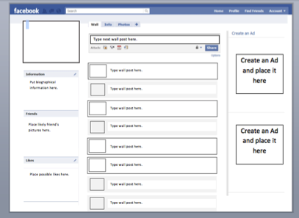

Lesson Plan—Days Three & Four

Unit Outcomes:

* The students will be able to devise questions they would ask of Mikhail Gorbachev in an interview. (Application)
* The students will understand the economic motives of Mikhail Gorbachev. (Analysis)
* The students will understand the relationship between Gorbachev’s policies and freedom for the Soviet Satellite States. (Analysis)
* The students will elaborate on the reason(s) why some Soviet leaders staged a coup when Boris Yeltsin was in power. (Synthesis)
* The students will be able to make a judgment on the veracity of the most recent presidential election in Russia. (Evaluation)

1. Introductory Activity: (5-10 minutes)

* Ask students to turn in their Facebook assignments.
* Ask students how many of them have Twitter accounts. Talk about Tweets and hashtags.
* Using the random selector feature in the Smartboard software, select five different “characters” to work together with today’s and tomorrow’s assignment.
* Explain to the students that they will be using the Twitter template I sent them via email to talk back and forth to each of the other four characters in their group.

2. Developmental Activity (35 minutes)

* Have students open their MacBooks and log into Lanschool number 202.
* Have students download the attached Twitter template they will use for this assignment.
* Have one group member open up a Google Doc and share it with the other four members and myself.
* All group members will then copy and paste the Twitter template to the Google Doc. This is what they will use to converse with one another.
* Remind students about school appropriate language and public record.
* Start the movie, *13 Days*.

3. Concluding Activity (5 minutes)

* With five minutes left in class, go over some of the best Tweets, which I will have screen captured and then put on the Smartboard.

4. Key Questions:

* Day one—Do you think Kennedy will take the advice of his military advisors? Why or why not?
* Day two—How would the Cuban Missile Crisis been different if Kennedy would have heeded the military’s plans?
* Day two—What are your perceptions of JFK after the movie?

Summary:

1. Evaluation:

* On a Pages Document, the students will write a one page self-reflection paper on this assignment. The self-reflection should include what they liked, disliked, and what they would change to make it better. It should also include a brief, accurate summary of the Cuban Missile Crisis. The self-reflection will be emailed to me by the start of class the following day.

|  |  |  |  |  |  |  |  |  |
| --- | --- | --- | --- | --- | --- | --- | --- | --- |
| * What are the most important people in this topic? * What was their most important moment within the topic? * What would their comment be about it? * What particular keywords would they use within their comment? * What hashtag could they maybe use at the end of the message? * What nickname did they have / could we invent to use as their username?  |  |  | | --- | --- | | Username | *Tip - use their real / a believable nickname | | Real Name | *Give a full name to ensure an accurate picture | | Tweet |  | | Date | *Make this historically accurate | |