Junior Fritz Jacquet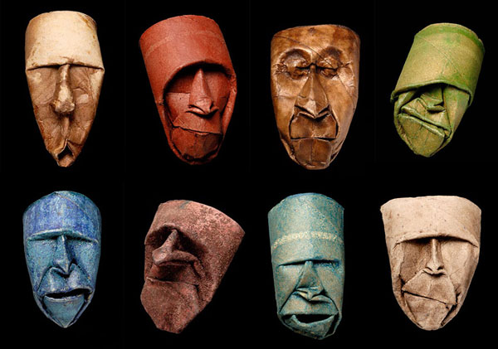

Uses toilet paper rolls

<http://christinemccoyartjournal.blogspot.com/2010/10/planes-of-head.html> Discuses class that models human heads. 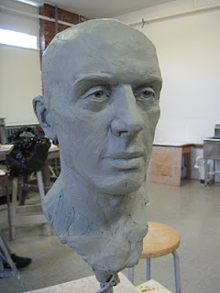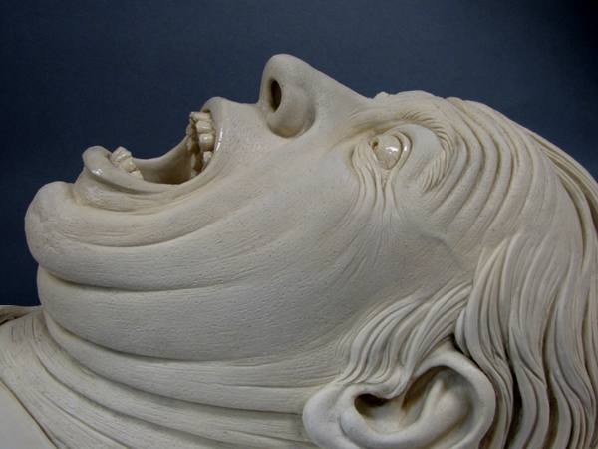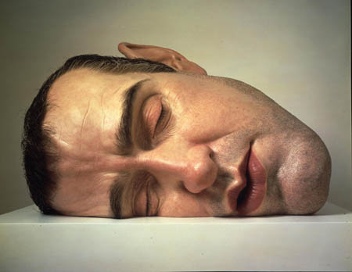

Ron Mueck

<http://inkbloodmagic.blogspot.com/2011/04/ron-mueck.html>

Nnamdi okonkwo

http://artnectar.com/2011/03/face-clay-pot-sculptures-debbie-englund/ Debbie Englund makes pots out of faces.