**Joseph**

**Castor**

**Catapult**

***Abstract***

A catapult is an ancient engineering engine for hurling an object. I plan to build all the pieces in an Inventor (3d modeling software) and then print them to make a catapult. The connections will have to be tight so that when it launches an object it will not fall apart, so that way there will be a bigger focus on tectonics (which is the art of connections) and on the strength of the design. I will learn more about the 3d printers, perfect tectonics, and find the strengths of the plastic in extreme conditions. I most likely will have a lot of problems with the 3d printer being able to print the tectonics I want. I expect to have a fully functioning catapult by the end of the project.

***Outline***

**March 22:** Finish abstract and start designing

**March 27:** Work on 1st design

**March 29:** Print something

**April 3:** Test and edit design

**April 5:** Make design better and more elaborate

**April 10:** Figure out how to make range adjustable

**April 12:** Make range adjustable by changing the launch trajectory

**April 17:** Print

**April 19:** Edit and test and reprint if necessary, Get supplies for poster over the weekend

**April 24:** Finish Poster

**April 26:** Turn In

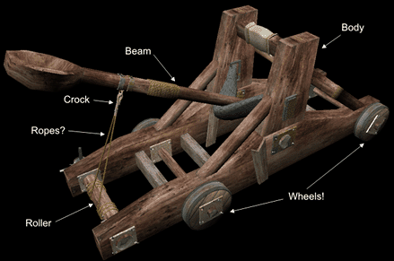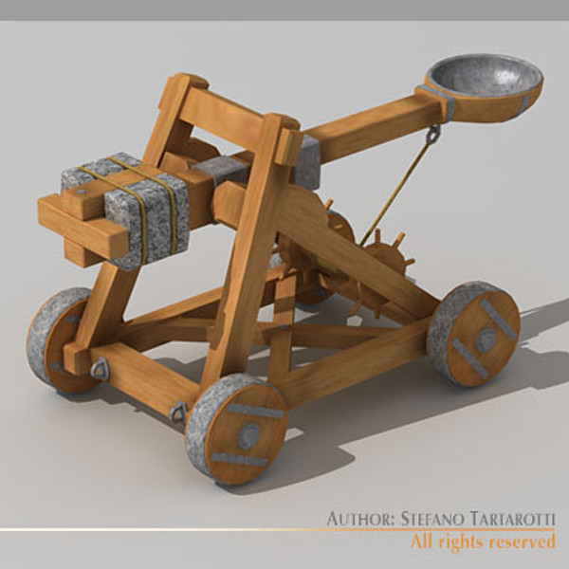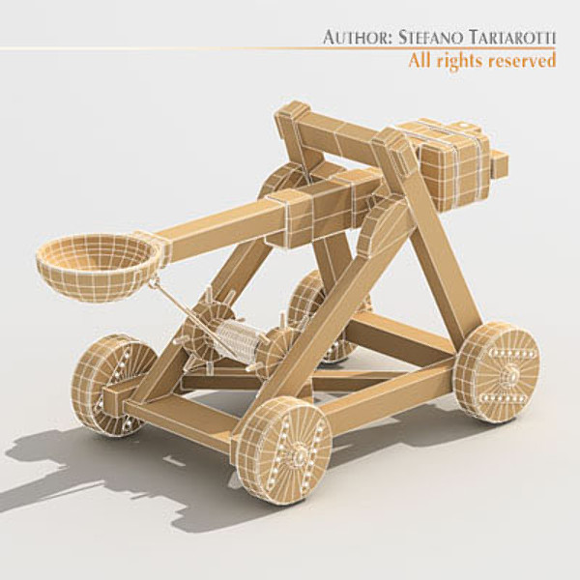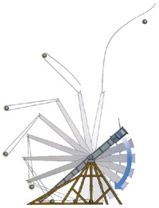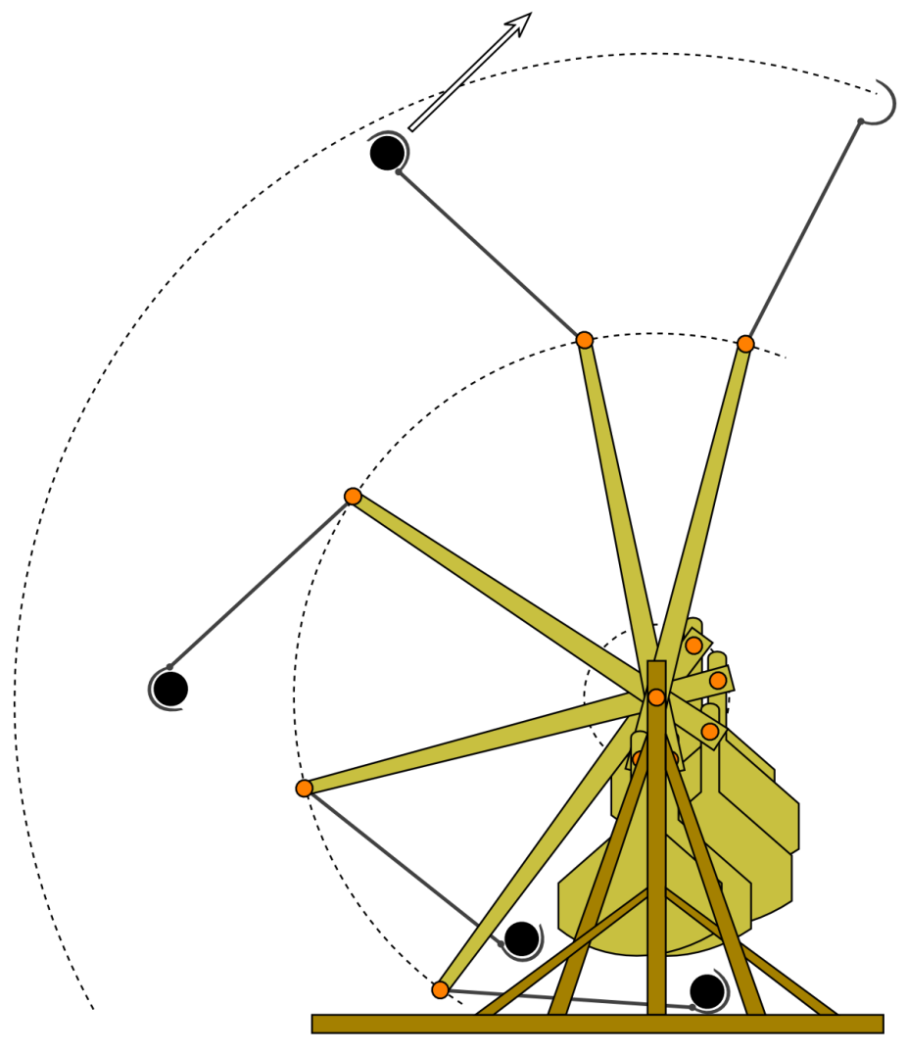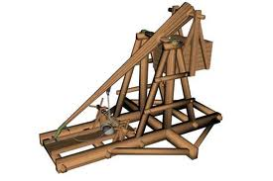

**References**

<http://www.inframez.com/papers/xsi_catapults.htm>

<http://www.turbosquid.com/FullPreview/Index.cfm/ID/543040>

<http://www.scottishmist.com/index.php?option=com_content&view=article&id=111:jewellery-with-a-history&catid=51:latest&Itemid=66>

<http://library.thinkquest.org/05aug/00627/phy.html>

http://transformerstrebuchet.pbworks.com/w/page/24114717/Welcome