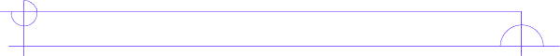
Literature Circle Role Sheet

Vocab Enhancer
This student focuses on (at least 8) unfamiliar words or words used in unusual ways. In order to fill this role you must think “outside” of yourself. There may be words that you understand, but your classmates may find strange or difficult. The goal is to help group members not only recognize and understand new words, but also begin to use them in their writing and speaking. WORDS MUST BE SCHOOL APPROPRIATE!

While you read…
Fill out the chart below whenever you come to a word that you find to be unfamiliar, critical, made-up, etc.

Word and Page # | Sentence from book | Definition

During Literature Circles…
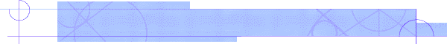
Guide group members through your chart, while pointing out where you found the words and why you picked them.

