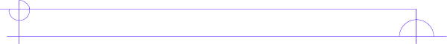
Literature Circle Role Sheet

Metaphor Master
This novel is full of symbolism/metaphors, as well as themes. The Metaphor Master will guide each group member in the understanding of metaphors and/or themes throughout the novel. The Metaphor Master also compares events with the same theme and makes connections between a theme, a selection, and students’ own lives.

Before Reading the Selection
Think about/ list developing themes or metaphors used in the novel. Consider how these new selections relate to previously developing themes or ideas. Write your conclusions below.

____________________________________________________________________________________________________________________________________________
____________________________________________________________________________________________________________________________________________

While Reading the Selection
Jot down your ideas about how this selection relates to the theme or the use of symbols.

________________________________________________________________________________________________________________________________________________________________________________________________________________________________________________________________________________________

Add your own questions:

____________________________________________________________________________________________________________________________________________
______________________________________________________________________

During the Group Discussion
Ask the questions you prepared. You might also discuss the points below to help group members explore the theme and apply it to their own lives. Remember to respect others’ opinions at all times and especially during the discussion. People will answer the questions based on their own values and experiences.


