Bitácora 0:
- My expectations about this class are learning new methods and ways of using new technologies in my process of teaching languages; besides, I hope I could learn even more about the process of learning and teaching a new language.

- Process of teaching:
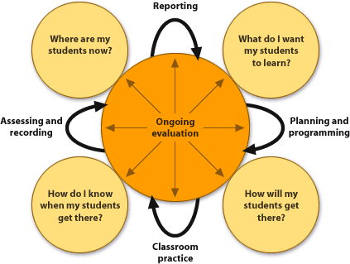
- No, I’ve never taught before.

- I would use ICT’s in my language lessons because I think that they are extremely useful because they represent a whole new world of new material and ideas for teaching and learning languages.

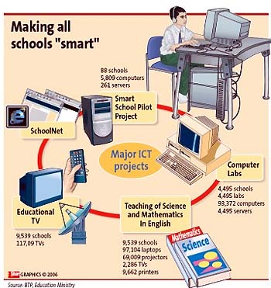

- Catalina Moreno Correa.
- Cata, this is so simple but full of great ideas that reflect on what we should do in L2 classrooms with ICTs to foster learning.
- 4.3/5.0 - Harold

