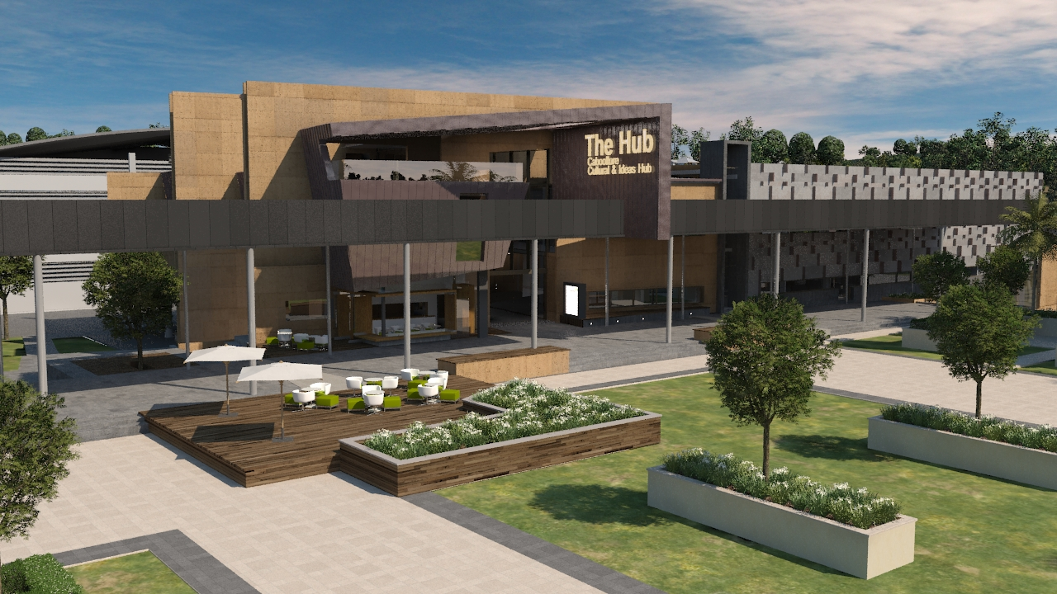

“Facebook” - What is it?

- Are your family & friends talking about facebook?
- Don’t have a computer or internet access?
- Wish you could connect with family and old friends via facebook but don’t know how?

Caboolture Hub proudly presents

“Discover the World of Facebook”

- Free to the public
- Courses commence Monday 12th December 2011
- Surprise your family & friends before Christmas!
- Bring your photo’s and learn how to scan & post them

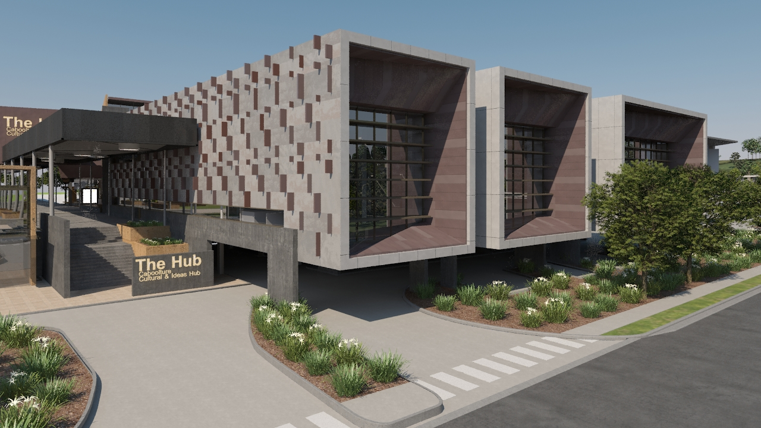

Bookings essential
Ph: 07 54333700
E: CabooltureHub@moretonbay.qld.gov.au
W: www.moretonbay.qld.gov.au/caboolture-hub
A: Caboolture Hub, 4 Hasking Street, Caboolture

