Materials:
Computer (Mac or PC) Google earth (free at http://www.google.com/earth/download/ge/agree.html)
Streaming Soil Data .KMZ (free from http://casoilresource.lawr.ucdavis.edu/drupal/node/538)

Procedure:
- Begin by opening Google Earth. If you do not have Google Earth you can download it for free from the link above. When Google Earth opens it will be zoomed out on the whole globe.
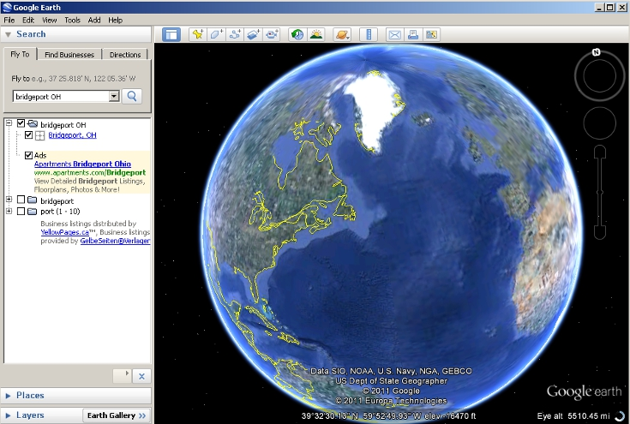

- Open your internet browser and download the Streaming Soil Data .KMZ from the CA soil resource lab. Make sure you save the .kmz file somewhere you can find it.

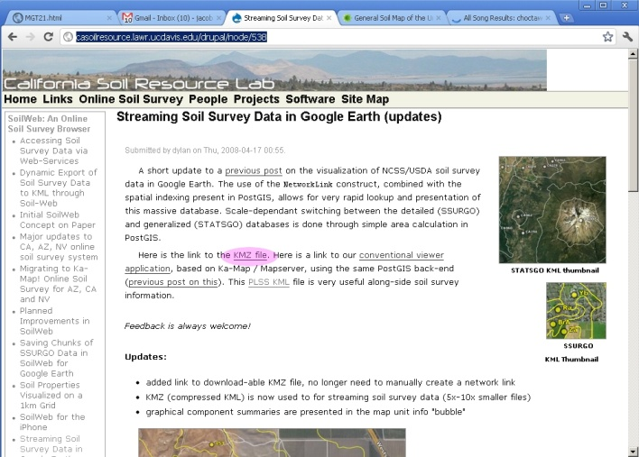

- In Google Earth Click File->Open, and select the .KMZ file you just downloaded.

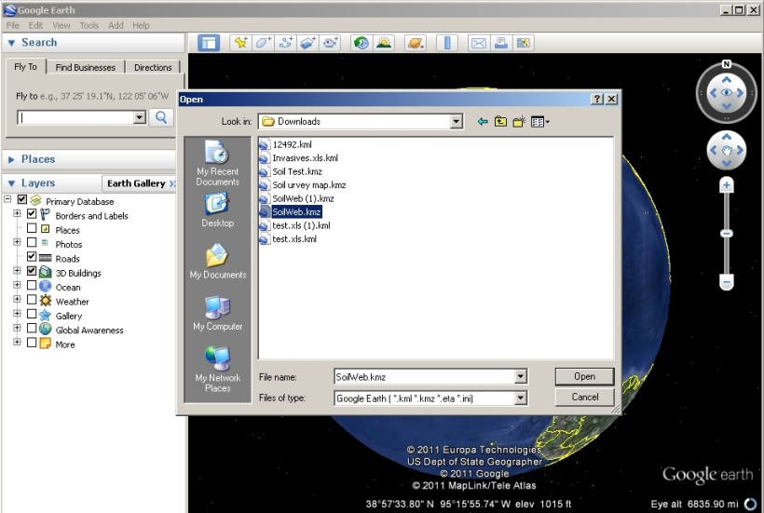

- On the left-hand tool box there will be a search tab. Type the name of the location that you wish to determine the soil type for, and click the magnifying glass to fly to that area. If your search terms are too vague (e.g. “Wheeling” instead of “Wheeling WV”) you may get too man results. In this case refine your search terms.

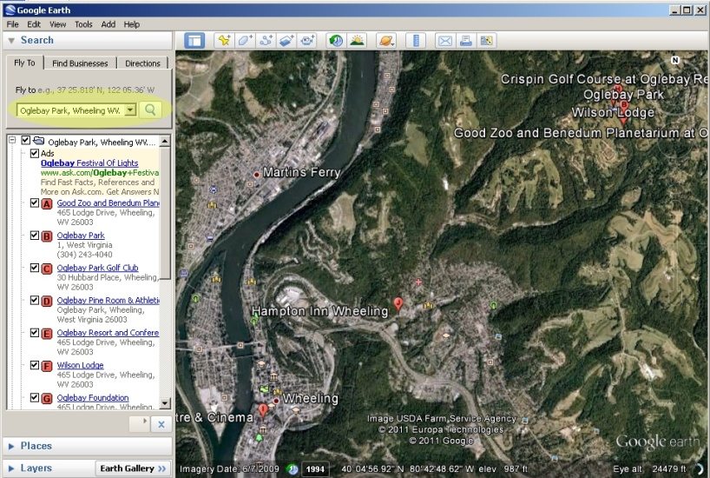

- You can now navigate to get a good view of the fragment you are trying to measure. On the right hand side of the map, there are navigation tools that appear when you move your cursor over them. The top circle (highlighted in red) changes your direction of view, you do not need this tool to find your forest fragment. The next circle down (highlighted in green) moves the map, use it to center your forest fragment on the screen. The scroll bar (highlighted in orange) controls the zoom, zoom in your fragment takes up most of the field of view. You can also click and drag to move the map and zoom in and out using the scroll wheel on your mouse.
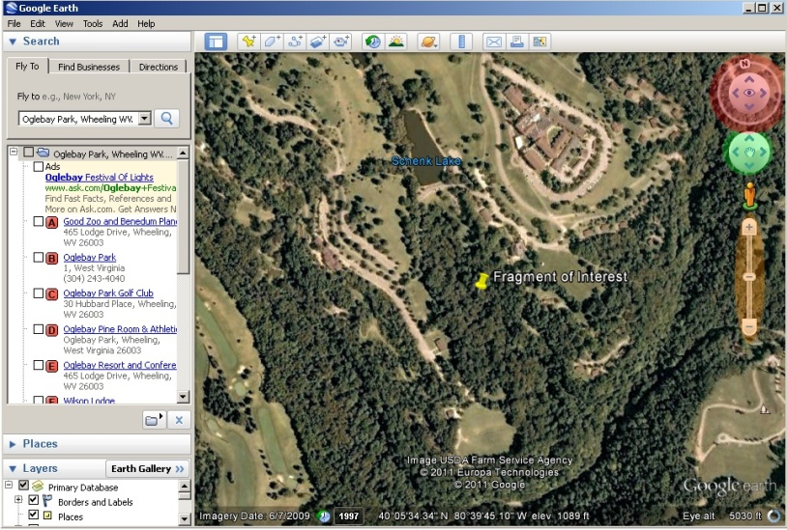

- If you have opened your SoilWeb.KMZ file it will appear under the “temporary places” (highlighted in green) folder in your “Places” tool box (highlighted in red). If you cannot see the “Places” tool box click the arrow to the left of the label to expand the tool box. This type of .KMZ file streams the data to your computer via an internet connection so it may take a minute for the soil boundaries to appear.

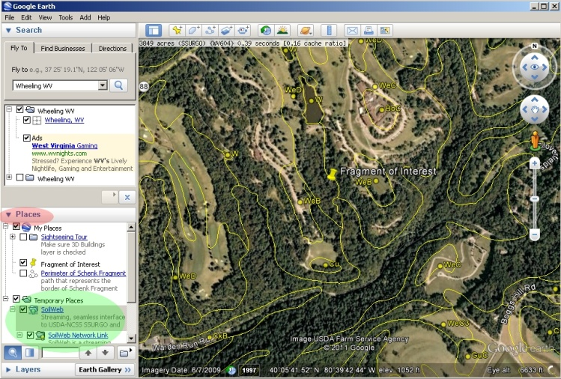

- To get data about the type of soil in the area you are interested click on the yellow label (one of which is highlighted in red). The speech bubble that appears will show you a soil profile of the soil type in that area and some limited information about the soil type. To get more information about the soil click the soil name (highlighted in green).

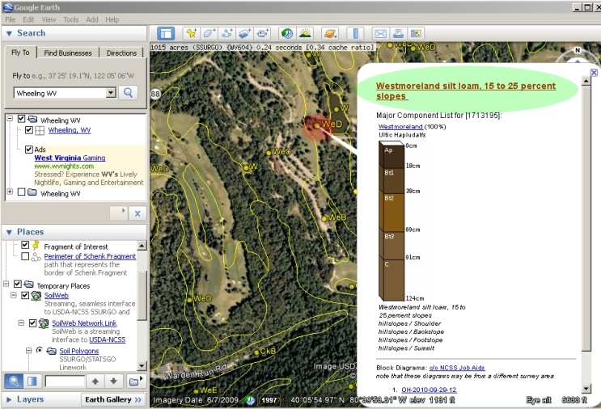

- A website for the California Soil Resources Lab will open. On this page you can find how many acres of your area of interest (the map you had open in Google Earth) contain that soil type (highlighted in green). You can click on the soil’s name (highlighted in red) to find out more information about your soil type.
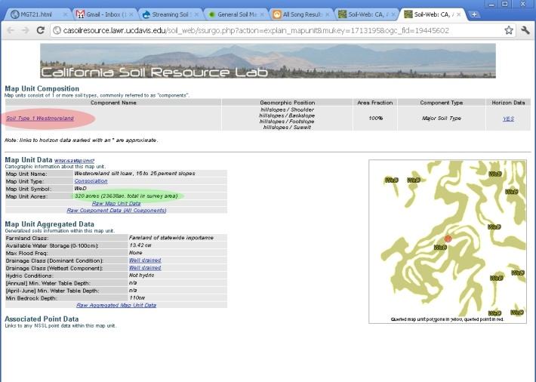

- A page will open with more specific information about your soil type. Scroll Down and look for the data on plant growth( highlighted in red), pH (highlighted in green), and percent clay and sand (highlighted in orange). The data presented about plants is a relative measure of a species’ productivity, or how well a plant will grow in that soil.
