Materials:
Computer (Mac or PC) GE Pat Software (free at http://www.sgrillo.net/googleearth/gepath.htm)
Google earth (free at http://www.google.com/earth/download/ge/agree.html)
Procedure:
- Open Google Earth. If you do not have Google Earth currently installed on your computer it is free to download. When Google Earth opens it will be zoomed out on the whole globe.

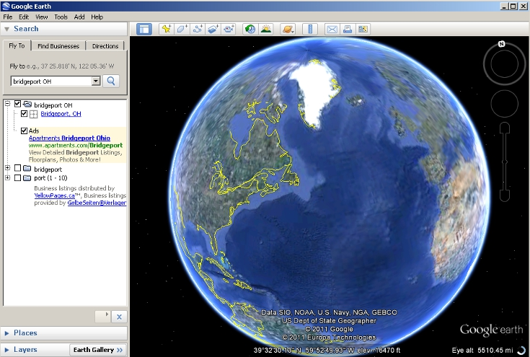

- On the left-hand tool box there will be a search tab. Type the name of the location of your forest fragment or an area near your forest fragment that you wish to measure and click the magnifying glass to fly to that area. If your search terms are too vague (e.g. “Wheeling” instead of “Wheeling WV”) you may get too man results. In this case refine your search terms.

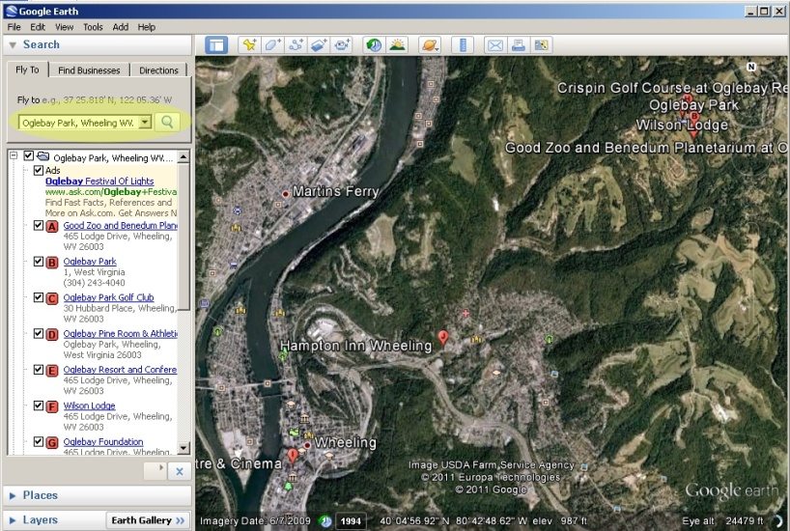

- You can now navigate to get a good view of the fragment you are trying to measure. On the right hand side of the map, there are navigation tools that appear when you move your cursor over them. The top circle (highlighted in red) changes your direction of view, you do not need this tool to find your forest fragment. The next circle down (highlighted in green) moves the map, use it to center your forest fragment on the screen. The scroll bar (highlighted in orange) controls the zoom, zoom in your fragment takes up most of the field of view. You can also click and drag to move the map and zoom in and out using the scroll wheel on your mouse.
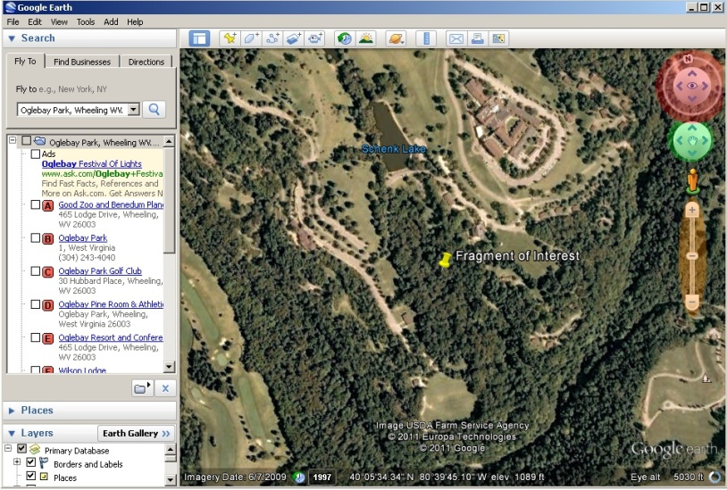
- Begin by creating a path around the fragment you wish to measure. To do this select the path tool. When you do a window will pop up asking for a name and description. To make a path simply click along the perimeter of your fragment of interest. If you make a mistake you can delete a part of the path by right cliking it. To finalize your path click ‘OK’

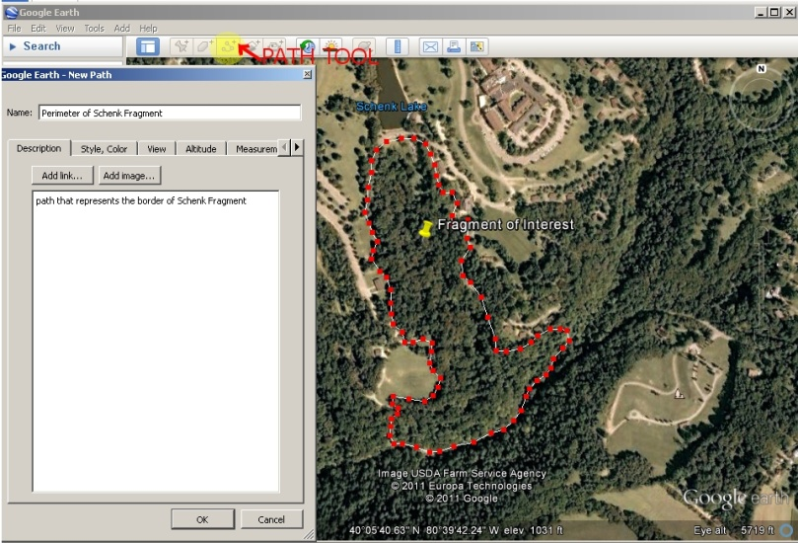

- Once you have finalized your path it will appear under the “My Places” tab in the left hand toolbox labled “Places”. Right click the name of your path and select “save place as”. In the window that pops up name your file something descriptive and save it in a place you will be able to find it. Also Select the file to save as a “.KML” as shown in the second picture below.
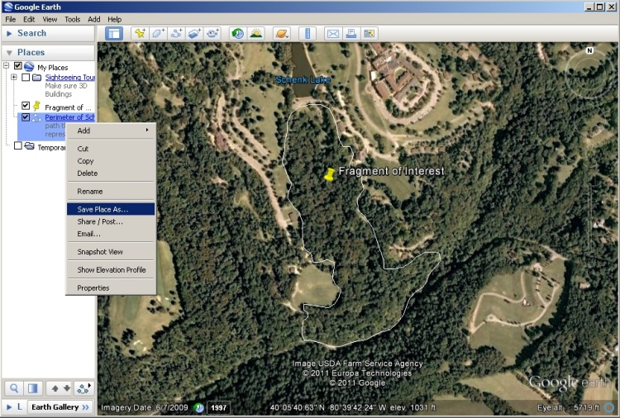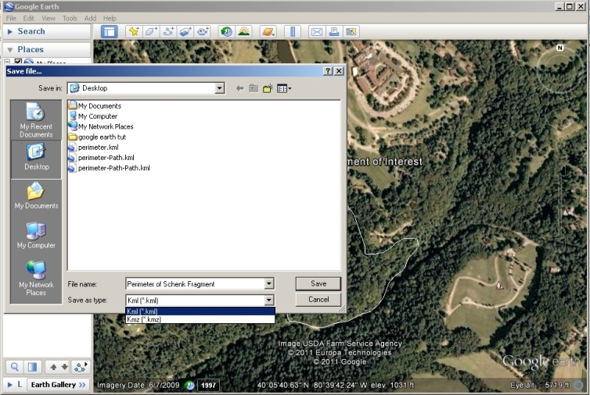

- After you have saved your perimeter as a .KML open the “GE Path” program. If it is not installed on your computer it is free to download via the link in the materials portion of this document. When the program opens select “File” and then “open KML”.

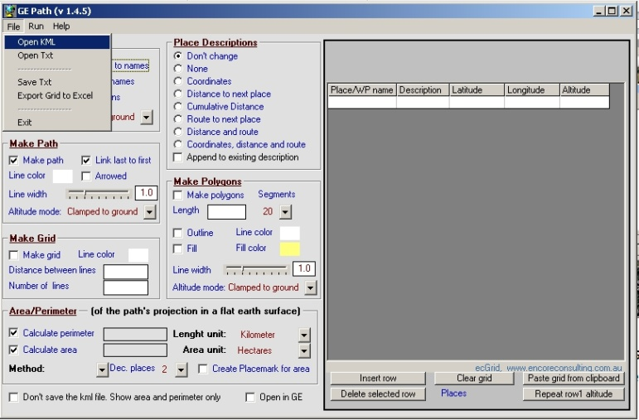

- Once you open your file, a list of the points that make up you perimeter will appear in the grey box on the left. First check “Calculate perimeter” and “Calculate area” which are highlighted in red below. Then Select the units you would like the program to output (in our case Kilometers and Hectares). Next select “Small Area” from the dropdown highlighted in blue. Finally make sure “Don’t Save the KML file” is selected and “open in GE” is not selected (both highlighted in orange). Finally Click “Run” (highlighted in green) and your answers will appear in the boxes circled in bright green!

