Many applications have no need to supply such high current devices. There are smaller h-bridges that require little additional circuitry. Consider the 754410 (see[SN754410.PDF](http://www.learn-c.com/sn754410.pdf)). The following is derived from the data sheet:

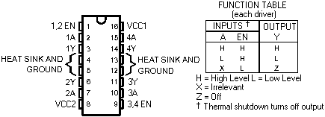

There are 4 sections inside, each with an input designated A, and an output designated Y:

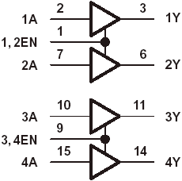

Each output is good for about 1 amp continuous output. The EN pins enable the outputs when high. The outputs are disconnected from what they are driving when the EN lines are low. An inverter can be added to provide bi-directional operation:

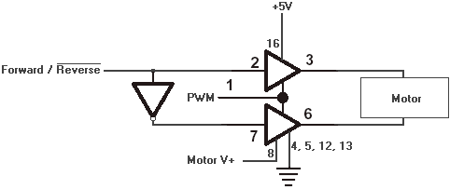

When the Forward/Reverse line is high the motor will rotate forward if the PWM line is also high. When the Forward/Reverse line is low (indicated by the bar over Reverse) the motor will rotate in reverse if the PWM line is high. Thus, the PWM line switches the motor on and off, providing pulses in the direction desired. The inverter could be one made out of a gate as above, or something such as the 74HC04, a HEX (means 6 here) inverter (see [74HC04.PDF](http://www.learn-c.com/74hc04.pdf)).

Rather than use up room for a whole IC though, a single transistor can be used as an inverter. The PPI can provide a minimum of 3V and 2.5ma to the inverter. The inverter shown below only needs about .6ma input at 3 volts, and the 1.5K output resistor is small enough to restore the 2.5ma drive of the PPI. Stand the resistors on end for minimum space. The circuit with some additional protection rectifiers added looks like this:

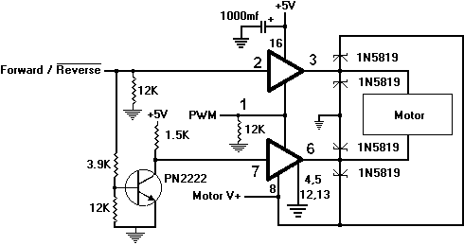

I tested this circuit for extended periods using the .4 amp motor provided with [Experimenter's Kit #1](http://www.learn-c.com/experimenters%20kit%201.htm) which can be [ordered](http://www.learn-c.com/order.htm), and the IC didn't even get warm without a heatsink. To duplicate the test, simple connect Motor V+ to +5V. Connect the 2K Hz test oscillator above to the PWM input. Disconnecting the oscillator should turn off the motor. Alternately connect and remove +5V from the Foward/Reverse line to check for proper direction control. The circuit will easily fit on the breadboard that can be [ordered](http://www.learn-c.com/order.htm) with Experimenter's Kit #1.

This would require two (2) output lines from the USB IO 24R. One to signal direction, and one to drive the motor. This latter on can be PWM to regulate the speed.

All sections can be used to increase output capability:

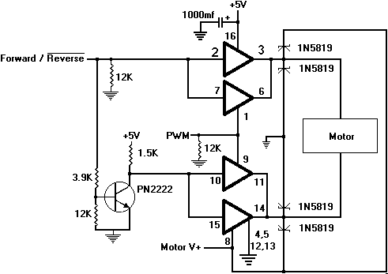

This one got a little too warm to touch with a 1.5 amp, 12 volt motor. That's because I forgot an important parameter of the chip. Its maximum power is only 2 watts. It didn't much like 18 watts! Actually, with the 50% duty cycle test I ran it was actually more like 9 watts since it was on only half the time. It's a good idea to use 100% in calculations though, since that could happen. Fortunately, the IC has a thermal shutdown circuit that helps protect it from dumb mistakes.

Here's how to calculate what the chip can take:   
Since P = V * I, the maximum current at 12 volts is I = P/V = 2/12 = .167 amp.

**Low Voltage, Bi-Directional DC Motor Driver**

*Apr 17, 2009 12:06 PM*

[**Allegro**](http://www.allegromicro.com/)® introduced the A3908, a new low voltage bi-directional DC motor driver with a typical input voltage range of 3.0 V to 5.5 V and output currents up to 500 mA. The unique full-bridge output incorporates source side linear operation to allow a constant voltage supply across the motor coil. This regulated output minimizes motor voltage change due to I×Rds(on) variation and battery voltage tolerance. Allegro's new motor driver is targeted at the portable and instrumentation markets.

Two logic inputs are provided to control the motor direction of rotation, brake and standby (<500 nA supply current) modes and to allow optional PWM of the sink drivers. Internal protection circuitry includes thermal shut down, under voltage lockout, and crossover (shoot through) protection.

The A3908 is supplied in a 2.0 mm × 2.0 mm × 0.575 mm nominal, 8-lead DFN package, with exposed thermal pad (package suffix "EE"). This small footprint package is lead (Pb) free, with 100% matte tin leadframe plating.

It is priced at $0.45 in quantities of 1,000 and has a 12 week typical lead-time to market.