ACS560
Microblog 911
Software Design Description

Version 1.0
Prepared by Kassie M. Bowman
November 1, 2011

Revision History
Date | Version | Description | Author
11/1/2011 | 1.0 | Initial creation | Kassie Bowman

Table of Contents
1. Introduction 5
1.1 Purpose 5
1.2 Scope 5
1.3 References 5
1.4 Overview 5
1.5 Constraints 5
2. System Overview 6
3. System Architecture 6
3.1 Architectural Description 6
3.2 Component Decomposition Description 6
3.3 Architectural Alternatives 6
3.4 Design Rationale 6
4. Data Design 6
4.1 Database Description 6
4.2 Global Data Structures 6
4.3 New Section 6
5. Component Design 6
5.1 Component identifier 7
5.2 Purpose 7
5.3 Function 7
5.4 Subordinates 7
5.5 Dependencies 7
5.6 Interfaces 7
5.7 Data 7
6. Human Interface Design 7
6.1 Overview of the User Interface 7
6.2 Screen Images 7
6.3 Screen Objects and Actions 7
6.4 Report Formats 7
7. Requirements Matrix 8
8. Resource Estimates 8
9. Definitions, Acronyms and Abbreviations 8

Introduction
The Software Design Description provides a description of how the software will be implemented for Microblog 911, an emergency detection and notification application that will allow emergency services personnel and application subscribers to receive real-time information about emergency situations.

Purpose
The purpose of this document is to provide a detailed description of how the software for Microblog 911 should be implemented in order to fulfill the requirements specified in the Software Requirements Specification (SRS). The intended audience for this document includes project stakeholders and developers.

Scope
The scope of this document is all software necessary for the Microblog 911 emergency detection application. This includes software for interfacing with users, both public subscribers and emergency services personnel, as well as software for collecting and processing microblog data.
The objective of this application is to detect emergency situations in real time by analyzing microblog data. The application will notify users of detected situations, allowing them to respond appropriately.

References
Document | Availability
Application Architecture | http://www.students.ipfw.edu/~kbowma
Software Requirements Specification | http://www.students.ipfw.edu/~kbowma
Vision Document | http://www.students.ipfw.edu/~kbowma

Overview
TBD
Describe what the rest of the SDD contains and explain how the SDD is organized.

Constraints
TBD
Briefly describe any restrictions, limitations or constraints that impact the design or implementation

System Overview
TBD
Briefly introduce the system context and design, and discuss the background to the project.
Put context diagram from SRS here to supplement the text.

System Architecture

Architectural Description
The Microblog 911 application is constructed as shown in Figure 1. The main components are the presentation layer, the business layer, and the data layer. The presentation layer will provide the user interface to the application via two methods: mobile application and web browser. The data layer will provide a means to access the data store for the system as well as communicating with external services to obtain microblog data. The business layer will provide all of the actual processing for the system. Additionally, security, operational management, and communication apply to the entire system. The latter elements will not be an area of focus for this project, as illustrated in Figure 1.
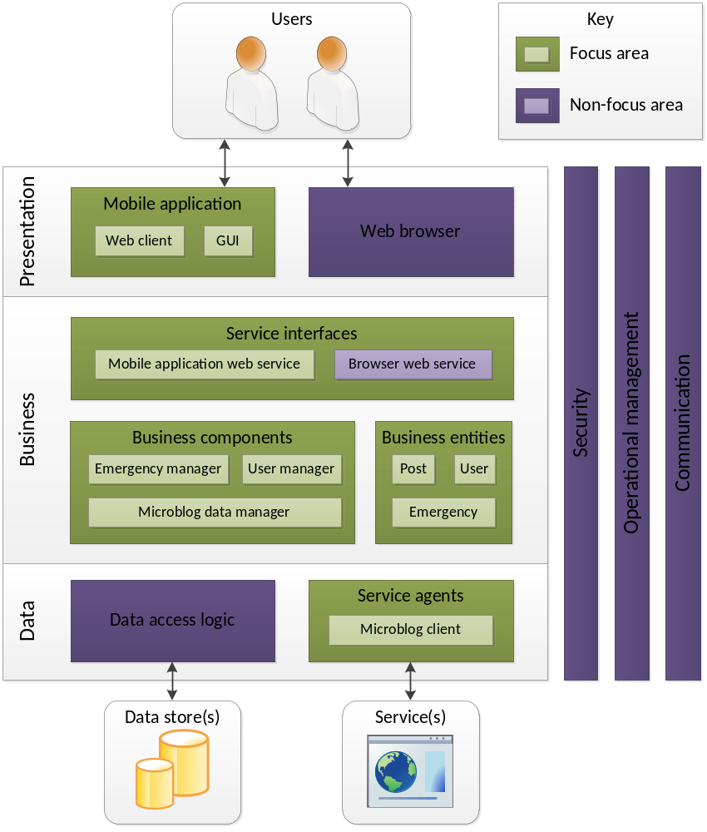
Figure 1: Microblog 911 Application Architecture

Component Decomposition Description
TBD
Describe the decomposition of the subsystems that summarizes the software components.
Functional – Put data flow diagram (DFD) and structural decomposition diagram here.
OOD – Put object diagrams and aggregation chart here.

Architectural Alternatives
TBD
Discuss other architectures that were considered.

Design Rationale
TBD
Discuss the rationale for selecting the architecture described in 3.1, including the critical issues and trade/offs that were considered.

Data Design

Database Description
TBD
Describe the database(s) which is/are part of the system.

Global Data Structures
TBD
Describe any data structures that are a major part of this system.
This should include major data structures that are passed between components. That is, it is not restricted to truly “global” data structures.

New Section
TBD
Functional – Put data dictionary here and call the section Data Dictionary. Refer the reader to the structural decomposition diagram in Section 3.2.
OOD – Put object-use description diagrams here and call the section Object-use Description Diagrams. Refer the reader to the object diagrams in Section 3.2.

Component Design
TBD
Include a top-down description of the design components.
Functional – Put the function mini-specs (PDL descriptions) here. Relate them to the structural decomposition diagram in Section 3.2.
OOD – Put the PDL for the object member functions here. Relate them to the object diagrams in Section 3.2.
You may want to reorganize this section (5.1 – 5.7) to make it flow better. That is fine as long as all of the information below is presented in some manner.

Component identifier
TBD
Assign a unique identifier for use throughout the SDD.

Purpose
TBD
A reference back to the requirements spec.

Function
TBD
What does the component do? Describe its processing.

Subordinates
TBD
The components used by this component.

Dependencies
TBD
Constraints placed on this component by other components.

Interfaces
TBD
Control and data flow into and out of the component.

Data
TBD
Descriptions of internal data

Human Interface Design

Overview of the User Interface
TBD
Describe the general functionality of the system from the user’s perspective.

Screen Images
TBD
Include screenshots showing the interface from the user’s perspective.

Screen Objects and Actions
TBD
A discussion of screen objects and actions associated with those objects.

Report Formats
TBD
Include a description of major reports provided by the system.

Requirements Matrix
TBD
Provide a cross reference that traces components and data structures to the requirements.
Use a tabular format to show which system components satisfy each of the functional requirements from the SRS. Refer to the functional requirements by the numbers/codes that you gave them in the SRS.

Resource Estimates
TBD
A summary of computer resource estimates required for operating the software.

Definitions, Acronyms and Abbreviations
Term | Definition
emergency services | Public organizations that respond to and deal with emergencies when they occur, esp. those that provide police, ambulance, and firefighting services
ES | Emergency Services
ESP | Emergency Services Personnel
GUI | Graphical User Interface
microblog | Web service that allows the subscriber to broadcast short messages to other subscribers of the service
PS | Public Subscribers
public subscribers | Members of the general public who subscribe to the service provided by the application
SDD | Software Design Description
SRS | Software Requirements Specification

