Book F: Chapter 3, Sec2 Date ___________________
INSIDE THE RESTLESS EARTH:
THE ROCK AND FOSSIL RECORD: RELATIVE DATING

Objectives (Sec 2)
- Explain how relative dating is used in geology.
- Explain the principle of superposition.
- Describe how the geologic column is used in relative dating.
- Identify two events and two features that disrupt rock layers.
- Explain how physical features are used to determine relative ages.

______________- Determining whether an object or event is older or younger than other objects or events.
  - In relationship to surrounding objects.
- Principle of Superposition
  - ____________ try to determine the order in which events have happened during Earth’s _________________.
  - They rely on __________ and _____________to help them in their investigation.
  - Layers of sedimentary rock, such as the ones shown below, are stacked like ______________.
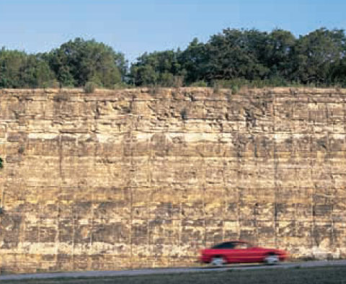
  - As you move from the ____________to the ________________in layers of sedimentary rock, the lower layers are ____________.
  - ____________________ is a principle that states that younger rocks lie above older rocks, if the layers have_______ been ________________.
  - ____________ Forces
    - Not all rock sequences are arranged with the oldest layers on the bottom and the youngest layers on top.
    - Some rock ______________ have been disturbed by forces within the Earth.
    - These forces can push other rocks into a sequence, __________ or ___________ rock layers, and _____________ sequences into moveable parts.

- The Geological Column
  - The geologic column is an ___________ sequence of rock layers that contains all the known ____________ and ___________ formations on Earth, arranged from ____________ to ________________.
  - Geologists use the geologic column to ______________ rock sequences and to ______________ the layers in puzzling rock sequences.
  - There is ______ place on Earth where the geological column exists _______________ in nature.
  - The picture below shows a geological column.
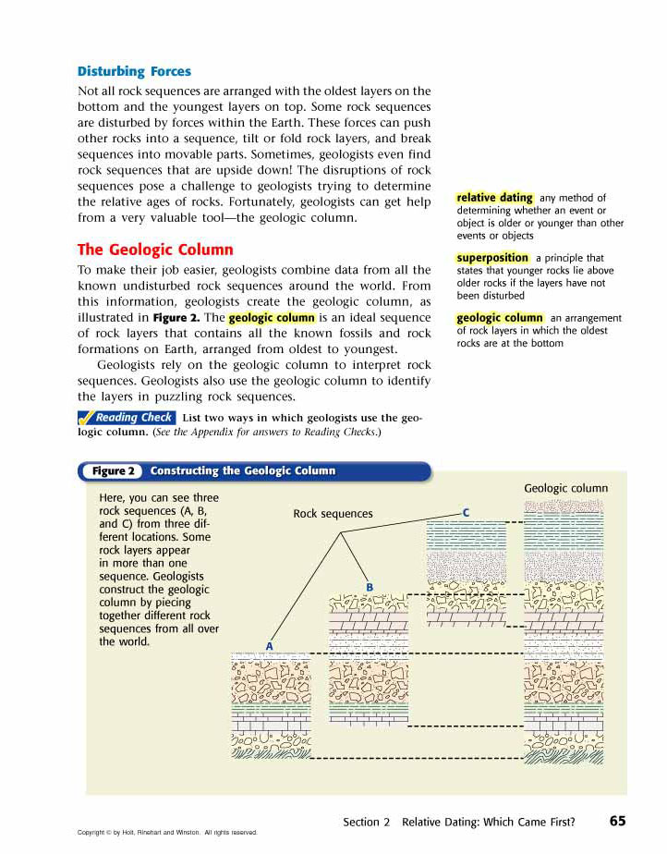

- Disturbed Rock Layers
  - ___________ often find features that cut across existing layers of rock.
  - Geologists use the _____________________ between rock layers and the features that cross them to assign ________________ _________ to the features and the layers.
  - The features must be_____________ than the rock layers because the ____________ ______________ had to be present before the features could cut across them.
  - __________ That Disturb Rock Layers
    - Geologists assume that the way -________________is deposited to form rock layers — in _______________ layers — has not changed over time.
    - If rock layers are _______ ___________________, something must have disturbed them after they formed.

    - The below are the four ways that rock layers may become disturbed.
1. A __________ is a break in the Earth’s crust along which blocks of the crust slide relative to one another.

- An ____________ is molten rock from the Earth’s interior that squeezes into existing rock and cools.

- _____________ occurs when rock layers bend and buckle from Earth’s internal forces.

- ____________ occurs when internal forces in the Earth slant rock layers.

- Gaps in the Record- Unconformities
  - Missing Evidence
    - Sometimes, ____________ of rock are ____________, creating a ________ in the geologic record.
    - ______________ rock layers create breaks in rock-layer sequences called ___________________.
    - An ____________________ is a break in the geologic record.
      - created when rock layers are ______________.
      - when sediment is not ______________ for a long period of time.

- Types of Unconformities
  - __________________ - exist where part of a sequence of parallel rock layers is missing. (see below)
  - __________________- exist where sedimentary rock layers lie on top of an eroded surface of nonlayered igneous or metamorphic rock.
  - ______________ _______________- exist between horizontal rock layers and rock layers that are tilted or folded.
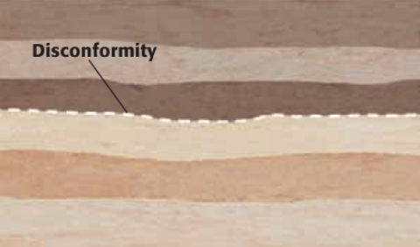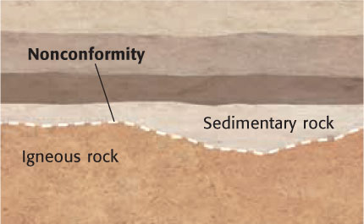

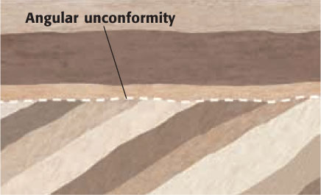

- Rock Layer Puzzles
  - Rock-layer sequences often have been affected by more than one ____________ ____________ or ______________.
  - For example, __________________ may squeeze into rock layers that contain an _________________, as shown at below.



