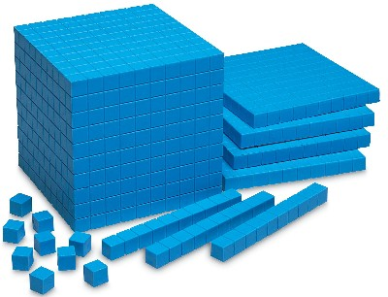
Name ________________________

Place Value Assessment

Section 1, Place Value: Write the following numbers in written form. (1 point each)

- 17,135

- 9, 751,395

- 425,000

Section 2, Place Value: Write the following numbers in expanded form. (1 point each)

- 182

- 3,415

- 24,729

Section 3, Place Value: Write the following numbers in standard form. (1 point each)

- fifteen thousand, four hundred and ninety-two

- nine hundred and twelve

- twelve million, two hundred thousand, three hundred and twenty-nine

Section 4, Place Value: Identify the place and value of the underlined digit. (1 point per box)

 | Number | Place | Value
 | 6,070,321 | 10. | 13.
 | 6,070,321 | 11. | 14.
 | 6,070,321 | 12. | 15.

Section 5, Rounding: Round each number to the given place value. (1 point each)

- Round to the nearest ten: 3,912

__________________________________________________________________________

- Round to the nearest million: 2,513,999

__________________________________________________________________________

- Round to the nearest ten thousand: 76,410

__________________________________________________________________________

Section 6, Estimation: Estimate each answer. (1 point each)

- Estimate the sum by rounding each number to the nearest ten.

361 + 432 = ______________________

- Estimate the difference by rounding each number to the nearest thousand.

3289 - 1,500 = ____________________

Section 7, Number Ordering: Order the numbers from least to greatest. (1 point each)

- 1,537,340; 1,538,781; 1,537,360

- 432; 502; 437

Section 8, Number Ordering: Order the numbers from greatest to least. (1 point each)

- 5697; 5690; 5700

- 18,072; 18,702; 18,207

Section 9, Estimation: Estimate the following answer by rounding. (1 point)

- There are 48,109 books on the first floor of the library, and there are 51,719 books on the second floor of the library. About how many books total are in the library? Estimate.

