Rational or Unit Plan
The instructional subunit I have chosen to work with is Number and Operations-Fractions. This makes up multiple chapters in the current book and is an area that this year’s class had trouble with. Fractions will become very important in the years to come, especially for students who plan to enter a skilled trade’s area. This unit will be constructed using the basic lesson planning model. I am choosing this model because this is the way that I will most likely plan all of my Math lessons. It is also the way I am most comfortable with. Another reason is that the teacher I will be relying on used this method, so we will be able to compare notes and she will be able to help me and read my lesson plans easier. I also like to change up the activity in the classroom about every fifteen minutes due to attention spans; if I am able to do this twice in the procedure section this will help me with that goal. This unit plan will also use behaviorist and constructivist theories of teaching and learning (Chiarelott, 2006).
This unit will introduce students to a new concept which can prove difficult for some students at this age level. During this unit I will monitor students progress of learning and provide extra reinforcement where it is need, whether for individuals or for the whole class. This plan may also need modified to accommodate any special needs students. This plan may also need to be modified as the teacher becomes more experienced or based on class needs.
This unit will also use group learning summative and formative assessment. These lessons will also align with the contextualized teaching and learning practices we have learned about from our class textbook. This unit will also be based on the Common Core Math Standards.
When it comes to the girls in my class I am going to try and use more words to describe problems along with giving them more physical opportunities to manipulate objects. I will try to do this because girl’s brains do not activate as many cortical areas as the male’s for abstract and spatial thinking (Gurian and Stevens, 2004). For the males in the class I am going to try and give them different examples of real life uses for what we are learning. This is because the male brain is constantly scanning for threats, challenges and things it needs to survive, if it doesn’t see any of this it tends to zone out (King, Gurian, and Stevens 2010). By using both of these strategies the hope is that it benefits both genders.
As a result of this unit students will be able to understand the basics of fractions. They will be able to name the numerator and denominator. They will be able to put a fraction in the simplest form. Also as a result of this unit student will be able to compare the fractions and put them in numerical order.

Sources
Chiarelott, Leigh. Curriculum in Context, Thomson Wadsworth, 2006.
Gurian, Michael and Kathy Stevens. With Boys and Girls in Mind. Educational Leadership, Nov. 2004.
King, Kelley; Gurian, Michael and Katy Stevens. Gender-Friendly. Educational Leadership, Nov. 2010.

Unit Outcomes
Number & Operations—Fractions
Extend understanding of fraction equivalence and ordering. Comprehension level.
Build fractions from unit fractions by applying and extending previous understandings of operations on whole numbers. Synthesis Level
Understand decimal notation for fractions, and compare decimal fractions. Comprehension level
Measurement & Data
Solve problems involving measurement and conversion of measurements from a larger unit to a smaller unit. Application level.

Preassessment for Fractions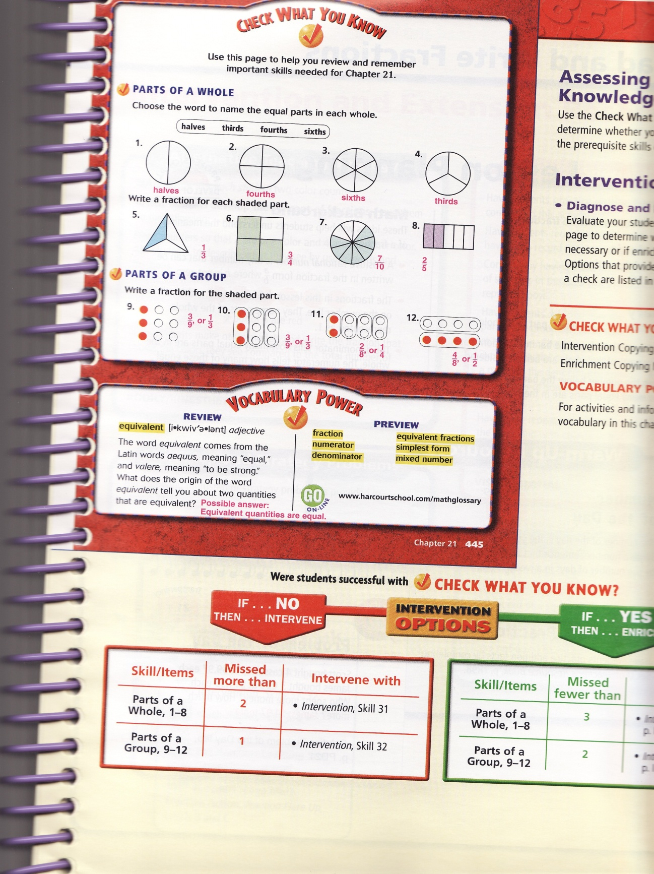

Lesson Plans
Lesson 1
Objective: Students will be able to read and write fractions.
Key Questions: What parts or terms make up a fraction?
How could you represent a fraction in pictures and numbers?
Materials: Whiteboard, Markers, textbooks, workbooks, counting tiles
Procedures:
Page 446-447
Engagement:
5 Minutes: Give examples of when you need to split something or have students come up with such examples, cookies, mixing oil for a trimmer or boat motor. Tell students that you use fractions to do these things. Where have you seen fractions before? Why do you think fractions important?
10 Minutes: Write a couple of basic fractions on the board such as 1/2 and 1/4. Draw a representation or use fraction tiles, for example how many of the pencils are red. Explain that the bottom number is called the denominator and tells how many equal parts are in the whole. Explain that the numerator is the top number. The numerator tells how many of those equal parts to use. Use tiles on student’s desks to represent a fraction. Have students point to the numerator and denominator after having them make another simple fraction such as 1/3.
5 Minutes: Have students come up with a couple questions for teacher or other students to answer. Students should be able to come up with a few sample problems on their own similar to what was done on the board. If students want they can use the fraction tiles to represent the problem.
10 Minutes: Practice problems in cooperative groups. Have students use the tiles to make fraction sets. Have groups record what problem was given to them and what answer they recorded. Each group will have a designated recorder, problem maker and solver (to solve problems). Each group member will rotate positions with each problem.
10-15 Minutes: Students will complete problems 1-3, 6-8,14-16,and 26-28 in student textbook. We will go over these as a class after students have completed the problems, students will be instructed to silent read if they finish early.
10-15 Minutes: Closure: Students will complete workbook page 21.1

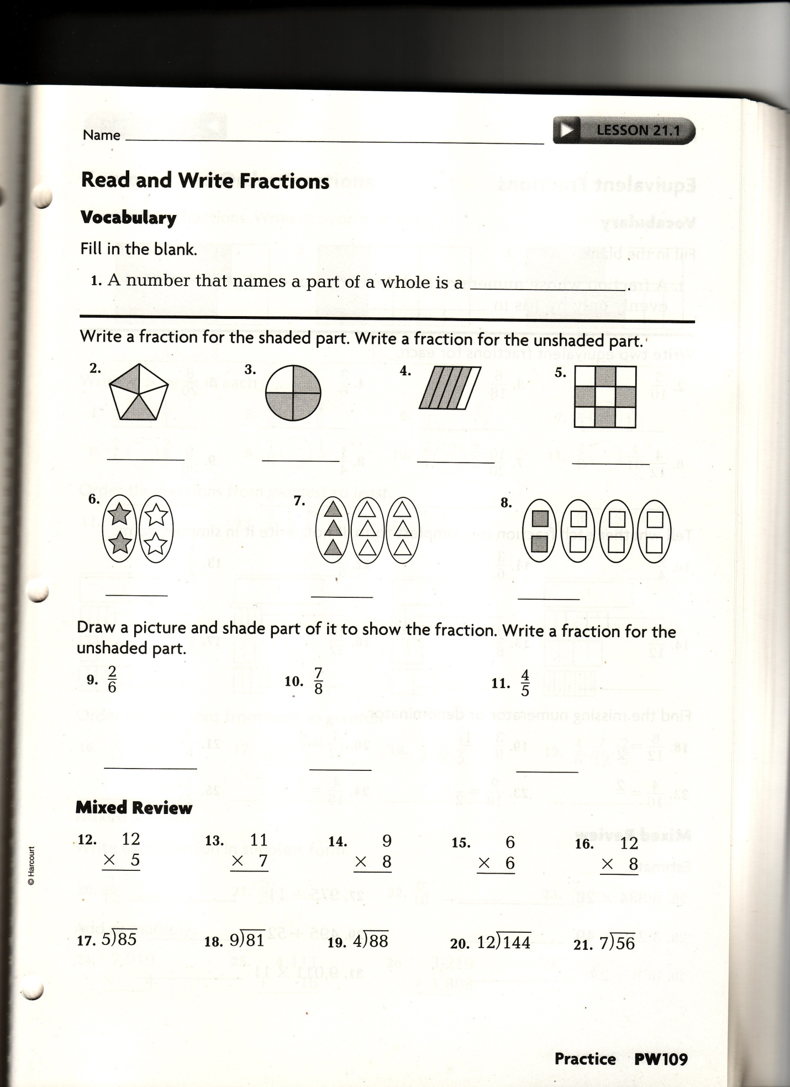
Lesson 2
Objective: To find equivalent fractions
Key Questions: Explain how to reduce a fraction to simplest form.
Be able to explain the terms simplest form and equivalent fraction.
Materials: fraction bars, white board, markers, textbooks, workbooks.
Procedures:
Page 448-451
Engagement: Now that we know a little about fractions, who can tell me how they have used fractions before, or maybe seen their parents use fractions?
5 Minutes: Review from yesterday. Who can tell me what we learned about yesterday? What is a numerator? What is a denominator?
10 Minutes: Introduce the terms equivalent fractions and simplest form. Equivalent fractions are fractions that are equal because they are the same amount, 1/2, 2/4, 4/8. Use fraction bars to show students an example, Allow students time in groups to experiment with the fraction bars. Simplest form is when you can only divide one into the numerator and denominator evenly. Why do you think it is important to be able to put fractions in simplest form?
5-10 Minutes: Go over some examples on board as a class. Show 6/12 in simplest form along with the fractions 8/16, 3/9, 12/16.
10 Minutes: In groups have students give three equivalent fractions for1/2, 1/3 and 1/5. Have students put in simplest form the fractions 10/20, 15/20 and 6/9. Challenge students to write three equivalent fractions for any two fractions of their choice (ex: 2/3 = 4/6 = 8/12).
15 Minutes: Have students complete questions 5-10, and 24-30 on page 450 of textbook. Go over these questions as a class
10 Minutes: Closure: students complete workbook page 21.2
Assessment: (see below)
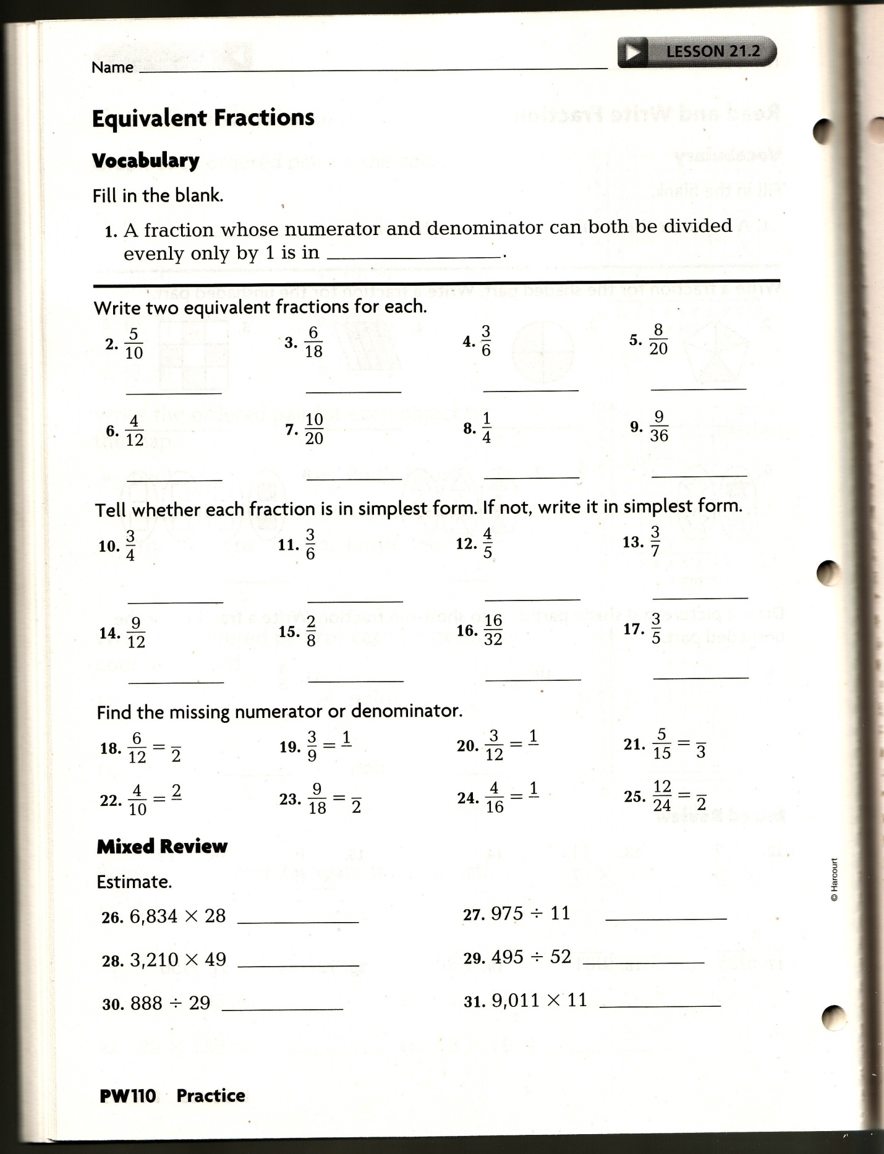

Lesson 3
Objective: Students will be able to compare and order fractions
Key Questions: Organize a group of fractions by size.
Materials: Textbook, whiteboard, Markers, Fraction Bars.
Procedures:
Engagement: In your groups see if you can make a list of all the fractions in the world? 5 Minutes
5 Minutes: Briefly review what we discussed yesterday.
Who can tell me what the difference is between simplest form and equivalent fractions?
10 Minutes: Give each student a blank number line to fill out. Explain to class that we will be putting fractions in order from 0-1. Start by placing ½ on the number line and then fill in ¼ and ¾. Fill out all fractions from ½ to 9/10. It may be a good idea to use a ruler to try and ensure equal spacing on the number line. Fill out number line as a class.
10-15 Minutes: Go around the room and place fractions on random objects such as chairs, pencils and folders. Have groups of students find at least five objects and place them in order from smallest to largest. Groups may use number lines if needed.
10-15 Minutes: Have students complete problems 2-12 on their own. Check the answers as a class
10-15 Minutes Closure: students complete workbook page 21.3 for a grade.

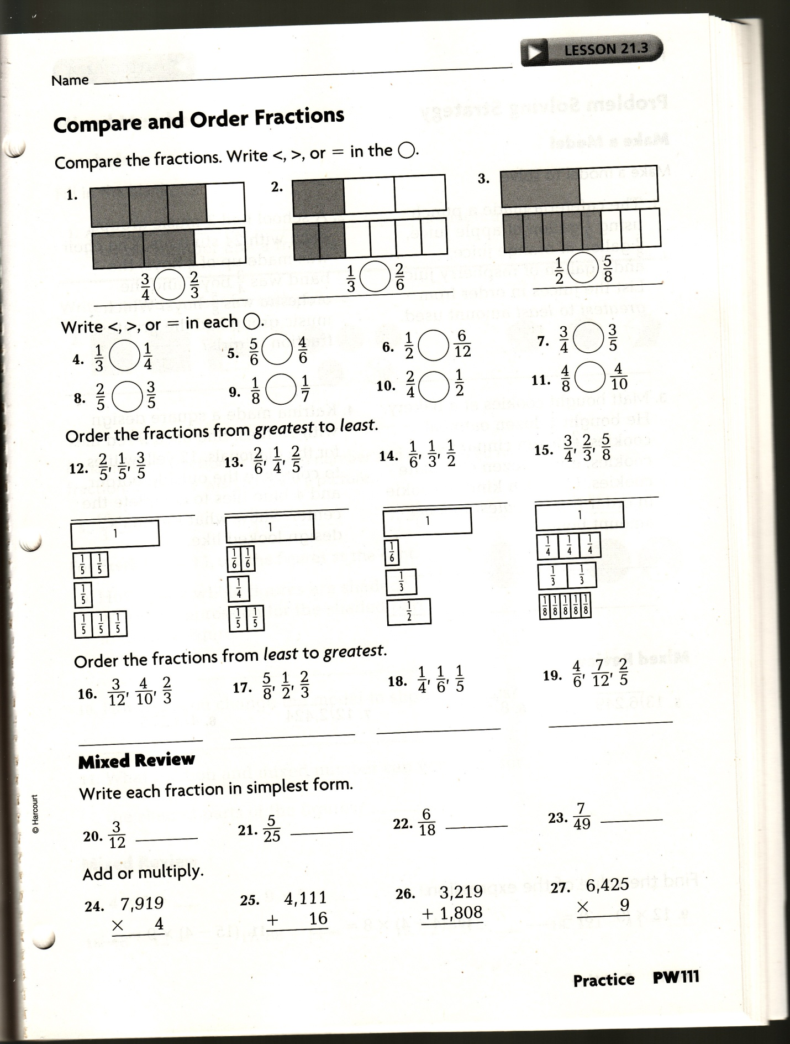

Lesson 4
Objective: To read, write, and compare mixed numbers and to express fractions greater than 1 as mixed numbers.
Key Questions: How would you write X as a mixed number.

Materials: Textbook, whiteboard, Markers, Fraction Bars.

Procedures:
Textbook Page 458
Engagement: Name a time when you or your parents have used a whole number and a fraction (baking, measuring and building) . Measure things around the school that could be mixed numbers: ex. gazebo railing. 5 Minutes
5 Minutes: Who can tell me what we learned how to do yesterday?
10 Minutes: Describe a mixed number to students as made up of a whole number and a fraction. Discuss then when students. How many of you have ever had to use a cup and a fraction to bake something, what was the fraction, what were you making? Show students fractions on a number line such as 3and1/2 or 4and1/4. If possible let students move a marker up and down the number line.
10 Minutes: Show the class how to convert a mixed number into a fraction and a fraction into a mixed number.
10 Minutes: Have students try in groups with the numbers 4/3, 7/2, 2and 1/3 and 4and3/5. Go over the classes answers together as a class.
10-15 Minutes: Assign students to complete problems 2-4,9-13 and 17-20. Go over as a class
10 Minutes: Closure: Workbook page 21.5 for a grade
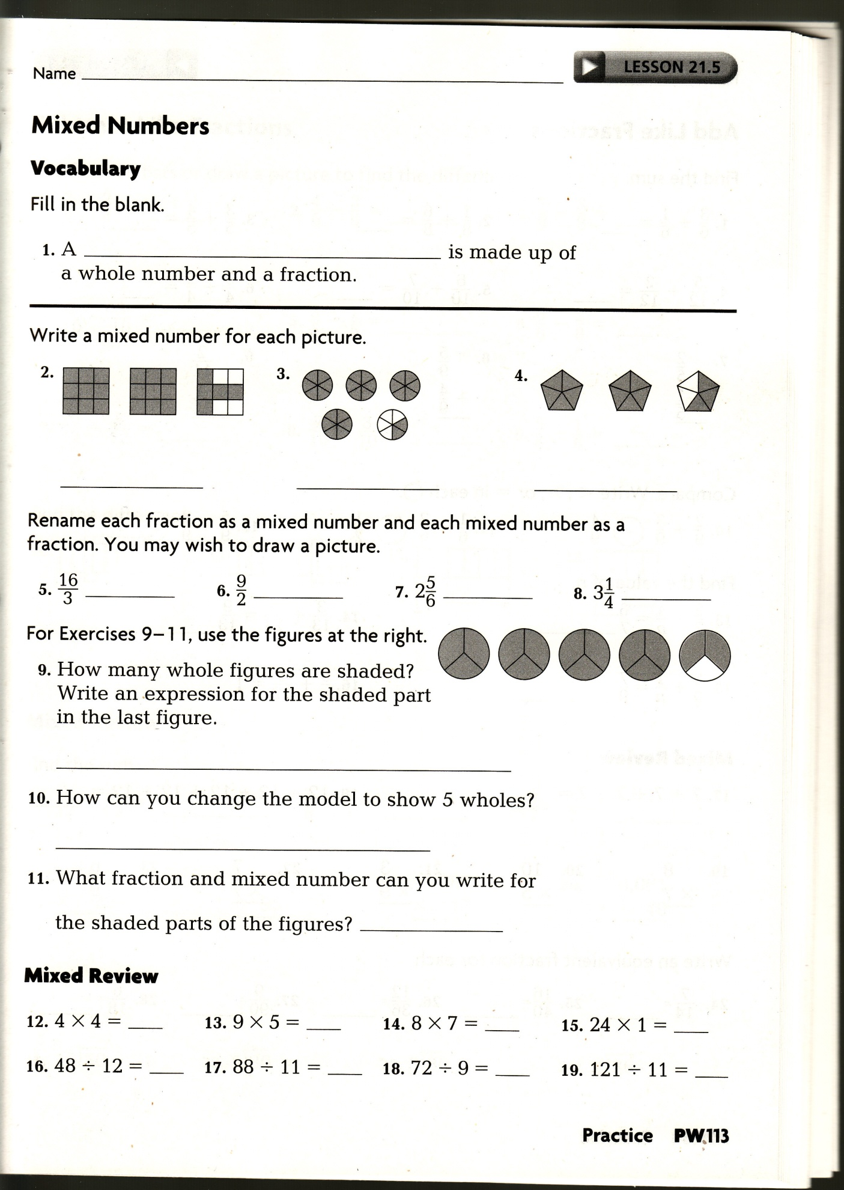
Post Assessment: (see bottom of page)

