**Geometry Lesson Plans**

**Lesson 1 (1 class period)**

**Target:**

Understanding Points, Lines and Angles (Lesson 18.1 Ohio HSP Math)

**Lesson Objectives:**

Review of Fourth Grade Geometry Concepts

**Materials Needed:**

dry erase boards and markers student text book computers

Homework Worksheet – Lesson 18.1

**Terms to know:**

point

ray

line

line segment

intersecting lines

perpendicular lines

parallel lines

right angle

acute angle

obtuse angle

straight angle

**Procedure:**

Introductory Activity (10 minutes)

Have students stand at their desks with a dry erase board.

Ask them to show a point, check responses, erase

Ask them to draw a ray, check responses, erase

Ask them to draw a line, check responses, erase

Ask them to draw a line segment, check responses, erase

*Remind the students the difference between the line and line segment is the line segment stops at both ends, the ray has a starting point but continues on forever and a line continues on forever in both directions

Ask them to demonstrate the following terms using their arms.

intersecting lines

perpendicular lines

parallel lines

right angle

acute angle

obtuse angle

straight angle

Correct any misconceptions the students may have. Remind students that perpendicular lines are always intersecting, but not all intersecting lines are perpendicular (only when the intersection makes 90 degree angle). If the class as a whole is struggling with any of the concepts, review the examples in the textbook on page 482 and 483. If students seem to understand, they may begin the developmental activity

Developmental Activity (15 minutes)

Students will work with their shoulder partner to answer questions on page 484 in the math textbook, numbers 25-28. If the students are struggling, they may read pages 482 and 483 as needed for assistance. See answers below. Have students check their answers with you, discussing any misconceptions.

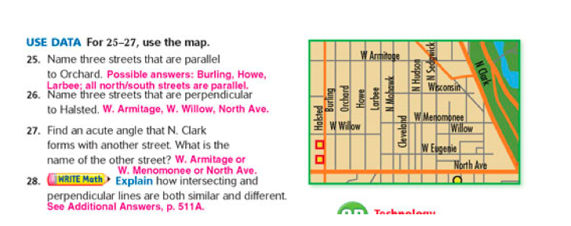

Make sure the writing activity is in paragraph form, not just a short fragment.

Write Math Sample response:

Intersecting and perpendicular lines are similar and different. First, both intersecting and perpendicular lines cross or intersect as a point. Intersecting lines can form any angle when crossing, however perpendicular lines must intersect at a 90 degree angle to be perpendicular.

Concluding Activity (15 - 20 minutes)

Students will then complete IXL Level G on the computer

B.28 [Lines, line segments, and rays](http://www.ixl.com/math/level-g/lines-line-segments-and-rays)

B.29 [Parallel, perpendicular, intersecting](http://www.ixl.com/math/level-g/parallel-perpendicular-intersecting)

B.12 [Types of angles](http://www.ixl.com/math/level-g/types-of-angles)

As students are working to master these skills, walk around the room and remind students to read the explanation on any missed questions. If anyone misses more than 3 in a row, they are to stop and wait for assistance so the teacher can clear up misconceptions and understand the mistakes. Students should complete at least 20-25 problems in each section, reaching a score in the 80’s. (Students not reaching this level may need intervention time before or after school or during homeroom)

**Evaluation Strategy:**

Students will complete Lesson 18.1 for homework. They may use any class time left to begin work on it. See the next two pages for the worksheet and answers.

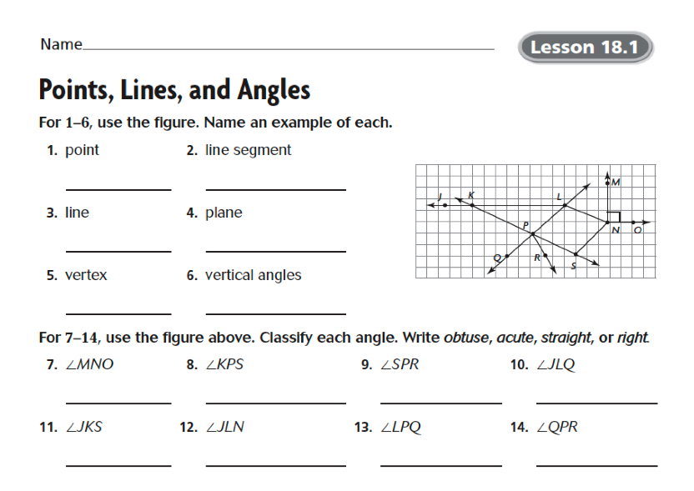

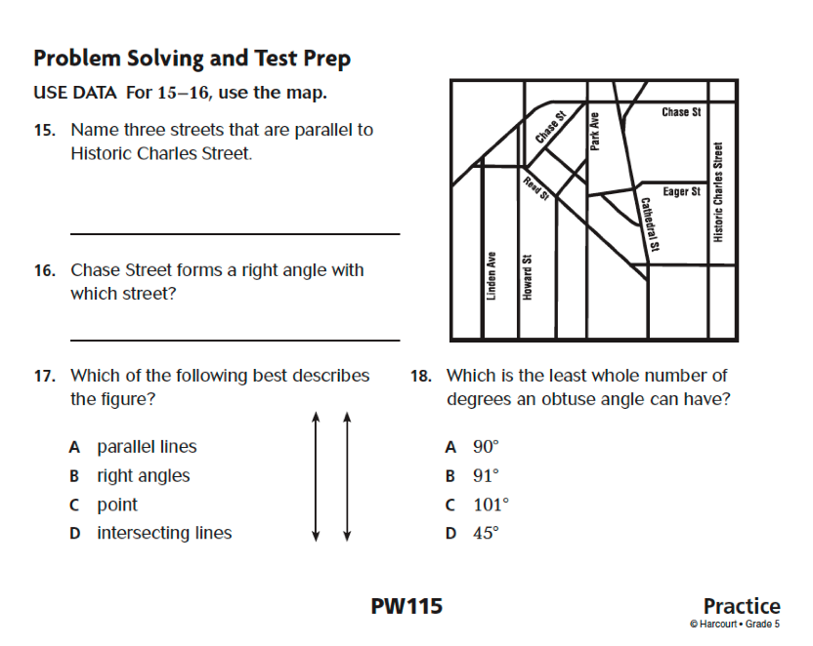

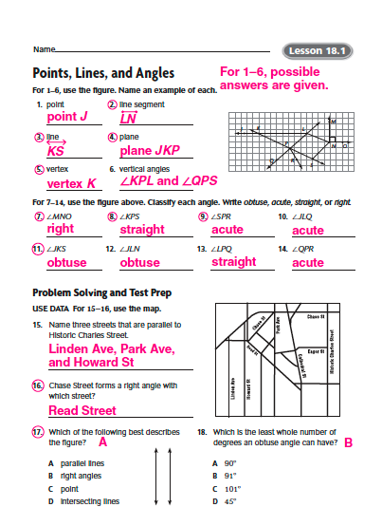

**Lesson 2 (3 days)**

**Target:**

Classifying two-dimensional figures based on properties

**Lesson Objectives:**

Students will classify two-dimensional figures into categories based on their properties.

Students will understand that attributes belonging to a category of two-dimensional figures also belong to all subcategories of that category. (ex. all rectangles have four right angles and all squares are rectangles so all squares have 4 right angles)

**Terms to know:**

similar

congruent

regular

polygon

quadrilateral

pentagon

hexagon

octagon

decagon

corresponding

isosceles

scalene

equilateral

**Day 1**

**Materials Needed:**

Video - downloaded from Discovery Education - United Streaming (link is on Cmap)

construction paper

computers

exit slip

various 2-dimensional objects in classroom

**Procedure:**

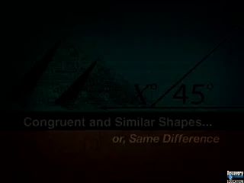

Introductory Activity (10 minutes)

Students will watch the Discovery Education video on Similar and Congruent

Developmental Activity (10 minutes)

Students will work in pairs to identify shapes in the room that are congruent and similar, writing down and drawing the shapes on the front of a piece of construction paper and classifying them as congruent or similar on the back.

Each pair will partner with another pair and quiz each other on the identified shapes for congruence or similarity. The groups will rotate clockwise on the outside of the classroom and counter clockwise on the inside of the classroom until the original pairs match up again. (1 minute with each group for @ 5 minutes) Monitor for students having difficulty and intervene as needed.

Concluding Activity (10 minutes)

Students will complete computer activities on IXL in Level G

**B.10** [Similar and congruent](http://www.ixl.com/math/level-g/similar-and-congruent)

**Evaluation Strategy:** (5-10 minutes)

Students will complete the entrance slip for homework

ENTRANCE SLIP

Name __________________________

Write the definition of congruent in your own words.

Write the definition of similar in your own words.

Use the figures to answer the questions.

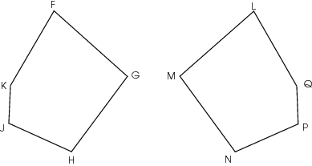

Which side is congruent to KJ? _____

Which side is congruent to LQ? _____

Which side is congruent to NP? ____

**Lesson 2 - Day 2 and 3**

**Materials:**

Notebook Paper and Pencil

Videos – Downloaded from Discovery Education – United Streaming

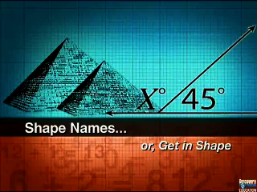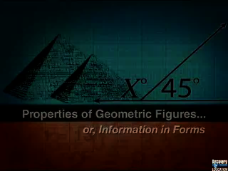

**Procedure:**

Introductory Activity (25-30 minutes)

Have the students make their own KWL worksheet and give them 5 minutes to write down “what they know” about polygons and “what they want to know”.

Students will watch the Discovery Education videos “Naming Geometric Shapes” and “Properties of Geometric Figures”.

Following the video, fill out the “what I learned” section of the KWL sheet and discuss their findings. Allow the students to guide the discussion, try to incorporate the use of the vocabulary terms and check for misconceptions, such as color as a way to categorize a shape.

Developmental Activity (15 minutes)

Students will be given a variety of two-dimensional geometric shapes, both regular and not regular and having 3-10 sides. Working together, with a partner, students will determine 3 rules to classify the various shapes into groups.

Ask the students what characteristics they used to compare and contrast the polygons.

Ask the students if there were other characteristics that could have been used to classify and sort the polygons.

Are there polygons that can fit into more than one category?

As a class, discuss the rules the students developed. Point out most of the time polygons are classified based on the number of number of sides, types of angles (right, obtuse, or acute), regular (all sides congruent) and the number of parallel sides.

Concluding Activity (10-15 minutes)

Students will each be given a secret polygon. Using words, but not pictures, the students will create a description of the polygon they were given.

Assign the students a number ranging from 1-10 and have the students will partner with the matching number, one partner facing the inside of the room, the other partner facing the outside of the room. The students will then provide each other with the description they created and see if the other student can figure out the polygon described. After 1 minute, have the students change partners by having the students on the outside of the room move one person clockwise. Students question each other about the polygons. After another minute, have the students on the inside move one-person counter clockwise. Continue the rotations until the students have had an opportunity to move 4-5 times.

The sheet below is what I referenced to determine the secret polygons. It is taken from the HSP math series. Student will complete a blank worksheet for homework.

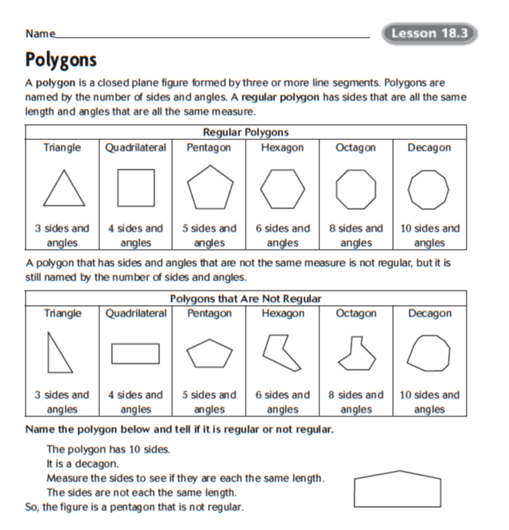

**Evaluation:** (15-20 minutes)

Students will complete IXL computer activities in Level G

**B.2** [Types of triangles](http://www.ixl.com/math/level-g/types-of-triangles)

**B.6** [Which figure is being described?](http://www.ixl.com/math/level-g/which-figure-is-being-described)

**B.7** [Classify quadrilaterals](http://www.ixl.com/math/level-g/classify-quadrilaterals)