Sight Picture:
On most biathlon rifles that you will encounter - e.g. the Anshutz and Marlin rifles, you will be using what is called a "peep" sight. With your eye positioned directly behind the rear sight and roughly an inch or two back from the eyecup as shown in Figure 5, you should line up the target so that it forms concentric circles with the front and rear sights, as shown in the stylized peep sight in Figure 9. For repeatability in positioning, you should have the cheek bone pressed against the side of the rifle stock. Don't squint. Try to keep both eyes open - use an eye patch if necessary.
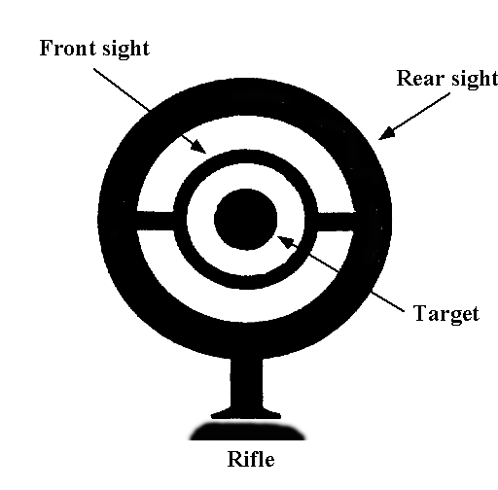
Figure 9 - Target Centering

