Instructions Design Project
Megan Scheid
EDTL 7100
Lena Ballone
November 5, 2010

Statement of Purpose
Geometric shape recognition is one of the early developmental skills we learn as young children. Many children recognize shapes before they even reach school as shapes and the exploration of spatial knowledge are naturally infused in our environment. “Familiarity with basic geometric concepts is an essential component of how a child comes to know and relate to his or her physical environment” (Heddens & Spears, 2001). By the time students reach seventh grade the geometry curriculum calls for the expansion of ideas from younger grades and new ideas added in. In order to make the geometry most relatable and relevant to the students it is important to present the information in such a way that the students can observe, communicate, manipulate, problem solve, and represent ideas about the concepts being learned. Learning through experience is crucial in the overall success of students gaining knowledge from this strand of mathematics. The instructional design on geometry in the seventh grade will review topics discussed in previous grades. It will also expand on the knowledge students have by asking them to show relationships among shapes and making generalizations derived from their experiences.
The models used in this unit will be a mixture of the Basic Lesson Planning Model and the 5-E Learning Cycle Model. Chiarelott (2006) states that a CTL classroom will involve both aspects of behaviorist and constructivist approaches depending on the context of the information being taught(p. 110). I agree with this statement wholeheartedly and have chosen to model my instructional design with this is mind with blending the two approaches. Some of the lessons will be taught through a behaviorist approach of concept attainment as the students will be teacher directed in the instruction and examples will be provided for study. Other lessons will be designed so the students will be manipulating the shapes to discover the “whys” of information they had previously just been told about. Students will be expected to make generalizations about shapes and construct new ideas to problem solve real life problems involving spatial relationships. I feel it is important to use a blended method of instructional design because I am responsible for the education of many children, all with differing learning needs. By using a variety of methods of instruction I am allowing opportunity for each student to shine in their best learning style and comprehend the material in a way they can best understand.
In conclusion, the geometry is such an integral part of our everyday lives that student comprehension is important to their success both in and out of school. In the course of their studies in geometry the students will also be exploring other skills such as communication, problem solving, making connections and representing ideas. Through this instructional design the students will reinforce, expand, and extend their learning of geometric structures and concepts utilizing direct instruction, manipulatives, and discovery learning.

References
Chiarelott, L. (2006). Curriculum in context: Designing curriculum and instruction for teaching and learning in context. Belmont, CA: Wadsworth.
Heddens, J. & Speer, W. (2001). Today’s mathematics: Part 1 Concepts and classroom methods. New York, NY: John Wiley & Sons, Inc.
Geometry Unit Outcomes
- Analyze characteristics of polygons and plane figures and classify them – analysis
- Recognize representations of three-dimensional geometric objects from different views – knowledge
- Perform transformations of two-dimensional figures using a variety of methods – application
- Discover and apply the Pythagorean Theorem – application
- Recognize and use properties of shapes to make mathematical arguments – synthesis

Geometry Unit Pre-Assessment
We will be using these vocabulary words throughout the geometry unit. Some of the vocabulary words will be familiar to you while others will be new. For the words that you know the definition for and can visualize what the picture looks like (if applicable) place a (+) on the line. For the words you are familiar with but maybe cannot define or picture place a () on the line. For the words that are completely new to you place a (-) on the line. On the back side of this sheet draw a quick sketch or write a short explanation of the terms you are familiar with.

_____Point
_____Line
_____Segment
_____Endpoint
_____Ray
_____Plane
_____Parallel lines
_____Intersecting lines
_____Perpendicular lines
_____Skew line
_____Angle
_____Vertex
_____Acute angle
_____Obtuse angle
_____Right angle
_____Complementary angles
_____Supplementary angles
_____ Adjacent angles
_____ Vertical angles
_____Acute triangle
_____Obtuse triangle
_____Right triangle
_____Scalene triangle
_____Isosceles triangle
_____Equilateral triangle
_____Circle
_____Center
_____Chord
_____Diameter
_____Radius
_____Central angle
_____Arc
_____Inscribed Angle
_____Polygon
_____Regular Polygon
_____Triangle
_____Quadrilateral
_____Pentagon
_____Hexagon
_____Heptagon
_____Octagon
_____Nonagon
_____Decagon
_____Trapezoid
_____Parallelogram
_____Rhombus
_____Rectangle
_____Square
_____Kite
_____Translation
_____Rotation
_____Line of symmetry
_____Reflection

Point | Line | Segment | Endpoint | Ray
Plane | Parallel lines | Intersecting lines | Perpendicular lines | Skew lines
Angle | Vertex | Acute angle | Right angle | Obtuse angle
Complementary angles | Supplementary angles | Adjacent angles | Vertical angles | Acute triangle
Right triangle | Obtuse triangle | Scalene triangle | Isosceles triangle | Equilateral triangle
Circle | Center | Chord | Diameter | Radius
Central angle | Arc | Inscribed angle | Polygon | Regular polygon
Triangle | Quadrilateral | Pentagon | Hexagon | Heptagon
Octagon | Nonagon | Decagon | Trapezoid | Parallelogram
Rhombus | Rectangle | Square | Kite | Translation
Rotation | Line of symmetry | Reflection

Lesson: Parts of a Circle
Concept/Skills: Identify and determine relationships among parts of a circle. Communicate mathematical thinking with others. Recognize and use mathematical symbols when reading, writing, and conversing with others.
Lesson Objectives: Students will identify and determine relationships among the parts of a circle. Students will communicate and analyze mathematical thinking strategies with others.
Procedures: Introductory Activity (5 minutes)
Pass out circle templates, rulers, and protractors to each student. Ask the students to trace a circle on their paper and draw and label a center, diameter, radius, and chord on the circle. Have students explain what they drew to make each of these parts. Once the class has come to a consensus on the definitions of the terms the students should record them on their paper along with how to correctly label them.
Developmental Activity (35 minutes)
Ask the students to draw a new circle on their paper and label the center with Point K. Give the students the definition for central angle for them to record in their notes. From the written definition ask the students to draw a central angle on the circle K. Correctly label the figure.
Have the students highlight the edge of the circle between the two points that were formed when creating the central angle. Define this term as arc and label the arc. Have students use their protractor to measure the central angle and arc. Students should note that these measurements are the same.
Using circle K, ask the students to draw two chords from the points on the circle we drew in for the central angle. (Demonstrate for the students if necessary.) Define this figure as an inscribed angle and have the students record the written definition.
In groups of three, have students determine the relationship between the radius and diameter and the central angle and inscribed angle. The teacher will monitor the groups (provided assistance as needed) until each group has concluded that the diameter is twice as big as the radius and the inscribed angle is half the measure of the central angle.
Closing Activity (8 minutes)
Use the following circle to check student understanding.
Ask students: If AB = 2 in, what would the diameter of the circle be?
Name two chords.
Name the central angle.
Name the inscribed angle.
If ∠CAB = 124° what is the measure of ∠CDB?
Evaluation Strategy: Ask students to independently complete the Circles worksheet asking them to identify and analyze the parts of a circle. This will be completed as homework and checked in class tomorrow.
Materials/Resources: Circle templates, rulers, protractors, and Circles worksheet.

Circles
Name___________________________________________________________ Date___________________

Use circle M for numbers 1-10.
- Name the center. _________________________
K
V
- Name two chords. ________________________
- Name two arcs. __________________________
- Name two radii __________________________
- Name two central angles ___________________
- If KM = 14 cm how long in AD? ______________
M

True or False?
- KR is a diameter. ________________________
- VT is a chord. ___________________________
T
R
- VM is a radius. __________________________
- ∠MVT is a central angle. ___________________

Use circle W for numbers 11-15.
- Draw a radius. Label it WR.
- Draw a central angle. Label it ∠ PWS
- Draw a chord. Label it CD.
- Draw a diameter. Label it ST.
- Draw and inscribed angle from the angle drawn in number 12. Label it ∠PVS
W
Lesson: Triangles
Concept/Skills: Classify triangles, mind the missing angle of a triangle, communication of mathematical reasoning.
Lesson Objectives: Students will classify triangles according to sides (scalene, isosceles, equilateral) and angles (acute, right, obtuse). Students will explore the sum of the interior angles in a triangle. Students will problem solve for the missing angle measure of a triangle.
Procedures: Introductory Activity (3 minutes)
Ask students to stand. Assign arm motions to represent the different types of angles learned in previous lessons. Play a game of “Angle Simon Says” using these arm motions to help reinforce student understanding of the types of angles in geometry.
Developmental Activity (40 minutes)
Give the students a piece of construction paper, scissors, and a glue stick. Define the types of triangles according to their sides. Upon each definition the students should cut out a triangle matching that description and glue it into their notes demonstrating their understanding of the definition.
Repeat the previous activity, this time with according to the triangle angles.
Pass out different triangles to students with each corner labeled A,B,C. Ask the students to draw a horizontal line on their notebook paper. Using their triangle and the horizontal line ask students to prove why there are 180° in a triangle. Make sure the students know they may cut/tear/fold their triangle to help make their argument. Allow the students time to work individually on this task. After two minutes, give the students an opportunity to discuss their ideas with their peers. Teacher will monitor student discussions. When adequate time has passed ask a student to volunteer to demonstrate the proof (tear the angles off the triangle and place them on the straight line to prove there are 180° in a triangle) at the front of the class.
Closing Activity (5 minutes)
Pose the following questions to the students:
If a triangle has angle measurements of 40° and 70°, what is the measurement of the third angle? What was your problem solving strategy? What type of triangle is this?
If a triangle has angle measurements of 43° and 47°, what is the measurement of the third angle? What was your problem solving strategy? What type of triangle is this?
Ask the students if they can find a relationship between the measurements of the angles and the side lengths of a triangle. (3 equal angles = equilateral triangle, 2 equal angles = isosceles triangle, all different angles = scalene triangle)
Evaluation Strategy: Ask students to independently complete the Classify Triangles worksheet asking them to correctly name the triangles and find the missing angles of the triangles. This will be completed as homework and checked in class tomorrow.
Materials/Resources: Construction paper, scissors, glue stick, triangles, Classify Triangles worksheet (From Scott Foresman’s Exploring Mathematics 7)
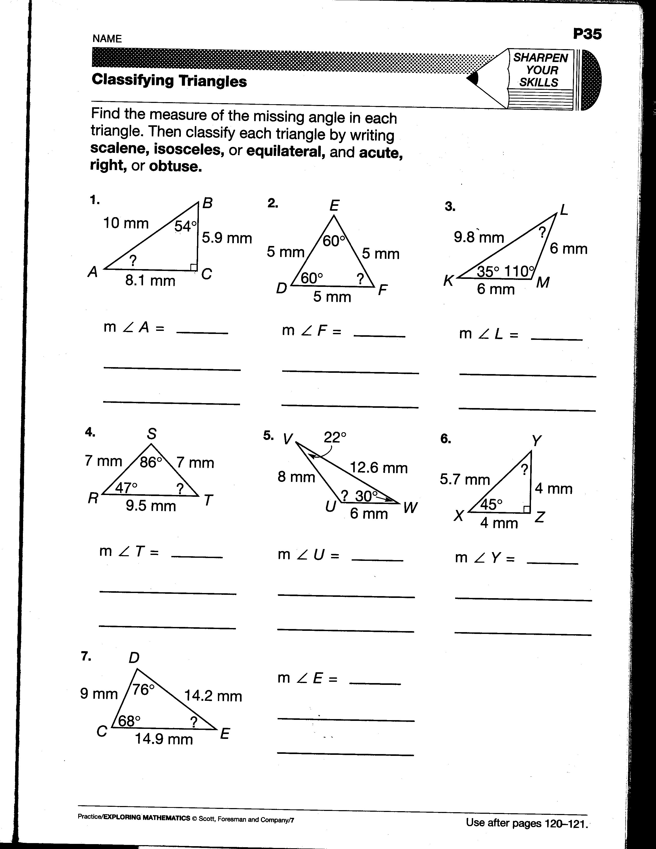

Lesson: Transformations
DAY 1
Concept/Skills: Recognize and apply translations, rotations, and reflections, use spatial memory and spatial visualization skills.
Lesson Objectives: Students will define, recognize, and apply translations, rotations and reflections to plane figures. Students will be able to describe positions of plane figures after a transformation. Students will manipulate tangram pieces to demonstrate their knowledge of how translations, rotations, and reflections are used in pictures. Students will create a unique figure with tangram pieces using the concept of transformations.
Procedures: Introductory Activity (5 minutes)
Move students to an open space in the classroom. Ask them to slide their feet three spaces up and 2 spaces right. Next ask them to rotate 90 degrees clockwise. Finally, ask them to find a partner and become mirror images of each other in a silly pose. Repeat this process again with similar directions. Inform students that they just performed what in geometry is called transformations.
Developmental Activity (38 minutes)
Give each student section of grid paper and ask them to cut out a unique shape of their choosing (they won’t want it to be too large or too small because they will be tracing it throughout the lesson). Once the students have their shape, begin discussing the first of the transformations while students take notes on grid paper.
Define translation. Ask the students to slide their cut-out shape up, down, left and right across their grid paper. What they are doing is performing transformations. Ask the students to trace their figure on their paper and then translate the original shape 4 down and 2 right. Re-draw the shape in its new location. Ask the students to create their own translation then trade with a neighbor. The neighbor is to describe what the translation was.
Define reflection. Tap into the students’ prior knowledge of the line that the figure is “flipped” over is called the line of symmetry. Have students again trace their figure on their paper and draw a line beside or under it. Students should then reflect their figure over the line. Their figures should form mirror images of each other.
Define rotation. Have the students trace their figure on their paper once again. They need to mark one corner of their figure for the point of rotation. At this point of rotation ask the students to draw a pair of perpendicular lines through the point. This will help them with their 90° and 180° rotations. Discuss the difference between a clockwise and counter-clockwise rotation. Have them perform a 90° clockwise rotation and trace the new location.
Closing Activity (5 minutes)
Have students name ways they use transformations in everyday life (examples: moving shapes around on the computer, moving their desks, etc)
Have students name capital letters and shapes that have line(s) of symmetry.
Have students name ways they see rotations used in everyday life (examples: clock, fan, windmill, etc)
Evaluation Strategy: Students will record in their math journal what they learned about transformations in geometry and draw a picture to represent each term they learned today.
Materials/Resources: One section of grid paper for each student, scissors, grid paper for notes, students’ math journal.
DAY 2
Procedures: Engagement: (13 minutes)
Read Grandfather Tang’s Story by Ann Tompert to the students. Have a set of tangrams on the ELMO presenter and invite students up to create the animals throughout the story. Discuss how the students needed to use slides (translations), flips (reflections), and turns (rotations) to create the different animals. Explain that the students will be using the tangrams to explore transformations while creating different figures.
Exploration: (25 minutes)
Each student will have a computer to utilize virtual tangram from the website http://standards.nctm.org/document/eexamples/chap4/4.4/standalone1.htm. Students will work through four puzzles to investigate how transformations of tangram pieces can create different pictures. Students will record their answers on the worksheet provided.
Explanation: (10 minutes)
Students will record in their math journal how the used translations, rotations, and reflections to solve the puzzles presented to them. They then need to reflect on how this same process is used in real life to solve problems and provide examples on their ideas.
Extension:
Students will create a tangram animal or creature and write a short story about it. Students will share their story with their first grade literature buddy and discuss the tangram shapes with them.
Evaluation:
Students will complete a worksheet that challenges them to use their tangram shapes (they will be able to use the virtual tangrams or a set of tangrams). The worksheet will require the students to use a variety of translations, rotations, and reflections in order to complete each challenge.
Materials/Resources: Grandfather Tang’s Story, laptop lab, Virtual Tangram Pictures worksheet, students’ math journal, tangram pieces, Tangram Challenge worksheet.
NCTM’s Illuminations. http://illuminations.nctm.org/LessonDetail.aspx?id=L168

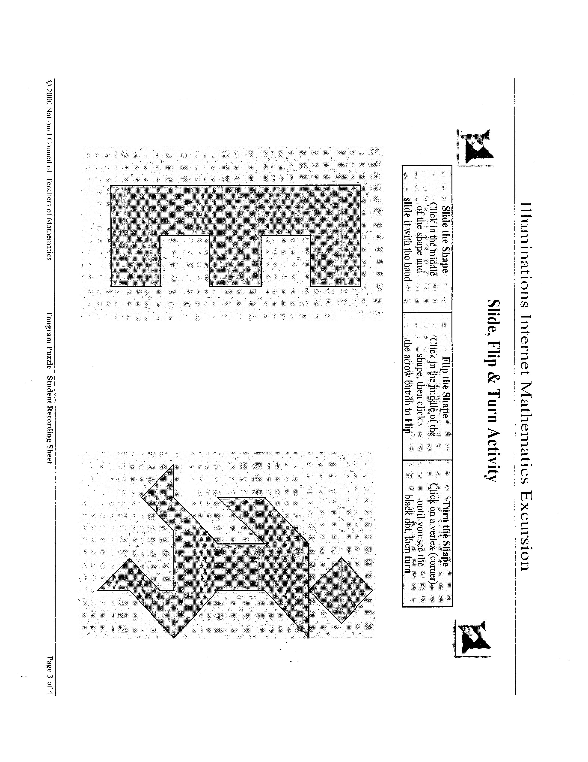

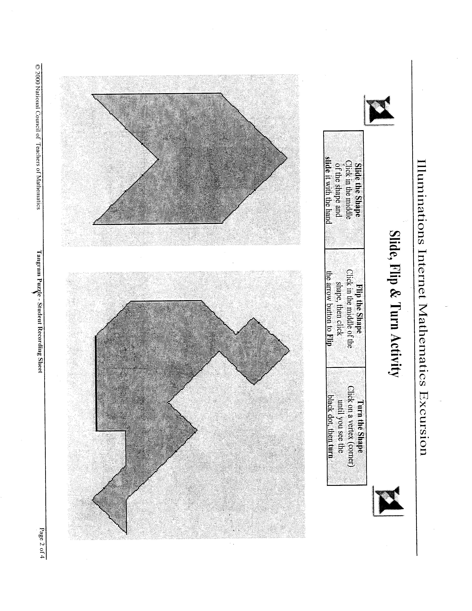
Tangram Challenge
Name_____________________________________________________Date________________
Try to complete these tasks with the tangram pieces. Draw the answer to the tasks that are possible. Hint-only one task is impossible.
- Make a square using only one tangram piece.

- Make a square using two tangram pieces.

- Make a square using three tangram pieces.

- Make a square using four tangram pieces.

- Make a square using five tangram pieces.

- Make a square using six tangram pieces.

- Make a square using seven tangram pieces.

Draw each of these figures using all seven tangram pieces.
- A trapezoid

- A rectangle that is not a square

- A parallelogram that is not a square or rectangle

- A triangle
Geometry Test – Post Assessment
Name_______________________________________
A. Use the diagram to name the following.
- A segment
B
A
D
- One pair of intersecting lines
C

- A ray
E

- One pair of vertical angles

- One pair of parallel lines

B. Draw the following figures.
6. A hexagon 7. An octagon

C. Use the diagram to name the following.
Y
- One pair of adjacent angles
Z
X

- An obtuse angle
V
T
W
- One pair of complimentary angles

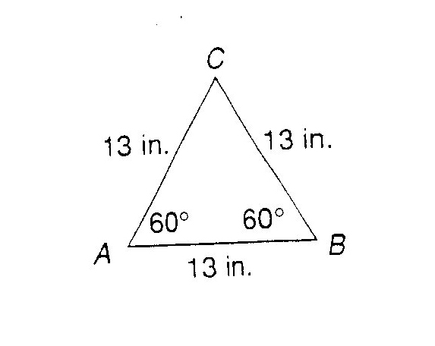
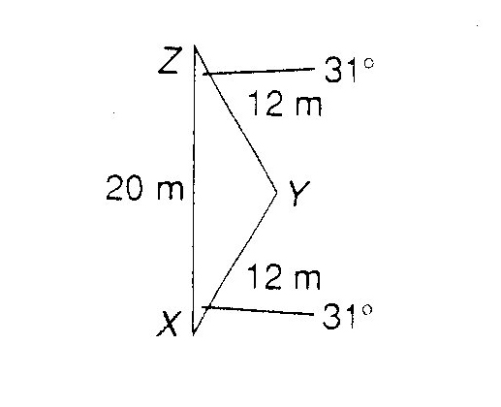
D. Find the measure of the missing angle and classify the shape.
- ∠C____________ 13. ∠Y____________

12. Shape________________ 14. Shape________________
________________ ________________
E. Using circle A, name the following.
- A diameter

- A central angle

- A chord

- An arc

F. Describe the translation that moved figure 1 to figure 2.
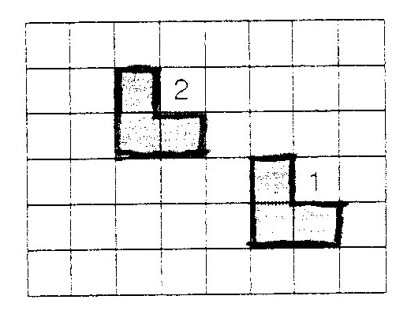
19.

G. Tell whether figure 2 resulted from a rotation or a reflection of figure 1.
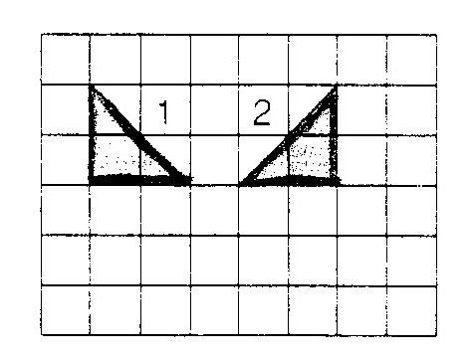
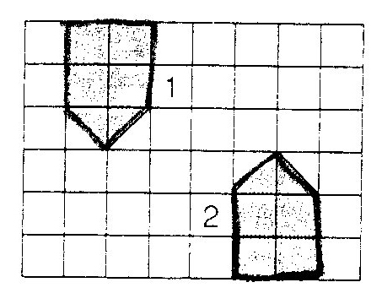
20. 21.

H. Circle the best choice for questions 22-25.
- Which is the same as a parallelogram with 4 right angles?
a. rhombus b. trapezoid c. hexagon d. rectangle

- Which figure is impossible?
- a trapezoid that is not a quadrilateral
- a pentagon with all angles equal
- a parallelogram with 4 equal sides
- a quadrilateral that is not a parallelogram

- Which numeral has two lines of symmetry?
a. 2 b. 8 c. 3 d. 6

- Two angles that are equal in measure are
a. adjacent b. supplementary c. congruent d. complimentary

