Build a DNA model Name:
Objective: To identify the parts of a DNA molecule and construct a DNA model.
Each DNA molecule is made up of nucleotides. The nucleotides have 3 parts(Use the key on the attached worksheet to fill in the following blanks):

Each base has a complementary base pair. This means it can only pair with one other base. Look at the shapes of the bases(A, T, C, G) on the key to tell which bases pair up.
Adenine(A) pairs with _________________________
Guanine(G) pairs with _________________________
Procedure:
- Color each part of the nucleotide according to the key.
- Cut out each nucleotide on the dotted lines.
- Construct the sides of the DNA molecule by lining up sugar and phosphates. Look at the attached diagram if you need help.
- Now, make sure that the correct bases are paired together.
- When your model is complete, glue the model to a sheet of paper.
- Clean up your lab station.
- Answer the questions and complete the “Genetic Code” diagram.

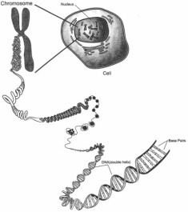
Did you know that :
- One single cell contains two meters of DNA.
- If you unravelled all your chromosomes from all of your cells and laid out the DNA end to end, the strands would stretch from the Earth to the Moon about 6,000 times.
- A simple list of the bases of the entire DNA in your genes—the As, Cs, Ts, and Gs—would fill about 200 New York City phone books(about 3 billion letters.
- Genomically speaking, all races are equal and you cannot tell simply by looking at someone’s DNA whether they are black or white.

