Biomes Name ___________________________________
Objectives: You will be able to name and explain the types of biomes and identify where they occur.
According to the movie, fill out the biome chart below:
Biome | Average precipitation | Temperature/Climate | Animals/plants
Tundra
Taiga or Coniferous/Boreal
Forest
Temperate deciduous Forest
Desert
Rainforest
Grassland
Freshwater | ----- | --------------
Saltwater  In your own words, define a biome:  Class definition: | ----- | --------------
Color the map according to the clues listed below. You may need to look at a map of North America if you get stuck. Place a check mark in the box once you have completed that step.
- The dotted lines represent the border between the U.S. and Mexico and Canada. All other lines show biome borders. Color the U.S. borders (dotted line) red.
2. Northern Canada and Alaska are tundra - color the tundra light blue
3. Most of Canada is boreal forest. Color the boreal forest dark green.
4. The Midwest (middle of the country) is temperate grassland. Color the grassland yellow.
- 5. The west coast of the U.S. is mainly temperate deciduous forest where California is. There is a temperate deciduous forest between the Midwest and the Eastern U.S. coast. Color the Temperate deciduous forest light green.
6. The eastern edge of Mexico and Central America, Hawaii, and the Caribbean Islands are all tropical rain forests. Color those purple.
7. There is a northwest coniferous forest located in the far corner of the U.S (northwest) near Washington. Color the northwest coniferous forest brown.
7. The great lakes and the lakes in Canada are freshwater. Find each freshwater lake and color it pink.
8. The bodies of water surrounding the continent are salt water. Color the coastal areas dark blue.
9. The western region of the U.S. as well as Northern Mexico is desert. Color the desert orange.
10. The western edge of Mexico is temperate forest. Color it the same color as you did the other temperate forests.
11. Color code the squares at the bottom to match your biome colors.
12. Label the countries: U.S.A., Canada, Mexico

Questions
- Name the 3 main biomes of the United States (land only).
2. What two biomes are closest to where you live? __________________________________
Place an X on the map to show your approximate location.
3. What U.S. state could a person visit a tropical rain forest in?
4. If you were vacationing in Florida, where is the nearest tropical rain forest?
5. Point out Alaska by drawing an arrow to it. What biome is found in Alaska? ____________
6. If you traveled due north of your current location, what biomes would you pass through (just going to the north pole) ______________________________
7. A person is driving from Los Angeles, California to Washington D.C. Name the biomes the person will pass through, in the correct order. ___________________________________
8. A person is driving from Alaska to Mexico, staying close to the west coastline. Name the biomes the person will pass through, in the correct order. ___________________________
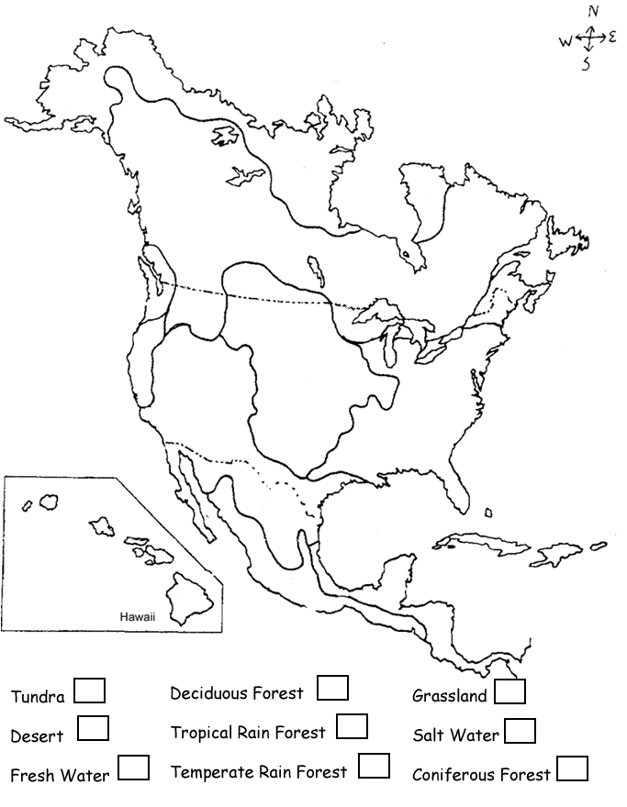

[Type a quote from the document or the summary of an interesting point. You can position the text box anywhere in the document. Use the Text Box Tools tab to change the formatting of the pull quote text box.]

