**Scientific Method** - **Variables** Name __________________________

SpongeBob and his Bikini Bottom pals have been busy doing a little research. Read the description for each experiment and answer the questions.

**SpongeBob Clean Pants**

SpongeBob noticed that his favorite pants were not as clean as they used to be. His friend Sandy told him that he should try using Clean-O detergent, a new laundry soap she found at Sail-Mart. SpongeBob made sure to wash one pair of pants in plain water and another pair in water with the Clean-O detergent. After washing both pairs of pants a total of three times, the pants washed in the Clean-O detergent did not appear to be any cleaner than the pants washed in plain water.

6. What was the problem SpongeBob wanted to investigate?

7. What is the independent variable?

8. What is the dependent variable?

9. What should Sponge Bob’s conclusion be?

**Squidward’s Symphony**

Squidward loves playing his clarinet and believes it attracts more jellyfish than any other instrument he has played. In order to test his hypothesis, Squidward played a song on his clarinet and counted the number of jellyfish he saw in his front yard. He repeated the experiment using a flute and a guitar. The results are shown in the chart.

10. What is the independent variable?

11. What is the dependent variable?

12. What should Squidward’s conclusion be?

13. Are the results reliable? Why or why not?

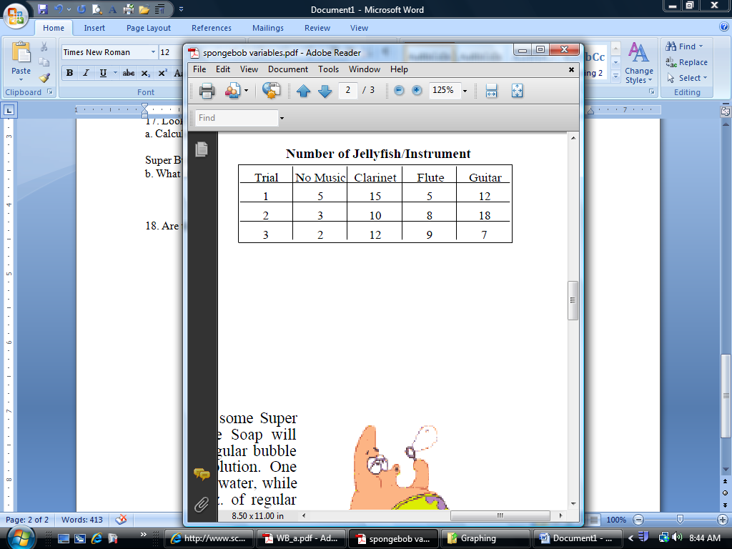

**Super Bubbles**

Patrick and SpongeBob love to blow bubbles! Patrick found some Super Bubble Soap at Sail-Mart. The ads claim that Super Bubble Soap will produce bubbles that are twice as big as bubbles made with regular bubble soap. Patrick and SpongeBob made up two samples of bubble solution. One sample was made with 5 oz. of Super Bubble Soap and 5 oz. of water, while

the other was made with the same amount of water and 5 oz. of regular bubble soap. Patrick and SpongeBob used their favorite bubble wands to blow bubbles and did their best to measure the diameter of each one. The results are shown in the chart

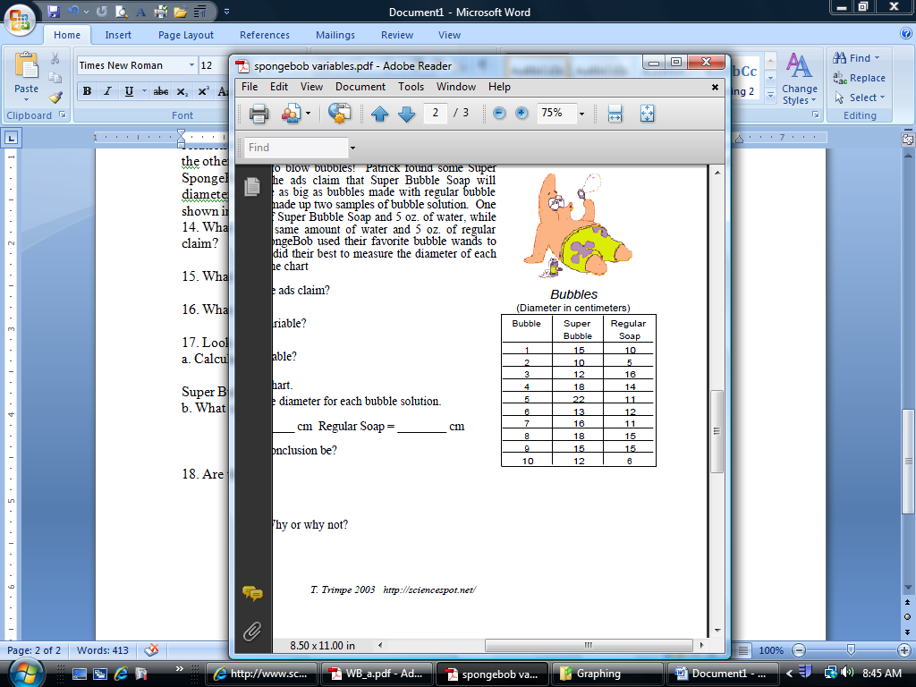14. What did the Super Bubble ads claim?

15. What is the independent variable?

16. What is the dependent variable?

17. Look at the results in the chart.

a. Calculate the average diameter for each bubble solution.

Super Bubble = ______ cm Regular Soap = ________ cm

b. What should their conclusion be?

18. Are the results reliable? Why or why not?