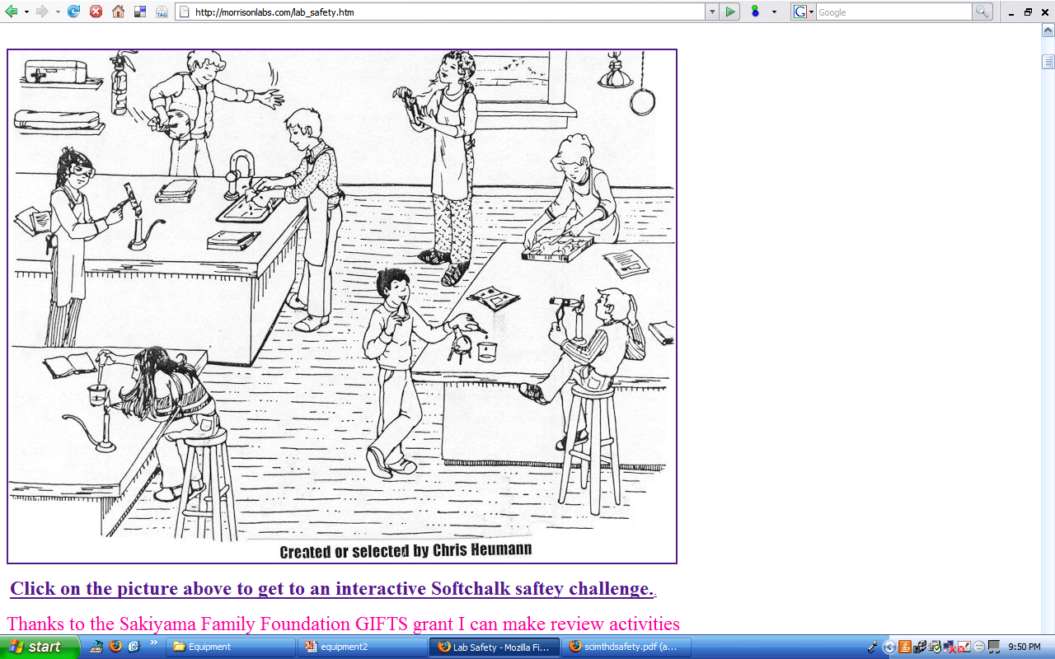
Directions: Circle and # at least 6 unsafe things happening in this picture and explain how to correct them:

