Burners
Burners are the devices responsible for:
- Proper mixing of fuel and air in the correct proportions, for efficient and complete combustion.
- Determining the shape and direction of the flame.

Burner turndown
An important function of burners is turndown. This is usually expressed as a ratio and is based on the maximum firing rate divided by the minimum controllable firing rate.
The turndown rate is not simply a matter of forcing differing amounts of fuel into a boiler, it is increasingly important from an economic and legislative perspective that the burner provides efficient and proper combustion, and satisfies increasingly stringent emission regulations over its entire operating range.
As has already been mentioned, coal as a boiler fuel tends to be restricted to specialised applications such as water-tube boilers in power stations. The following Sections within this Module will review the most common fuels for shell boilers.
Air-steam atomizing oil burners
The ability to burn fuel oil efficiently requires a high fuel surface area-to-volume ratio. Experience has shown that oil particles in the range 20 and 40 µm are the most successful.
Particles which are:
- Bigger than 40 µm tend to be carried through the flame without completing the combustion process.
- Smaller than 20 µm may travel so fast that they are carried through the flame without burning at all.
A very important aspect of oil firing is viscosity. The viscosity of oil varies with temperature: the hotter the oil, the more easily it flows. Indeed, most people are aware that heavy fuel oils need to be heated in order to flow freely. What is not so obvious is that a variation in temperature, and hence viscosity, will have an effect on the size of the oil particle produced at the burner nozzle. For this reason the temperature needs to be accurately controlled to give consistent conditions at the nozzle.

Steam assisted
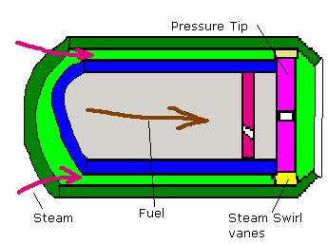
Steam assisted atomisers. This can refer to both external and Internal steam/fuel mixing although conventionally they refer to external mix. In these no mixing of the steam and fuel occurs within the burner itself.
Fuel is suplied to a standard pressure tip atomiser. Steam passes around the fuel passage and exists through an open annulus having being given an angle of swirl to match the fuel spray. At low fuel pressure the steam, supplied at constant pressure throughout turndown, provides for good atomisation. At higher fure pressure the pressure tip provides for the atomisation.
For first start arrangements compressed air may be used.

Steam atomisation
The two main types of internal mixing (the most common) ar the 'Y' jet and the Skew jet .
Y- Jet
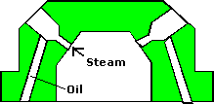
Here the steam anf fuel are mixed into an emulsion and expanded in the holes before emision creating good atomisation. This design is tolerant of viscosity changes and is frugal on steam consumption and require reduced fuel pump pressures .
Skew Jet
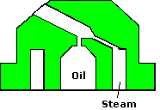
The main advantage of this design over the 'Y' jet is the reduced 'bluff' zone due the reduced pitch diameter of the exit holes.
Matched to a venturi register, a very stable efficient flame is formed. The Fuel/Steam mix exits the nozzle in a series of conic tangents, fuel reversals inside the fuel cone allow efficient mixing with air over a wide 'Turn-Down ratio (20:1). In addition this type of nozzle is associated with reduced atomising steam consumption (0.02Kg per Kg fuel burnt) Venturi and conventional register throat design
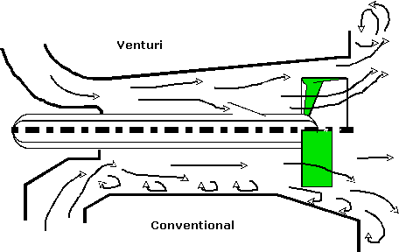

Ultrasonic
Manufactured by Kawasaki is said to offer the following advantages;
  - Wider turn down ratio with lower excess air (15 :1)
  - Low O₂ levels
  - Simplified operation
  - Reduced acid corrosion problems
Atomisation is achieved primarily by the energy of ultrasonic waves imparted onto the fuel by the resonator tip which vibrates at a frequency of 5 MHz to 20 MHz under the influence of high speed steam or air impinging on it. Extremely small droplet sizes result which allow for a very stable flame.
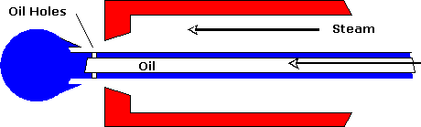

Spinning Cup
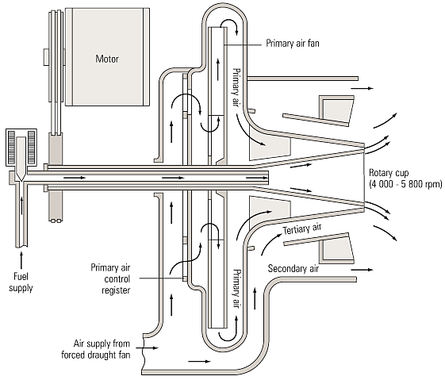
Fig. 3.6.2 Rotary cup burner

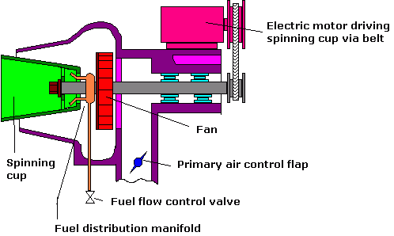
Fuel is introduced onto the inner running surface of a highly polished fast spinning cup (3 to 7000 rpm). Under centrifugal force this fuel forms a thin film.
Due to the conical shape of the cup the fuel flows to the outer edge spilling into the primary atomising air stream. The fuel is broken into small droplets and mixed with the primary air supplied by the shaft mounted fan. Secondary air is supplied by an external fan for larger units.
Packaged units of this design have the air flow valve controlled by the fuel supply pressure to the distribution manifold.
The spinning cup offers the following advantages;
  - Wider turn down ratio with lower excess air
  - Low O₂ levels
  - No requirement for atomising air or steam
  - Low fuel pressure requirements to an extent that gravity flow is sufficient
  - stable flames achievable with very low fuel flows although maximum flow limited by size of cup. This, allied to being limited to side firing making the design more suitable for smaller installations.

Blue Flame
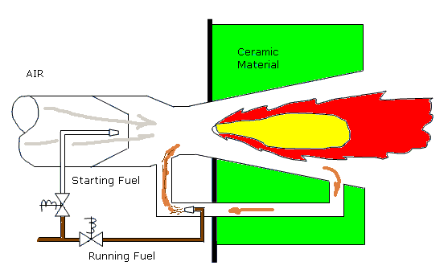
This highly efficient and claen burning method is very close to stoichiometric combustion. Under normal conditions a portion of the hot gasses from the combustion process is recirculated. Fuel is introduced into the gas were it is vaporised. The resultant flame is blue with little or no smoke

Gas burners
At present, gas is probably the most common fuel used in the UK.
Being a gas, atomisation is not an issue, and proper mixing of gas with the appropriate amount of air is all that is required for combustion.
Two types of gas burner are in use 'Low pressure' and 'High pressure'.
Low pressure burner
These operate at low pressure, usually between 2.5 and 10 mbar. The burner is a simple venturi device with gas introduced in the throat area, and combustion air being drawn in from around the outside.
Output is limited to approximately 1 MW.
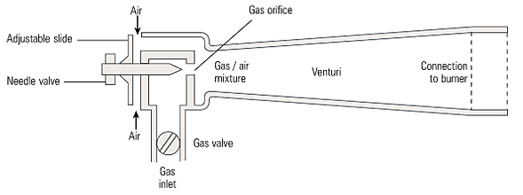
Fig. 3.6.3 Low pressure gas burner
High pressure burner
These operate at higher pressures, usually between 12 and 175 mbar, and may include a number of nozzles to produce a particular flame shape.

Dual fuel burners
The attractive 'interruptible' gas tariff means that it is the choice of the vast majority of organisations in the UK. However, many of these organisations need to continue operation if the gas supply is interrupted.
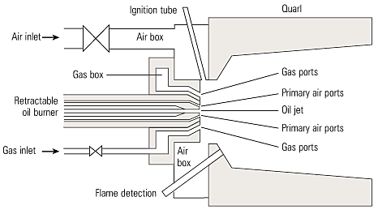
Fig. 3.6.4 Dual fuel burner
The usual arrangement is to have a fuel oil supply available on site, and to use this to fire the boiler when gas is not available. This led to the development of 'dual fuel' burners.
These burners are designed with gas as the main fuel, but have an additional facility for burning fuel oil.
The notice given by the Gas Company that supply is to be interrupted may be short, so the change over to fuel oil firing is made as rapidly as possible, the usual procedure being:
- Isolate the gas supply line.
- Open the oil supply line and switch on the fuel pump.
- On the burner control panel, select 'oil firing'
(This will change the air settings for the different fuel).
- Purge and re-fire the boiler.
This operation can be carried out in quite a short period. In some organisations the change over may be carried out as part of a periodic drill to ensure that operators are familiar with the procedure, and any necessary equipment is available.
However, because fuel oil is only 'stand-by', and probably only used for short periods, the oil firing facility may be basic.
On more sophisticated plants, with highly rated boiler plant, the gas burner(s) may be withdrawn and oil burners substituted.
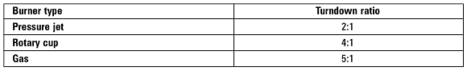
Table 3.6.4 Typical turndown ratio available with different types of burner

