Combustion of fuel in furnace

Process
The heat producing constituents of the fuel are hydrogen, carbon and sulphur.
The calorific value of the combustion processes measured in mega joules for each Kg of fuel burnt
  - Carbon to carbon dioxide - 34
  - Hydrogen to water - 120.5 ( assuming the water vapor is not allowed to condense)
  - Sulphur to sulphur dioxide - 9.3
The main cause of heat loss with the process is that taken away by nitrogen. Therefore, to achieve maximum efficiency the excess air should be kept to a minimum. However there is a limit to the reduction in the excess air in that the combustion process must be fully completed within the furnace and within a finite time.
The main type of combustion process is called the suspended flame. The flame front remains in the same position relative to the burner and quarl.. The fuel particles pass through the flame completeing their combustion process and exiting at the same rate as the fuel entering.
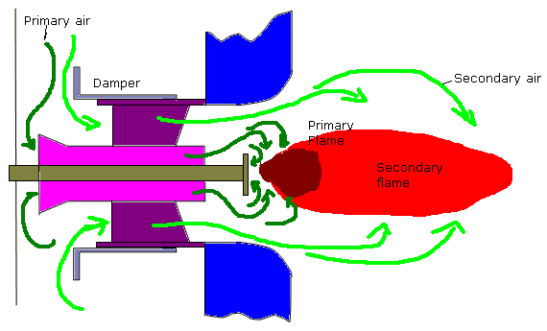
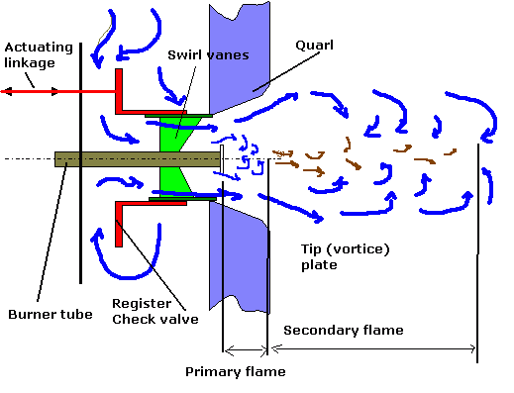
Primary Flame-To burn oil the temperature must be raised to vaporisation temperature, this can not be done in heaters due to gassing but is done by radiant heat in the flame. The lighter hydrocarbons in the atomised spray are rapidly heated and burnt in the primary flame. The heavier fractions pass through this achieving their vaporisation temperature. The primary flame is essential to good combustion. By design the primary flame exists where it receives maximum reflected heat from the shape of the quarl. The size of the primary flame ( shown smaller than actual in drawing) just fills the quarl space. Too large and impingement leads to carbon deposits building up. Too small unheated secondary air reduces combustion efficiency. The tip plate creates vortices reducing the mixing time for the air/fuel and reduces the forward speed of the flame
Secondary Flame-Here the heavier fractions are burnt. The velocity of the air and fuel must be matched to the required flame propogation rate.

Combustion in furnace space
For proper combustion of fuel in the furnace and adequate supply of air must be supplied and intimately mixed with a supply of combustible material which has been presented in the correct condition.
Air- it is the purpose of the register, swirler vanes and (vortice) plates, and quarl to supply the correct quantity of air for efficient combustion suitably agitated to allow proper mixing.
The air is generally heated on larger plant to;
  - prevent thermal shocking
  - improve the combustion process
  - improve plant efficiency (bled steam and regenerative)
Fuel It is the purpose of the burner to present the fuel in suitable condition for proper combustion. Generally this means atomising the fuel and giving it some axial (for penetration) and angular (for mixing) velocity. For effective atomisation the viscosity of the fuel is critical, for fuels heavier than gas or diesel oils some degree of heating is required. It should be noted that the temperature of the fuel should not be allowed to raise too high as this can not only cause problem with fuel booster pumps but also can cause flame instability due to premature excessive gassification (is that a real word-answers to the normal address)
The smaller the droplet size the greater the surface areas/volume ratio is, this increases evaporation, heating and combustion rate.
Combustion zones
Register- supplies the correct quantity of excess air. Too little allows incomplete combustion, smoking, soot deposits and flame instability. Too much excess air reduces combustion efficiency by removing heat from the furnace space, may cause 'white' smoking and promote sulphurous deposits. In addition too much excess air increases the proportion of sulphur trioxide to dioxide promoting increase acid corrosion attack in the upper regions.
The register and to some extent the quarl determine the shape of the flame, short and fat for side fired boilers, long and thin for roof fired.
Flame burning off the tip- may occur after initial ignition or after a period of high excess air. The effect of this is to move the primary flame away from the quarl thereby effecting the combustion process leading to black smoke and flame instability. Two methods of bringing the flame back are to reduce excess air and introduce a hand ignitor to ignite the fuel correctly, or to rapidly close then open the register damper

Registers

AIR REGISTER
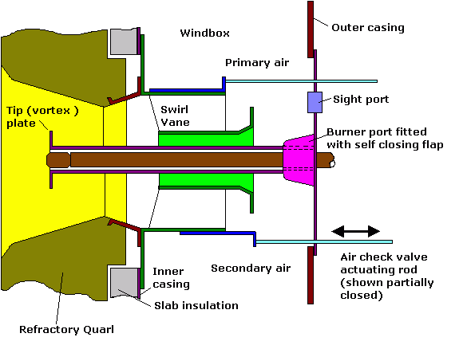This is the name given to an assembly of vane air swirler plates etc fitted within the boiler casing in association with each burner, its functions is to divide air into primary and secondary streams and to direct them such as to give the correct air flow pattern.
The air must pass through the air check to enter the register. In some cases the check can be formed by the swirl vanes themselves by rotating them about their axis, in other cases a sliding sleeve is used.
The inner primary air flows until it reaches the tip plate (stabiliser) then spills over to form a series of vortices which reduces the forward velocity of the air. This retains the primary flame within the quarl . The outer, secondary air passes over the swirler vanes which cause the air to rotate thus assisting the mixing of air and fuel.
The secondary air shapes the flame, short and fat for side fired, longer and thinner for roof fired.
A small amount of cooling air is allowed to flow to the tip plate and atomiser tip.
It is important that the air check forms a tight seal otherwise thermal shock can damage the quarls when the burner is not in use The front plate is usually insulated , the complexity of the air control is related to the TDR .The steam jet types have the steam providing additional energy for the mixture of air and fuel.
- see 'burners' for description of profiled registers

PREPURGING OF FURNACES
Furnace explosions caused by oil vapour and air present in furnace in explosive proportions. To a lesser extent a blowback is a furnace explosion. Prevention is by purging with air.
Usually adequate purging is provided within the combustion control however makers timings should be strictly followed .
N.B. This is particularly important with membrane wall boilers where the pressure wave is contained within a strong cell which if ruptured, has disastrous consequences.

Modern design
