Turbine Glands

GLAND STEAM SYSTEM
The purpose of the gland steam system is to reduce steam leakage to a minimum and to prevent air ingress.
Steam leakage leads to the requirement for increased make up; this increases the load on the feed and boiler water treatment chemicals and to a deterioration of the working environment surrounding the power plant.
Air ingress leads to a loss of vacuum and hence reduction in plant efficiency , and causes problems of thermal stressing around the gland as well as increases oxygen content of the exhaust steam.

System
The system consists of a set of glands fitted to the turbine, and a steam supply and exhaust system to service them.
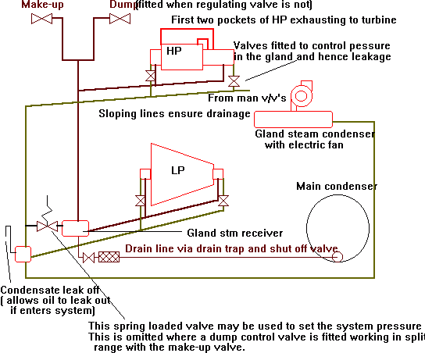
The system above shows the two means of controlling the gland receiver pressure; the first is by having a dump in split range with the make-up valve, the second is the use of a pressure regulating valve which dumps excess pressure to the exhaust line. The normal operating pressure is around 0.1 to 0.2 bar.

Gland steam condenser
The gland steam condenser is cooled by the condensate extracted from the main condenser and so acting as a feed heater.The gland steam often shares its condenser with the air ejector reducing the cost of having two units
A fan is fitted to induce a flow through the system without incurring a negative pressure in the final pocket as this would allow the ingress of air. This is ensured by the fitting on valves to the exhaust line from the glands so enabling the back pressure to be set.

Miscellaneous
A vapour hood is sometimes fitted with extraction at negative pressure reducing leakage still further.
The turbine rotor is shaped to prevent oil which leaks from the bearing traveling down the rotor and entering the gland
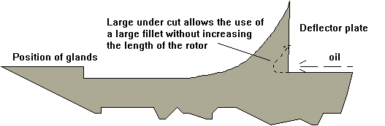

Schematic of pockets on inlet end of HP turbine
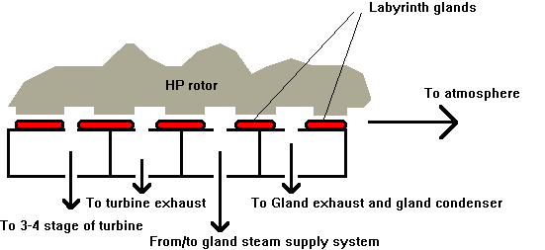
There are two pockets in the glands fitted to all the ends of the turbine; the inner pocket is connected to the gland steam supply and the outer to the exhaust line . The HP turbine has to further inner pockets due to it having to deal with steam at higher pressures and hence increased leakage. The innermost pocket simply passes leakage steam back to the casing a few stages downstream, the next pocket passes the leakage steam to the HP turbine exhaust.
When the engine is stopped the gland steam make-up supplies the system requirements. When the engine is in use the flow of steam to the supply pocket of the inlet end to the HP end reverses and the gland starts to supply the system reducing the quantity the make-up has to provide. At full power the only gland requiring steam will be the exhaust end of the LP turbine, the other will be either supplying the system or supplying themselves sufficiently to not require steam from the system.In this condition the make-up would be shut and the pressure regulated by the dump opening.

Principle of the Labyrinth Gland
The leakage of steam is reduced by the use of labyrinths, these provide a tortuous path for the steam to follow to exit the turbine reducing the pressure across a series of fine clearances to a level that can easily be managed by the gland steam system.
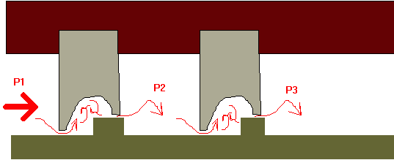Within the cavity where the flow is turbulent, the velocity of the steam is increased with an associated drop in pressure. The kinetic energy is then dissipated by the change in direction, turbulence and eddy currents.fugal action. Very small heads can deal with large pressure drops

Materials
A typical clearance between the rotor and the fixed gland is about 0.25 to 0.38mm, hence with very little rotor distortion the possibility of rub occurs. This has led to the use of soft, self lubricating materials for the gland segments.
The simplest form of gland consists of carbon rings held on to the shaft by the use of garter springs. Carbon Dioxide is formed with contact with superheated steam making this material only suitable for low temperature requirements.
Brass and Copper led alloys have been found suitable with an alloy of Lead, Copper and Nickel being suitable up to 520ºC.

Shaft Rub
Should the rotor bend, say due to carry over the area of rub on the gland will be over a small arc. With successive revolutions the heat generated will increase bend. This increases the area of contact and magnifies the condition by the increased generation of heat.
Plastic flow occurs when the material yields under compression to reduce the stress and on cooling a permanent set occurs.
One side of the gland, typically the stationary part is made up of thinned sections thereby reducing the contact area to a minimum. Spring loaded glands prevent this from happening by giving under contact with the rotor , limiting the heat generated and giving time for the rotor to recover its shape.

Spring backed gland
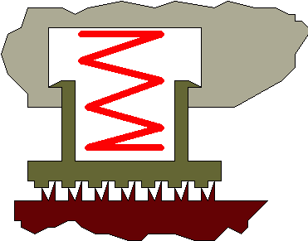
The minimum clearance for a spring backed gland ranges from 0.3 mm fot eh HP inlet to 0.63 mm for the Astern turbine. For fixed glands the minimum is 0.5 mm. With the smaller clearances there is an increase in efficiency

Hydrostatic Gland
A wheel forged on the rotor ends runs in a water bath. This water is flung out by centrifugal action. The gland only needs to be small as large pressure drops require little head.
The system cannot be used on reversible sets as the seal effect is lost at reduced revolutions. It is more likely to be seen on turbo-alternators.
