Boiler feed pumps
High speed, multistage centrifugal pumps are the preferred type due to their ability to supply large quantities of water and to provide it at steady flow avoiding shock loads on pipe lines and valves.
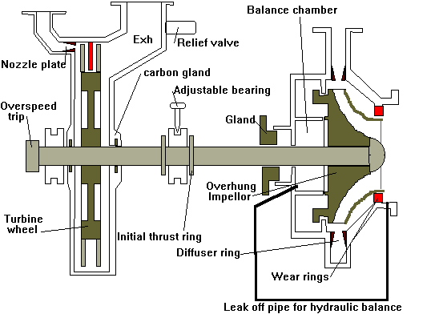
Materials
  - Nozzle plate- Creep resistant steel
  - Blades-Stainless iron
  - Bearings-White metalled ( oil lubricated )
  - Turbine glands- Carbon
  - Turbine casing- Cast steel
  - Turbine wheel- Stainless steel
  - Shaft- Nickel Chrome steel
  - Wear rings- Leaded bronze
  - Impeller-Stainless steel or monel
  - Diffuser ring- Aluminium bronze
The impulse Curtis wheel (velocity compounded) rotates at speeds of around 7000 rpm. Velocity compounding means that there is very little pressure drop across the stages reducing the need for fine clearances. This allows the turbine to be run up quickly from cold.
The balance chamber must have a diameter greater than the suction wear ring. If the pump is designed to be supercavitating hard metal inducers are fitted which screw into the water. Any cavitation occurs on this which is made sacrificial.
Inlet steam pressure around 60 bar, outlet around 3 bar. Expansion down to lower pressures would require excessively large casings and would lead to problems of centrifugal stresses due to the larger blading required.
Carbon seals are used instead of labyrinths for simplicity and to keep the length of the unit down to a minimum. Due to the different coefficients of expansions between the carbon and the steel a madrill must be used to set the correct running clearance. For multistage pumps an extra end bearing is required and hence additional packed gland.
The pump is dynamically balanced by means of the balance chamber leak off to the suction eye, and the dam edges on the back of the impeller

Balancing of two stage pumps
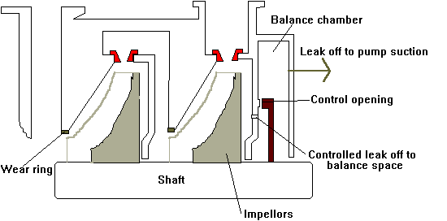
Feed pumps of this type of balance are best started against either a closed or spring loaded discharge v/v to ensure rapid build up of pressure

Bearings
Water lubricated bearings- Steel backing onto which is sintered a layer of porous bronze impregnated with PTFE (0.025mm thick). This PTFE is transferred to the shaft so providing very low coefficients of friction
Bearings operate at 115ºC with water supplied at 5.5bar 70ºC.
Bearing clearance- 0.15 mm
Max- 0.25mm must be replaced
Danger- 0.3 mm severe damage will occur
The bearings should also be replaced if less than 75 % shows on the surface.

Flow characteristics of controlled feed pumps
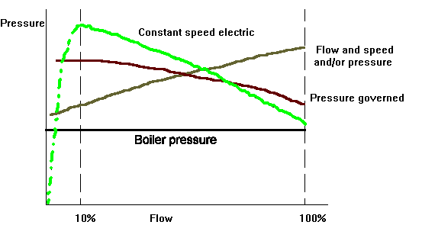
Constant speed ( electric )- Below 10% turbulence becomes so great that the pump operates very inefficiently and must not be worked in this range. Hence, a recirc valve must be used. At full flow pressure is only just sufficient to feed the boiler
Pressure governed- Pressure droop designed in to give stable control.
Flow + Speed and/or Pressure- The extra element must be added with the flow otherwise the system becomes unstable. Characteristic can be level or slightly rising giving low pressure at low flow rates conserving energy and preventing water being forced at high pressures through partly open feed control valve.

Gland
Can be operated at very low flow rates due to reduced speed
