Feed system
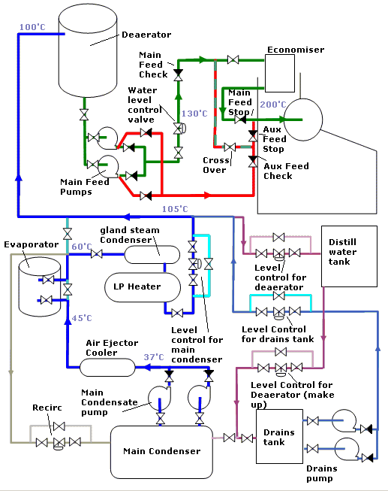
Shown above is a typical feed water system for a modern steam plant. Water is pumped from the main condenser by special centrifugal pumps having an inducer to allow suction from the very low pressures without vaporisation of the water. The water passes through the air ejector cooler to the Condensate cooled evaporator. A recirculation valve is available to return some condensate to the main condenser. The purpose of this is to increase the overall flow though the evaporator cooler thereby increasing water production as well as to ensure a minimum flow through the condensate pumps.
The water passes via the gland steam condenser and LP heater which in this case are shown as a combined unit on to the Main Condenser level controller. This prevents the level in the condenser falling below a set level thereby causing the main condensate pumps to run dry.
Some times mounted after this is a deioniser and feed filter before the water is passed to the deaerator.
The deaerator is mounted as high as possible in the engine room increasing the suction head for the feed pump preventing vaporisation in the suction eye of the pump. Not shown is an automatic recirculation valve fitted to the main feed pump outlet to ensure a minimum flow through the pump. The boiler water then passes via the boiler water level controller to the economiser and then through to the boiler steam drum.
A second supply is available for use in emergencies to the drum either via or by passing the economiser.
The drains tank condensate is pump via the drains tank level controller into the main feed system.

System level Control
Control of the amount of water in the system is by level control of the deaerator. One of the purposes of the deaerator is to act as a reserve capacity of high quality feed for the boiler. Water may be spilled to the feed tank or made up to the drains tank. An emergency filling valve is available for the main condenser the use of which is avoided as it introduces large quantities of gasses into the condenser reducing efficiency

