Deaerator

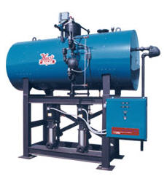
Introduction
Mechanical and chemical deaeration is an integral part of modern boiler water protection and control. Deaeration, coupled with other aspects of external treatment, provides the best and highest quality feed water for boiler use.
Simply speaking, the purposes of deaeration are:
- To remove oxygen, carbon dioxide and other noncondensable gases from feed water
- To heat the incoming makeup water and return condensate to an optimum temperature for:
  - Minimizing solubility of the undesirable gases
  - Providing the highest temperature water for injection to the boiler
Deaerators are typically elevated in boiler rooms to help create head pressure on pumps located lower. This allows hotter water to be pumped without vapor locking should some steam get into the pump.

Reason to Deaerate
The most common source of corrosion in boiler systems is dissolved gas: oxygen, carbon dioxide and ammonia. Of these, oxygen is the most aggressive. The importance of eliminating oxygen as a source of pitting and iron deposition cannot be over-emphasized. Even small concentrations of this gas can cause serious corrosion problems.
Makeup water introduces appreciable amounts of oxygen into the system. Oxygen can also enter the feed water system from the condensate return system. Possible return line sources are direct air-leakage on the suction side of pumps, systems under vacuum, the breathing action of closed condensate receiving tanks, open condensate receiving tanks and leakage of non-deaerated water used for condensate pump seal and/or quench water. With all of these sources, good housekeeping is an essential part of the preventive program.
One of the most serious aspects of oxygen corrosion is that it occurs as pitting. This type of corrosion can produce failures even though only a relatively small amount of metal has been lost and the overall corrosion rate is relatively low. The degree of oxygen attack depends on the concentration of dissolved oxygen, the pH and the temperature of the water.
The influence of temperature on the corrosivity of dissolved oxygen is particularly important in closed heaters and economizers where the water temperature increases rapidly. Elevated temperature in itself does not cause corrosion. Small concentrations of oxygen at elevated temperatures do cause severe problems. This temperature rise provides the driving force that accelerates the reaction so that even small quantities of dissolved oxygen can cause serious corrosion.

Operation
Mechanical deaeration is the first step in eliminating oxygen and other corrosive gases from the feed water. Free carbon dioxide is also removed by deaeration, while combined carbon dioxide is released with the steam in the boiler and subsequently dissolves in the condensate. This can cause additional corrosion problems.
Because dissolved oxygen is a constant threat to boiler tube integrity, this discussion on the deaerator will be aimed at reducing the oxygen content of the feed water. The two major types of deaerators are the tray type and the spray type. In both cases, the major portion of gas removal is accomplished by spraying cold makeup water into a steam environment.
Tray-Type Deaerating Heaters
Tray-type deaerating heaters release dissolved gases in the incoming water by reducing it to a fine spray as it cascades over several rows of trays. The steam that makes intimate contact with the water droplets then scrubs the dissolved gases by its counter-current flow. The steam heats the water to within 3-5 º F of the steam saturation temperature and it should remove all but the very last traces of oxygen. The deaerated water then falls to the storage space below, where a steam blanket protects it from recontamination.
Nozzles and trays should be inspected regularly to insure that they are free of deposits and are in their proper position

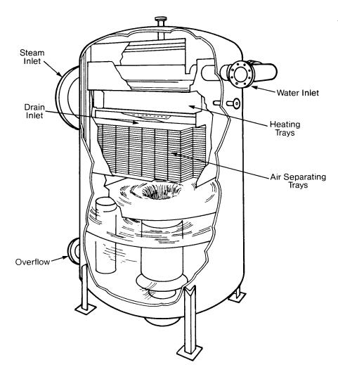
Tray-Type Deaerating Heater (Cochrane Corp.)

Spray-Type Deaerating Heaters
Spray-type deaerating heaters work on the same general philosophy as the tray-type, but differ in their operation. Spring-loaded nozzles located in the top of the unit spray the water into a steam atmosphere that heats it. Simply stated, the steam heats the water, and at the elevated temperature the solubility of oxygen is extremely low and most of the dissolved gases are removed from the system by venting. The spray will reduce the dissolved oxygen content to 20-50 ppb, while the scrubber or trays further reduce the oxygen content to approximately 7 ppb or less.
During normal operation, the vent valve must be open to maintain a continuous plume of vented vapors and steam at least 18 inches long. If this valve is throttled too much, air and nonconclensable gases will accumulate in the deaerator. This is known as air blanketing and can be remedied by increasing the vent rate.
For optimum oxygen removal, the water in the storage section must be heated to within 5 º F of the temperature of the steam at saturation conditions. From inlet to outlet, the water is deaerated in less than 10 seconds.
The storage section is usually designed to hold enough water for 10 minutes of boiler operation at full load.
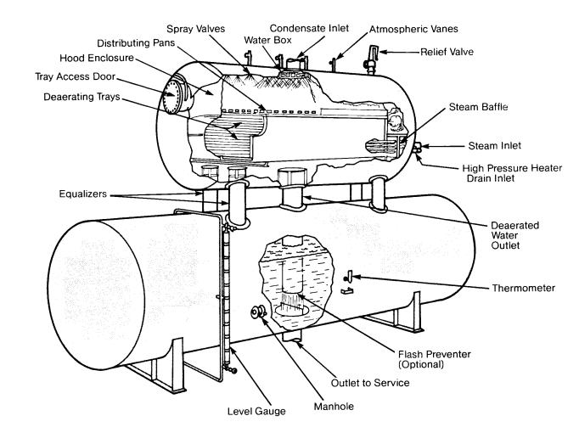
Click on image for larger view
Spray-Type Deaerating Heater (Graver)
Limitations
Inlet water should be virtually free of suspended solids that could clog spray valves and ports of the inlet distributor and the deaerator trays. In addition, spray valves, ports and deaerator trays may become plugged with scale that forms when the water being deaerated has high hardness and alkalinity levels. In this case, routine cleaning and inspection of the deaerator is very important.

A next generation deaerator system from Hurst Boiler, called the Oxy-Miser, utilizes a scrubbing section to contact oxygen-rich feedwater with steam rather than the more traditional tray arrangement.
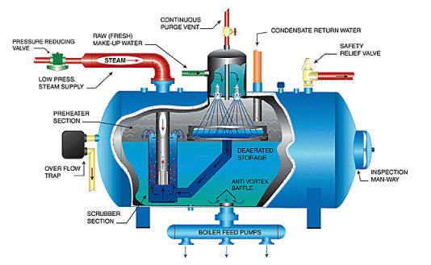
In this design, both the treated boiler feed water and the condensate return are sent through the scrubbing section of the deaerator. The Oxy-Miser system is available in capacities ranging from 5,000 to 200,000 lb/h (2300 to 91000 kg/h).
