Condenser
Condenser refers here to the shell and tube heat exchanger installed at the outlet of every steam turbine in Merchant Vessels generally. These condensers are heat exchangers which convert steam from its gaseous to its liquid state, also known as phase transition. In so doing, the latent heat of steam is given out inside the condenser.

Basic Purpose
- The purpose is to condense the outlet (or exhaust) steam from LP steam turbine to feed water.
- To provide a low pressure exhausting condition much below atmospheric pressure. This improves thermodynamic cycle efficiency.
- To provide for the 1st stage of deareating of the condensate.
- To provide some degree of regeneration by allowing some steam
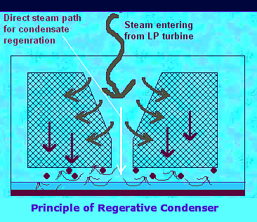

With the regenerative effect the water is heated to within one degree of the sat temperature so releasing dissolved gases which may have been re-absorbed as the drops where falling.
The dissolved oxygen content should be less than 0.02 ml/litre.
At the air ejector take off for the gasses, a cooling space is so arranged so a to ensure that there is no reheating of the gasses which would lead to expansion and reduce the efficiency of the process.
Drains which are led to the condenser are led to the top so the water is reheated/dearated before extraction.
The increasing use of scoops has led to the single pass condensers with SW velocities of 2 - 4 m/s being the ideal with minimum's to prevent silting of 1m/s.

Material of tubes
Cheap aluminium brass has a low allowable flow speed of 5 m/s; cupro-nickel has a higher flow of 10 m/s but is dearer and a poorer conductor of heat.

Tube fitting
This is by expanding and bell mouthing or with by ferrules and alternately fibre and metallic packing at the other end,

Stays
Tube stays cannot be used where the tubes have been expanded at both ends, the tubes must support themselves.
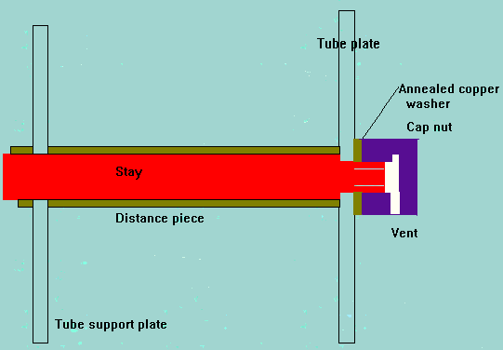

Why is a condenser required in the steam cycle?
The steam turbine itself is a device to convert the heat in steam to mechanical power. The difference between the heat of steam per unit weight at the inlet to turbine and the heat of steam per unit weight at the outlet to turbine represents the heat given out (or heat drop) in the steam turbine which is converted to mechanical power. The heat drop per unit weight of steam is also measured by the word enthalpy drop. Therefore the more the conversion of heat per pound (or Kg) of steam to mechanical power in the turbine, the better is its performance or otherwise known as efficiency. By condensing the exhaust steam of turbine, the exhaust pressure is brought down below atmospheric pressure from above atmospheric pressure, increasing the steam pressure drop between inlet and exhaust of steam turbine. This further reduction in exhaust pressure gives out more heat per unit weight of steam input to the steam turbine, for conversion to mechanical power. Most of the heat liberated due to condensing, i.e., latent heat of steam, is carried away by the cooling medium. (water inside tubes in a surface condenser, or droplets in a spray condenser (Heller system) or air around tubes in an air-cooled condenser).

Construction
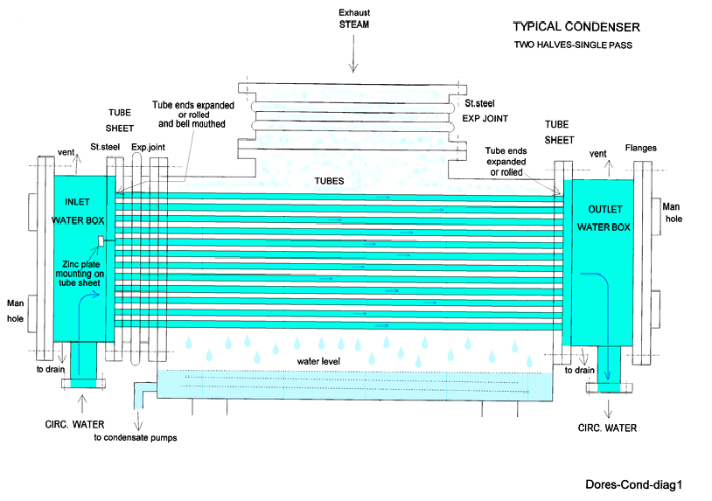
The following drawing shows a typical construction of a condenser of high capacity and the same is described here. The description is for a two part and one pass condenser. There are variations in fabricating designs depending on the manufacturers, the size of the steam turbine unit, and also some requirements dictated by the site conditions.

Shell
The shell is the outer most body of the condenser providing arrangement for installation of tubes. The shell is fabricated from fairly thick carbon steel plates. Due to its large size the shell is sufficiently strengthened or stiffened internally with carbon steel plates to give sufficient rigidity for the shell proper. The shell also gives support to number of intermediate support plates for the long tubes, depending on the size of the condenser. These intermediate tube support plates also help to avoid the sagging of long length of tubes. These support plates have sufficient number of holes of suitable diameter drilled with the help of a jig in a suitable drilling machine to facilitate the easy threading of each and every tube during installation or during replacements. At the same time the intermediate tube support plates allow for the free movements of tubes in all directions particularly lengthwise due to expansion and contraction occurring during operation.
The shell is connected to the outlet (exhaust) of the steam turbine by means of an expansion joint made generally of stainless_steel, flanged at both ends. The whole condenser is supported on heavy springs, mounted on steel sole plates at suitable places on the foundation, normally with a slight inclination towards the outlet water box to assist complete water box drainage.
At the bottom of the shell where the condensate is allowed to collect, a sump is provided. This sump is common to both the halves but separated by a partition wall in the middle up to the height of the bottom row of tubes. This is to facilitate the measurement of conductivity of condensate on both sides independently. This is to detect contamination of condensate and from which half side it is.
On each side of the sump pipe connection with a flange is provided for connection to external pump for continuous removal of condensed water during normal operation. This small pipe is also provided with an expansion joint on the sump side to avoid the condenser movement coming on the rigidly mounted pumps.
The inside of shell and outside the tubes as a whole remains under vacuum under normal operating conditions. Inside the tubes the cooling or circulating water passes through.

Air zone
Inside the shell, a central or side portion longitudinally is separated by an outer shield except at the bottom. This partition is called the Air zone. This air zone is found in all the condensers irrespective of the manufacturers or the size. All the gases released in the condenser due to cooling are taken out via these air zone tubes.
From a suitable portion of this air zone inside the shell an air vent pipe is taken out and brought out of the shell for connection to an air extraction device.

Practical Experience on Condenser
Average condenser vacuum in Japan Sea – 0.999 at sea temp of 14 deg C (approx)
Average condenser vacuum in Gulf – 0.943 at sea temp of 45 deg C [June, July, August] (approx)
… Ahmed Almuhairi (from National Gas Shipping Co. Oct’07)

Tube sheets
At each end of the shell, tube sheet of sufficient thickness generally made of muntz_Metal is provided, with holes for the tubes to be inserted and rolled. However at the inlet end each tube is also bell-mouthed for streamline entry of water. This is to avoid eddies at the inlet of each tube giving rise to erosion. Some makers also recommend plastic inserts at the entry of tubes to avoid eddies eroding the inlet end. In smaller units some manufacturers use ferrules to seal the tube ends instead of rolling. To take care of length wise expansion of tubes some designs have expansion joint between the shell and the tube sheet allowing the latter to move longitudinally. In smaller units some sag is given to the tubes to take care of tube expansion with both end water boxes fixed rigidly to the shell.

Water boxes
The tube sheet at each end with tube ends rolled, for each half condenser is enclosed in a fabricated box known as water box, with flanged connection to the tube sheet. The water box cover is provided with minimum of two man holes on hinged covers.
These water boxes on inlet side will also have big size flanged connections for cooling water inlet at lower level for butterfly valves, small vent pipe with hand valve for air venting at higher level, and hand operated drain valve at bottom to drain the water box for maintenance. Similarly on the outlet water box the cooling water connection will have large flanges but at higher level for butterfly valves, vent connection also at higher level but drain connections at lower level. Similarly thermometer pockets are located at inlet and outlet pipes for local measurements cooling water temperature.
In smaller units of the size of about 5 KW, some manufacturers make the condenser shell as well as water boxes of cast iron.

Tubes
Generally the tubes are made of brass, aluminium brass, cupro-nickel or titanium depending on the reliability requirement at site conditions. The lengths are fixed, depending on the size of the condenser. The size chosen is based on transportability from the manufacturers’ site and ease of erection at the installation site. The outer diameter is limited to a maximum of one inch for ease of handling and ease of insertion through the shell tube holes and for rolling at both ends.

Corrosion
The tubes, the tube sheets and the water boxes are all made up of materials having different compositions. These materials are always in contact with circulating water. The circulating water, depending on its chemical composition will act as an electrolyte between the metallic composition of tubes and water boxes. This will give rise to electrolytic corrosion which will start from more anodic materials first. The condenser tubes being the lowest in series of anodic material will get corroded first. This makes the condenser tube ends to get eaten away first.
Sea water based condensers, in particular when sea water has added chemicals pollutants, has the worst corrosion characteristics. River water with pollutants also is not desirable for condenser cooling water.
However due to large quantity of water flow requirement for large condensers, the corrosive effect of sea water or river water has to be tolerated and remedial methods have to be adopted in practice.
The concentration of undissolved gases is high over air zone tubes. Therefore these tubes are exposed to higher corrosion rates. Some times these tubes are affected by stress corrosion cracking, if originally stress is not fully relieved during manufacture. To overcome these effects of corrosion some manufacturers provide higher corrosive resistant tubes in this area.

Effects of corrosion
As the tube ends get corroded there is the possibility of cooling water leakage to the steam side contaminating the condensed steam or condensate, which is harmful to steam generators. The other parts of water boxes may also get affected in the long run requiring repairs or replacements involving long duration shut downs.

Protection from Corrosion
Cathodic protection is employed to overcome this problem. Sacrificial anodes of zinc (being cheapest) plates are mounted at suitable places inside the water boxes. These zinc plates will get corroded first being in the lowest range of anodes. Hence these zinc anodes require periodic inspection and replacements. This involves comparatively less down time. The water boxes made of steel plates are also protected inside by Epoxy paint.

PROTECTION OF CONDENSERS
Avoid low water speeds, which cause silting.
Too high a speed leads to erosion.

Marine growth prevention
  - -chlorine dosage
  - -Electro chlorine generator making sodium hypochlorite ( switched off when dosing with ferrous sulphate )

Erosion protection
  - -Inlet of tubes streamlined to smooth flow by expanding and bell mouthing
  - - the fitting of plastic ferrules
  - -for aluminium-brass inserts fitted and glued
When laying-up the following procedures should be carried out to prevent damage;
  - -Drain sea water side
  - -If ferrous sulphate has been used then the SW side should be refilled with fresh water to maintain film
  - -Where it is not practical to drain then the SW should be circulated daily

CONDENSER CLEANING
Before draining ensure no special chocking arrangements are necessary to prevent loading on springs or damage to the LP exhaust inlet gasket.
Water side
  - General inspection before cleaning
  - Place boards to protect the rubber lining
  - Use water jets or balls blown by compressed air through the tubes
  - Only brushes or canes as a last resort
  - When plastic inserts are fitted work from the inlet end
  - Test for leaks on completion
  - Clean or renew the sacrificial anodes
  - Remove the boards and prove vents and drains clear
Steam side
  - Inspect the steam side for deposits, clean with a chemical solvent where required
  - Examine the baffles, tube plates and deflectors
  - Look for vibration erosion damage of the tubes
  - Inspect for possible air leakage
  - Box up and remove chocks.

Leakage
The indications that a leak is in existence is that of high salinity measured in the condensate and boiler combined with a rapid drop in pH.
The first aid should be the injection of sawdust followed by a shut down at the soonest possible time.
There are three methods for leak detection;
Ultrasonic-Here, electric tone speakers are fitted in the steam space, and a microphone passed down the tubes. Alternately, instead of speakers a vacuum can be drawn with the microphone picking up air leakage.
Fluorescent-The water side is cleaned and dried, chocks are fitted and the steam side filled with water containing a quantity of flourescene. A UV lamp is then used on the water side.
Vacuum test- Draw a vacuum and cover the tube plate with plastic or use the ultrasound microphone.
Helium Leak Detection - A helium leak detector permits the localization of leaks and the quantitative determination of the leak rate, i.e. the gas flow through the leak. Such a leak detector is therefore a helium flow meter. In practice the leak detector performs this task by firstly evacuating the part which is to be tested, so that gas from the outside may enter through an existing leak due to the pressure difference present. If only helium is brought in front of the leak (for example by
using a spray gun) this helium flows through the leak and is pumped out by the leak detector. The helium partial pressure present in the leak detector is measured by a sector mass spectrometer and is displayed as a leak rate. This is usually given in terms of volume flow of the helium (pV-flow). (More of Helium Leak Detection)

Scoop systems
This single plane design of condenser is of the single pass type and is well suited to use with scoop systems. This is were cooling water flow to the condenser is supplied from an angled inlet pipe on the ships side. For this to operate the engine has to be travelling at a certain speed to give the correct flow of water. Below this speed the scoop must be shut off and a centrifugal main circulating pump in use. The advantage of this system is that the main circ can be of a much smaller size than would be required if it had to supply cooling water requirements for full engine load conditions. In this case it would be normal to fit to pumps of 50% capacity.

Scoop System layout
