Distillation systems used in LNG ships

Steam turbine engine ships require extremely pure fresh water for high pressure boiler feed water, as well as a high level of reliability.
These distilling plants use low pressure steam from the turbine bleed to heat seawater. A part of seawater evaporates into vapor which is condensed to fresh water in the distiller.

Multi Stage Flash Evaporator
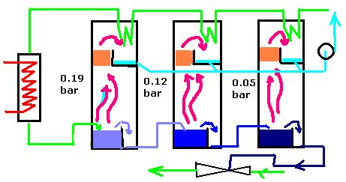
A typical multi stage flash system is based upon preheating of a pressurised sea water stream, or more typically a recycle brine stream to which the feed sea water is added; the stream is heated in the heat input section brine heater. From here the recycle stream is passed into the first stage of a series of flash chambers. Here the pressure is released, permitting a portion of the brine stream to flash to form salt-free vapour which is condensed to give the fresh water. In condensing the vapour gives off its latent heat to the recycle brine stream. From the first stage the flashing brine stream is passed to the second stage which is kept at a slightly lower pressure; more vapour flashes off. In the same way the flashing brine stream passes to the next stage and so on through the plant with a portion of the vapour flashing off at each stage. A heat balance shows that the heat supplied in the brine heater has to be rejected. This is done in the last two stages of the plant which are cooled by a sea water stream which subsequently passes to waste.

Types of distillation plants
There are two methods for generating fresh water, Reverse Osmosis (RO) and distillation. Reverse osmosis is generally used were large quantities of relatively low quality water is required. Typical examples of water produced are;
Treatment | Total Hardness | Calcium Hardness | Silica | Sodium Chloride | TDS
Sea Water | 250 | 200 | 14 | 15000 | 15000
Evaporator | <0.2 | <0.2 | <0.2 | <20 | <20
Reverse Osmosis | 20 | 5 | <1 | <750 | <750
After Demineraliser | 0 | <1 | Trace | <2 | <3

Distilling Plant Types

- Flash-Type
- Vertical Basket
- Vapor-Compression
- Reverse-Osmosis

Flash Type
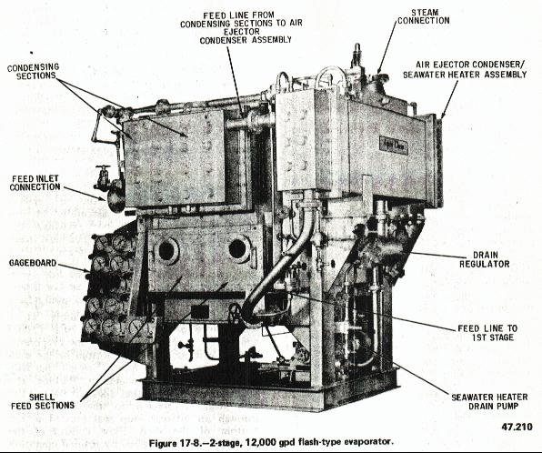
- Most combatants
- High capacity (12,000 –50,000 GPD)
- Distillate (<.065 ppm)
- 150# Auxiliary Steam
- Vacuum operation
- More efficient
- (-) soluble salts

