Manouevring Valves

Obturated manoeuvring valve
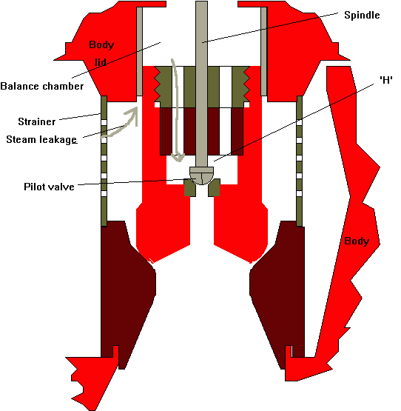
Steam leakage past the side of the main valve trim pressurises the top of the valve and holds it tight on to the seat. The seat and valve trim are stellite coated.
A steam strainer if fitted to remove any large particles such as scale, magnetite flakes etc. traveling on to the turbine.
The height 'H' is important and should be limited otherwise when the pilot valve spindle contacts the valve trim and starts to lift it, steam acting underneath the trim will tend to lift it increasing the valve opening quickly.
The conical seat and spherical valve trim shape ensures tightness. The seat is shaped to ensure that there is no velocity increase which is associated with the pressure drop leading to losses. The shape also means at low lift the steam stream is designed to meet in the centre and pass on without contacting the sides hence reducing erosion.
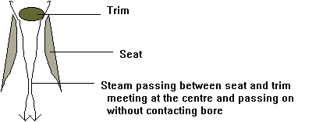
The valve operates as follows; The valve is closed with closing force coming from the pilot spindle and the pressure of the steam acting on the top of the valve trim. On open signal to the motor arrangement the pilot valve spindle moves easily opening up the balance chamber to the turbine pipework so releasing the pressure. the spindle travels further to contact the valve trim and hence lift it. The advantage of this system is that the spindle motor does not have to cope with opening the valve against the pressure acting on the back of the valve and hence can be accurately positioned for low lift.
The steam path through the opening valve is designed to give a linear lift/flow characteristic. the stem external to the body often has an arrangement for allowance for thermal expansion. Should the valve be manually over tightened shut or should he arrangement fail then seriously high stresses can be generated in the spindle which can jam.

Throttling
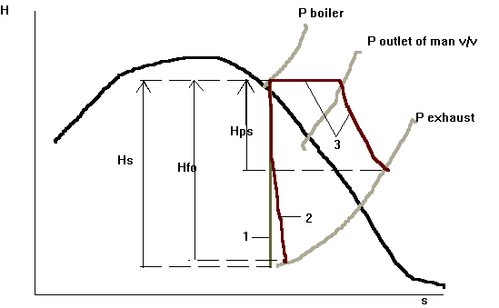
Line 1: Isentropic expansion through the turbine realising an enthalpy of 'Hs'
Line 2: True expansion through the turbine, through an open manoeuvring valve and realising an enthalpy of 'Hfo'
Line 3: Expansion through a partially open man v/v at constant enthalpy to a lower pressure but higher degree of superheat; the steam is then expanded through the turbine. It can be seen that there is an increased slope due to a drop of efficiency of the expansion through the turbine
The amount of heat that is available to do work is determined by the initial conditions i.e. boiler conditions, and the final conditions i.e. condenser temperature and pressures.
Hence, by varying the flow of steam so can the amount of work produced by the turbines also vary. This is the basis of nozzle control at full power outputs.
However, at reduced loads, even with the additional nozzle groups closed it is necessary to reduce the flow of steam by closing in the man v/v.
Closing the man v/v has other effects other than a reduction in mass flow. With the steam being throttled through the valve in an uncontrolled way and hence with no increase in velocity the steam at lower pressure but containing the same heat energy then exists at a higher degree of superheat (but lower temperature)with a certain amount of reheating due to friction occurring in the turbulent outlet stream. The expansion through the turbine is now carried out at a lower pressure, with the turbine operating at reduced revs due to the reduction in power developed there is a loss in diagram efficiency for the steam being expanded though the turbine.
It can be clearly seen that throttling through a partially open valve incurs a certain degree of superheat at outlet of the turbine. This can lead to overheating the main condenser due to the high exhaust temperature. However, as the mass of the steam is reduced this can generally be ignored.

