Types of Gearing

Spur gears
These are the most common form of drive. They are cylindrical and have the teeth cut straight and parallel to the axis of rotation. The tooth form can be one of several, but there is no axial thrust component on the bearings as the teeth are straight. The efficiency of the spur gear can be as high as 98% and capable of practical speed ratios of 10:1 although 6-7:1 is more common.
The main disadvantage of spur gears lies in the fact that they tend to be noisy at over 1000ft/min. If made to exceptionally fine limits of accuracy, plain spur gears can be used at far higher speeds in turbine drives.

Single Helical gears
Helical gears are produced by cutting the teeth at an angle to the gear axis and the teeth follow a spiral path thus making for gradual tooth engagement and load distribution. Efficiency is as great as for spur gears.
Ratios of 10:1 are possible with increased load over spur gears. A degree of axial thrust is produced which must be catered for in the bearing design. Angular contact or tapered roller bearings are employed. On larger designs where plain bearings are fitted a thrust block arrangement must be fitted.
Single helical gears can be used at speeds up to 4000 ft/min

Double Helical gears
Commonly specified where the axial thrust from a single helical design would be too large or where there plain bearings are used. To balance the side thrust the teeth are formed on each gear in helices of identical angle but opposite hand. For cast commercial gears the teeth are sometimes of the uninterrupted type, cut by the planing process. For hobbed gears a 3 in wide gap is left for the hob clearance.
Single reductions of 10:1 with double reductions of 75:1 and triple reductions of 350:1 are used
Pitch line velocities from 4000 to 20000ft/min are possible depending on the accuracy of manufacture.

Bevel gears
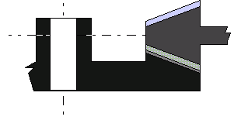
Bevel gears are used in situations where it is desired to transmit motion between two shafts whose axis intersect. The most common type is that in which the teeth are radial to the point of intersection of the shaft axes or apex and these are known as straight bevel gears.
The tooth action is similar to that of spur gears, being in line contact parallel to the pitch line. There is no longitudinal sliding between the teeth, but there is an end thrust developed under tooth load which acts away from the apex, thus tending to separate the gears. Thrust bearings must therefore be provided. The maximum gears ratio is 4:1. The maximum speed at pitchline is 1000ft/min.

Spiral bevel gears
The spirally cut gears like the helical gear in its relationship to the spur gear, can withstand higher speeds than the straight cut bevel and is quieter in action. Unlike the straight cut bevel gears which can be shaped or precision forged the spiral bevel gears must be made on a special machine ( made by Gleason Co). Pitchline velocities of 4000ft/min maximum can be handled.

Hypoid gears
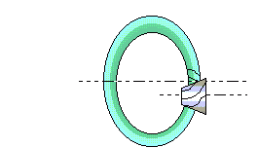
Similar in appearance to the spiral bevel gear it is distinguished by having the pinion axis offset to the wheel axis. They are mainly used in the automotive back axle drives where they provide smooth tooth engagement at the high speeds combined with high load carrying capacity.

Spiral or crossed axis gears
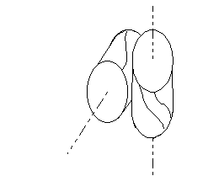
These gears are identical in every way to helical gears, the only difference is that they are used to transmit power between shafts that are not parallel. Mating gears must have the same base pitch but their helix angled may vary. The contact made by the pitch cylinders of spiral gears is point contact only and there fore spiral gears are suitable for light duties only.

Zero Bevel gears
These gears have teeth that are curved in the same general direction as straight teeth. They are spiral gears of zero spiral angle.

Skew Bevel gears
In this form the pinion shaft is offset in relation to the wheel. The pinion may have straight teeth or it may have skew teeth similar to a helically cut bevel gear. The object is to obtain more gradual tooth engagement than with a straight tooth bevel. An additional advantage is that it sometimes makes possible the provision of bearings at both ends of the pinion shaft. Skew bevels are seldom used as they are difficult to set up.

Internal gears
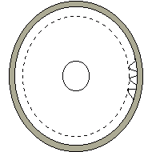
The meshing condition of this sort of gear are said to be better than those of the external gears for the reason that the contact area is between a concave and a convex surface, while also making better conditions for lubrication.
Other advantages include shaft direction is the same for input and output, Greater load capacity is possible, increased safety as the teeth are guarded.
Disadvantages include difficulty in supporting the shaft, range of gear cutting processes is reduced and tooth interference is a common problem.

Worm reducer gears
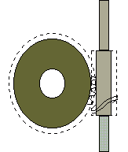
conditions for worm gears include the following;
  - shafts at right angles
  - large speed reductions in smallest compass
  - smallest number of gears
A worm drive comprises a cylindrical worm having helical teeth or threads, similar to a helical gear, meshing with wheel with a concave face. The tooth contact is a line one and heavy loads can be handled. Efficiencies claimed for worm gears are 97% and above. Ratios of 1000's to one is possible with double worm drives and it is the most popular form of industrial drive.

Spiroid gears
In addition to the above bevel gears there is a special type which has right angle non intersecting gears having tapered pinions with threads of constant axial lead meshing with face type gears. This is used mainly in the automotive industry.

Turbine Construction

Vertical Casting
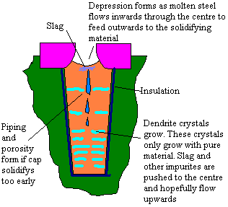
Only the bottom part of the ingot is used.

Rough Forging
It is a requirement that forgings are heavily worked. Any small holes or defects can become hammer welded together. No forging is carried out below the plastic flow temperature as this can lead to work hardening. Forging will allow continuous grain flow
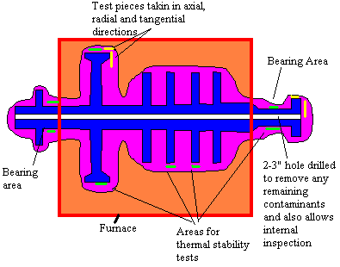
ultimate tensile stress and elongation checked. This must be near enough equal in all 3 directions.
After rough machining it is put in for a thermal stability test. For this final machining is given to the areas indicated. The end flange is marked at 90' intervals. Then the rotor is encased in a furnace. Pokers are placed onto the machined areas and accurate micrometer readings taken. The rotor is rotated though 4 positions marked on the flange.
The rotor is then heated to 28'C above normal operating temperature and slowly rotated.
Measurement is then taken at hourly intervals until 3 consistant readings are taken ( hence the rotor has stopped warping). The rotor is then allowed to cool and a set disparity allowed.
For turbine sets operated at greater than 28'C above their designed superheat then run the risk of heavy warping as well as high temperature corrosion and creep.
Final machining is now given. The rotor is statically balanced and then dynamically balanced and check to ensure homogenity.The rotor is bladed then again dynamically balanced.

HP rotor
Most modern HP rotors are made of a single gashed forging of high quality steel.A hole of 50mm is bored axially through the rotor to allow for internal ispection and to remove impurities and internal flaws which can cause premature failure. In addition to the blade wheels also found on the rotor are; Thrust collar, Journal bearing surfaces, Oil thrower, Gland, Conical seat, thread or flange to attach flexible coupling
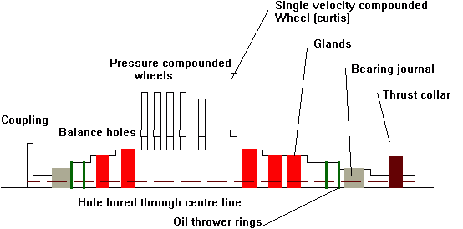
Most modern HP turbine rotors are of the Rateau or pressure compounded design.
Reduced number of stages ( 8 to 10 ) give a shorter rotor and provides savings in weight and length. Also provides for better critical vibration characteristics.
Rotors are solid forged providing
  - Homogenous rotor with even grain flow
  - Even expansion
  - Good thermal stability with less likelihood of distortion under high temperatures
After forging the rotor is machined, wheels may be parallel or slightly thickened at the base . The methods is also used for the LP turbine which has 7 to 9 stages plus 2 to 3 astern.
After rough machining rotor is given a thermal stability test, after further machining and fitting of blades the rotor is given a static and dynamic balance.
This design is known as the Gashed disc rotor and gives a minimum shaft thickness and hence a minimum area for gland sealing to prevent steam leakage.
Material ( up to 566ºC )
  - 0.27 - 0.37% Carbon
  - 1.0% Manganese
  - 0.04% Sulphur
  - 0.2% Silicon
  - 1.0% Chromium
  - 0.5% Nickel
  - 1.5% Molybdenum
  - 0.3% Vanadium

Advantages of Helical and Double Helical gearing
SINGLE HELICAL | DOUBLE HELICAL
Comparative simplicity in grinding No gap, low helix angles - 15 ' | Longer grinding times , normal gap normal helix angle - 30 '
Complete absence of pinion shuttling obviates the use of sliding couplings Apex wander due to different composite pitch errors cause shuttling.Gear tooth couplings do not respond because of the high frictional loads. Best compromise is to use axially flexible couplings. With highly accurate gear manufacture this effect is small
Axial thrust on primary high speed pinion unless taken by turbine thrust bearing can lead to high losses if flooded thrust pads are used. The use of brown boveri thrust cones can be used to overcome this problem.(see Below) | No axial thrust and no high speed thrust bearings required. Final reduction wheel located by propeller thrust bearing
Ball and roller bearings may be used to take end thrust
Quill shafts can be solidly coupled to primary wheels and secondary pinion. The helix angle on each being arranged to balance the axial thrusts.
Simple side bearings serve to locate the shafts . The axial thrust of the final reduction wheel being carried by the propeller thrust bearing.
Axial tilting moment on wheels generally negligible. | No tilting moment
Small helix errors can be perfectly corrected . Allows tooth helix angle adjustment to negate bending , torsional and heating effects and hence balance loading across the teeth. Helix errors can be adjusted in a similar way, but not so perfectly as for single helical

Summary
The main advantage is that the double helical gear does not have end thrust However they do take more time to manufacture and are slightly heavier

Brown Boveri Thrust Cone
This is a method of absorbing end thrust in single helical gears without resorting to large thrust bearings. This design is seen insmall steam turbine generator sets.
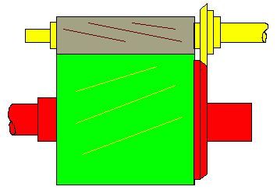
With the cone system there is a line of contact and a very large relative radius of curvature with a large oil entraining velocity of 220 ft/s .There is thus considerable axial resilience with the large radius of curvature, a small radial width of cone is sufficient to take the th

Gear layouts
SHown below are various layouts for a two stage reduction gearbox

Interleaved (split secondary)
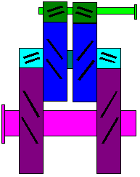

Interleaved (split secondary)
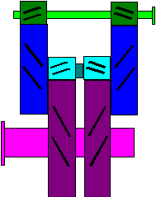

Tandem
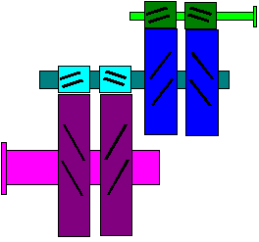

Tandem (articulated)
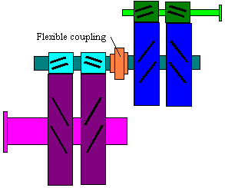

Locked Dual Tandem
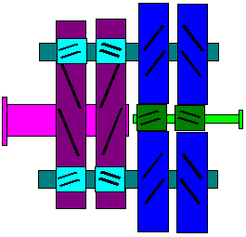

Locked Dual Tandem (articulated)
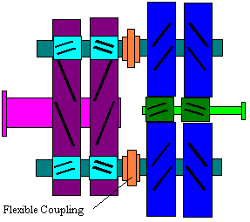
The connection between the rotor and pinion shaft is always via a flexible coupling
The dual tandem arrangement has the advantage that there are two pinion contacts on the secondary wheel. This halves the tooth load and allows a much smaller wheel.
To achieve this, however, requires very accurate setting uo so that one pinion does not sit in its backlash whilst the other is loaded.
This may be achieved by setting one pinion so that it gives the correct contact then slightly rotating the other pinion until it is fully contacted and then 'Locking' the whole arrangement. One method of doing this is by taper fit flexible couplings which can be moved relative to the shaft by application of hydraulic pressure between the mating surfaces.
Extensive use of quill shaft and flexible couplings is made to negate effects from pitch errors creating high dynamic tooth loading. Great care must be taken with the alignement of the primary pinion and primary wheels as this is very highly stressed.

Single Tandem
- Advantage
  - Simple
  - Length of shafting provides damping to vibration
  - carry very high loads
  - capable of accepting minor manufacturing errors
  - primary and secondary gear may be dismantled independently
  - large turbine axis / output shaft distance allows use of underslung condensers
- Disadvantage
  - Heavy
  - Large

Dual Tandem
- Advantage
  - Much smaller secondary wheel
  - Lighter
  - Small turbine axis / output shaft distance allows reduced height
- Disadvantage
  - Small turbine axis / output shaft distance requires axial flow condenser or angled prop
  - Complicated alignement proceedure and fault intolerant
  - Multitude of parts

Triple/Double reduction steam plant gearbox
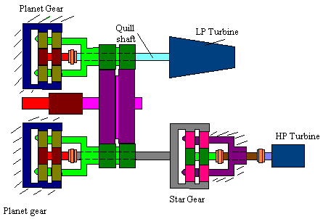
The main wheel pinions are fre to move axially because of the axial freedom of the planets on their bearing oil film
The first stage of the HP turbine is a start gear. This due to the high speed of the HP turbine causing centrifugal stress to distort a free planet carrier causing meshing problems. With a star gear the plane carrier is fixed.
Sun wheels are connected via flexible couplings to allow for manufacturing and alignement errors

Commisioning and Inspections
Gear Inspections
  - Ensure that the steam is off the turbines and the turning gear is engaged.
  - Wipe around inspection doors to prevent immediate dirt ingress
  - Allow sufficient time for the gear case to cool before opening
  - If inspection is non-routine, that is say due to an abnormality ensure extra time for cooling and open doors initially away from the area of concern
  - Guard against items being dropped accidentally into gearcase
  - Use only flame proof lighting
  - Rotate main wheel at least one full turn
  - Inspect all teeth for damage, record defects as appropriate. This normally takes the form of a sheet onto which a sketch showing the size and extent of damage (such as pitting) and a section fo added notes. These sheets are kept as a historic record of the gear allowing judgement on deterioration rate.
  - Observe oil sprays and other internal fittings
  - Look for rusting indicating faulty dehumidifier
Should a fault be found it may be necessary to check alignment, the condition of the flexible couplings, bearings and mounting arrangements.
Checking for mis-alignment
This can be done by blueing one of the teeth then viewing the complimentary mating teeth. Where the blue has transferred this is where the teeth have meshed and this can be compared to the polished area of the on load contact areas.
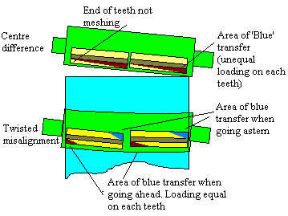
There will be some difference to the on load polished area as the displacement component tending to push the two centres apart, pushes the pinion up in its bearing. For very accurate aligement this force can be represented by pulling the pinion away from the wheel
If damage to the Bull wheel is suspected , say due to rapid decelleration of the propeller, and the Bull wheel may have slipped its shrink fit then alignment should be checked in a number of positions.
Operation and Maintenance
A gear set will operate satisfactory provided;
  - It is operating within limits
  - It has sufficient high quality oil supply
  - Close attention is paid to alignement during refits
  - Flexible couplings are maintained
Oils should have anti-rust additives, water content should be kept below 0.2%
Excessive rust and sludge can lead to failure due to corrosion fatigue particularly in gears suffering from pittings
Blued tapes taken on inspection may be kept to record wear
IME recommends inspection periods no more frequent than 6 months to prevent undue contamination.

Clutches
Clutches are generally designed to engage at minimum load and engine speed. Operation above this can lead to excessive gearbox and clutch loading and can shorten life or lead to catastrophic failure

Friction Plate
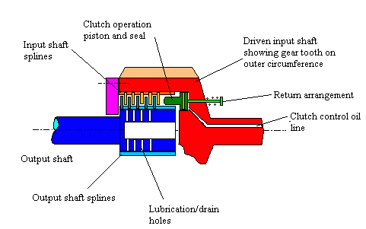
Oil forces the friction plates, generally made from a suitable steel alloy material or leaded bronze, together. These loose plates are alternately splined to drive or driven shaft.
The oil is supplied under a controlled flow via an accumulator so allowing a gradual engagement over a short period. The oil is generally supplied via a solenoid valve from the gearbox lube oil system
Emergency drive is allowed by fittings screws which jack the plates firmly together

Pneumatic clutches
Takes the form of an inflatable tyre on which is mounted ferrodo clutch lining. Air is supplied via a slipper arrangement to the tyre segments which inflate forcing the clutch material into contact with the driven inner circumference.
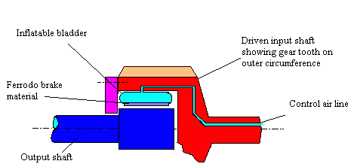
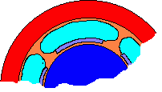
Emergency drive is via though bolts which pass radially though drive and driven wheel circumferences

Fluid friction clutches
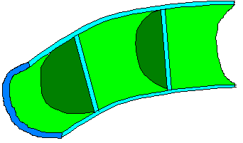
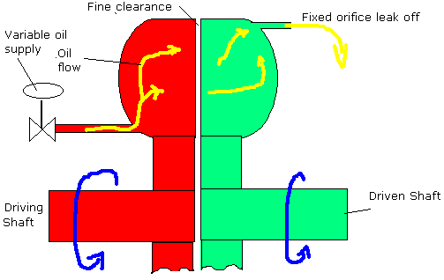
Operate using the shear resistance of the clutch fluid. For marine use this is generally a fine grade mineral oil although synthetics may be used.
A pumped control flow is delivered to the drive assembly and allowed to flow to the driven assembly. As the flow increases so more of the assemblies become available for driving and slippage reduces eventually reaching a maximum.

Epicyclic gearing

Principles of operation
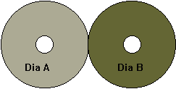
If dia 'A' = dia 'B' then for one rotation of 'A' a point on the surface of 'A' would move through a distance equal to 2 x Pi x Ra; the distance that would be traveled by a point on 'B' would be 2 x Pi x Rb and as Ra=Rb. the ratio is 1:1.
One rotation of 'A' causes one rotation of 'B'
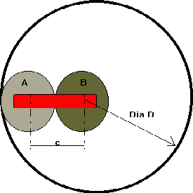
If the gear 'A' is fixed and 'B' allowed to rotate freely around it constrained within an annulus; then for one rotation of 'A' and corresponding rotation of 'B' the point of contact on the annulus would have moved through a distance equal to 2x P x Ra.
The circumference of the annulus would be equal to 2 x P x (Ra + Rb), hence for
one revolution of 'A' then 'B' would have only traveled half way round the annulus.
By varying the size of the sun and planets the gear ratio can be altered. The outlet drive could be taken either off the bar 'c' or if 'c' was fixed off the rotating annulus.

Comparison of Epicyclic gearing to Tandem gearing
Advantages
  - The output may be reversed to requirement
  - Small size and weight for given ratio ( approx. 75% of wheel/pinion)
  - Output same direction as input for planetary ( ratios of 3-12:1)
  - Output opposite direction to input for star (2-11:1)
  - Co-axial input/output
  - Initial cost may be slightly lower
  - Slightly improved efficiency
  - Operating cost lower
  - Lower plant height
Disadvantages
  - Requires very accurate alignment
  - relatively high tooth load
  - increased number of rotating parts
  - Inspection and maintenance more difficult
  - Increased meshing frequency means higher grade materials required

Types
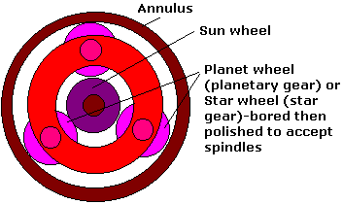
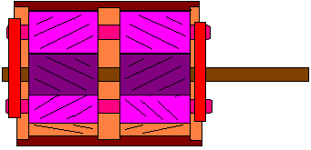The Star annulus has teeth on the inner rim. A resilient mount is provided when the star annulus is fixed. This allows a certain degree of distortion to occur reducing tooth loading. The planet wheels are located by a planet carrier ring, on fitted at each end
The system may be constructed in three different ways
  - Planetary- The star annulus is fixed. Input is via the sun wheel and out put through the plant wheel carrier ring
  - Star-The planet wheel carrier is fixed. Input is via the sun wheel and output through the star annulus- This system is often seen as the first stage of turbine reduction gearing due to the possibility of high centrifugal stresses distorting the plant carrier ring and causing tooth overloading
  - Solar- The sun wheel is fixed. This system is seldom used except in back to back epicyclics
The fixed member is called the torque reaction member. The number of wheels is determined by tooth loading

Epicyclic gearing alignement
In normal operation epicyclic gear designs the planet pins are straddle mounted on a rigid carrier and are precisely aligned to each other.
If they are not the load distribution across the face is affected, but not the load sharing.
The sun pinion and flexible annulus are centered by the planet wheels when under load
With the ideally supported annulus, load sharing between the planets is ensured by the radial flexibility and uniform loading across the teeth by the self correcting toroidal twisting of the annulus and by the high accuracy of the gearing.

Toroidal twisting of annulus
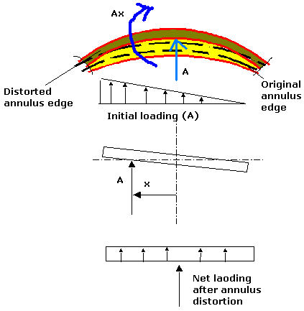
The effect on tooth loading depends of on the supporting method of the annulus.

Introduction of Annulus flexibility
MAAG star gear
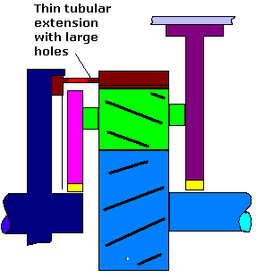
Toroidal twisting effect on the annulus is reduced to a minim by having the tubular extension thin, and nearly in line with the axial thrust from the teeth.
Other designs include the Allen-Stoeckicht where the split annulus of a double epicyclic gear are given a degree of movement within the carrier fo the two rings, this carrier itself is given a degree of axial movement by being fixed to the outer casing by a straight cut tooth coupling.
Also the Renk design has the annulus supported by a series of leaf sleeve spring packs. The annulus is split into two separate annuli. This design permits both torsional and radial movement and to a lesser degree angular movement in the diametrical plane. All movement is dampened by the oil and friction within the spring packs

Introduction of flexible pin
Plane wheel spindle (vickers)
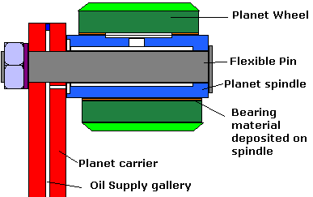
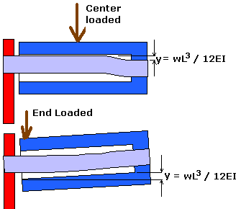
For this design the annulus is made radially stiff.

Tooth Design
Standard involute double helical tooth arrangements are used.
The planet/annulus centres and pressure angles are standard
Changing the diameter of the base circle within the tooth height does not effect the gear ratio. However, matching the root circle to the base circle makes the tooth all addendum and hence all the tooth is on the involute curve and no undercutting exists. This is especially used for the highly loaded teeth of the sun wheel.
The sun/planet ring used slightly increased diameters so as much as the tooth depth is used as possible.

Carrier ring
Nearly always in the form of a short hollow cylinder .
having the following advantages
  - ease and economy of manufacture
  - strength and stiffness
  - concentricity and potentially good balance

Renk Compound Gear
Offers 17-1 reduction capacity. The sleeve pack is adjustable to give the required torsional characteristics. The springs also give some bending flexibility and dampening through oil and friction.. This resilience from the secondary pinions gives greater isolation to the gear 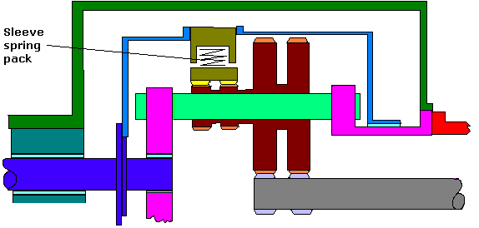

Reversing
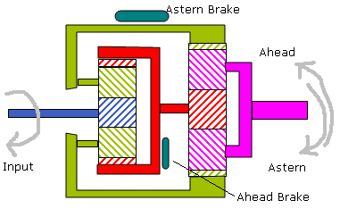
By application of either the ahead or astern brake the direction of the output shaft can be controlled. This system act as abn alternative to a reversing engine or CP propeller

Gearbox casing and layout
These are subjected to a complex array of forces from all the components. It is preferable that all these are dealt with within the gearcase and little or no residual forces act on the supports. Also it is preferable that there is no transfer of load from an external source, say the propeller.
The gear casing is generally constructed of fabricated steel plates, the casing must have a certain degree of flexibility internally in the planes in which the bearing loads act to allow for incorrect tooth contact.
The residual weight and turning moment is supported by as small an area as possible to negate forces transferred by the movement of the ships hull

Turning moment (generally found on systems using Tandem style gearing)
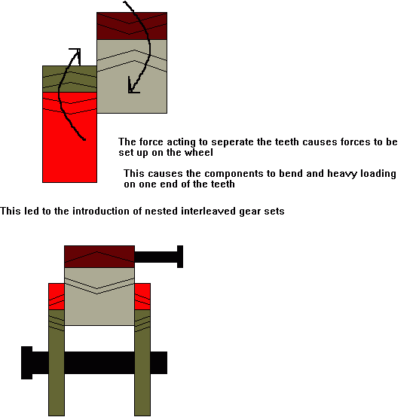
However, to prevent undue movement in the oil clearance of the mid component, the pitch of the primary pinion and secondary wheel had to be the same. The pitch on the secondary wheel was limited to commercial viability. This makes for a coarse pitch on the primary ,all addendum teeth where encompassed on the primary pinion for strength
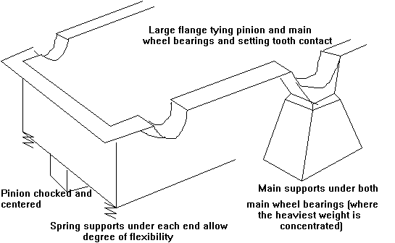

Gear oil sprays
The position of the oil sprays within a gear casing are of paramount importance. Power losses and overheating in high speed gears may be reduced by applying some of the oil to the teeth as they disengage. This being the side where the cooling effect is greatest. This helps to prevent scuffing and shows the importance of reducing the bulk temperature of the oil.
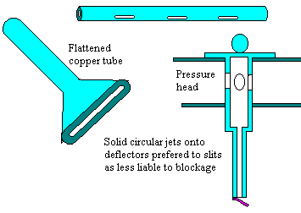
Lubricating oil is supplied to flexible couplings, bearings and the line of contact between pinion and wheel.
For the gearing oil is sprayed under pressure diectly into the line of contact from a distance of 25 - 50mm. there may be three or four sprays per mesh. For bothahead and astern directions. Oil must be supplied under sufficient pressure to ensure total wetting before being flung off by centrifugal force.
Vents as fitted to the crankcase as the oil at the point of contact becomes hout leading to increased vaporisation. Sight glasses or indicators may be provided to ensure positive flow of oil

QUILL SHAFTS
The turbine is connected to the pinion by a torque tube. Here two flexible couplings are used ; this may be dynamically balanced before fitting
Quill shafts are fitted to increase the length of the shafting without increasing the overall length. This has the advantage that gear teeth may be brought to mesh at the node point and hence point of minimum vibration.
Teeth hence have a steady load instead of a fluctuating cyclically with vibration. Hence, the drive is sometimes called a nodal drive.

Plant layout
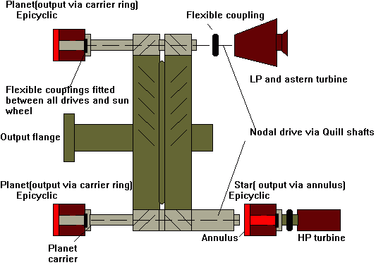
The gearing fitted to the SS Leonia and other large turbine propulsion plants is of the Articulated type, this is indicated by the fitting of the flexible couplings to the Epicyclics allowing a certain degree of misalignement to exist and allow for any machining errors in the fully floating sunwheel.
The first stage reduction is that of Start type Epicyclic, Star rather than Planetary is used due to the problems of distortion of the Planet carrier ring under centrifugal stress can lead to uneven tooth contact and loading.
The Pinion is allowed free axial movement by the planets on their oil film, this allows for the shuttling of the main wheel to be accommodated ( the shuttling caused by machining errors in the rim)

The Brown Boveri Thrust cone
The disadvatage of using a single helical gear is that there is a resultant axial thrust. Traditionally this would be counteracted by using an oversize thrust block. A simpler method is shown below where resultant axial forces are reacted out by thrust cones mounted on the pinion and wheel 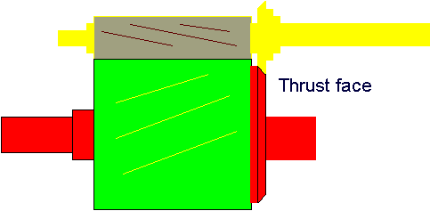With the cone system there is a line of contact and a very large relative radius of curvature with a large oil entraining velocity of 220 ft/s .There is thus considerable axial resilience with the large radius of curvature, a small radial width of cone is sufficient to take the thrust

Faults associated with Spur and helical gearing

SLOGGER
Hammer like action between teeth caused by variations in pitch or torsional vibration , may be negated by nodal drives

PITTING
The mechanism for pitting is poorly understood . One theory is that it starts below the surface and parallel to it . When extended to surface oil under hydrodynamic pressure is forced in.
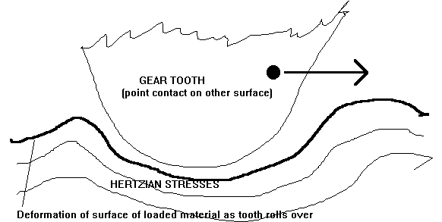
Shown above is the deformation of the surface due to the rolling action of one tooth over the other. Subsurface hertzian stresses are formed which run parallel to the surface.
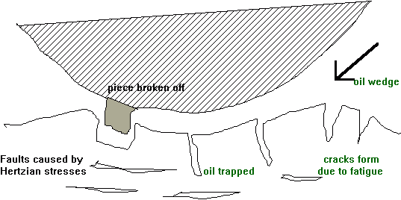
Most severe on the pitch line or just below it , but may also be found on the dedendum of both driving and driven teeth and is dependant largely on finish
There is experimental evidence which suggests that pitting occurs only where there is a low ratio of slide to roll. With worm and most hypoid gears, excessive side slide tends to wear away high spots before true pitting would occur.
With spur and bevel gears , as each tooth passes through the centre of the mesh , the entire load is momentarily concentrated on the pitch line. If the area along the pitch line has already started to pit , this concentration of load on the roughened surfaces of spur gears is quite likely to increase the pitting progressively until the tooth surfaces are destroyed or severely damaged.
On the other hand , with helical , herringbone and spiral gears , there is less likely hood of destructive pitting . This is because each tooth during the mesh makes contact along a slanting line which extends from root to tip. This line cuts across the pitch line , and therefore, though pitting may have roughened the area along the pitch line, the line of contact always extends beyond this roughened surface, and thus the load is carried on undamaged root and tip areas. Under these such circumstances , pitting may cease as soon as the few, isolated high spots along the pitch line have been removed.
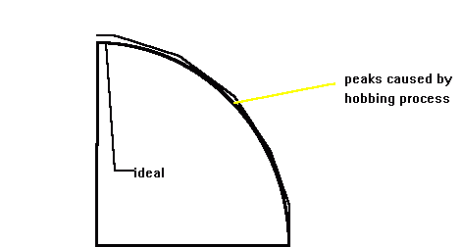

INITIAL
New gears suffer initial pitting , these can disappear on the teeth as they work harden. Normal wear polishes out pits . Further problems can be avoided by proper running in
Back to back loading of the gearbox on opposite hand sets can allow the gearbox to be run in using high torque , low speeds.
Initial pitting is attributed to local overstressing caused by asperities and profile irregularities (see diagram above). The teeth of new gears may have variations in smoothness. Although these variations may be too small to break through the oil film , yet they may be large enough to affect gear operation. In addition , there may be variations in the hardness of the surface metal. When smoothness or hardness is non- uniform across the tooth , the distribution of load is also non- uniform. Thus as the teeth pass through the mesh, the load is concentrated on local high spots or hard spots.
The running in process reduces asperity's , and profile irregularities , surface stress becomes more uniform and pitting is arrested .
Profile inaccuracy can lead to root pitting and more rarely pitting on the addendum.

INCIPIENT/( corrective )
Most commonly found on wide-faced gear teeth, because of the difficulties in obtaining true and uniform contact across the entire width of the teeth.
On routine inspection pitting may be found . This is incipient pitting and requires close monitoring, unlike initial pitting which is only found on the maiden voyages, and can occur at any time during the life of the gearbox.
Careful monitoring will determine whether this is an isolated case or whether it will lead to progressive pitting with potentially destructive results.
Classic causes are overloading and misalignment ( similar to progressive, and different to initial which is caused by high spots. ) .If found then the gear case should be regularly inspected and the cause ascertained and removed.
The pitting , once the cause has been eliminated should polish out.

PROGRESSIVE
May occur were initial or incipient pitting has not been arrested . However progressive pitting may be mistaken for initial but the pitting is not caused by asperities.
Progressive pitting may halt or may continue to destroy the face.
Alternately it may halt , lie dormant then restart.
Most progressive pitting is wider in scope than initial pitting with branching fatigue cracks extending deep into the metal. Progressive pitting is followed by DESTRUCTIVE pitting which rapidly leads to failure

MICROPITTING
Fine attrition of the dedendum surface with a distinct wear step at the pitch line . Mating teeth may wear to a conformable shape and operate as so without problem.
May be regarded as a form of wear . However , secondary pits may occur increasing roughness to an unacceptable point.
Development of wear steps, is not fully understood but may be associated with superimposed vibration - say from propeller or main engine.
If the tooth surface is poor or if overloading occurs pitting proceeds reducing load bearing surface eventually destroying the tooth.

SPALLING
Deep scallop shaped pieces of metal are removed , possible causes are overloading but is more generally seen as a surface hardening process failure.
It is caused by the same mechanism as pitting and flaking. Subsurface cracks form below the surface following the lines of hertzian stress. These may be joined to the surface by cracks formed due to the deformation of the surface under load. Oil forced in to these cracks under hydrostatic pressure enters the subsurface cracks were its non compressibility causes the crack to expand, were it joins other surface cracks and the piece detaches .
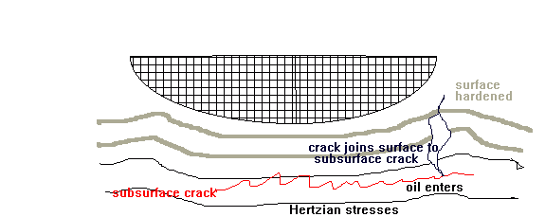
Very careful honing with a carborundum stone can be helpful but care should be taken not to alter the tooth profile
Cracking , flaking and spalling often indicate incorrect heat treatment ; or in the case of ground gears, faulty grinding.
Most often found in case hardened or surface hardened gears but may also appear on work hardening gears such as phosphor bronze.
It can be seen that pitting, flaking and spalling are all related , the mechanics of failure is the same in each case and only the size of metal loss is different .

FLAKING
Caused by heavy overloading or over stressing the subsurface of the metal and is a surface hardened phenomena.
The heavy compressive or shearing action on the subsurface can exceed the yield point stress of the metal and large flakes may break away.
Can be caused by insufficient depth of surface hardening
Rippling of the subsurface may also occur caused by plastic flow.
Similar formation to pitting but has a much increased length/breadth to depth ratio .
On hardened gears , flaking or spalling may be accelerated by abnormal heat hardening strains which decrease resistance to sub surface shearing forces . Heavy loads on worm gears may subject fairly large areas of tooth surface to greater stresses than the metal is able to permanently carry. Sub surface fatigue takes place which results in damage to the bronze gear-tooth surface . This condition is often referred to as worm wheel pitting.

SCUFFING/ (WEAR)
This type of failure - caused by the local breakdown of oil film as the surfaces slide over each other during mating and disengaging - led to the development of EP additives. It was also found that increasing oil viscosity was beneficial.
With oil film breakdown, very high tempo are generated and welding of local high spots occurs Similar to that occurring with microseizure). These are then torn apart.
It is most prevalent at the tips and the root were relative sliding is at its greatest .
Were the oil film thickness is greater than 3x the CLA values of the surface finish scuffing is unlikely to occur.
Evidence shows that onset occurs when a tempo related to the lubricant an surface material exceeds a flash point.
Scuffing is definitely due to failure of the oil film to carry the load, either because the operating conditions are abnormally severe, or because of incorrect oil selection. In either event , the thick wedge type film gives way to the microscopically thin , boundary type lubrication which in turn lacks sufficient film strength. to protect the gear teeth from excessively friction and the plastic flow of the 'skin surface' of the metal.
Under conditions of wedge film lubrication, failure of the film would occur where the combined film- forming effect of both rolling and sliding is least, namely the pitch line. Therefore , with fluid film lubrication , seizure would first occur near the pitch line and plastic flow would then tend to wipe the metal over onto the tooth areas that are in contact during the second half of mesh ( interval of recession ) . Scuffing in the areas above the pitch line on driving gears and below the pitch line on driven results.
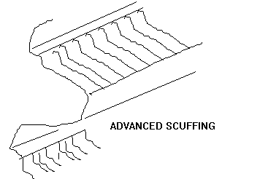
Where operating conditions are more severe and boundary lubrication is resultant , the entire surface of the tooth will be scuffed .Pressure welding and plastic flow then takes place during the intervals of approach as well as recession , and surface destruction will extend from root to tips of the teeth of both gears . Even though scuffing is the initial cause of failure , severe damage may eventually bring about abrasion and scratching.
It should be noted that EP additives are very soluble in water ,hence, care should be taken when putting this oil through a purifier.
During the interval of approach , the direction of sliding on the contact surfaces is toward the pitch line on the driven gear and away from pitch line on this pinion. At the pitch line the direction of slide reverses , so that during the interval of recession it is still toward the pitch line on the driven gear and still away from the pitch line on the pinion.. Thus , when surfaces scuff, weld and flow under pressure , the direction of slide always tend to wipe the metal on the metal on the driven teeth towards the pitch line and away from the pitch line on the pinion teeth.
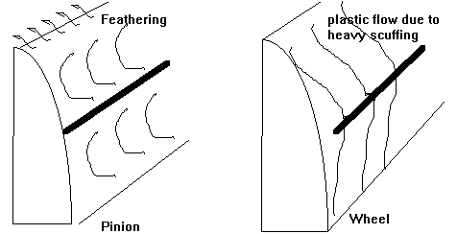
May spread to whole tooth , a feather being formed over the tooth tip . If occurs at one end of the tooth this can indicated a misalignment.
Poor surface finish and overloading are the prime causes normally found in softer materials of the wheel.
Use of scuff resistant materials , better surface finish , chemical cleaning and thermo chemical treatments can help, as can surface coatings
Light honing plus more attention to oil viscosity and tempo may help.
Experimental evidence show that scuffing or scoring resistance is raised by increasing the pressure angle, increasing tooth depth or when possible increasing the helix angle and providing tip relief. Scuff resistant metal combinations may be used, better surface finish, chemical and thermo-chemical treatments, surface coatings can all help to increase scoring resistance

Incipient scuffing
If the surface finish is poor , contact between the asperities can be made through the almost rigid ( i.e. very high viscosity caused by the very high pressures ) oil film, generating heat causing the tempo of the gears to rise, reducing inlet oil viscosity and reducing oil film thickness . Some materials when supplied with the correct lubricant quickly polish out incipient scuffing . With harder gears this process takes longer . The risk is high due during the running in period but minimised by chemically active EP oils or with a surface treatment such as phosphating

SCORING
Should a ferrous particle enter the mesh it can be embedded in a tooth .On mating the particle is heated up by welding, fails in the heat effected zone , and quenches in the copious supply of oil. Some of the oil is carburised , absorbed into the particle , which is now very hard and becomes embedded in a tooth forming a spike. This then gouges a score in the teeth as they mesh until it becomes polished out . If the mark is on the pitch line then a point will form rather than a gouge

ABRASION/ (SCRATCHING )
Caused by foreign abrasive materials entering the mesh
May appear as a score from root to tip caused by hard projection on one or more teeth penetrating oil film- this can be referred to as scoring or ridging or may appear as random scratches caused by dirt in the oil.
Another form leads to a highly polished surface and is caused by very fine particles or dust in the oil.
The only remedy is careful filtration and honing of bad grooves. Cleanliness is most important. Very heavy abrasion can lead to change in tooth profile.

PLASTIC FLOW
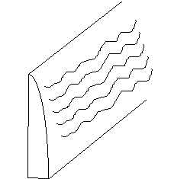
Due to plastic , cold working of the metal which flows ahead of the pressure area building up a wave of metal until by work hardening the ripple resists the flow.
Immediately after this a further wave forms. in extremes, a line of pits form on the crest caused by the subsurface shearing rather than the compressive stress.
Main factors are unsuitable material , overloading and misalignement .
Hypoid and spiral gears are particularly susceptible to this . This type of failure occurs particularly following partial lube oil failure. Plastic flow rather than scuffing occurs.
When slight , the rippling effect maybe advantageous acting as oil reservoirs.

Fish scaling
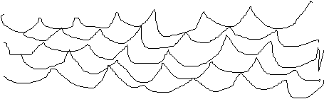
As the flow increases in severity, then the tooth profile alters to a similar condition to that seen due to scuffing.

GALLING.
Very heavy teeth damage due to various reasons, requires new teeth.

BREAKAGE
Has four main causes;
  - overload
  - defective material
  - faulty workmanship.
  - fatigue
Also may be caused by foreign material falling in to the mesh. Checks for cracks should be carried out at regular intervals especially following overload.
Checks can be carried out using dye penetrant on magnetic indicators.

CORROSION
The supply of dehumidified air to the crankcase is carried out to prevent corrosion.
Corrosion products can lead to the rapid deterioration of the lube oil and lead to sludge formation .
Regular checks should be carried out to ascertain the efficiency of the dehumidifier.

INTERFERENCE WEAR.
This occurs where teeth become too closely engaged .This can occur when fitting new bearings which are incorrectly bored.
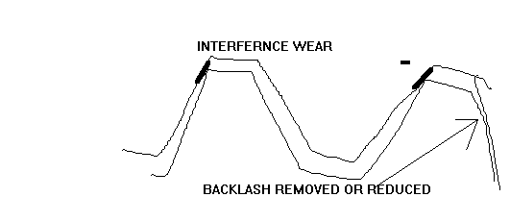

PROBLEMS FOUND DURING NORMAL USE.
In normal use, a contact area becomes polished .A wear ridge may form which may move as the bearings become worn, if new bearings are fitted then the position of the ridge will move. Problems may the occur of the teeth slipping off the ridges leading to noise and possibly removing thin shards of metal.
Plants running at reduced load, hence reduced tooth bending moment wear in a certain area . Should the plant then be run at full load it may be found that due to the wear the tip relief is now insufficient.
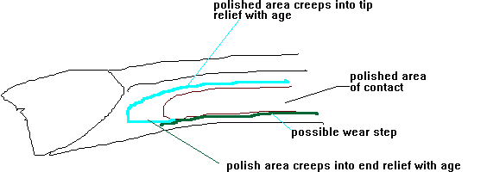
MISALIGNEMENT- Causes problems of overloading at the ends of teeth.
EXCESSIVE BRG CLEARANCE-Pinion moves out of mesh to far, hence load taken on ends of teeth giving excessive bending forces.
INCORRECT TOOTH PROFILE- Pitting and noise
PARTIAL SEIZURE OF ROTOR FLEXIBLE COUPLING- Gearing loads transferred to turbine possibly causing to turbine.
If the axial clearance is completely taken up then the main thrust ( as the pinion is locked by the double helical arrangement ) WORM GEAR FAILURES Pitch line pitting as described for spur tooth gearing does not occur in worm gearing. Due to the greater slide in this type of gear than in spur or helical gears, the tendency is for the tooth surface in equalities to be worn away before metal fatigue occurs . Tooth surface failure by abrasion or scoring can occur exactly as in other type gears, but the most commonly encountered worm gear failures are the flaking or scuffing types. Heavy loads on worm gears may subject relatively large areas of tooth profile to stresses sufficient in severity to cause sub surface fatigue and eventual flaking of relatively large pieces of bronze. Flaking on worm wheel gears is frequently heaviest on the ends of the tooth leaving the mesh. Spot tempo in this areas are higher than elsewhere and it is probable that the fatigue resistance of the bronze is lowered as a result . In some cases localized flaking may be due to misalignment. Lubrication failures do occur on worm gears either due to unsuitable oils , incorrect or excessive loading. Scuffing is the usual type of failure and this is influenced by the grain structure of the bronze .

HYPOID GEAR FAILURES
Where hypoid gears are involved , surface failures on teeth may take several different forms . These steel to steel gears are generally so heavily loaded , especially in automotive equipment, that although they are flood lubricated , boundary lubrication is the usual condition. Metal to metal contact is therefore , unavoidable. With the correct lubricating oil in use , the degree of metallic contact and the generation of frictional heat between the rubbing surfaces is minimized . Irrespective of speed, such conditions result in smooth , dull polished or brightly burnished tooth surfaces with negligible wear. When hypoid gears show evidence of unsatisfactory lubrication , the surfaces may have the appearance of being either rippled , ridged , flaked , pitted or scored.
The particular surface appearance that developed depends on the type and severity of operating conditions i.e. on the speed of rubbing and the magnitude of loading carried by the working surfaces. Furthermore it depends on the lubricity, film strength and anti weld characteristics of the lubricant.
The working surfaces of hypoid gear teeth sometimes develop fine ripples ( fish scale appearance ) . When this happens , the ripples have the appearance of being formed by the metallic flow which builds up a wave of metal ahead of the pressure area, The appearance of the surface indicates that each wave quickly becomes sufficiently work-hardened to resist further flow , whereupon contact then moves over the hard surface to repeat the process immediately beyond. This results in the formation of small wave-like ripples of work-hardened metal at right angles to the diagonal lines of slide , it seems to occur only at comparatively slow speeds.
As rippling progresses, the continued cold-working of the metal causes sub-surface fatigue cracks to develop, with the result that thin flakes of metal ultimately break loose from the surfaces and drop off. This flaking (spalling) action is more pronounced on the tooth surfaces of the pinion due to the smaller number of teeth among which the load is distributed.
A tooth sometimes appears to have a smooth and very highly polished or burnished surface. Under a microscope , however , the smooth surface may take on a very finely ridged appearance with innumerable short, parallel ridges extending diagonally across the working surface of the tooth i.e. in the direction of the slide. Each ridge appears to be made up of many short ridges added approximately end to end. They do not have the appearance of typical scratches or score marks. The hills and valleys have a smoothly rounded outline.
Either a rippled surface or a burnished surface may develop a ridged appearance with ridges of such size that they can be seen and felt .There is no evidence of gouging or tearing but due to the size of the ridges considerable cold working has occurred. Continuation of this cold working leads to the fatigue point being passed . When this this happens , small cracks develop and minute particles of overstressed metal break loose and drop off., leaving fine pits along the crests of the ridges . This pitting may occur over the entire working surface of a hypoid gear tooth . It , therefore , should not be confused with pitting of spur or helical gear teeth which is due to entirely different causes and occurs only near the pitch line. Continued and extensive pitting eventually results in the removal of considerable areas of metal from the tooth surfaces and extensive flaking.
On hypoid gear teeth , scoring results when particles of metal are displaced or transferred from teeth of one gear to the teeth of the mating gear. It may also be referred to as scuffing or galling, particularly in the advanced stages. Scoring is the final result of a combination of factors i.e. High rubbing . speeds and loads , low film strength and insufficient anti-weld character of the oil. When film strength is lacking, considerable metal-to-metal contact will occur, and if the rubbing speed is high enough , frictional heat at microscopic points of contact will create local welding tempo .If the oil lacks anti-weld ( E.P.) character scoring results.

Normal wear
When gears are of the proper design , construction and hardness, do not operate at excessive loads and are correctly lubricated, a condition of normal wear result. Normal wear over a long period and under conditions of flood lubrication gradually smoothes rubbing surfaces of the teeth and work-hardens them to a polish. As the surfaces become smoother and more work hardened , friction and wear decreases until a condition may be reached where further wear practically ceases. There may be signs of long use , but the metal is peened , rolled and polished to a smooth hard surface. Correct boundary lubrication on hypoid gears results in a smooth , dull matted gear-tooth surface and relatively little wear.

CALCULATION OF MAX TOOTH LOADING.
Severity of tooth contact ; is generally expressed in terms of:
Tangential load/face width
Alternately a 'K' factor based on the Hertzian stresses is used
K= W/Fod x mg + 1/mg
W= tangential load on gear teeth ( lb )
(pinion torque/pitch radius of pinion)
Fo = face width of teeth (inches)
d = pitch diameter of pinion ( inches )
mg = gear ratio; pinion speed / wheel speed
In the 1950's 'K' factors for turbine reduction gears were about 35 to 80 for unhardened alloy pinions on carbon steel wheels. With improved materials, heat treatment and manufacture; hobbed, shaved gears can have 'K' factors of:
150 max. for primary reduction ( through hardened )
130 max. for secondary reduction
For hard/soft combinations 240-210 respectively
Certain high performance naval vessels have a 'K' factors of 300
The most common failure is when a tooth or part of a tooth breaks off due to fatigue
Impact failure is rare and generally due to negligence.

Problems caused by incorrect warming through
The main object of warming through is to ensure straightness of the rotor.To do this a negligible temperature gradient must exist throughout the rotor.
There is a tendency for the rotor to hog where the steam is introduced( that is to say the rotor bends due to temperature gradient rather than sagging under gravitational forces) with the rotor steam is introduced. Hence the rotor must be rotated.
The graph below indicates the importance of this.
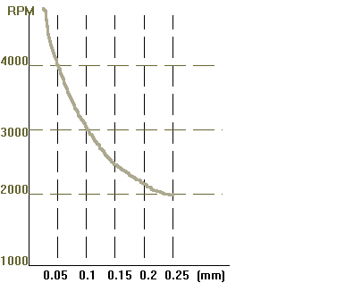
The line is the out of balance force due to centrifugal force equal to the mass of the rotor.
Hence, the offset at 3000rpm to cause an out of balance equivalent to the mass of the rotor is 0.102 mm
testing of the engines after shut down ahead and astern should be taken as part of the warming through process. Close watch of the relevant nozzle box temperatures is a good indication of the condition of the turbine.
Second object of warming through is to prevent distortion of the casing. Rotation of the rotor churns up the steam and provides adequate mixing. With underslung condensers the temperature gradient is virtually unavoidable, hence separate condensers are better.
The third objective is to prevent thermal stresses caused by the temperature gradient in thick materials such as at the bolt flanges. Vertical slots are often provided to help alleviate this problem, this distortion can also lead to non concentricity of the casing
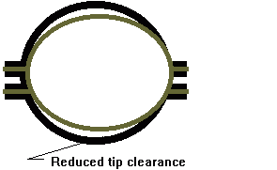
This is particularly prevalent in open cylinder designs such as axial plane or double casings.
Heat transfer rate is at its greatest where the steam is condensing on the surface of the casing. This in turn is governed by the inlet pressure of the warming through steam. Hence, warming through in steps providing adequate period to stabilise the temperature at each step.
Complete warming through cannot occur until nearly at full power , hence, warming through much above atmospheric saturation temperature is pointless.
Also as part of the LP turbine runs at lower temperature, warming above 100ºC is unnecessary. Protracted warming through periods are unnecessary. A temperature of 82ºC at the LP inlet belt in 30 mins is acceptable
Vibration caused by an out of balance of the rotor may be alleviated by running for a short period at reduced engine speed followed by a slow increase in speed.

