BEARINGS

THRUST BEARINGS

The thrust bearing is placed at the inlet end of the turbine casing as this is the hottest end and hence the most effected by differential turbine/casing expansion. This helps to prevent damage to the glands and also allows the use of reduced clearances, necessary as the specific volume of the steam is at its highest
Standard
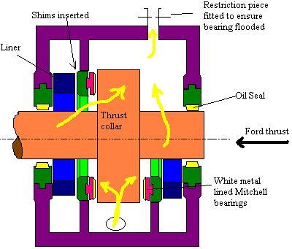
A half set of pads are fitted in the aft thrust direction as these are mainly for location only and do not carry any axial loading caused by the passage of the steam.
Oil enters the lower portion of the bearing and passes up via a restriction to ensure the assembly remains flooded with oil

Self Aligning

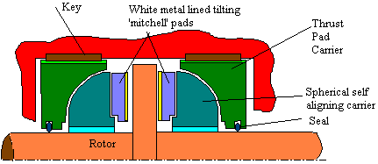
The high inertia of the spheical carrier reduces the arragements ability to cope with distortions and imperfections. The key prevent sthe rotation of the carrier.
Modern Self Aligning
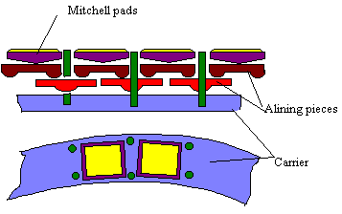
This design has less inertia and hence is more effective with dealing with distortion.
Mitchell tilting pad bearings are commonly used due to their self aligning properties. The length of the pads is limited due to lubrication problems at the thin end of the oil wedge.
The pads are formed initially as a single ring then machined to requirements. This is why all pads must be changed following failure
Thrust Bearing Clearance
For inital setting up the rotor is centralised by jacking for'd and aft, and the clearance on the ahead side measured. A complete set of pads with carrier are made up to exactly the correct size. The astern size is measured, a running lube oil clearance subtracted and the astern set built up. The whole lot is fitted and final clearances measured.
The retaining ring is split at the horizontal axis. Stop plates at the joints prevent movement of the mitchell pads, one of these stop plates is extended and prevents the retaining ring moving
On the HP turbine normally only a half set of thrust pads are fitted. For the LP turbine with an astern turbine a full set is used. Shils and liners are fitted to set clearance.
There is a tendency for oil to be flung to the periphery under centrifugal action. ence, the orifice is fitted to ensure flooding, also metering flow from main system.
Total clearance = 0.25mm
This may be checked by attaching a finger plate to the casing and jacking the rotor for'd and aft. Poker guages may be used when the turbine is running.
Gun metal or mild steel is used for backing plate. Babbit metal (87% Tin, 8-9% Antimony, 3-4% Copper) for bearing face

MAIN BEARING
Main Bearing
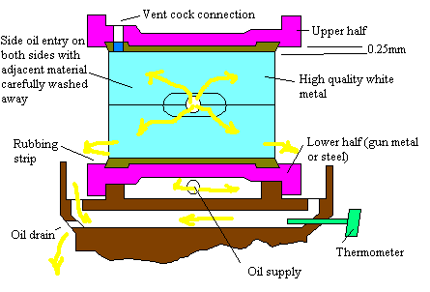
Teh length/diameter ratio is 2/3 to 3/2, the smaller figure is more relative to modern designs and can help reduce oil whirl. The top clearance is 0.5mm, this is sufficiently large to allow for large quantites of oil flow to aid cooling. No oil ways are provided other than a small amount of metal washed away at the inlt oil ports.
Maximum oil temperature is 83'C
White metal thickness 0.25 to 0.5mm, the thicker this layer the greater the ability to cope with dirt absorbtion. Thicker white metal is required for gun metal backed bearings due to the possibility of copper pick up should the white metal run. The white metal adheres better to the steel and provides better rigidity.
Typical white metal 85% tin, 8.5% Antimony, 6% copper.
An antisiphon device prevents all the oil leaving bearing if there is a failure of oil supply
Dummy bearings must be introduced to allow removal of lower bearing for inspect

