Turbine blades

Impulse blading system design
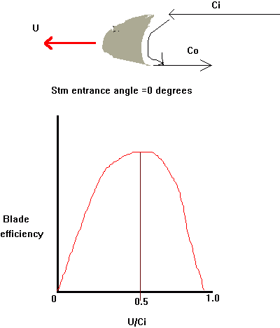
Hence, maximum blade efficiency is when entrance angle is at 0º and when the blade is rotating at 1/2 the speed of the jet stream
As the steam must enter at an angle aº
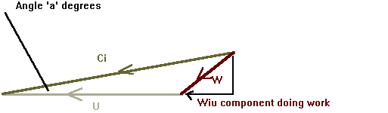
Optimum value for U / Ci = 1/2 cos a ( 0.45 to 0.48 )
Maximum blade efficiency = Cos² a (14º to 20º)
Impulse blading may have up to 20% reaction effect at mean blade height.
Astern turbines generally consist of a single wheel on which are mounted a tow stage velocity compound followed by a single stage wheel
Properties required of the blade material
  - Good tensile and fatigue strength
  - Toughness and ductility at working temperature
  - Resistance to corrosion and erosion
  - Rate of expansion similar to both rotor and casing
  - Machinability
  - Low density
  - Good vibration dampening properties
  - Good crep resistance
  - Weldability
Typical blade material is
  - 11.5 to 13.5% Chromium
  - 1% Nickel
  - 1% Manganese
  - 1% Silicon
  - 0.12% Carbon
  - Trace Sulphur & phosphorus
Low tensile stainless steel preferred to high tensile stainless iron due to better fatigue resistance. Where lacing wires are to be brazed in special care must be made as to the intergrannular penetration effects of the braze

Bull nosed blades
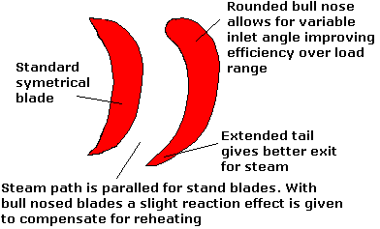
Standard blades have the same inlet and outlet angles.
Bull nosed blades are capable of accepting a wide range of steam angles without serious increase in blade losses.
The cross sectional area is increases and hence the blade is stronger and better resistant to vibration. The increase thickness also allows a circular tang to be fitted for attaching a shroud. Non circular such as square tangs require the shroud to be punched rather than drilled which introduces residual stress, micro-cracking etc.
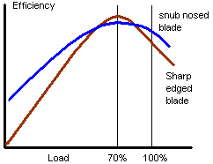

De Laval Impulse Turbine-Single Stage
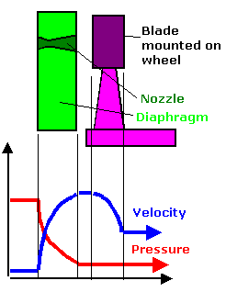
Optimum efficiency occurs when the blade is moving at half the speed of the jet stream. To achieve this very high rotational speeds would be required ( in the order of 15000 rpm). High centrifugal stress, high journal speed and excessive gearing requirements prohibits the use of such system for propulsion by itself.
This system is often found as the first stage of a HP turbine were a large pressure drop is required to allow for a smaller turbine. Only the nozzle box has to cope with full boiler pressure and temperatures simplifying design especially of gland boxes. Special material requirements are again restricted to nozzle box. Reduced pressure within the following stages reduces tip leakage
The steam leaving the blades has a high kinetic energy indicating high leaving loss.

Pressure Compounding (Rateau)
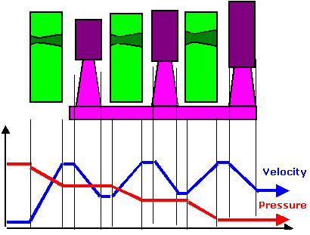
The overall heat and pressure drop is divided between the stages. The U/Ci ratio is 0.5 for each stage. By careful design the rotor mean diameter may be kept to a minimum.
Excessive number of stages produces an overly long rotor, these leads to problems of critical vibration, increased rotor diameter, increased stage losses due friction and windage and increased gland leakage both at the main glands and the diaphragm plate glands. This due to the increased number of glands and the increased rotor diameter.
Stage mean diameter and nozzle height are increased at the LP end as the steam expands to the limits of centrifugal stress. Nozzle and/or blade angles may be altered to accommodate the increase in volume reducing the requirement to increase blade height excessively.This is referred to as taper-twisting
The blade height increase towards the LP end means that the rotational velocity also increases. Hence for the same value of U/Ci they can deal with higher inlet steam velocities and hence higher enthalpy drops p>The design produces a short lightweight turbine used where size, weight and strength are more important than efficiency. E.G. feed pumps , astern turbines and the inlet portion of HP turbines where it provides a large initial drop in temperature and pressure lightening the rotor and reducing the need for high grade alloys for remaining stages

Velocity Compounded (Curtis)
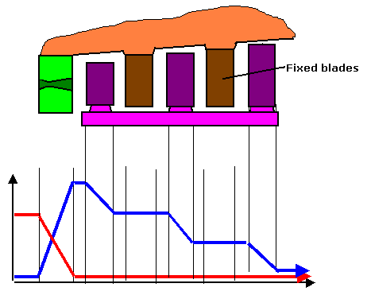
For a two stage system U/Ci = 1/4, for a three stage system U/Ci = 1/6
There is no pressure drop except in the nozzle ( although in practice some drop occurs due to losses as the steam passes over the blade). Dividing the velocity drop across the stages leads to a loss of efficiency but gives a more acceptable blade speed reducing centrifugal stress and simplifying gearing arrangement.
For a three row system, the steam speed at inlet to the first row is 6 times the blade speed, reducing the velocity makes the conditions at the final stages close to ideal.
To maintain the same mass flow for the reducing velocity, blade height is increased to the limit of centrifugal forces. Taper-twisting and flattening of the blade angle is then given to the final stage blades.
Some reheating occurs due to friction of the fixed blades associated with a loss of velocity of about 12%
Theoretically efficiency is independent of the row number. However in practice efficiency and work done in final stages reduces and therefore overall efficiency drops with increase rows.
- Typical values for efficiency are
  - two wheel curtis 68%
  - three wheel curtis 50%
  - Single wheel rateau 85%

Pressure-Velocity Compound
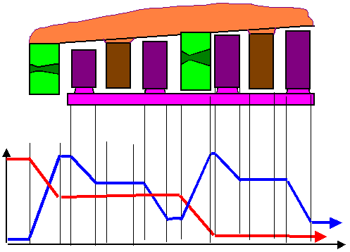
This system gives the advantage of producing a shortened rotor compared to pure velocity compounding. In addition it also removes the problem of very high inlet steam velocities and the reduction in efficiency and work done in the final stages.
In this design steam velocity at exit to the nozzles is kept reasonable and thus the blade speed (hence rotor rpm) reduced.
Typical applications are large astern turbines

Reaction
U=Blade speed
Ci= velocity of steam at inlet to blade, i.e. leaving nozzle( giving nozzle angle)
Ci rel= velocity of steam relative to the blade( giving blade inlet angle)
Co= Velocity of steam at outlet of blade
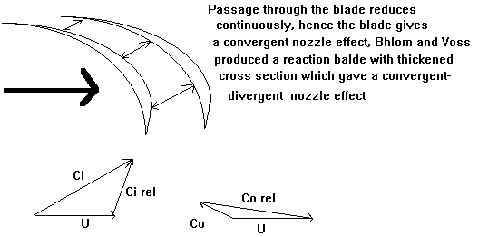

Parsons Impulse-Reaction
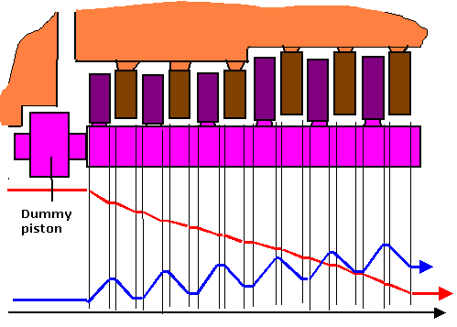
The original blade design was thin section with a convergent path. Blohm & voss designed blades similar to bull nose impulse blades which allowed for a convergent-divergent path. However due to the greater number of stages the system did not find favor over impulse systems
U/Ci = 0.9
If the heat drop across the fixed and moving blades are equal the design is known as half degree reaction.
Steam velocity was kept small on early designs, this allowed the turbine to be directly coupled to the prop shaft.
Increased boiler pressure and temperature meant that the expansion had to take place over multiple rotors and gearset.
As there is full admission over the initial stage, blade height is kept low. This feature alone causes a decrease in blade and nozzle efficiency at part loading. In addition, although clearances at the blade tips are kept as small as practical, steam leakage causes a proportionally higher loss of work extracted per unit steam
Blade tip clearances may be kept very tight so long as the rotor is kept at steady state.
Manoeuvring, however, introduces variable pressures and temperatures and hence an allowance must be made.
End tightening for blades is normally used. This refers to an axial extension of the blade shroud forming a labyrinth. When the rotor is warmed through a constant check is made on the axial position of the rotor. Only when the rotor has reached its normal working length may load be introduced. Alternatively tip tightening may be used referring to the use of the tips of the blade to form a labyrinth against the casing/rotor. This system is requires a greater allowance for loading and is not now generally used.
To keep annular leakage as small as possible these rotors tend to have a smaller diameter than impulse turbines.
To keep the mass flow the same with the increasing specific volume related to the drop in pressure requires an increase in axial velocity, blade height or both -see above. Altering the blade angle will also give the desired effect but if adopted would cause increased manufacturing cost as each stage would have to be individual. Generally the rotor and blading is stepped in batches with each batch identical.
The gland at the HP end is subjected to full boiler conditions and is susceptible to rub. The casing must be suitably designed and manufactured from relevant materials.
A velocity compounded wheel is often used as the first stage(s) giving a large drop in conditions allowing simpler construction of casing and rotor and reducing length. Special steels are limited to the nozzle box.

Dummy piston arrangement on Parsons Turbines
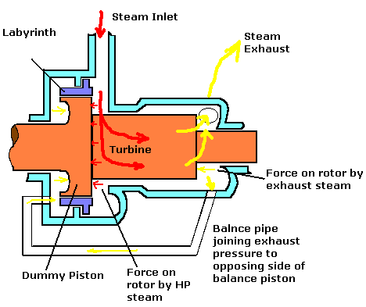In parsons reaction turbines there is always an end thrust due to the steam at inlet being higher than the exhaust. This leads to high thrust bearing loading. The dummy piston arrangement is a wheel or drum integral to the rotor. Forces are balanced by the drum offering a greater surface area to the low pressure balancing steam than to the HP steam.Note the drawing above is not to scale.
A labyrinth arrangement is fitted to seal the drum.
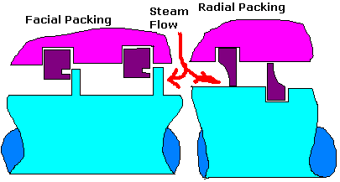

Double Flow Turbines
These are found mainly on large LP turbines. Here steam enters mid rotor and passes axially towards both ends. The advantages are;
  - End thrust is balanced removing need for dummy pistons or cylinders on reaction turbines . Reduces the size of the thrust on impulse-reaction turbines
  - As steam flow is split the final stages blade height and angle is reduced allowing for increased efficiency and reduced centrifugal stress. Greater power per unit size may be absorbed.
The main disadvantage of this system is increase rotor length leading to increased risk of sagging

Blade Sealing
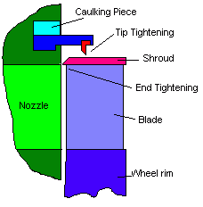
May be end or tip tightening
End Tightening
This is seen particularly on reaction turbines. It requires accurate positioning of the turbine rotor and is normally associated with lengthy warm up perios during which the position of the rotor is carefully monitored. Operational limitations on rapid power changes may be in place. The author has seen this system in use on very large but compact turbo alternators which required a warm up period consisting of increaseing the rotor speed in stages over one hour
Tip Tightening
Clearance is governed by maximum blade centrifugal stretch

Turbine blade fixing

Blade stresses
The predominant stress in turbine blades is centrifugal and concentrated at the root
Vibration is set up in blades due to fluctuations in steam flow.Particularly in impulse turbines where partial admission is used
Further stress is caused by expansion and contraction as well as bending stresses due to the action of the steam
In addition to these stresses occur during manoeuvring due to speed changes.

Fixed Blades
Although not subjected to centrifugal force, the fixed blades of curtis velocity compounded turbines are subjected to vibration in a similar way to the rotating blades. The root fixture must, by necessity, be secure to prevent fretting
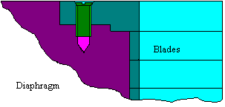

Reaction Blades
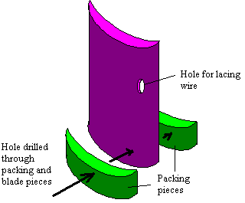Blades are rolled to correct shape then cut to length.
Up to 50 blades are then assembled in a jig of correct radiurwith a distance piece to give the correct spacing.
The root is drilled and the upper part machined so as to accept shrouding fro end-tightening, or thinned for tip tightening.
After assembly on the jig a hole is drilled though the base and a wire passed through. The whole assembly may then be removed and brazed or spot welded to form a solid curved section.
The arc is then machined to the desired root form. Shown below is a single blade section of the arc showing typical root form.
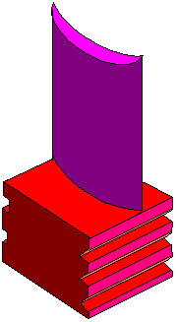
The segment is dropped into position pushed axialy and a caulking piece fixed

A gate is formed in the final blade which receives a further thin section piece made of copper which is caulked in.
The fixed blades in reaction turbines are made in a similar fashion except that the end blades as held in by a screw and locking strip as the horizontal joint. ALso the root may be of a simpler design due to the lack of centrifugal stress.
For higher speed, higher rated turbines the built up method may not be acceptable due to the stresses.
These blades may then be made of soild individual sections. The blades enter through a gate with the final blade being caulked into position.
The gates for each groove are staggered to assist balancing. The lacing wire/shrouding is then fitted.

Impulse Blades
The most common form is the dove tail.
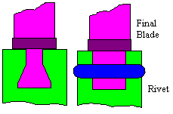
The groove is cut away to form a gate to allow the fitting of the blades. The final blade is riveted in position.
Blades subjected to higher centrifugal stresses, for example the longer tapered blades found in the final stages of the LP turbine, may have the fir tree root method which allows increased contact area without weakening root or wheel rim.
To reduce centrifugal stress on the wheel straddle root form of blade fixing may be used thinning the wheel rim. The straddle may be a simple fork design or of fir tree root. Rivets are added for strength.
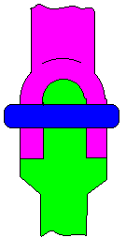
Inverted fir tree root
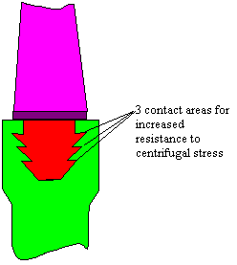
Fir tree root attachment is very strong but requires accurate machining and manual blade fixing is not possible. The gate is filled with a machined block with no blade and then riveted to secure.
Multiple forks
For very large blades, say at the end if the LP turbine, the root, and thus wheel rim, would be required to be very large. Multiple forks may be used which are comparitively easier to machine.
Straddle 'T'
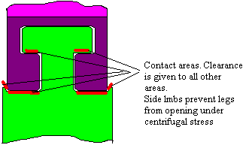
Straddle 'T' used rather than inverted 'T' so that the holding faces on the rim can be easily inspected for defects.
Stal Laval bulb root
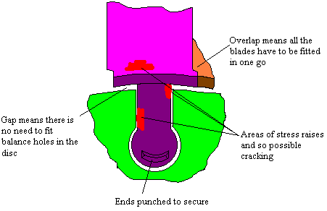
The main advantage of this system is that the blades are introduced into the rim axially. Therefore the individual fitting of the blades required with circumferential root arrangements is unnecessary
Where the distances between the bulb becomes so small as to risk failure of the rim, staggered bulb root depths are used with alternating short and long shank lengths.
For these types of blades the shrouds are part of the blade. On this shroud are two tabs. A shrouding wire is passed around the circumference over the shroud and the tanbs are bent over. This has the advantage that in the event of root failure some support is given to the blade. Multiple shroud wires are filled rather than a singe one for ease of manufacture allowing smaller tabs, and also to reduce mechanical stress. On more modern designs the groove is moved to the end of the shroud and a welded shroud wire fitted.

Sizing the rim

When the rim is first cut and the entrance gate formed, a test blade with slightly too large root ( or feet) is carefully filed and then tapped around the rim. This blade is then discarded. The real blades are then carefully filed and fitted taking into account the wear on the rim. The nating face of the blades are filed to ensure even blade pitch. A tight fit is essential with a steam turbine, if not then severe fretting and failure will occur. Turbine blade vibration
Damping wires, Lacing wires and shrouding are fitted to
  - reduce stress due to vibrations in the blade excited by such as steam flow fluctuations as the blades pass the nozzles. This is referred to as the 'passing frequency'. This particularly occurs with partial admission
  - To prevent spreading of the long thin blades found in the final stages of the LP turbine. Shrouding is not fitted to these blades to allow adequate drainage. Due to the high specific volume losses due to spillage is relatively small
  - Steam changing direction as it passes over the blade tends to build up in the concave face. There is a tendency to flow to the tip where if unchecked it can spill over leading to considerable loss of efficiency. This is particularly important in parsons turbines expecially as the initial stages of the HP turbine where the steam has a low specific volume.
The vibration associated with turbine blades is referred to as the 'clamp-pin' type and is determined by vieing the blades in their packets i.e. blade groups attached by their shroud.

Frequency types
The lowest frquency is of the whole packet vibrating.
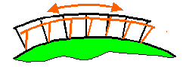
Higher frequency is where as equal number of blades bow in oposite directions
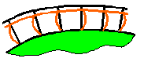
Higher still frequencies occur where each blade vibrates
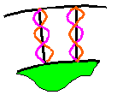

Lacing, Damping and Binding wires
There are four sources of vibration damping under normal operating conditions
  - Internal damping of the blade material
  - Inherent dry friction damping of the blade assembly at the root and tip
  - Fluid damping or viscous damping due to the steam environment
  - Mechanical damping through fitting of damping aids such as damping or lacing wires etc
Lacing wires fitted at an anitnode provide a very effective form of dampening. However, the antinode may exist at different positions for the different types of vibration so a compromise on the position has to be reached.
A Damping wire which is 'free fitting' is free to move within the holes. Centrifugal force throws the wire to the outside of the hile where frictional effects help dampen the vibration. The disadvantage of damping wires is that heavy fretting can eventually cause the holes to widen to an extent that the rotor has to be rebladed.
Lacing wires are brazed in and are therefore strengthening and hence are not necessarily placed at an antinode but rather where the blade is thickest.
Binding wire is used to strengthen the trailing edge of the blade. This is a very old fashioned technique and is little used.
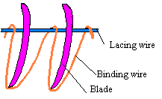
The use of round wire can lead to aerodynamic losses

Taper-Twisting of blades
Reasons for taper-twisting of the final stages of LP turbines
  - Due to the change in centrifugal velocity with the increase diameter towards the exhaust end the true vector velocity of the steam varies over the length of the nozzle. The blade must be twisted to ensure the steam enters at the correct angle
  - The tip has an aerofoil section to increase the reaction to equalise the flow of steam across it which would otherwise be non-uniform due to the pressure difference between the tip and base due to centrifugal action
  - The tapered blade design allows an increased distance between the blade and nozzles. This gives water droplets more time to increase in speed driven by the steam flow.
In addition the tangential velocity is much greater than that of the axial velocity and hence the rotating disc of steam tends to centrifuge out the water droplets
  - When viewed as a cantilever beam the tapered design is ideal from a mechanical point of view to resist bending
  - The tip aerofoil section increases the reaction to equalise the flow of steam across the bladewhich would otherwise be non-uniform due to the pressure difference between tip and base caused by the centrifuged steam
