A gear coupling is a power transmission coupling which uses a hub with gear teeth on the outside diameter of the input shaft. Like hub on the output shaft is connected by a flange or a sleeve with teeth on the inside diameter, to transmit torque and to accommodate shaft misalignment. This coupling is usually all metal in construction does require lubrication, is very rigid torosionally, and can transmit high torque through relatively small packages.
A coupling comprises a clutch having an input connection to the power take off and an output for connection to power transmission input of the trailer unit. The tension in the coupling when it connects the tractor and trailer units is monitored, and the slippage of the clutch is controlled in response to the monitored tension. This is required so as to maintain the speed at which the trailer unit is driven substantially the same as the speed at which the tractor unit is driven.

Types of couplings

* Flexible Coupling

- They couple or connect rotating members such as motors and drive shafts while allowing misalignment in either angular or parallel offset orientation. Coupling types can be sliding block, roller or silent chain. When searching for flexible couplings some mechanical properties are to be considered. These include rated torque, rated speed, torsional stiffness, and backlash. Rated torque is the maximum service torque for which coupling is rated. The rated speed is the maximum rated rotational speed of coupling. Stiffness is expressed in torque per unit angular deformation. Backlash is the rotational position loss due to a direction change.

* Rigid Coupling -

Connect or couple rotating members such as shafts. They secure onto both members and provide transmission of torque and motion. They do not allow for angular or parallel misalignment.

Coupling of several turbines
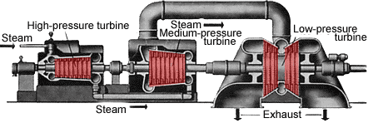
Grafic: Coupled steam turbine. source: Helmut Hütten, "Motoren", Motorbuchverlag Stuttgart, S.379
In power stations today, different types of turbines are used in a series, e.g. one high pressure -, two medium- and four low pressure turbines. This coupling leads to an excellent efficiency (over 40%), which is even better than the efficiency of large diesel engines. This characteristic and the relatively favorable production make the steam turbine competitionless in power stations. Coupled with a generator and fired by an atomic reactor, they produce enormously much electric current. The strongest steam turbines achieve today performances of more than 1000 megawatts.

