Turbine rotor

HP rotor
Most modern HP rotors are made of a single gashed forging of high quality steel.A hole of 50mm is bored axially through the rotor to allow for internal ispection and to remove impurities and internal flaws which can cause premature failure. In addition to the blade wheels also found on the rotor are; Thrust collar, Journal bearing surfaces, Oil thrower, Gland, Conical seat, thread or flange to attach flexible coupling
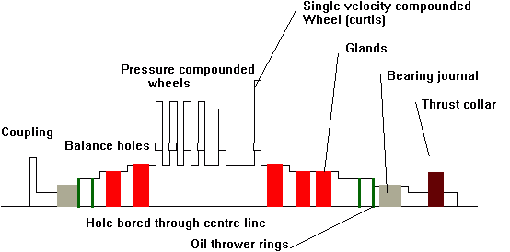
Most modern HP turbine rotors are of the Rateau or pressure compounded design.
Reduced number of stages ( 8 to 10 ) give a shorter rotor and provides savings in weight and length. Also provides for better critical vibration characteristics.
Rotors are solid forged providing
  - Homogenous rotor with even grain flow
  - Even expansion
  - Good thermal stability with less likelihood of distortion under high temperatures
After forging the rotor is machined, wheels may be parallel or slightly thickened at the base . The methods is also used for the LP turbine which has 7 to 9 stages plus 2 to 3 astern.
After rough machining rotor is given a thermal stability test, after further machining and fitting of blades the rotor is given a static and dynamic balance.
This design is known as the Gashed disc rotor and gives a minimum shaft thickness and hence a minimum area for gland sealing to prevent steam leakage.
Material ( up to 566ºC )
  - 0.27 - 0.37% Carbon
  - 1.0% Manganese
  - 0.04% Sulphur
  - 0.2% Silicon
  - 1.0% Chromium
  - 0.5% Nickel
  - 1.5% Molybdenum
  - 0.3% Vanadium

LP Rotor
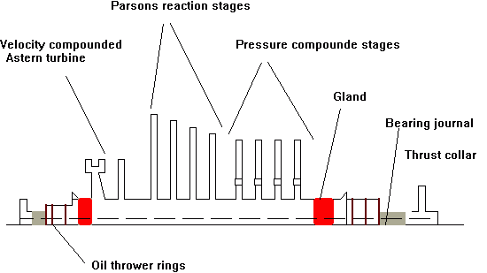
The loss of efficiency due to the two stage velocity compounding of the astern turbine is more than made up by the reduction in windage whilst running ahead ( the design must still be able to supply 70% of the ahead revs which approximates to 40% of the ahead power) The impulse blading may have up to 20% reaction effect at the mean blade height.
The astern stage consists of one single wheel two stage velocity compounded followed by a single stage wheel.
Material
  - 0.45% Carbon
  - 0.15% Silicon
  - Trace amounts of phosphorus and sulphur
Blade material
  - 11.5 - 13.5% Chromium
  - 1% Nickel,manganese and silicon
  - 0.12% Carbon
  - Trace amounts of sulphur and Phosphorus

